
CONFOEDERATIO,
RESEARCH DIVISION (CRD).

STADESTÉR 1.0.
A Global Database of 41000+ Cities from 3000BC to the Present.
16 August 2025 - Vis Tacitus and Aust Kätzchen | vistacitus@confoederatio.org, austkaetzchen@confoederatio.org

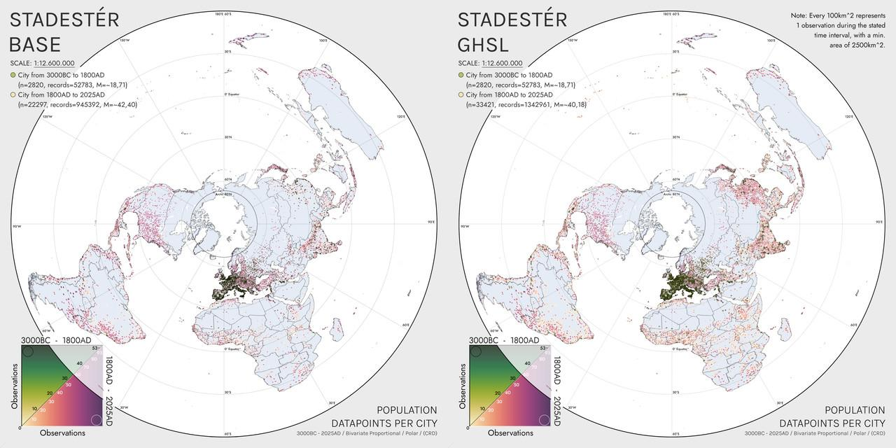
Figure 1. Population datapoints per city in Stadestér Base as compared to Stadestér-GHSL.

Abstract

Stadestér is an internally consistent global urban population database of ~41.214 cities and their populations from 3000BC to 2025AD as taken from Buringh, Chandler, de Vries, GHSL, GHS-POP, Modelski, Populstat, Reba et al., and Wikipedia. Resultant data was standardised, geolocated, cubic spline interpolated, and calculated at 1-year intervals via weighted geometric averages. Reliability was assessed via comparisons to other demographic sources and long-run urban estimates, out-of-model sampling, regional centre of population/gravity comparisons, and manual copychecking prior to calibration, deviating by a mean of 17,4% (SD = 13%) of HYDE/UN estimates over the long run.

To avoid duplicate entries, cities were merged based on their physical distance from one other as well as their semantic similarity between both contemporary and historical names. Metropolitan networks were corrected for by subtracting suburban populations from their metro area, and redistributing any negative numbers held by the metropolitan area back to their suburbs in a proportional manner. Geolocation was achieved via automated Selenium/Puppeteer scraping, the Google Places API, Google Maps, Nominatim/OSM, and manual transcription.

Area, density, rate of natural increase (RNI), and geospatial distributions of population within cities are also available at annual resolution starting from 1800AD. Note that rasters have only been outputted for the subset of HYDE years from 3000BC-2025AD, and that we provide an open-source CLI for generating data from specific years, in addition to a custom UI tool for geoprocessing and visualisation (Constele Red). Area/density calculations were derived from Angel, Bairoch, Clark, Pasciuti and Chase-Dunn, and Stanilov and Sykora. The work of Hanson, Ortman, and Storey on classical populations have not yet been implemented.

We also naturally provide rasters of global overall population and non-urban population as an alternative to HYDE3.2/3.3 based on HYDE corrected for outliers, McEvedy and Jones, and GHS-POP. To replace masked outliers, we created custom climate models based on the ALCC work of KK10/LUH2 as rural population fallbacks. Both the main substrata and fallback substrata were calibrated to reliable estimates of regional and global population.

Note. European decimals are used throughout this research. Accompanying each figure is a hyperlink for a full-resolution version of the image.

Background

What do we know about urban history? When this project had begun, we assumed this was a somewhat settled question - population figures had after all been published and tabulated in great detail for past cities, however HYDE3.3 had not done so, despite being commonly used in long run analysis and estimates of urbanisation, for example by Our World In Data, or as a background variable by V-Dem [OWID][V-Dem, 10.6.3, 10.6.4].

To their credit, it is confusing since HYDE3.1’s methodological paper implies that urban population totals did use estimates of historical urban population, HYDE3.2’s preprint implies otherwise, HYDE3.2’s paper refers back to HYDE3.1’s methodological paper, and there is an additional flowchart in said paper claiming that historical population was empirically derived:

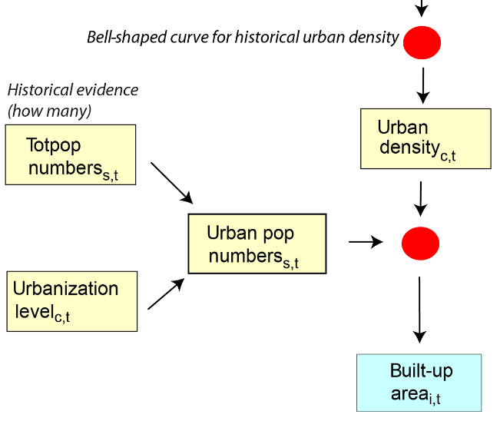

Figure 2. HYDE3.2’s flowchart implying historical urban population is empirically derived (Urban pop numbers _{s,t}).

‘Chandler (1987) and Mitchell (1993a, b, 1998) present hundreds of estimates for historical city population numbers, but they provide no area associated with them, therefore we decided to use historical urban densities as a proxy for computing built-up area instead’. [HYDE3.1]

‘Finally, an important point to be made is that in this HYDE3.2 version no empirical data is systematically used (yet) to improve the historical land use reconstructions. All allocation in in [sic] the deep past is done by general, globally applicable HYDE allocation rules. As Morrison (2015) rightly pointed out, these rules are often made with a Euro-centric point of view’. [HYDE3.2, Preprint].

HYDE3.3 does not have a corresponding methodological paper. It is difficult to tell which is which - we will charitably assume that urban population numbers not in land use, and that they did encode empirical figures. If so, there must have been a lot of clerical errors, because HYDE3.3’s assessment of principal cities in antiquity are off by orders of magnitude from Chandler and Modelski:

[WIP] - Formalise source links at a later point.

City | HYDE Population (1000s) | Estimated Population (1000s) | Discrepancy | Sources
Chengdu | 3,225 | 250 | 77,519x | Modelski [4]
Luoyang | 1,386 | 260 | 187,59x | Modelski [4]
Chang’an | 1 | 246 | 246x | Modelski [4]
Kaifeng | 1,297 | 100 | 77,101x | Modelski [4]
Taxila | 0,557 | 150 | 269,299x | Modelski [4]
Madurai | 1,833 | 50 | 27,277x | Chandler [5]
Pataliputra | 2,808 | 100 | 35,613x | Modelski [4]
Vaishali | 2,168 | 100 | 46,125x | Modelski [4]
Alexandria | 0,623 | 400 | 642,054x | Chandler, Modelski [4][5]
Jerusalem | 0,093 | 100 | 1075,268x | Chandler [5]
Seleucia | 0,147 | 400 | 2721,088x | Modelski [4]
Rome | 2,741 | 450 | 164,174x | Hanson & Ortman (City Proper), Storey, Chandler [5][6][7]
Caracol | 0 | 100 | N/A | Modelski [4]
Geomean Discrepancy: | - | - | 168,569x, SD = 778,214

Figure 3. Table of urban population differences between HYDE and academic estimates (1AD). Estimated populations are geometric means.

It is certainly not as though these estimates improve with time, or even the advent of modern data. HYDE claims, for instance, that the largest cities in the Soviet Union in 1950AD were Chelyabinsk and Novosibirsk, and that their peak population densities were roughly twice that of Moscow. It is also not self-consistent within countries as diverse as Bhutan, Denmark, Iceland, Russia, or the pre-Columbian United States and Canada [Footnote: Both 1AD and 1950AD are primary benchmark years: one represents the start of the Common Era, and the other the end of Before Present (BP)].

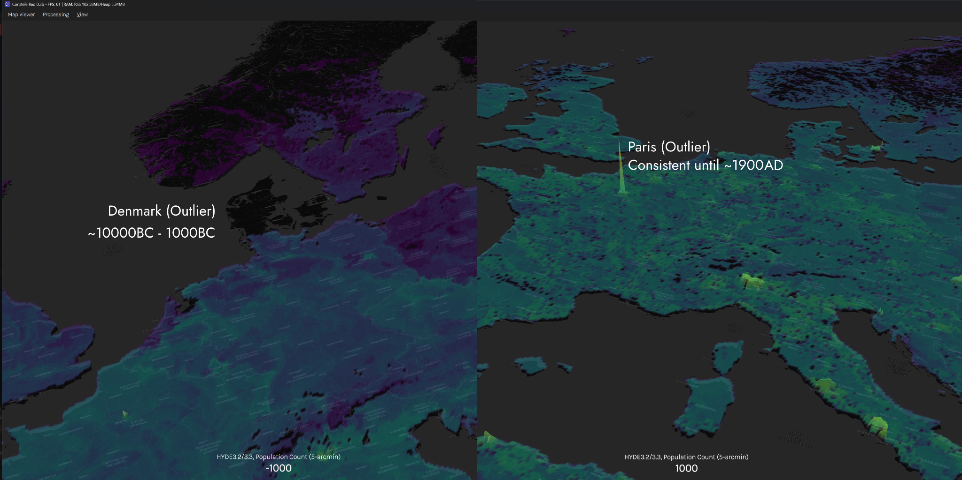

Figure 4. Screenshots of extant artefacting issues with with HYDE3.2/3.3 as viewed on an elevation heightmap in Constele Red.

All of this confusion is an especially undesirable outcome given that gridded population datasets are frequently used for urban planning or assessments of historical urban population [Stefan Leyk et al].

Extant Datasets

Stadestér originated from an attempt to fix historical populations within HYDE. We had unfortunately found in the process that HYDE3.2/3.3 was unworkable even on a regional scale, and so had to scale processed HYDE population rasters first to McEvedy and Jones, then to estimates to Amerindigenous populations as carried out by Denevan, Snow, Alchon, Peros, and Milner [Denevan][Snow][Alchon][Peros][Milner]. We then merged HYDE3.2/3.3 to get rid of some of the outliers in the most recent iteration of the dataset, before recalibrating it to various estimates of regional and global population [Nelson]. We will refer to this internal model throughout the paper as Velkscala 0.7.

An ideal solution for fixing urban populations within Velkscala 0.7 would have been to use existing comprehensive urban datasets at a global level, but despite large-scale advances in data sourcing from Wikipedia, YouTube, or various websites [Buringh][Bye], organised tables and aggregations of urban data remain limited. The field of historical demography in general may evolve in an OSINT/open-source like manner similar to data science, but we have relied mainly on scholarly research in aggregating this dataset.

However, we found that existing work had generally low urban coverage, was spatiotemporally sparse, and often did not incorporate better modern data post-1975 or even post-2000 as made available by GHSL, with an error margin of ~4,5-11,6% from satellite data [GHS-POP - R2023A][Calka and Bielecka]. The largest dataset with global urban coverage was Reba et al., whose work encompassed only 1.741 unique cities. Buringh has consistent listings for 2.261 cities, most of which appear consistently, though only for the European continent.

We did not assess the error margins of these historical datasets, though we did assess discrepancies between estimates of total urban population and raw sums from our uncalibrated dataset once merged, and estimate an error margin of ~20-30% from general testing and validation. Both Chandler and Modelski were prone to overestimate the size of ancient, and in some cases, mediaeval cities [Smith].

We must advise anyone using our dataset to be cautious of this until we can manually revise these figures to more conservative estimates for antiquity utilising sources by regional specialists in future iterations of this dataset (for example that by Hanson and Ortman, Storey, Broadberry, van Zanden, TAVO, or work carried out by archaeological statisticians), whom we have (not yet) integrated.

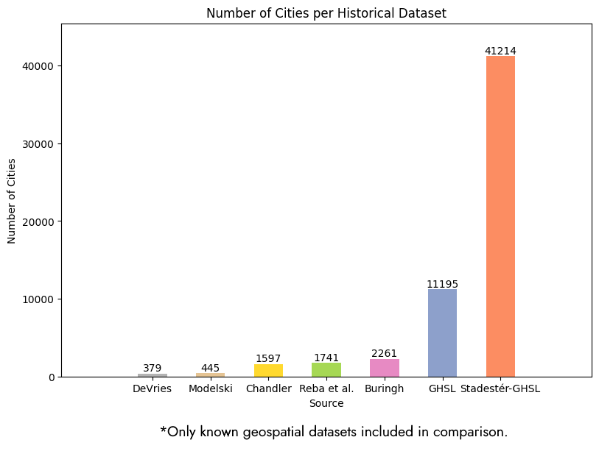

Figure 5. Number of cities in Stadestér compared to other datasets of historical population.

Dataset | Number of Cities | Geographic Domain | Time Domain | Sources
de Vries | 379 | Europe | 1500AD-1800AD
Modelski | 445 | Global | 3700BC-2000AD
Chandler | 1.597 | Global | 2250BC-1975AD
Reba et al. | 1.741 | Global | 3700BC-2000AD
Buringh | 2.261 | Europe | 700AD-2000AD
GHSL | 11.195 | Global | 1975AD-2025AD
Stadestér-GHSL | 41.214 | Global | 3000BC-2025AD

Figure 6. Geographic coverage and sample sizes of peer urban demographic datasets compared to Stadestér-GHSL.

The synthesis of extant datasets has led to a general increase in the number of cities in Stadestér-GHSL, with 8.181 of these cities being observed prior to 1900AD. Due to the relatively large size of our target resolution rasters, 5-arcmin being roughly 9,275km at the equator, we judged it unnecessary to calculate individual urban densities prior to 1800AD, as pre-industrial growth typically resulted in compact cities, and our data is granular enough to capture distinct peri-urban settlements.

The largest pre-industrial urban centre was likely Angkor, and with a city centre of 15x15km, it would barely exceed 4 gridcells at a 5-arcmin resolution, though its irrigation network is much larger at ~1.000km^2 [Evans et al.]. We were also unable to normalise much of the Wikipedia data during the course of this study, and ultimately did not integrate much of it into our dataset outside of some manual population fixes for the work of Reba et al.

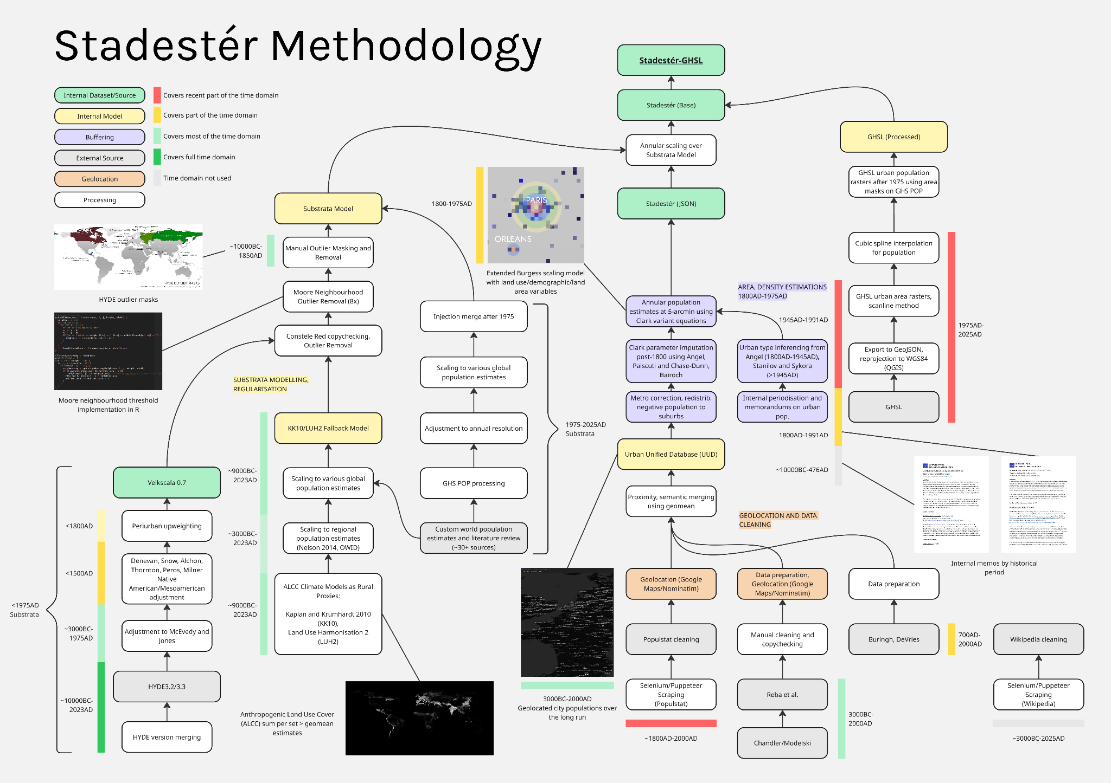

Figure 7. Schematic overview of Stadestér’s design showing both the rural substrata model and urban dataset construction.

At present, Stadestér consists of five parallel models working in conjunction to produce urban population data - a global substrata model from Velkscala 0.7 utilising climate models as a fallback for rural population, a dataset of human settlements and their populations, weakly interpolated over time, and an area/density buffering model for them between 1800-2000AD as taken from our extant population figures and work done by Angel, Paiscuti, Chase-Dunn, Bairoch, and Stanilov and Sykora [Angel][Paiscuti and Chase-Dunn][Bairoch][Stanilov and Sykora]. Unlike backcasted urban models, our urban model is casted forwards in time, such that it would enable us to perform out-of-model forecasting during the truncation period (1975AD-2000AD) between modern satellite data and our proxy model [Li et al][Borup][Eurostat]. Reliable historical data is also available for a representative sample of 30 global cities over the same time period in the Atlas of Urban Expansion [Angel], which we were also able to visually compare against (Figure 32).

The final model are those by GHS-POP and GHSL-UCDB, which we use after 1975AD after downscaling to a consistent 5-arcmin resolution (4320x2160) for the same standard projection (WGS84 Equirectangular) [Melchiorri et al]. We refer broadly to the resultant dataset as Stadestér, and will use qualifiers (Stadestér Base, Stadestér-GHSL, etc.) where appropriate.

Definitions & Glossary

- ALCC | Anthropogenic Land Cover Change (ALCC), taken here to be the cumulative fraction of a gridcell under anthropogenic use.
- Centre density, city centre density | The imputed density of a city at its city centre, typically measured in inhabitants per km^2, or ihb/km^2.
- GHSL | Global Human Settlement Layer (GHSL) dataset. When used in isolation, it refers specifically to GHSL-UCDB, or its urban layer by Melchiorri et al.
- GHS-POP | Refers specifically to GHSL population rasters from 1975-2025, as linearly interpolated and scaled to reliable estimates of world population.
- Global 30 | Refers to the 30 global cities taken as being a representative sample of varying world regions by Angel.
- Global 120 | Refers to the largest 120 cities by maximum population as present in Stadestér.
- KK10/LUH2 | Refers to a custom internal ALCC model as synthesised from KK10 (Kaplan and Krumhardt 2010) and LUH2 (Land Use Harmonization 2), as averaged and scaled to global population. Used as a fallback for HYDE/Velkscala 0.7.
- Stadestér-Base | The base dataset without the usage of GHSL layers post-1975.
- Stadestér-GHSL | Piecewise data set that uses Stadestér Base prior to 1975AD, and GHSL after 1975AD.
- Stadestér Global, Stadestér Global Population | Global population rasters including both urban and rural population.
- Stadestér Rural | Resultant rural population rasters that include both peri-urban and semi-urban populations in addition to purely rural populations.
- Stadestér Urban | Resultant urban population rasters that include only human settlements that qualify against the Stadestér definition of a city.
- Substrata | The synthesised internal model of non-urban population that we use after urban outlier removal from a merged version of KK10/LUH2 and Velkscala 0.7.
- Velkscala, Velkscala 0.7 | A previous database of global population utilising a custom internal variation of HYDE3.2/3.3 with rescaling done at the national level.

Historical Names

Due to the long time domain of Stadestér, we have generally decided to utilise the last contemporary romanised name present for each unique city (i.e. Capua as Santa Maria Capua Vetere, but Seleucia, part of Ctesiphon, has maintained its antique name, as it was abandoned in 762AD after being briefly known as Veh Ardashir/Vēh-Ardaxšēr) [e-GEDSH][Morony]. Similarly, proximity and semantic merges have meant that cities may sometimes have the name of a close by city or neighbourhood, particularly as an artefact of disagglomeration and proximity merging in final datasets, as in the case of London, some of whose population entries were transferred to Kensington and Chelsea.

All listed historical and alternative names were merged under an other_names array which is present for each city’s JSON entry.

What Is A City?

There is no settled definition of a city [Mwaniki][Fedorenko and Kolos][UN Habitat]. As such, we take a city to be any permanent human settlement mentioned in constituent sources until 1800AD, mentioned as a town or city in censuses, encyclopaedias, or yearbooks from 1800AD-1975AD, with the GHSL/UN definition of a city (degree of urbanisation) being adopted after 1975AD for Stadestér-GHSL [Dijkstra][UN Statistical Division][Footnote: Recently it appears the UN has officially adopted the GHSL definition of a city for statistical purposes (degree of urbanisation), though it appears slightly problematic to us that the official global urban population would drop precipitously by ~28,41% because of it - from 4,61 billion to 3,3 billion].

Because this was not without its issues (i.e. there being no cities in the American South until 1980 by this definition outside New Orleans, Miami, Tampa, and Texas) [EU Degurba], we have also retained legacy cities carried over from the 1800AD-1975AD definition in non-Stadestér-GHSL rasters, updating their populations forwards until 2023AD. If you wish to revise this definition, we recommend the use of threshold filtering over the dataset by area, city centre density, population, or any other variable provided in Stadestér, since we aim to create a relatively comprehensive listing of historical human settlements.

World Regions

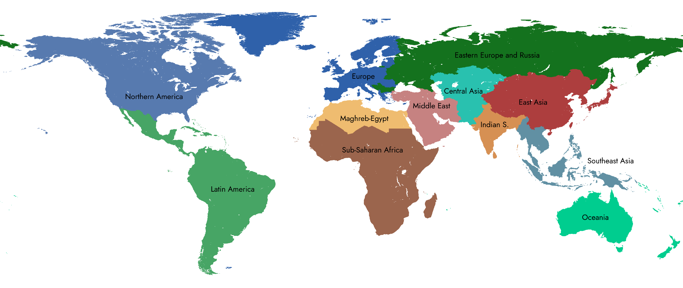

Figure 8. Choropleth map of major world regions as defined by Stadestér for statistical purposes.

In the interests of statistical transparency, we chose to use 12 major world regions for statistical purposes. These world regions cover each of the six inhabited continents, and are divided as follows:

- Northern America: the modern United States and Canada, both being primarily Anglo-settler colonies in the Americas.
- Latin America: those nations in the Latin American and Caribbean (UN) group, as well as French Guyana and Puerto Rico.
- Europe: national jurisdictions on the European continent which utilise the Latin alphabet and are not in Eastern Europe & Russia, as well as Greenland [Footnote: This definition also means it includes European dependencies in the Atlantic, i.e. the Falklands or St. Helena. In general, island European settler colonies and dependencies east of the Cape are in ‘Oceania’, whilst those in the Atlantic are in ‘Europe’].
- Eastern Europe & Russia: nations in the Orthodox World which were formerly part of the Socialist Bloc and utilise the Cyrillic alphabet.
- Middle East: any nation primarily in West Asia, including those of the Southern Caucasus, as well as Iran.
- Maghreb-Egypt: the northernmost nations in Africa bordering the Mediterranean, excluding the Sahelian states, but including Western Sahara.
- Sub-Saharan Africa: any nation on the African Continent not situated in Maghreb-Egypt or Oceania.
- Central Asia: the landlocked nations of Central Asia, as well as Pakistan [Footnote: We include those regions in Central Asia which were often under some form of Persian administration. Pakistan’s relatively late colonisation by Britain does not make including it in the Indian Subcontinent very helpful from a long-term perspective. In any case, it also helps to separate out the earlier Indus Valley civilisation. Additionally, Urdu is written in the Perso-Arabic script, so modern recordkeeping has a hard boundary. That is reason enough.].
- Indian Subcontinent: comprised of India, Sri Lanka, the Maldives, and Bangladesh.
- Southeast Asia: the nations of ASEAN as well as Papua New Guinea [Footnote: Papua New Guinea is in the Malay Archipelago, which is why it is included here].
- East Asia: China, Taiwan, the Korean Peninsula, and Japan [Footnote: Until very recently, Mongolia was a part of the Qing Empire, and before that had constant interactions with Chinese civilisations, most notably in the form of the Yuan Dynasty. Like CJK, the Hudum Mongol bichig requires special handling. Vietnam is not included here, as virtually all its historic documents today have been transcribed into the Latin alphabet; it is instead in Southeast Asia.].
- Oceania: the otherwise conventional definition of Oceania; extended to the Mascarenes and Mayotte [Footnote: Oceania is extended to the Mascarenes and Mayotte due to the former’s late settlement by Europeans, and the fact that the latter remains a European dependency].

Certainly there will never be a good non-arbitrary way to divide the Earth. What motivated us to divide statistical regions in such a manner were mainly differences in archival practices, infospheres, and documentation. In having such hard boundaries, we may at least assess the statistical quality of each region relative to its own recordkeeping.

Methodology

‘What is now known about the pre-nineteenth century urban population of Europe? The short answer to this question must be: surprisingly little … this negative appraisal may seem odd to some readers who are aware of the impressive advances made since the late 1950s in the study of historical demography’. - de Vries, European Urbanisation (p. 17).

The good news is that we now know a surprisingly great deal not just of European cities prior to 1800, but of the world more generally, thanks to the enduring work of historical demographers. The bad news is that in the years since de Vries issued his various statements, the field has effectively collapsed and died [Werlin p. 448].

Presumably this occurred sometime between the first and second editions of the International Encyclopedia of the Social & Behavioral Sciences, when its entry switched from that of a living field to a biography [Saito], and it now occupies (n=7) ~1,1-1,7% of demographic papers presented out of a sample of 507 [Footnote: As taken from the IUSSP International Population Conference (2013), PAA annual meeting (2015). This sort of sampling is now impossible - the IUSSP’s Historical Demography panel was cancelled for the 6th year straight [IUSSP Historical Demography].

It is now filed under ‘Past Panels and Groups’. From 1997-2018, there were 5 reboots and an annual presence, but the most recent panel (the 6th) has no roman numeral and only met for one year. The call for papers (2022) is after their last report (2021), in which they announce the conference is cancelled due to COVID-19. The panel was shelved immediately after their call for papers. They list a total of four publications from proceedings for the period from 2018-2021. That works out to one publication a year. If you are perhaps thinking that COVID extends into 2025, I assure you none of the present panels are inactive. None of them, however, are on historical demography.][Matthis et al., Tsuya, p. 190, Reber, p. 193-194, Lee 199, Vikström 203]. For those that might object to the portrayal of its collapse, let me remind you that in living fields, there are generally not academic perspective essays entitled ‘Reach out to bring in rejuvenation: on the need to populate historical demography’ [Footnote: Perhaps living fields such as anthropology do have essays entitled ‘on the need to populate anthropology’, but I am not aware of any such phenomenon. As Lee puts it, ‘In addition, the emergence of young innovative researchers who spearhead historical demography has become a rare occurrence, thereby eroding the pool of published research theses from which to quote’. If new research is so rare that one is struggling for works to cite, I certainly would not portray the field as alive.

As Werlin, who quotes Steve Hindle puts it: ‘The increasingly muffled conversation between historical demographers and early modern historians has, depressingly, deteriorated still further into a dialogue of the deaf’.].

Historical demography, in other words, must now be the work of us pseudonymous amateurs. Let us now explain that work.

Data Scraping

Lahmeyer (Populstat) was the last great historical demographer to have published exhaustive research [Federico and Tena-Junguito]. However this work had not been geospatialised, and so required scraping and preprocessing [Populstat]. A recursive scraper using CURL/JSDOM was first built to crawl Populstat and fetch relevant links to pages on the towns and settlements of various jurisdictions (‘of some important towns’), and the resultant HTML tables were cleaned and processed into JSON files, with redundant keys having their population entries merged [JSDOM].

Relevant tables were selected with query selectors, with the first table row being taken as the header, as it typically contained years in Populstat. Any numeric headers that resolved to an integer were assumed to contain years, and the main table underneath had European figures parsed as such and multiplied by 1.000 [Footnote: Buringh and de Vries, to my knowledge, also utilise figures in their thousands, typically either with European decimals or whole numbers]. The first column was taken as containing the name of a place.

Variants of the name were appended to other_names, and generic field handling was implemented for various fields which did not match the pattern specified above. To help map agglomerations to non-agglomerations, we also mapped semantic patterns such as (agglomeration) and is agglomeration of onto one another, as we intended to utilise these mappings to avoid double counting both metropolitan and suburban populations in mixed registries, which has proven an issue even for modern gridded population maps and statistical agencies such as GEOSTAT and Canadian census data [Eurostat][Statcan].

A general scrape of data from Wikipedia was also conducted utilising a scoring system in an attempt to associate Populstat cities with Wikipedia articles, but this approach proved noisy due to a weak implementation of NLP algorithms and near-indiscriminate table selection, and so we opted to exclude any resultant Wikipedia JSON data from the final model in Stadestér 1.0.

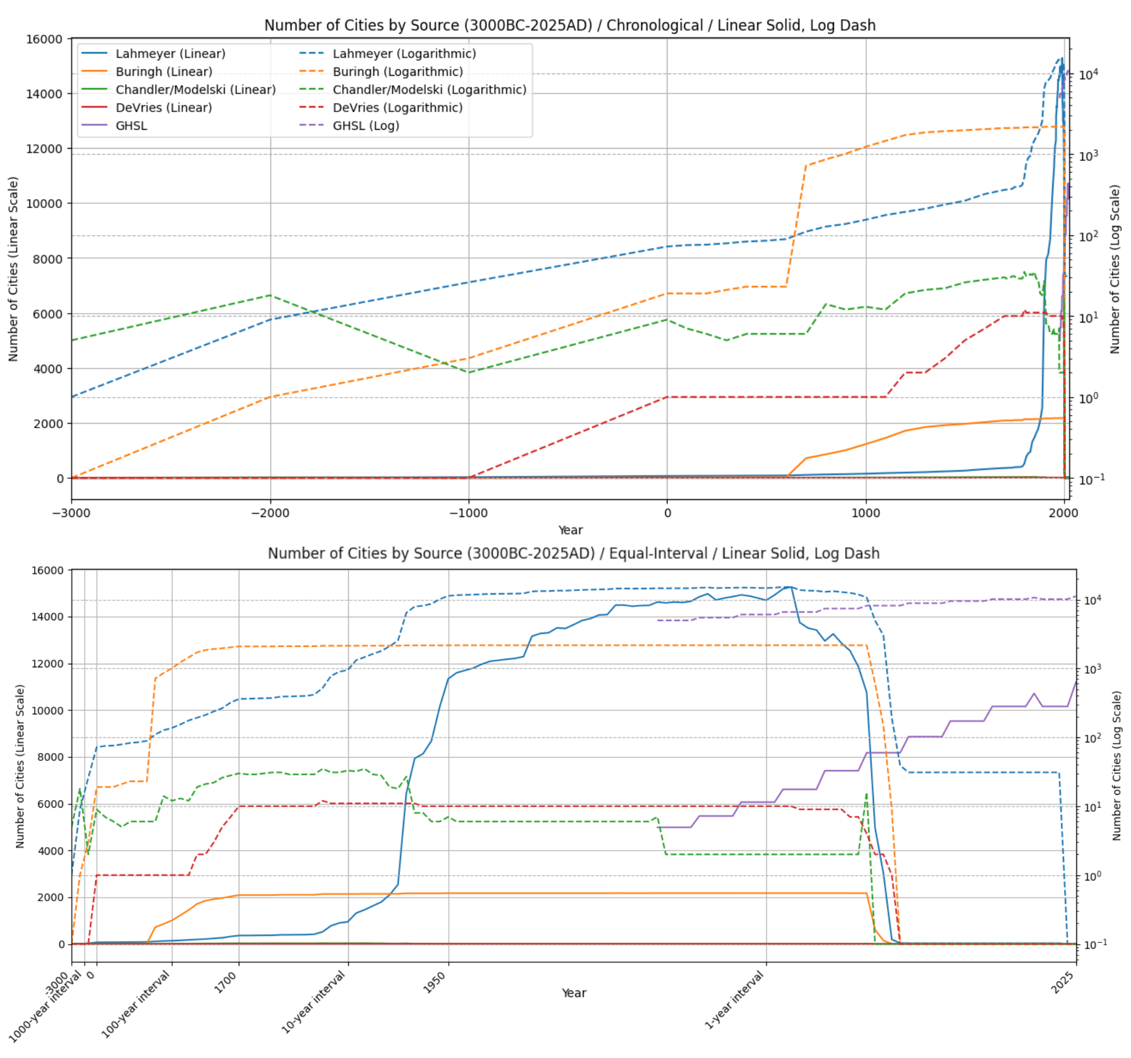

Figure 9. Provenance of principal sources of population data used in Stadestér over time (3000BC-2025AD). Note that Lahmeyer denotes Populstat.

Similar tasks have previously been attempted [Bhagavatula et al], but they differed from our use-case in that population figures and placenames are inconsistently placed and named, decimal notation differs, and that the order of magnitude chosen for population figures can differ dramatically from figures without distortion, as in the case of Berlin, to listing residents in millions, as in the case of Nanjing [Wikipedia - Berlin][Wikipedia - Nanjing].

We propose in future iterations of Stadestér to utilise long-context LLM agents for data extraction, though significant problems would likely remain in terms of data structuring, though we view these challenges as surmountable [Bodensohn et al][Lee et al]. Preprocessed datasets were also brought forth to cover different eras of the dataset - in particular, details from both Chandler and Modelski (via Reba et al) were synthesised by way of having equivalent keys merged into a single population object utilising weak geometric means as follows:

Let $S=\{x_{1},x_{2}, ..., x_{n}\}$ be your set of values, where
$S^{+}=\{x_{i}∈S : x_{i}≥0\}, S^{-}=\{x_{i}∈S : x_{i}<0\},$
$n^{+}=|S^{+}|, n^{-}=|S^{-}|, n=n^{+}+n^{-}+n^{0}$, and $n^{0}$ is the number of zeroes.
$GM^{+}(S)=(\prod_{x∈S^{+}}{}x)^{1/n^{+}}, GM^{-}(S)=(\prod_{x∈S^{-}}{}|x|)^{1/n^{-}}$, where the weighted geomean function is:
$WEGM(S)=\frac{n^{+}}{n}GM^{+}(S)-\frac{n^{-}}{n}GM^{-}(S)$.

Definition 1. Given a set of negative and positive values, construct a weighted geometric mean such that a set of values $S$ resolves to a single value.

Let $K=∩_{j=1}^{m}{}keys(S_{j})$ be the set of overlapping keys, where
$U=∪_{j=1}^{m}{}keys(S_{j})$ is the set of all keys, and $N=U \backslash K$ is the set of non-overlapping keys, where $V_{k}=\{S_{1}[k], S_{2}[k], ..., S_{m}[k]$} is the list of values for key $k$ across all sets.
The weakly-resolved set of keys is then represented by the resolution map:
$R[k]=\{ k →WEGM(V_{k})$ for $k∈K$, $k→S_{j}[k]$ for $k∈N$, where $k∈keys(S_{j})$}.

Definition 2. Given multiple sets $S_{m}$, weakly resolve the set such that the resolution map $R$ maintains the non-overlapping keys of each set, whilst applying a weighted geometric mean to remaining figures (Definition 1).

Of course, this means that $WGM(V_{k})=R[k]$, where $WGM$ is our weak geometric mean.

This type of implementation is a generalised workaround for being able to process negative numbers [Costa]. Weak geometric means differ from ‘strong geometric means’ in that strong geomeans are cubic spline interpolated over the course of the entire course of their domain prior to being geometrically averaged between overlapping values. Strong geometric means are generally more useful when there are enough data sources such that large divergences are smoothed out in processed data.

We mainly utilise a bounded log-space cubic spline interpolation, which we define as follows:

Given $X=\{x_{1}, x_{2}, ..., x_{n}\}⊂ℝ$, $Y=\{y_{1}, y_{2}, ..., y_{n}\}⊂ℝ_{≥0}$, let $x^{*}∈ℝ$ be the point at which to interpolate.
$L_{i}= \{ log(y_{i})$ if $y_{i}>0$, $log(ϵ)$ otherwise, where $ϵ=10^{-6}$.
Let $S(x_{i})=L_{i}$ for $i=1, ..., n$ | $S(x)$ is the cubic spline interpolant, and
$L^{*}=S(x^{*}), y^{*}=exp(L^{*})$.
Let $x_{p}$ and $x_{n}$ be the largest and smallest $x_{i}$ | $x_{p}<x^{*}<x_{n}$, where $y_{p}=y(x_{p}), y_{n}=y(x_{n}$).
$(∃x_{p}∧∃x_{n})→{(y}_{lin}^{*} :=y_{p}+\frac{x^{*}-x_{p}}{x_{n}-x_{p}}(y_{n}-y_{p}))$, where the final value is bounded thus:
$ŷ^{*}=\{min(max(y_{p},y_{lin}^{*}), y_{n})$ if $(∃x_{p}∧∃x_{n})$, $y^{*}$ otherwise.
$BCS(X,Y,x^{*})=ŷ^{*}$ , where $BCS$ represents the bounded cubic spline at a particular value.

Definition 3. Given a set of x-values over a domain $X$, and a set of y-values over a range $Y$, cubic spline interpolate the value $x^{*}$ in log-space such that $x_{p}<x^{*}<x_{n}$.

Ergo, a strong geometric mean would have the resolution map $R[k]=SGM(V_{k})=(\prod_{x^{*}∈D_{k}}{}BCS(X_{k},V_{k},x^{*}))^{1/|D_{k}|}$,
where $D_{k}$ is the set of domain point integers that were sampled or interpolated.

Certainly analogous boundings on cubic splines have been attempted before, though strong geometric means do not seem to appear in the statistical literature, though their constituent parts (i.e. splines of weighted geometric means) and bounded cubic splines have been independently analysed, if only in a geometric, and not necessarily statistical context [de Boor][Nava-Yazdani].

In any case, they have not been utilised in Stadestér 1.0 outside density modelling or global population estimates, and this can lead to larger swings in population entries than expected. We simply did not feel that there were enough ‘clean’ sources to utilise this approach, although we plan to implement such strong geometric means on a case-by-case basis in the future.

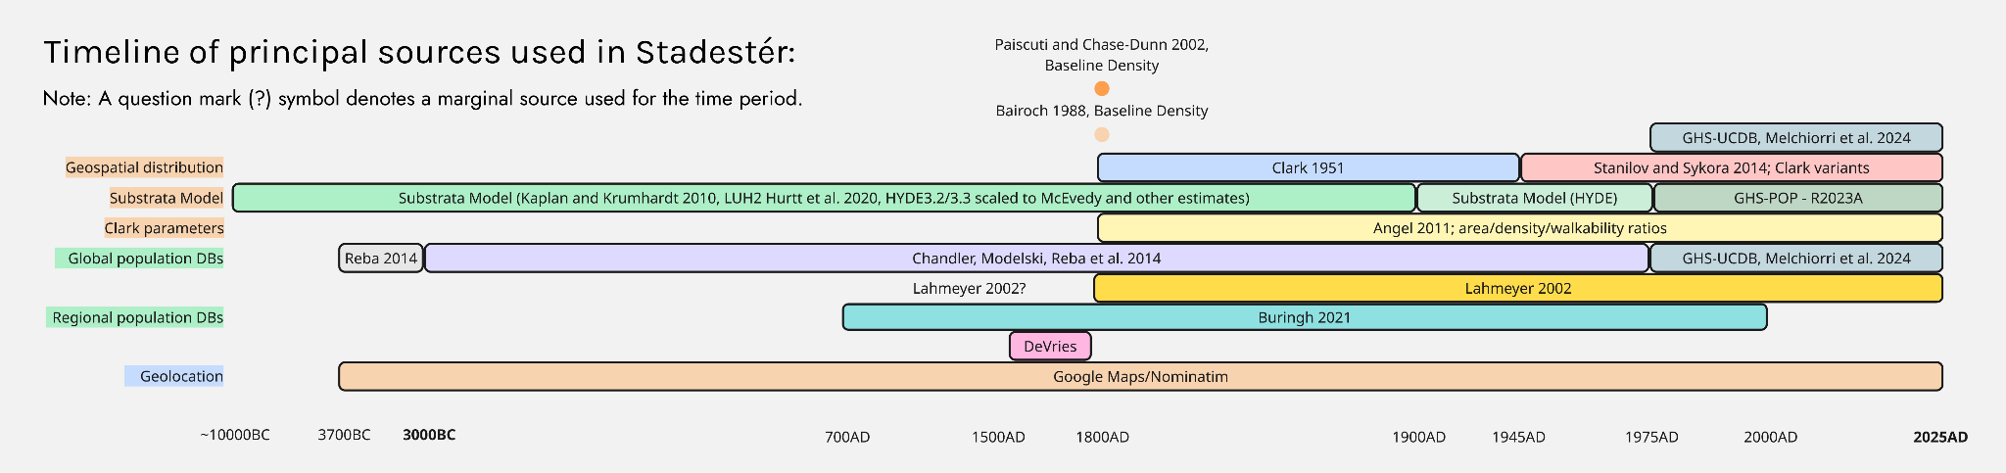

Figure 10. Timeline of sources used in Stadestér’s internal models (3000BC-2025AD).

Naturally, a particular issue was the scarcity of sourcing prior to 1800AD, with the number of cities (not accounting for peri-urban settlements) between 1800AD-2025AD accounting for 92,22% of the total dataset (n=33421), with the only 2.820 cities having unique records prior to 1800AD, the majority of which originated from Chandler, Modelski, Reba et al., Buringh, and de Vries. The share of records equally drops from n=1342961 after 1800AD to n=52783 (3,91%).

Ironically, the number of cities in Stadestér-GHSL also drops assiduously in 1975AD as the definition of a city changes, falling from n=~14922 to n=8691, as all other databases, and particularly Populstat are overridden by GHSL (note that this drop does not occur in the set of merged Stadestér urban rasters). This is in part due to density thresholds being introduced to define cities, which work relatively poorly unless adjusted by country, but are applied indiscriminately by GHSL/Degurba, resulting in a dearth of cities in countries where cars are widespread [Hanberry][Ostermeijer et al].

Apart from GHSL and Reba et al., remaining sources were already geolocated and came as CSV files which could be easily parsed [Buringh Dataset][Lincoln and Pett]. GHSL city areas were processed in QGIS to convert from Mollweide to WGS84 Equirectangular, before their GeoJSON files were spit out before being fed into a MultiPolygon scanline process, with their ID fields (ID_UC_G0) being converted to 32-bit RGBA, where each pixel’s decoded value is merely $n=16777216r+65536g+256b+a$ .

For cities small enough that a single pixel had not been written to the raster, a pixel was placed at their polygon centroid to represent that GHSL city. In GIS and raster processing, a centroid is typically analogous with the pole of inaccessibility, rather than a weighted centre of gravity, and this term is used interchangeably (unlike in geometry) [Noyel et al][ESRI Documentation].

GHS-POP rasters were separately from its 5-year resolution timespan between 1975-2025 (1975, 1980, 1985, 1990, 1995, 2000, 2005, 2010, 2015, 2020, 2025) via a keyframe approach, whereby in-between years used the spatial distribution of the previous keyframe scaled to the global population for that year [Freire et al].

The urban extents taken previously from GHSL-UCDB were used as masks for each urban centre, geolocated, and well-formed JSON objects with populations per year inferred from the intersection of GHS-POP and GHSL-UCDB rasters.

Data Preparation

Unfortunately, Reba et al. contained a multitude of errors which prevented us from using it without alteration. Part of this was due to semantic transcoding - Birmingham, UK, for example, was swapped with Birmingham, Alabama, and certain data fluctuations had to be normalised. An automated flagging process was implemented, whereby growth rates > +/-25% in a single year were flagged for manual review.

A number of corrections for the Reba dataset were issued as follows:

City Name | Year(s) | Action Taken | Rep. Val. (1000s) | Error
Aleppo, Syria | 1300AD | Key deleted | N/A | Stray zero value
Alexandria, Egypt | 361AD, 365AD | Key for 365AD moved to 361AD | N/A | Erroneous date for Alexandrian earthquake
Algiers, Algeria | 1925AD | Changed pop. | 222 | Order of magnitude clerical error
Algiers, Algeria | All | Changed country to Algeria | N/A | Algiers was stated to be a city-state
Augsburg, Germany | All | Changed spelling to ‘Augsburg’ | N/A | Spelled as ‘Augsberg’
Birmingham, United States | All | Swapped with Birmingham, UK | N/A | Accidentally swapped with Birmingham, UK
Delhi, India | 1375AD | Changed pop. | 200 | Order of magnitude clerical error
Delhi, India | 1398AD | Changed pop. | 25 | Tamurlane sacking Delhi dated to 1450AD
Delhi, India | 1596AD | Changed pop. | 80 | Order of magnitude clerical error
Fez, Morocco | 1800AD | Changed pop. | 60 | Population randomly drops 42,8% in 1 year
Goa, India | 1510AD | Key deleted | N/A | Population randomly drops 40% due to the Portuguese conquest. No known source affirms this [Footnote: there is a single source, Kerr 1824, who claims 6.000-9.000 deaths of the Muslim inhabitants].
Izmail, Ukraine | All | Changed country to Ukraine | N/A | Supposedly part of Romania
Lahore, Pakistan | 1600AD | Changed pop. | 200 | Population randomly drops from 300.000 (1590AD) to 34.000 (1600AD)
Lahore, Pakistan | 1622AD | Changed pop. | 250 | Population of Lahore allegedly rebounds from 34.000 to 500.000
Lahore, Pakistan | 1627AD | Changed pop. | 255 | See previous entry
Lahore, Pakistan | 1631AD | Changed pop. | 284 | Supposedly crashes again from 500.000 (1627AD) to 84.000 (1631AD)
Nanjing, China | 1970AD | Changed pop. | 2.000 | Supposed population just 200.000
Nanjing, China | 2000AD | Changed pop. | 5.448,9 | Supposed population of 1,2M in 2000AD
Palermo, Italy | 1150AD | Changed pop. | 125 | Supposedly had 125 people, even though pop. was estimated at ~150.000 [De Long and Shleifer]
Philadelphia, United States | 1914AD | Changed pop. | 1.750 | Order of magnitude clerical error
Skopje, Macedonia | All | Changed country to Macedonia | N/A | Skopje supposedly in Serbia
Srirangapatna, India | 1780AD | Changed pop. | 30 | Figure of 150.000 comes from Buchanan, but given the city was 60,7ha, it defies belief [Buchanan][Bartholomew]
Srirangapatna, India | 1799AD | Changed pop. | 50 | See previous entry
Tbilisi, Georgia | 1100AD | Key deleted | N/A | Stray zero value
Tokyo, Japan | 2000AD | Key deleted | N/A | Population suddenly declines from 23M in 1975AD to 8,13

Figure 11. List of manual corrections issued for Reba (361AD-2000AD).

Although this process was certainly not rigorous, it is likely to have dealt with some of the more egregious values present in Reba et al for the time being. It is likely that many of the values will have to be systematically reappraised and reassessed in future versions, since Chandler and Modelski’s estimates are known to have been exceptionally liberal and crude [Chase-Dunn et al][Fernández-Götz].

Geolocation

Much else can be learned from the dataset provided by Reba et al., namely the lesson of attrition via poor geolocation - an initial 10% of cities were removed for having no location, after which an additional 25% were ‘cities where geolocations are suspect’ (leaving just 67,5% of the original dataset).

To avoid such problems in our own collection of cities, a multi-stage fallback system was implemented using Selenium/Puppeteer, Google Maps, Google Places API, and OSM/Nominatim, with manual copychecking and coordinate assignment to catch any cases that fell through [Google Places API][OSM][Nominatim][Selenium][Puppeteer]. This approach was principally applied to Populstat data, which to our knowledge has not been geolocated by any extant projects, except in extremely limited cases, such as that of Brazil and a selected subset of national capitals from 1872AD-2007AD [Quistorff].
The complete set of names for each city was iterated over until latitude and longitude coordinates could be established. In many cases, our Selenium/Puppeteer agent proved only semi-reliable, and so its fetched coordinates were double-checked with the Google Places API. In all, this geolocation process took 24 days from start to finish on a high-end consumer workstation over n=23.619 cities, though we did not multithread or distribute our work.

Manual fixes were issued for Bristol and Washington, D.C. for Populstat, although this appears to have been the extent of geolocation errors, which we estimate to occupy ~0,008-0,1% of the geolocated set. Datasets which already came with coordinate pairings were not re-geolocated, though this may have caused some aspects of proximity merging to have suffered.

Data Merging

Merging in Stadestér was primarily done on a proximity threshold, with semantic matches altering the proximity threshold needed to qualify for a city to be merged into another. This is of course, a subset, or weak implementation of distance-based clustering [Matsumoto et al]. This was applied over the set of all cities as follows:

Let $C=\{c_{1,}c_{2}, ..., c_{n}\}$ be the set of cities in all datasets, where each city ${\{x}_{i},y_{i}\}⊆c_{i}$ and $name(c_{i})∈c_{i}$, where:
$sem(c_{i},c_{j})=\{1$ if $name(c_{i})≡name(c_{j})∨name(c_{i})⊂name(c_{j})$, 0 otherwise | $sem(c_{i},c_{j})$ defines a semantic match,
$T'(c_{i},c_{j})=\{T_{sem}$ if $sem(c_{i},c_{j})=1$, $T$ otherwise; where $T$ is the base proximity threshold, $T'$ is the adjusted threshold for semantic matches, and $T_{sem}≠T$.
Then for each city $c_{i}$,
Let $M_{i}=\{c_{j}∈C \backslash \{c_{i}\} : d(c_{i},c_{j})<T'(c_{i},c_{j})\}$ be the list of candidate cities such that
$c_{i}^{*}=arg min_{c_{j}∈M_{i}}d(c_{i},c_{j}),$
$c_{i}^{*}=mergePop(c_{i},c_{i}^{*})$.

Definition 4. Given multiple datasets such that the universal set of cities $C$ may contain redundancies, merge the populations of duplicate cities until $∀c_{i}→ (M_{i}=∅)$.

Differences in distance between points ($x_{1},y_{1}),(x_{2},y_{2})$ was merely Euclidean in terms of degrees, such that $d_{lat}=x_{j}-x_{i},d_{lng}=y_{j}-y_{i}$, and $d(c_{i},c_{j})=\sqrt{{d_{lat}}^{2}+{d_{lng}}^{2}}$. Whether a semantic match was detected depended entirely on either an exact name match or substring match in the case of data merging, with the closest city favoured for matching cities to be merged into. This may be ill-fitted when it comes to geodesic distances, but as threshold distances are typically infinitesimal, this was not generally viewed as a concern [Flater].

Proximity thresholds were encoded thus:
- Buringh: $T=$ 0,05; $T_{sem}=$ 1
- Chandler-Modelski: $T=$ 0,1; $T_{sem}=$ 1
- de Vries: $T=$ 0,1; $T_{sem}=$ 1

A generalised merge population function was defined as being an extension of the weak geometric mean, such that $mergePop({c_{i},c}_{i}^{*})=WGM(Population(c_{i})∪Population(c_{i}^{*}))$. In any case, preliminary values would be divided by a metro-adjustment geomean scalar based on the weighted set of discrepancies between conventional populations and metro populations if a dataset was flagged as having metropolitan figures. Only Chandler, Modelski, and Reba et al. met this criteria. Those datasets whose coordinates had less significant figures were assigned larger proximity thresholds.

The order of precedence for data merging was principally Populstat > Chandler/Modelski > de Vries > Buringh.

Metro Adjustment

Metro adjustment has previously been performed to avoid double counting both agglomerative and urban populations, though these methods appear to have varied widely and were reliant on uniform hierarchical data, where synthetic/administrative nth-level subdivisions were capable of covering the entirety of a national jurisdiction [Cattaneo et al][Dijkstra et al]. Given that Stadestér contains both mixed historic and modern data, such approaches would quickly become infeasible the further back in time one went.

After duplicate keys were removed, the metropole was generally determined from encoded is_agglomeration_of (for dependent cities) and (agglomeration) substrings contained within each city’s name. Metro cities were determined by an exact match/substring/Levenshtein distance scoring system within a list of candidate cities which were determined by their Haversine distance and population observations such that $|Population(c_{i})|<|Population(c_{i}^{*})|∧d_{haversine}(\{x_{i},y_{i}\}, \{x_{i}^{*},y_{i}^{*}\})<250$, where the Haversine distance is given in kilometres.

Certainly it is intuitive that cities with a greater number of population observations should generally be more important or serve as the metropole for nearby smaller settlements [Sánchez-Meca and Marín-Martínez][Buck et al], as it follows a well-known curvilinear relationship between an object’s sample-size and its weighting [Obrecht], even if this was not applied in a purely rank-ordinal sense.

Once suburbs were mapped onto their respective metropoles, there needed to be a reliable method of adjustment of population for each year, especially given the prevalence of mixed data. This was accomplished by subtracting the populations of each suburb from their metropole, and proportionally redistributing any negative remainders back to the suburbs. Because the sum of all suburbs and their metropole form a closed system, any proportional negative remainder is guaranteed to be less than the population of an individual suburb, where our formulation as follows:

Given a metropole $c_{m}$ and a set of suburbs $s=\{s_{1,}s_{2}, ..., s_{k}\}$, where each city has a population $Population(c_{m}), Population(s_{j})$ for $j=1, ..., k$, where:
$\{c_{m},s_{1}, ..., s_{k}\}$ forms a closed system $Population(c_{m})+\sum_{j=1}^{k}{}Population(s_{j})=ΣPop$, where $\sum{}Pop$ is a constant.
Let $R=Population(c_{m})-\sum_{j=1}^{k}{}Population(s_{j})$,
If $R<0: ∀s_{j}(Population(s_{j}) :=Population(s_{j})-\frac{Population(s_{j})}{\sum_{i=1}^{k}{}Population(s_{i})})|R|$, where
$α_{j}=\frac{Population(s_{j})}{\sum_{i=1}^{k}{}Population(s_{i})} | Population'(s_{j})=Population(s_{j})-α_{j}|R|$, since
$\sum_{j=1}^{k}{}α_{j}=1∧|R|=\sum_{j=1}^{k}{}α_{j}|R|$.
Where for $∀s_{j}(α_{j}|R|<Population(s))$ $∵$
$α_{j}|R|=\frac{Population(s_{j})}{\sum_{i=1}^{k}{}Population(s_{i})}|R|<Population(s_{j})⇔|R|<\sum_{i=1}^{k}{}Population(s_{i})$.
By construction $(R=Population(c_{m})-\sum_{j=1}^{k}{}Population(s_{j})<0⇒$
$|R|=\sum_{j=1}^{k}{}Population(s_{j})-Population(c_{m}))∧(Population(c_{m})>0, |R|<\sum_{j=1}^{k}{}Population(s_{j})$
$∴ ∀j(α_{j}|R|<Population(s_{j})$ .

Definition 5. Assuming a set of suburbs $s$ attached to a metropole $c_{m}$, subtract $ΣPop$ from $Population(c_{m})$ and proportionally redistribute any negative remainder $R$ such that $R=0$, and all suburbs have a positive population.

Certainly this is a very similar problem to overlapping geometries in areal weighting, though the difference is primarily that metros and their suburbs are typically represented as points in historic data, meaning that they are represented as a directed graph rather than nested geometries whose administrative levels may differ [Lin et al][Doxsey-Whitfield et al]. As such, analogous methods may be extended to a more generally applicable solution.

Naturally, one would prefer dasymetric mapping to buffer out populations contained in point data, but as we do not have complete built-up extents, we have decided to settle for point kriging-based areal interpolation methods based upon our substrata layers, from which we can infer land use and geography of gridcells surrounding a centre point [Amos et al][Swanwick et al]. It is equally possible to scan historical maps to form vector geometries of the extents of built-up areas in the past, though we have not done so [Litvine et al].

We define the production of this hybrid land use and resultant rural population map more strictly in our sections on ALCC Fallback Modelling/Substrata Modelling.

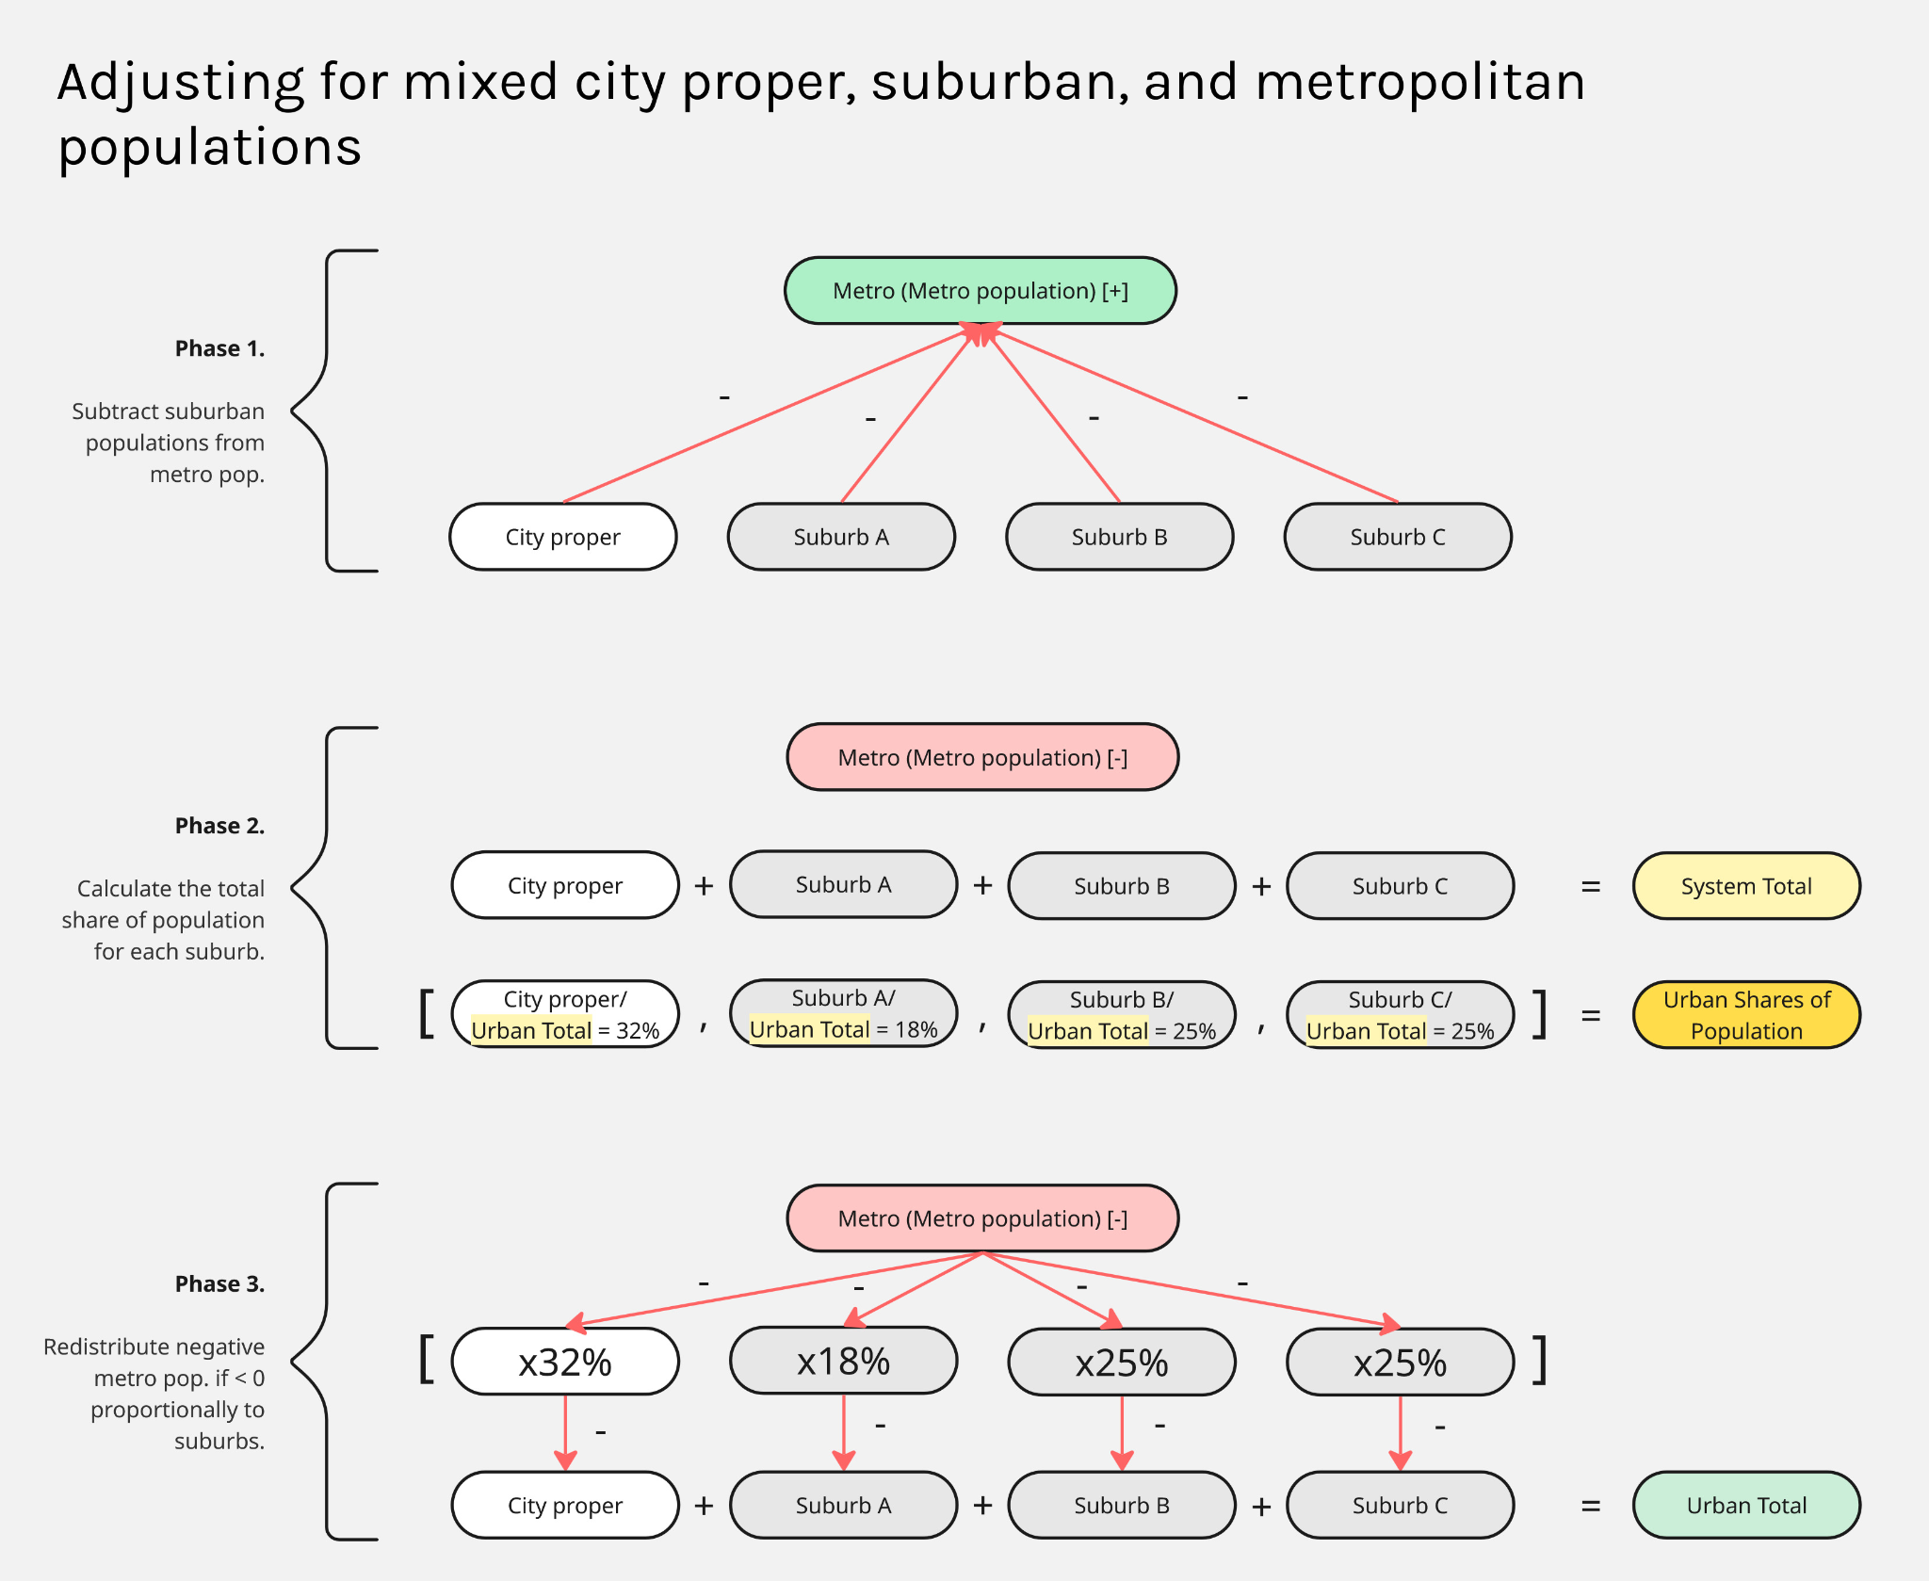

Figure 12. 3-step schematic view of how mixed population figures were adjusted for agglomerative effects within Stadestér.

Of course, non-metro adjusted versions of Stadestér 1.0 were also produced in an effort to maintain the original population figures present in our constituent datasets. These are also available alongside the principal metro-adjusted version, which we advise to use.

Population Buffering

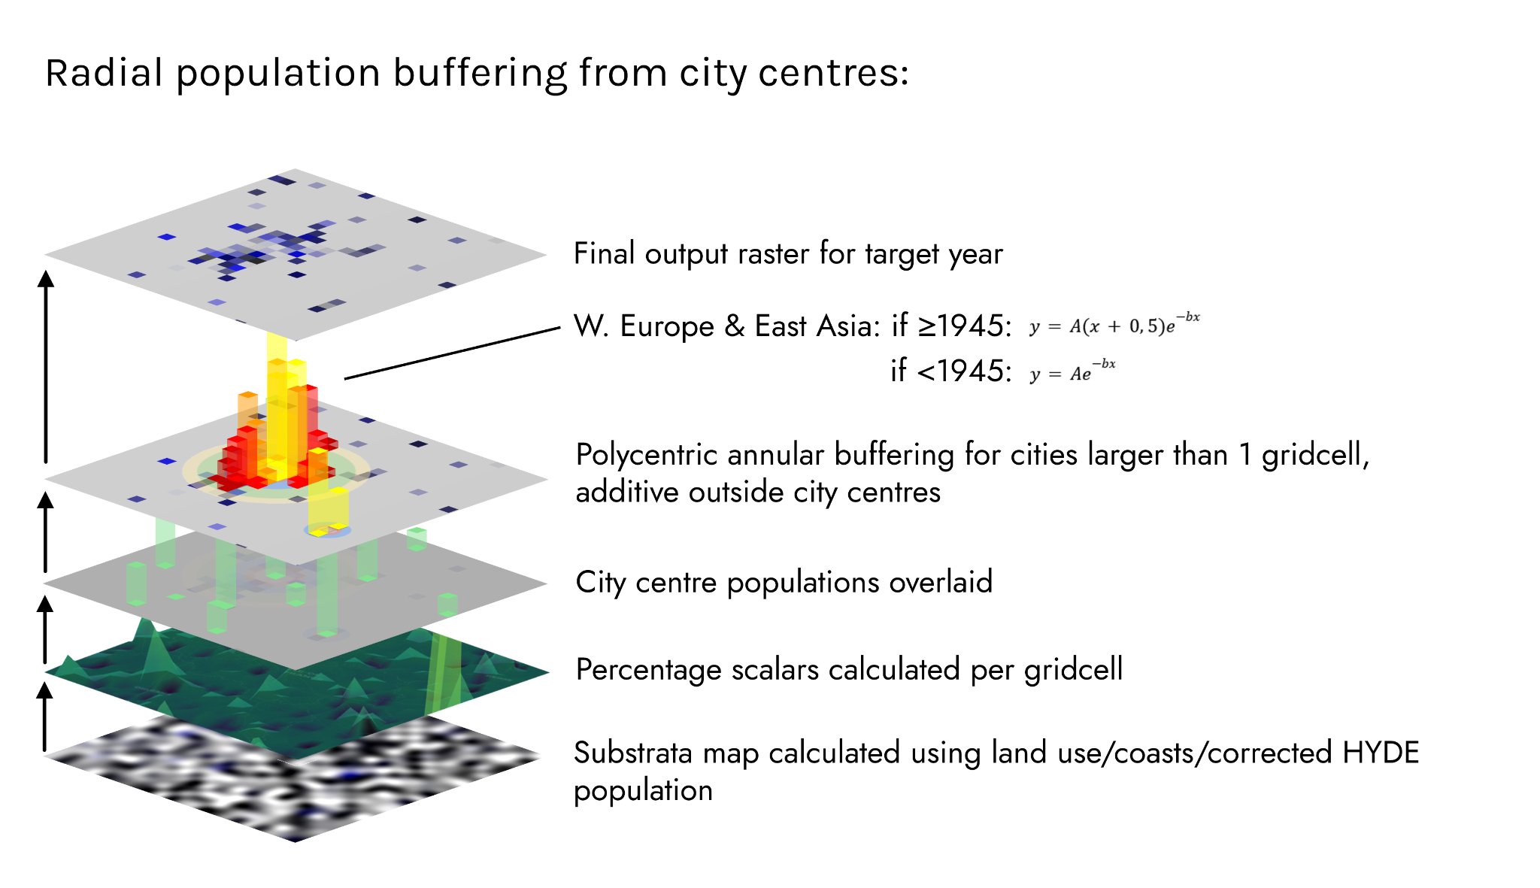

Figure 13. Sample visualisation of region-specific annular buffering over a large urban area (Paris and the Grande Couronne).

The annular/radial population buffering model utilised in Stadestér 1.0 is primarily an extended Burgess model factoring in both land use, potential population distribution (from dasymetric mapping) and geographic stocks [Puttick]. Density and resultant population is calculated per annular ring. The density between each ring functions entirely as a probability density function as measured from the urban centre, and is thus capable of representing both industrial and preindustrial cities [Abbott][Sjoberg]. Furthermore, such annular buffers are additive, meaning that they are capable of representing polycentric cities [Rienow].

Of course, since annular rings were being evaluated over a gridmap, this required fractional interpolation for pixels which were only partly inside of an annulus [Shepard et al]. A density model was cobbled together from Bairoch, Paiscuti and Chase-Dunn, Angel, Stanilov and Sykora, and most notably Clark’s research on urban density and walkability and ease of transport.

Such models were only developed for the period between 1800AD-1991AD, with the expectation that we could perform out-of-model forecasting for the period between 1975AD-2000AD, when GHSL data becomes available, as well as over the Global 30, for which well-formed historical data was present [Footnote: Much of this section was typed up in preliminary memoranda, which was held internally].

Global Density from 1800-1815AD: ~175-190/ha [Bairoch]

Much of the global-level data during this time period comes from Bairoch’s Cities and economic development, as well as Angel 2010. It is also during this period that city densities become near perfectly Zipfian by country, as seen in a case example of Great Britain [Litvine et al]. Prior to 1800, density ranks are believed to have been log-normal [Dittmar][González-Val].

We considered utilising estimated regional population density from HYDE/substrata models to inform estimates of population density for each urban area using a raster buffering technique, but we ultimately decided against it.

Clark provides the radial function $y=Ae^{-bx}$ for estimating urban density, where $x$ is the distance in km from the centre of the city, and $y$ is the density of the resident population at the centre of the city in thousands per km^2. $A$ is the density of the resident population at the centre of the city, and $b$ is effectively that of the degree of public transport available [Clark].

That information was not entirely useful to us, since we sought to inform our radial spread estimates using only two parameters: urban density of a city, and its population. The data that we took to inform our estimates came primarily from Angel’s Atlas of Urban Expansion (2016).

Area/Density Calculations

We mainly assumed a base model as follows: $Δarea=1$,$27(Δpopulation)$, R^2 = 0,969 between 1900-2000; $ihb/ha=-130ln(x)+634$, R^2 = 0,99; where $x$ was the density ordinal of a city globally. [Figure 11.7, p. 178, Angel 2012, Planet of Cities][Xu et al].

Given that the sample size used in the original equation was n=120, and the mean density 128ihb/ha, the generalisable version of city centre density should be:
$y=130ln(\frac{n/120}{x})+d+506$, where $d$ = mean global density, $n$ = total sample size, and $x$ = density rank-ordinal of a city globally.

The initial area baseline was to be calculated by dividing the population in 1800AD by 182,5 to fetch the total number of hectares, with the area to be iteratively calculated per city first before fetching a city’s ihb/ha.

Radial Spread Calculations

Implied population densities were taken from modelled area and cubic spline interpolated population values to establish rank ordinals to inform imputed city centre densities prior to calculating cities’ ihb/ha, whereby $A$ was the city centre density previous, and $b$ was informed by the walkability ratio present in Angel’s various world regions using a strong geometric mean ($SGM$). Parameter $b$ is further expounded upon by Newling [Newling].

Immediately prior, we standardised walkability ratios by taking the value such that ${WR}_{year}=1-max(\frac{ΣWR_{year}}{|WR|})$, where $WR$ represents a walkability ratio time-series for a specific world region, and $1800≤year≤2000$. Base walkability ratios were specified as follows for the Global 30:

City/Region | S1 Year:Value | S2 Year:Value | S3 Year:Value | S4 Year:Value | S5 Year:Value
W. EU & JP
London | 1800:1,6 | 1880:1,9 | 1929:1,6 | 1955:1,7 | 1989:1,7
Moscow | 1800:1,7 | 1893:1,6 | 1939:1,6 | 1957:1,6 | 1991:2,1
Paris | 1800:1,5 | 1900:1,6 | 1928:1,6 | 1955:1,8 | 1987:1,6
Tokyo | 1800:1,4 | 1892:1,4 | 1929:1,5 | 1954:1,6 | 1990:1,4
Warsaw | 1800:1,6 | 1888:1,6 | 1936:1,6 | 1958:1,5 | 1992:1,6
E. Asia
Bangkok | 1800:1,5 | 1900:1,6 | 1922:1,7 | 1953:1,5 | 1988:2,0
Beijing | 1800:1,5 | 1900:1,4 | 1929:1,6 | 1959:1,7 | 1988:1,8
Kolkata | 1800:1,4 | 1883:1,7 | 1931:1,8 | 1961:1,6 | 1990:1,6
Manila | 1800:1,4 | 1898:1,5 | 1945:1,7 | 1971:1,6 | 1990:1,7
Mumbai | 1800:1,5 | 1909:1,6 | 1931:1,5 | 1968:1,5 | 1991:1,8
Shanghai | 1800:1,4 | 1902:1,5 | 1944:1,4 | 1973:1,8 | 1991:1,7
MENA
Algiers | 1800;1,4 | 1903:1,6 | 1929:1,9 | 1972:1,7 | 1987:1,7
Cairo | 1800:1,5 | 1897:1,6 | 1927:1,6 | 1960:1,6 | 1992:1,7
Istanbul | 1800:1,6 | 1899:1,8 | 1934:1,8 | 1960:1,7 | 1990:2,0
Jeddah | 1800:1,9 | 1900:1,7 | 1925:1,5 | 1964:1,6 | 1990:1,7
Kuwait City | 1800:1,6 | 1900:2,1 | 1922:1,8 | 1963:2,0 | 1990:2,1
Tehran | 1800:1,5 | 1899:1,4 | 1925:1,5 | 1956:1,6 | 1987:2,0
Tel Aviv | 1800:1,4 | 1917:1,4 | 1929:1,5 | 1956:1,6 | 1987:2,0
Africa
Accra | 1800:1,6 | 1903:1,6 | 1929:1,8 | 1956:1,5 | 1991:1,7
Johannesburg | 1800:1,5 | 1900:1,7 | 1938:1,6 | 1957:1,7 | 1990:2,3
Lagos | 1800:1,4 | 1900:1,6 | 1920:1,6 | 1962:1,8 | 1984:1,8
Nairobi | 1800:2,0 | 1906:1,6 | 1926:1,5 | 1964:1,5 | 1988:1,6
Lat Am.
Buenos Aires | 1800:1,3 | 1887:1,4 | 1918:1,4 | 1964:1,5 | 1989:1,6
Guatemala | 1800:1,5 | 1900:1,4 | 1936:1,6 | 1976:1,7 | 1990:1,9
Mexico City | 1800:1,4 | 1886:1,4 | 1929:1,5 | 1970:1,7 | 1990:1,7
Santiago | 1800:1,4 | 1900:1,5 | 1930:1,5 | 1970:1,7 | 1990:2,0
Sao Paulo | 1800:1,5 | 1905:1,6 | 1929:1,7 | 1974:1,7 | 1988:1,7
LRDC
Chicago | 1800:1,5 | 1893:1,5 | 1945:1,6 | 1967:1,4 | 1989:1,7
Los Angeles | 1800:1,7 | 1907:1,4 | 1937:1,7 | 1970:1,8 | 1990:2,0
Sydney | 1800:1,5 | 1895:1,7 | 1945:1,8 | 1975:1,7 | 1991:1,8

Figure 14. Table of walkability ratios for the Global 30, where higher figures are worse. Base figures were then processed and inverted prior to annular density calculation.

The World Postwar (1945AD-1975AD)

In the postwar world, the urban regions of the globe can largely be collapsed into five categories: Anglo-Settler Colonies, Western Europe and East Asia, the Socialist World, and that of the Global South, as urban patterns increasingly diverged between them. Much of the data here comes from Pénzes et al. in addition to Stanilov and Sykora and Bertaud [Pénzes et al][Bertaud]. Clark variant equations were derived from best fit integrations between Clark and observed density dropoff formulas provided by Pénzes et al, Angel, and Guterbock.

Anglo-Settler Colonies
Modified Clark: $y=xe^{-0,067x}$

Note that because this is prior to 1975AD, ‘Anglo-Settler Colonies’ included those countries under white minority rule in Sub-Saharan Africa, i.e. modern-day South Africa and Zimbabwe (Rhodesia), which often followed an American style of urban planning complete with residential segregation and suburbanisation [Binder]. Starting in the 1980s, its general applicability in South Africa and Zimbabwe are likely to have waned [Maharaj and Mpungose].

The negative exponential density-distance function applicable to Anglo-Settler colonies is attested to by Guterbock, with density peaking outside the city centre crater. Whilst Guterbock defended Clark’s Law, it is clear that the contribution of $b$ (walkability) gradually converged to be close to zero in such cities (declining from b=0,326 in 1940 to b=0,133 by 1990), and we have thus excluded it from the equation [Guterbock].

Western Europe and East Asia
Modified Clark: $y=A(x+0$,$5)e^{-bx}$

Certainly of the density in Western Europe and East Asia remained stagnant during this period, with urban metropoles retaining much of their initial density, despite limited amounts of suburbanisation in the immediate aftermath of World War II [Kostas et al][Berndgen-Kaiser et al][Nakai][Sorensen].

Socialist World
Modified Clark: $y=\frac{1}{1+e^{4(x-1,8)}}$

Urbanisation in the socialist world was given by ‘spatial chaos’ until the large-scale takeover of Soviet-style central planning, which focused many cities and so-called ‘monotowns’ onto heavy industry, with large-scale concrete prefab developments constructed to serve as housing [Musiaka][Hirt].

This of course led to an inverse logistic curve in which the density dropoff was very sharp, as socialist microdistricts often surrounded an inner ‘old city’ [Tomaszewicz and Majczyk, p. 35][Lankots][Smith]. To what extent there was a small city centre crater has not been generally quantified and hunting about for literature on the (post)socialist city is an exhausting business.

In any case, we thought its exclusion would not skew our dataset since our resolution at 5 arcminutes is quite large, and the development of socialist cities were generally constrained until the 1970s and 1980s, during which time we have good satellite data in any case [Becker et al, p. 44-48][Footnote: There is a great degree of dispute over exactly how density drops off or how world regions ought to be divided. We have opted for a Cold War sort of division to model urban regions between 1945-1975AD, but these sorts of strict equations are more rules of thumb for radially buffered dasymetric mapping than anything else].

Like in Anglo-Settler colonies, whether or not a city was walkable was entirely irrelevant: central planners imposed urban development from above, and haphazard housing often sprung up as infill, whether in the form of the dachas of the core republics of the Soviet Union, or informal settlements/mahalale between the ‘canyons’ of many systematised buildings in Romania [Marin and Chelcea][Teodorescu].

Global South
Modified Clark: $y=Ae^{-bx}$

No such modification was needed for the rapidly urbanising cities of the Global South, to which Clark’s law applied handily [Dávila][Mookherjee et al]. Certainly in the context of the Cold War, it deserved to be a separate category, since development there is quite organic [Randolph and Storper].

These models were truncated and replaced with GHSL satellite data starting from 1975AD onwards, although we also performed out-of-model forecasting between 1975-2000AD in an attempt to verify the applicability of the sort of radial buffering seen above (Testing and Validation).

ALCC Fallback Modelling

At this point, one required a potential population model at a global scale on which the annular buffering process aforementioned could be reliably performed. These substrata maps generally consist of a dual-model approach - a Velkscala 0.7 primary model, and a KK10/LUH2 secondary model that served as a fallback. In both cases, we sought to address the underrepresentation of rural population, which is generally believed to range from -53% to -84% in most gridded datasets [Láng-Ritter et al].

To this end, Velkscala 0.7 underwent peri-urban upweighting by a factor of 2, and both the KK10/LUH2 fallback model and Velkscala 0.7 were systematically scaled to global population. In addition, ALCC models generally have a maximum population ceiling to downweight urban population, since gridcells cannot exceed more than 100% of their land cover being utilised for anthropogenic purposes [Kaplan et al]. Because all stocks were anthropogenic for each dataset, we took the liberty of adding them up to fetch the total fraction of each gridcell under anthropogenic land use. The stocks of each dataset were divided as follows:

Land Use Harmonization 2 (LUH2) [Hurtt et al]:
- c3ann | C3 annual crops
- c3nfx | C3 nitrogen-fixing crops
- c3per | C3 perennial crops
- c4ann | C4 annual crops
- c4per | C4 perennial crops
- pasture | Managed pasture
- urban | Urban land use
Kaplan and Krumhardt 2010 (KK10) [Kaplan and Krumhardt]:
- Fraction of gridcell under anthropogenic land use

Where both datasets intersected (900AD-1850AD), we took the additive mean of both datasets per gridcell as being representative of anthropogenic land use, multiplying it by estimates of regional and world population.

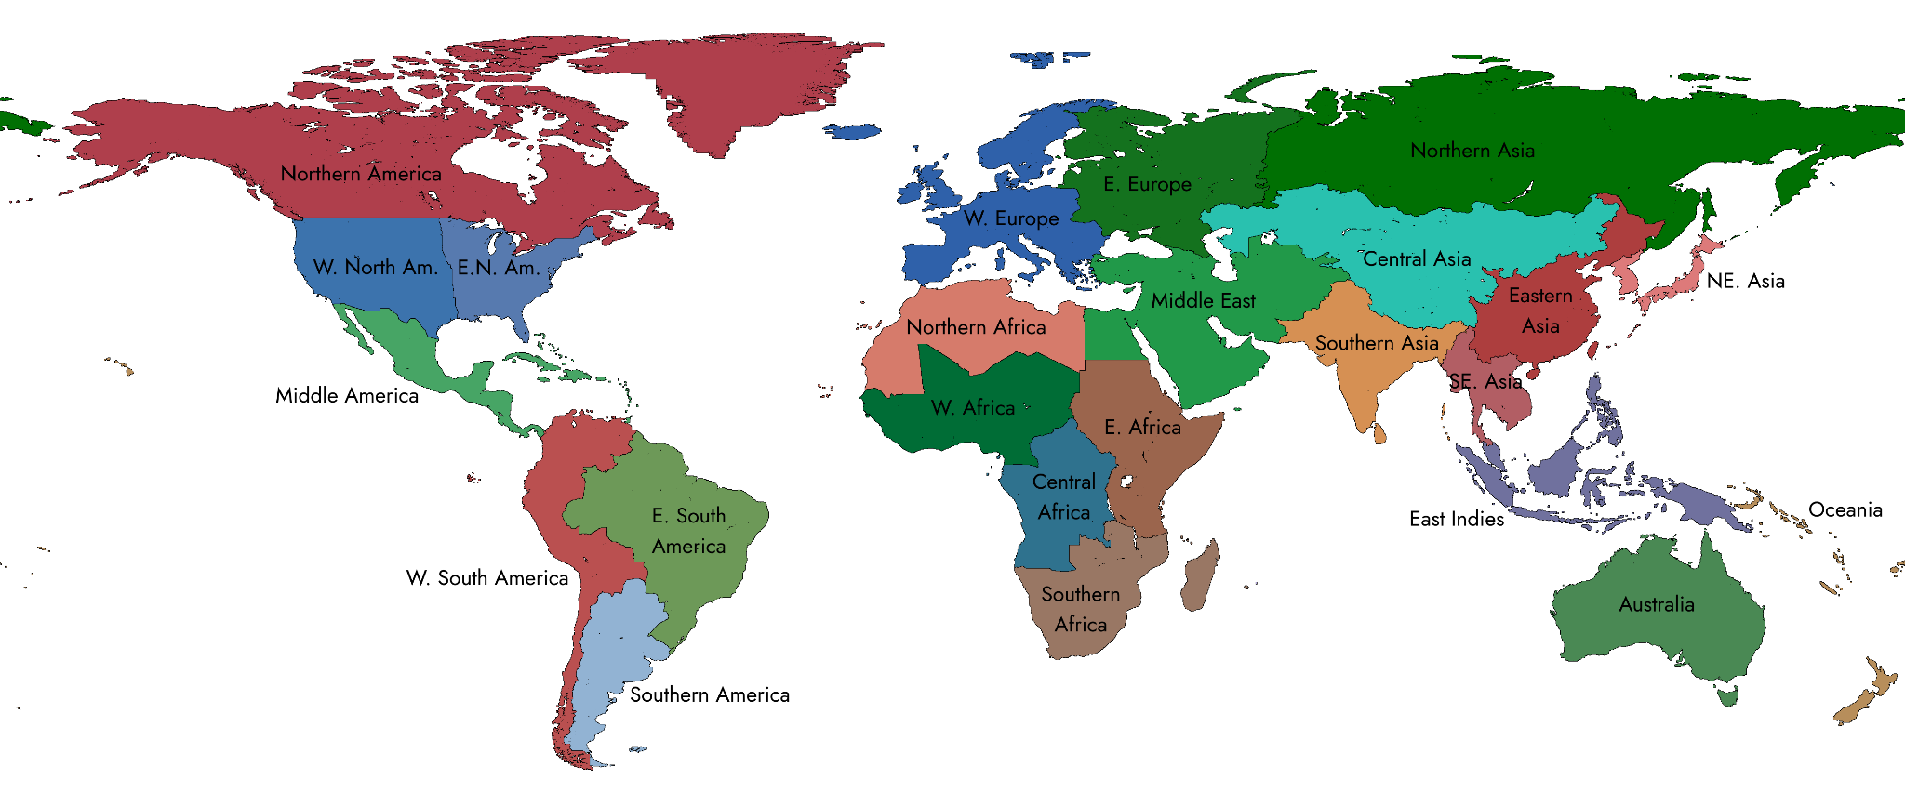

Figure 15. Chloropleth map of world regions as defined by Nelson.

We used the world regions as developed by Nelson in the Historical Atlas of the Eight Billion to perform regional scaling prior to world population scaling such that populations were generally representative, if not at a granular level [Nelson].

After being regionally and globally scaled, KK10/LUH2 rasters were produced for all intersecting HYDE years to serve as its principal fallback.

Substrata Modelling

The main sources which we utilised to produce long-run estimates of global population should be given some mention here. They were Woytinski and Woytinski 1950, Winkler-Prins 1950, Clark 1967 (lower), Clark 1967 (upper), Tuve 1970, Winkler-Prins 1970, McEvedy and Jones 1978, Durand 1974 (lower), Durand 1974 (upper), Durand 1977 (lower), Durand 1977 (upper), McEvedy and Jones 1978, Biraben 1980, Richards 1980, Bogue 1985, Merrick et al. 1986, Eric 1987, Grigg 1987, Demeny 1988, Stern K. 1990, United Nations 1990, WRI 1990, Kapitsa 1997, Kremer 1993, Klein Goldewijk and Battjes 1995, Maddison 2001, PRB 1973-2016, HYDE 2010-2020, UN 2015, UN 2019-2024, US Census Bureau 2017, Macrotrends 2025, and Gapminder, in order of appearance [Woytinski and Woytinski][Winkler-Prins, 6. Ed][Winkler-Prins Atlas, 1950][Clark][Tuve][Winkler-Prins 1970][McEvedy and Jones][Biraben][Richards][Grigg][Demeny][Stern and Kaufmann][UN][WRI][Kapitsa][Kremer][Klein Goldewijk and Battjes][Maddison][PRB][Klein Goldewijk et al][UN][UN][UN][UN][US Census Bureau][Macrotrends][Gapminder].

Here we utilised strong geometric means to average between them. This had not been used for city populations, since there were much fewer estimates for population datapoints between them, and they disagreed more heavily, whilst global population estimates seemingly agree in general on overall figures [De Long].
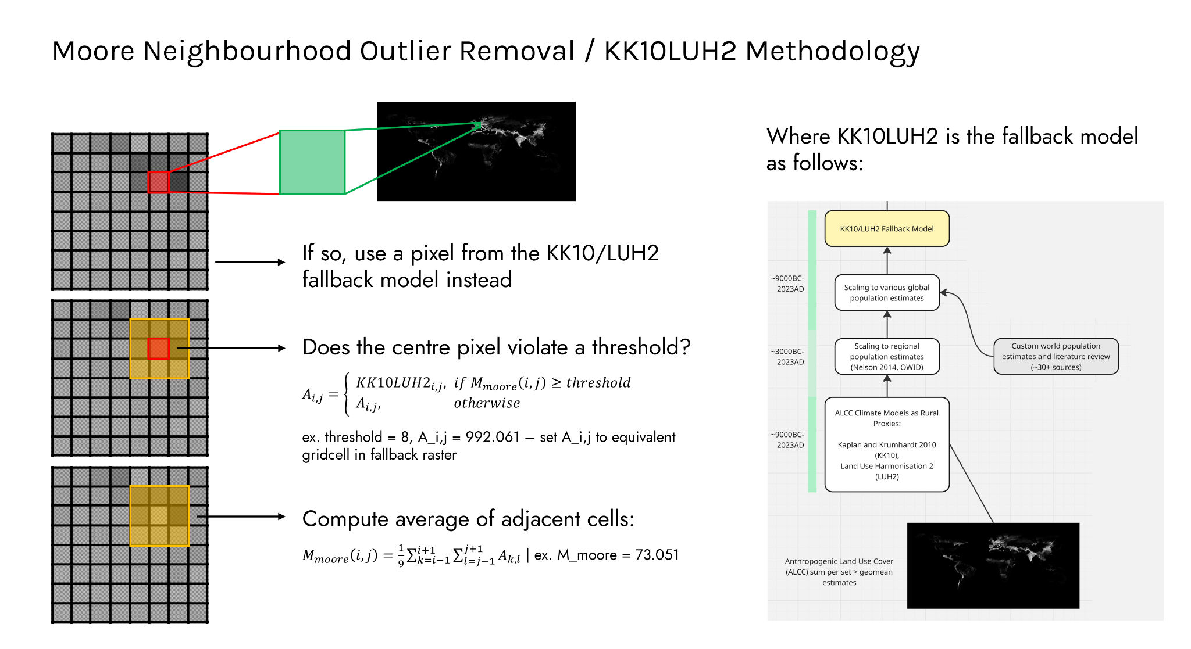

Figure 16. Moore neighbourhood outlier removal.

Since KK10/LUH2 served as our principal fallback model, the task now fell to us to determine when to use it after we had calibrated Velkscala 0.7 to regional and global population estimates in the same manner. For this, we performed a first pass utilising Moore’s neighbourhood with a threshold of 8 to detect and remove stray pixels. Flagged pixels were replaced with their corresponding population values in the underlying KK10/LUH2 raster.

Whilst this approach is common for geospatial outlier detection in semiconductor manufacturing (where it is known as GDBC/GDBN), it does not appear to be as common in statistics, even though it effectively performs edge/stray pixel detection and is cheap to compute [Lizaranzu and Cuesta][Chen et al]. It would appear to us to be a natural exaptation of the fact that Moore neighbourhood analysis is relatively robust when it comes to edge detection, such that fine tuning filtering/threshold algorithms would reliably flag any localised artefacts or stray pixels which appear in gridded data [Amrogowicz et al].
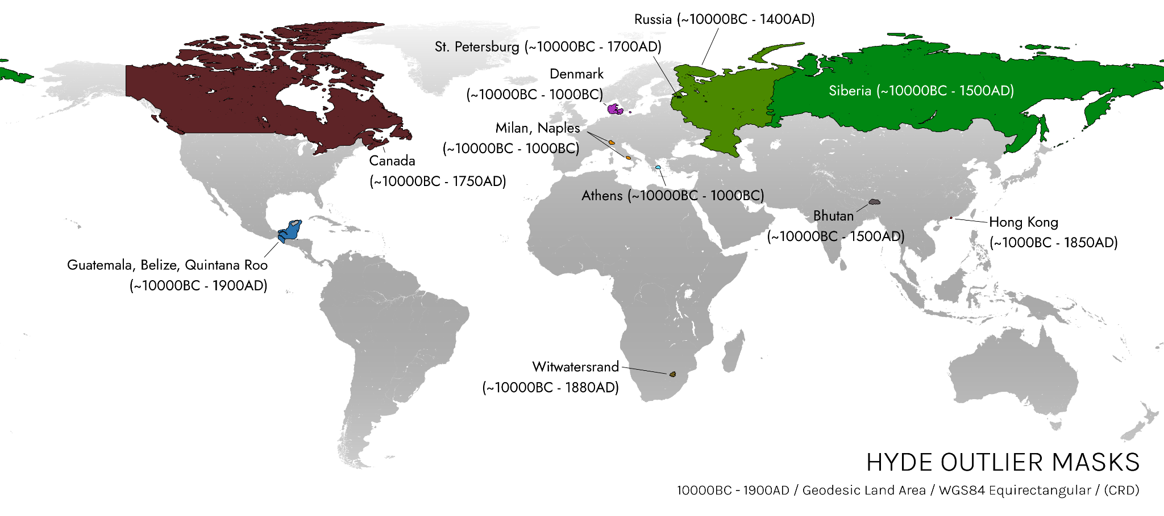

Figure 17. Map of masked HYDE3.2/3.3 outliers.

After first-pass outlier removal, a second pass had to be made to replace HYDE3.2/3.3 regions - now inherited by Velkscala 0.7 - in which population distributions simply appeared either incongruous with the historical record or implausible. In some cases, such as that of the pre-Columbian United States, we were forced to leave such artefacting issues alone since their replacement would have required specialised regional modelling beyond even the scope of our KK10/LUH2 fallback - neither HYDE nor ALCC climate models were up to this task [Koch et al].

We certainly hope to establish a better model of sedentary and non-sedentary populations in Northern America and Siberia at some later date, since these regions remain under-modelled relative to other areas prior to 1500AD [Kelly et al][Sikora et al][Wong et al]. Manual masks were encoded for second-pass outlier removal, in which entire regions were replaced by underlying KK10/LUH2 rasters for problematic years.

Regional Outlier | Start Date | End Date | Replaced | Notes
Athens | 10000BC | 1000BC | Yes | 2nd-pass replacement
Beirut, LB | 10000BC | 1000AD | Yes | 1st-pass replacement
Bhutan | 10000BC | 1500AD | Yes | 2nd-pass replacement
Canada | 10000BC | 1750AD | Yes | 2nd-pass replacement; replaced by region-specific modelling
Denmark | 10000BC | 1000BC | Yes | 2nd-pass replacement
Eastern CAR | 10000BC | 2025AD | No | Requires manual correction [Footnote: the Eastern Central African Republic, to my knowledge, displays consistent artefacting even in models reliant upon satellite data, such as GHS-POP, GPWv4, or LandScan].
Guatemala, Belize, and Quintana Roo | 10000BC | 1900AD | Yes | 2nd-pass replacement
Hong Kong | 10000BC | 1850AD | Yes | 2nd-pass replacement
Milan, Naples; IT | 10000BC | 1000BC | Yes | 2nd-pass replacement
Paris, Pontoise; FR | 10000BC | 1500AD | Yes | 1st-pass replacement
Russia | 10000BC | 1400AD | Yes | 2nd-pass replacement
Siberia | 10000BC | 1500AD | Yes | 2nd-pass replacement
St. Petersburg, RU | 10000BC | 1700AD | Yes | 2nd-pass replacement
United States (Amerindigenous) | 10000BC | 1870AD | Yes | Replaced by region-specific modelling
Witwatersrand-Johannesburg, ZA | 10000BC | 1880AD | Yes | 2nd-pass replacement

Figure 18. Table of spatiotemporal domains of manual outlier masks compared to all known regional outliers for HYDE3.2/3.3.

Like with first-pass Moore neighbourhood outlier removal, the area covered by these masks were replaced with pixel values from the underlying KK10/LUH2 fallback model. Final substrata rasters were checked and confirmed to be self-consistent prior to calibration to global population estimates, with errors from the geomean falling between 1-2%.

Satellite Data post-1975

Post-1975AD, we utilised GHS-POP data as scaled back up to global population, since gdalwarp -r sum, which we utilised for downscaling and reprojecting GHS-POP rasters from Mollweide (30-arcsec) to WGS84 Equirectangular (5-arcmin) was relatively lossy [gdalwarp]. This truncation was done only for Stadestér-GHSL, and not Stadestér Base, both of which we intended on keeping as intermediate lines prior to final raster processing.

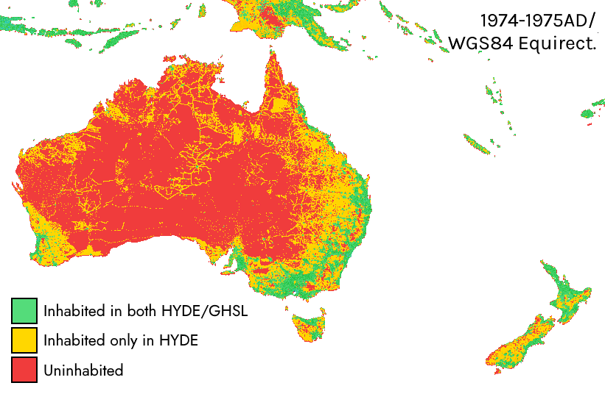

Figure 19. Rural discontinuity between HYDE and GHS-POP in the Australian Outback (1974AD-1975AD).

In most cases, this break was discontinuous from HYDE was due to the abrupt change in how rural populations were modelled in GHS-POP, which systematically underestimates the prevalence of rural populations when compared to HYDE [Uhl et al]. The number of populated pixels between 1974AD-1975AD thus drops from 1.535.141 to 961.179, or a decline of n=573962 (37,39%). This is highly significant in raw area terms, but it is difficult to assess how this could have been rectified without falling back to HYDE, which is overzealous when it comes to areal coverage of modern rural populations, if not necessarily their quantity. Part of this overzealous coverage is due to LandScan’s reliance on nighttime lights which are prone to blooming errors, uninhabited roads, coastal fishing fleets, and natural gas flaring [Lebakula et al][Rose and Bright].

As always, the truth is likely to lie somewhere in the middle - the areal coverage provided by GHSL is likely to be quite accurate, and HYDE’s assessment of modern rural populations is likely to be somewhat more reliable than the persistent undercount present in GHSL. But we certainly have not focused nearly as much on modern data as we have on the data of the past, for the models there are plenty, and the models here are few.

Raster Processing

At this point, we looked upon our work, and saw that it was not good, for it had only included urban data, and no part of the cohesive whole - namely that of non-urban and total populations at an equivalent gridcell level. To address this, we first created hybrid urban rasters by maintaining Stadestér Base cities for pixels in which GHSL had recorded a null value for urban population, provided that the city had population entries persisting after 1975AD.

These new urban rasters were then overlaid on top of the rural substrata series earlier generated)and calibrated to global population estimates previously listed to form global population rasters over the long run. Finally, we subtracted urban values from these global population rasters to form a series of peri-urban and rural population rasters. These raster series are generally available as follows, encoded in 32-bit int format:

- Stadestér Population | ./output/stadester_population_rasters
- Stadestér Rural | ./output/stadester_rural_rasters
- Stadestér Urban | ./output/stadester_urban_rasters

These 32-bit int formats are analogous to single-year GeoTIFFs, flattened into PNG form such that they are accessible from conventional raster image editors [Devys et al]. One might recall earlier that we stated that Northern America would require specialised modelling and not mere outlier removal.

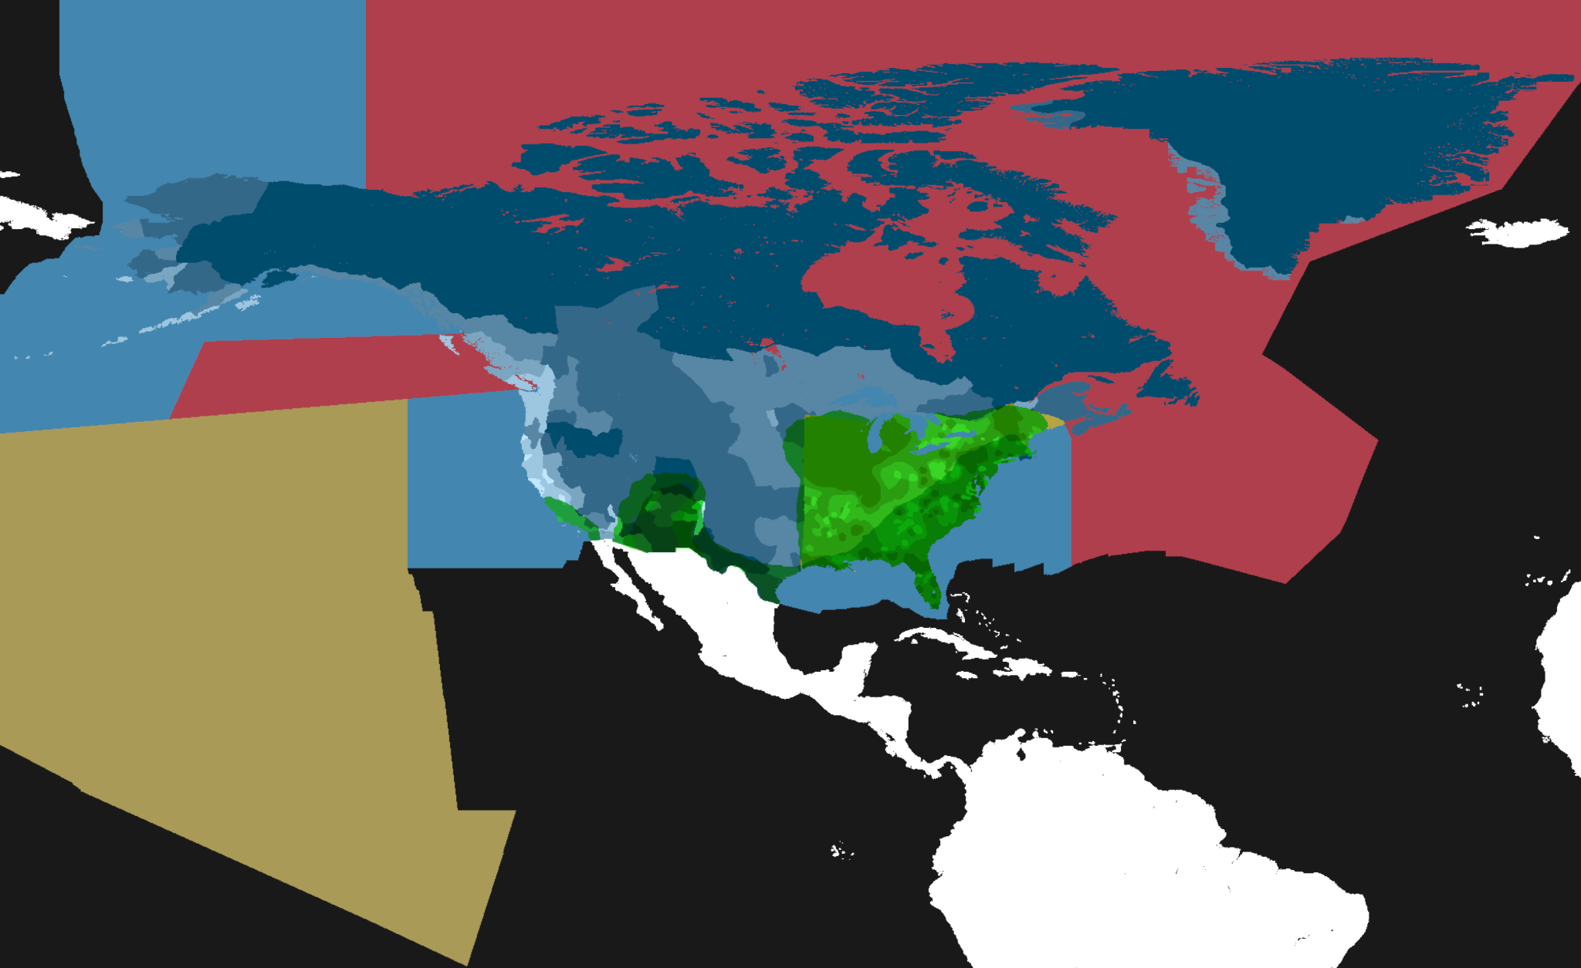

Figure 20. Approximate choropleth map of Native American and First Nation population and agricultural distribution in Northern America (10000BC-1600AD).

We thus commissioned a new internal model, Project Centaur, whose sole job it was to fix the rather sorry state that Northern American population distributions had found itself in as a result of botched outlier removal and KK10/LUH2’s various methodological shortcomings for the region. Like all internal models, it and its corresponding input data is available as part of Stadestér open-source code package.

Our main sources of region-specific estimates for this work came from McEvedy and Jones for regional trends and presumed heavy agricultural zones, Nevle and Bird for our agricultural and irrigation data, Williams, Driver and Massey, Milner and Chaplin, Dye, Swanson (who were both used for estimations of the Hawaiian Islands), and Nelson for macro-regional population trends [Nevle and Bird][Williams][Driver and Massey][Milner and Chaplin][Dye][Swanson].

These areal maps were then scaled over the rural substrata series previously mentioned over data-specific time domains: roughly from 10000BC-1600AD on the North American continent, and from 1100AD-1896AD on the Hawaiian Islands. We do not pretend this model is perfect: for instance, much more detailed tribal estimates are available from the likes of Krzywicki and Jones [Krzywicki][Jones], as well as possible nation-by-nation spatiotemporal kriging of p3k14c [p3k14c]. But that is principally a matter of regional demographics, not urban demographics, and so we have thus declined its inclusion in this dataset [Footnote: This does not mean that we do not work on regional demographics - on the contrary: Velkscala is our non-urban demographic dataset, but Stadestér is reserved for urban populations, in the same manner that Eoscala is for historical economics].

Finally, these rasters were scaled back up to global population estimates and post-processed. It is worth mentioning that when we speak of rural populations, we mean only populations that are non-urban in our dataset, and they may often include suburban, periurban, and exurban settlements. Despite these changes, there still exists a 1974/1975 discontinuity due to a seemingly arbitrary lower bound cut-off in GHS-POP of ~64ihb/gridcell, meaning that many rural regions that fall beneath that density threshold are not included in our global raster.

It may also be that this is a consequence of rescaling GHS-POP back to global population estimates from earlier to address failures in gdalwarp, but it should add up regardless, since it is a top-down constrained model [Beale].

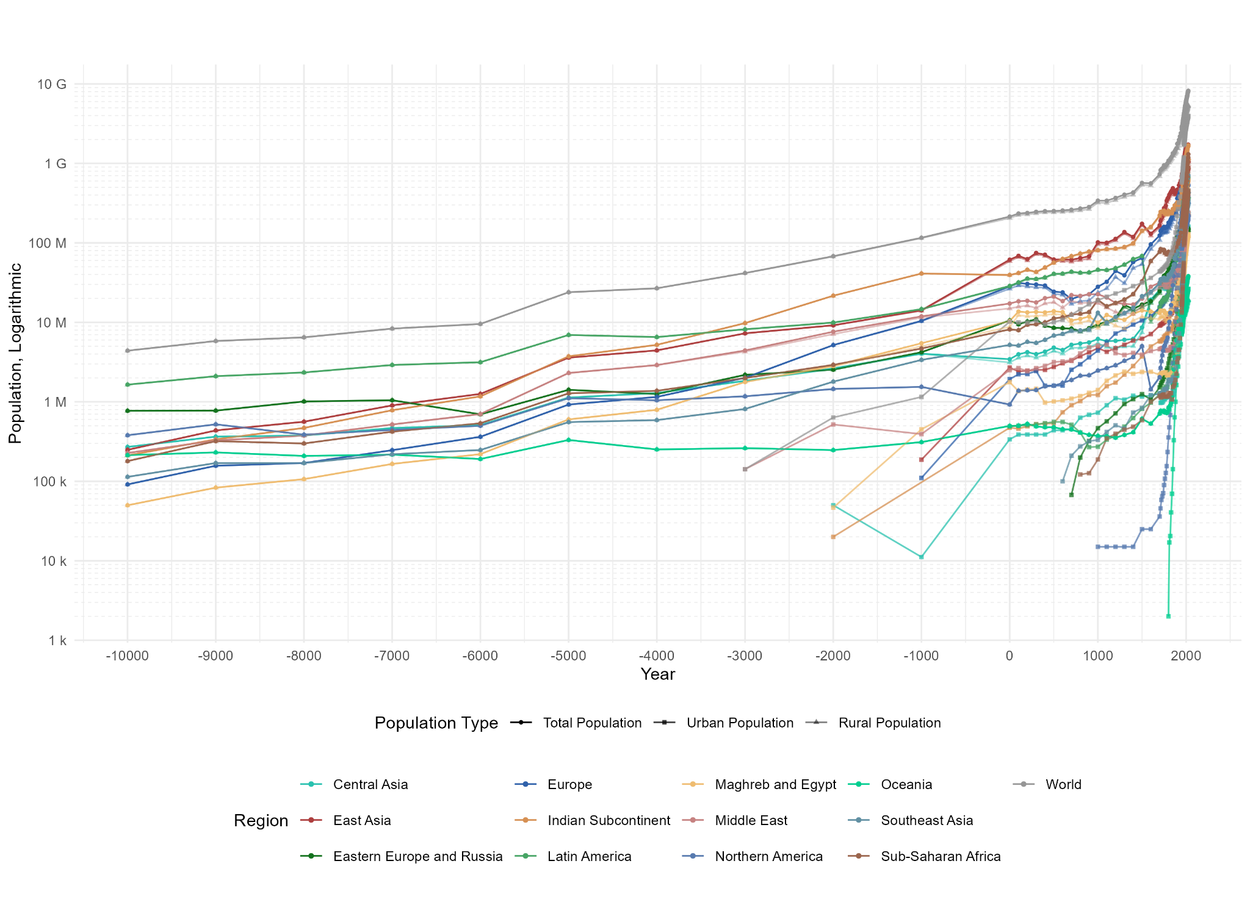

Figure 21. Regional and global urban/rural/total populations as given by direct summation.

But just because GGWP, GRUMP, LandScan or GHS-POP (with perhaps the exception of WorldPop) believe that no one lives on farms anymore in the modern day is no reason to examine how our model performs historically [Láng-Ritter et al].

Of course it must be noted that Stadestér’s gridded models of historical population are beyond the scope of mere urban population, but existing datasets are so sparse and flawed that we have had little choice but to release this dataset to serve as a stopgap. Despite the precision of our figures, estimates of regional populations in the dim and distant past are inherently uncertain, and they ought to be treated as such. Nonetheless, we believe our regional figures are within a range of +/-25%.
Region | -3000 | -2000 | -1000 | 1 | 500 | 1000 | 1500 | 1600 | 1700 | 1800 | 1900 | 2000
Northern America | 1,17 | 1,45 | 1,54 | 0,92 | 1,59 | 2,48 | 5,02 | 1,44 | 2,04 | 8,42 | 104,95 | 310,70
Latin America | 8,18 | 9,94 | 14,66 | 28,71 | 40,78 | 45,93 | 68,40 | 11,02 | 15,44 | 24,45 | 74,93 | 515,85
Europe | 2,01 | 5,17 | 10,45 | 28,30 | 24,34 | 28,03 | 64,49 | 95,78 | 123,97 | 179,42 | 362,95 | 488,10
Eastern Europe & Russia | 2,18 | 2,54 | 4,20 | 10,57 | 8,53 | 9,48 | 16,72 | 18,50 | 24,73 | 47,86 | 118,84 | 232,50
Middle East | 1,84 | 2,64 | 4,04 | 3,44 | 4,81 | 6,18 | 8,63 | 19,33 | 25,57 | 29,63 | 38,14 | 227,60
Maghreb-Egypt | 4,43 | 7,63 | 11,89 | 17,25 | 21,11 | 22,59 | 19,86 | 28,09 | 31,71 | 33,97 | 46,84 | 251,23
Sub-Saharan Africa | 1,78 | 2,84 | 5,46 | 10,39 | 13,82 | 9,92 | 14,13 | 13,68 | 13,15 | 13,08 | 27,50 | 144,22
Central Asia | 1,99 | 2,92 | 4,69 | 8,16 | 11,22 | 19,17 | 32,82 | 59,16 | 77,28 | 77,33 | 99,60 | 663,41
Indian Subcontinent | 0,26 | 0,25 | 0,31 | 0,50 | 0,48 | 0,37 | 0,61 | 0,53 | 0,71 | 0,85 | 7,34 | 27,09
Southeast Asia | 9,78 | 21,63 | 41,17 | 39,52 | 56,49 | 81,03 | 142,33 | 158,78 | 220,58 | 252,64 | 324,38 | 1.220
East Asia | 0,81 | 1,79 | 3,37 | 5,20 | 6,82 | 13,22 | 21,32 | 24,27 | 31,24 | 39,37 | 90,64 | 526,03
Oceania | 7,27 | 9,17 | 14,18 | 61,45 | 61,77 | 101,48 | 174,04 | 130,46 | 165,40 | 374,48 | 467,48 | 1.477
World | 41,70 | 68,97 | 116,96 | 214,41 | 251,76 | 340,90 | 568,37 | 561,04 | 732,82 | 1.081 | 1.764 | 6.084

Figure 22. Table of regional and global population totals for selected benchmark years, Millions.

It was extremely important for us to get these tables right, and not to be off because of some dull coding error. In this regard, these figures come from internal verification procedures, and the model was run several times to guarantee consistent results and reproducibility.

In particular, our rural substrata model was stored in a separate repository for organisational purposes, as part of Velkscala 0.7, which is attached in the supplemental materials in the appendix below. All best practices were followed in an attempt to avoid this issue: 1) automating the generation of figures such that they could be repeatedly checked and to ensure that figures were sensible, 2) stepping through code using LLMs to find and flag logic errors, 3) publishing code as open-source Git repositories prior to submission, in addition to providing CLI/UI tools for ensuring data reproducibility and easier visualisation [Tay].

It very well may be that this has not caught everything - databases such as ours are not static projects, but long-term bits of work whose versioning is iterative and subject to revision. There is every chance that this dataset will be updated in the time following its original submission. In this case, the latest version is preferable, but the Velkscala 0.7/Stadestér 1.0 versions shall always be available in the Releases section for use [Footnote: other platforms such as Zenodo may have other equivalents, i.e. ‘Files’. We principally use GitHub for the purpose of disseminating the latest up-to-date models].

Of particular instability are some of the early Eastern European populations, whom it may be argued to be overfitted to climactic modelling. In general, proxy modelling (either climactic or based on genetic bottlenecking) appears to pose major problems for Russian populations, since they overstate the number of inhabitants [Yunusbaev et al]. In our case, however, this came from KK10/LUH2 overfitting, with much of the population hovering between 8-10M within the modern Russian frontier (including all of Northern Asia under the UN geoscheme) based on carrying capacity.

However, we also doubt the traditionally lowballed figures of Siberian population of ~270.000-300.000 prior to the Russian conquest in the broadest sense (as given by Hartley or McEvedy) [Hartley], simply based off the fact that this would imply a population density on par with modern day Greenland, and it is not as though the Danish state has encouraged the population growth of that place in recent memory [Rink et al]. In fact, modern habitability is overwhelmingly defined by economic and job prospects, and Greenland has little in the way of that.

But Siberia is not Eastern Greenland, and if even 7,5% of the estimated 4 million contemporaneous Jurchens lived in Outer Manchuria, this would already exceed our conservative population budget [Xiong and Hammond]. The Mongolians are traditionally stated as counting one million at the time of the 1206 Kurultai [Ringmar], and 23,29% of their controlled area is believed to have been north of the Mongol frontier [Bennett et al].

Add up the Mongolians that lived in the southern steppes of Siberia, the Bashkirs, the Turkic khanates, and the various native tribes of Siberia on top of that, and figures in the range of 150.000-300.000 for Northern Asia start looking less and less plausible. These are not populations on the periphery, but within what is now Siberia/Northern Asia. If we accept the 300.000 figure, then the 3.000 Chukchi warriors (from arguably the least hospitable peninsula in Siberia) assembled to fight Vladimir Atlasov at a single battle near Anadyrsk would have represented a formidable 1-2% of the entire population of Siberia [Forsyth].

We therefore advise more cautious estimates of 900.000-1,2 million for the Siberian population before the Russian conquest, but accept that specialised modelling for this region (apart from roughly-fitted climate modelling) has not been implemented in Stadestér 1.0.
Region | -3000 | -2000 | -1000 | 1 | 500 | 1000 | 1500 | 1600 | 1700 | 1800 | 1900 | 2000
Northern America | 0,00 | 0,00 | 0,00 | 0,00 | 0,00 | 0,02 | 0,03 | 0,03 | 0,04 | 0,36 | 27,16 | 158,05
Latin America | 0,00 | 0,00 | 0,00 | 0,49 | 0,56 | 0,27 | 0,82 | 0,98 | 1,25 | 1,83 | 13,67 | 370,85
Europe | 0,00 | 0,00 | 0,11 | 1,93 | 1,60 | 4,41 | 10,59 | 11,91 | 15,41 | 23,97 | 95,56 | 311,23
Eastern Europe & Russia | 0,00 | 0,00 | 0,00 | 0,00 | 0,00 | 0,47 | 1,25 | 1,07 | 1,52 | 3,04 | 13,71 | 146,68
Middle East | 0,14 | 0,52 | 0,39 | 2,51 | 3,16 | 5,12 | 3,93 | 4,36 | 4,60 | 4,48 | 8,07 | 150,36
Maghreb-Egypt | 0,00 | 0,05 | 0,45 | 1,77 | 1,01 | 1,41 | 2,38 | 2,39 | 2,19 | 2,15 | 4,22 | 78,73
Sub-Saharan Africa | 0,00 | 0,00 | 0,00 | 0,00 | 0,00 | 0,19 | 0,59 | 1,00 | 1,19 | 1,29 | 3,15 | 213,41
Central Asia | 0,00 | 0,05 | 0,01 | 0,34 | 0,44 | 0,73 | 1,16 | 1,20 | 1,28 | 1,17 | 3,09 | 95,29
Indian Subcontinent | 0,00 | 0,02 | 0,00 | 0,47 | 0,54 | 1,22 | 3,72 | 4,97 | 5,81 | 8,29 | 16,31 | 401,78
Southeast Asia | 0,00 | 0,00 | 0,00 | 0,00 | 0,00 | 0,33 | 0,84 | 1,21 | 1,27 | 1,85 | 4,51 | 223,58
East Asia | 0,00 | 0,00 | 0,19 | 2,70 | 2,75 | 4,74 | 6,23 | 7,12 | 9,08 | 11,84 | 25,55 | 685,83
Oceania | 0,00 | 0,00 | 0,00 | 0,00 | 0,00 | 0,00 | 0,00 | 0,00 | 0,00 | 0,00 | 2,14 | 19,83
World | 0,14 | 0,64 | 1,16 | 10,21 | 10,06 | 23,91 | 32,54 | 36,24 | 53,64 | 60,26 | 217,14 | 2.856

Figure 23. Table of regional and global urban populations for selected benchmark years, Millions.

The urban population, unlike our rural populations are not modelled or estimated, but rather a direct sum of the population of all cities at a given point in time. Unlike with Stadestér Base or Stadestér-GHSL, urban rasters carry persistent population between both models as mentioned earlier.

Particular notice should be given to where urban populations decline: in Latin America between 500AD-1000AD (-51,79%), the Middle East from 2000BC-1000BC (-25%) and 1000AD-1500AD (-23,24%), in the Maghreb and Egypt from 1AD-500AD (-42,94%), in the Indian Subcontinent from 2000BC-1000BC (-100%). These of course, correlate with the Classic Maya Collapse [Masson et al], Late Bronze Age urban declines [Middleton], the Late Antique period [Laghmouche et al][Wilson], and the fall of the Indus Valley civilisations [Jahan and Quamar], into which our constituent sources (particularly Chandler and Modelski) likely placed great stock.

We are not members of such declinist schools when it comes to the population overall, but we do believe that urban populations shrunk by some margin (even if not as dramatic as claimed by Reba et al) during such periods. There are also some rounding errors present in the above graph - Oceania’s urban population in 1800AD is recorded as being ~2.000 within the dataset but is still <10.000, and therefore rounded down.

Region | -3000 | -2000 | -1000 | 1 | 500 | 1000 | 1500 | 1600 | 1700 | 1800 | 1900 | 2000
Northern America | 1,17 | 1,45 | 1,54 | 0,92 | 1,59 | 2,46 | 5,00 | 1,42 | 2,00 | 8,07 | 77,79 | 152,66
Latin America | 8,18 | 9,94 | 14,66 | 28,22 | 40,22 | 45,66 | 67,58 | 10,04 | 14,19 | 22,62 | 61,25 | 145,00
Europe | 2,01 | 5,17 | 10,34 | 26,38 | 22,74 | 23,62 | 53,90 | 83,88 | 108,56 | 155,45 | 267,39 | 176,86
Eastern Europe & Russia | 2,18 | 2,54 | 4,20 | 10,57 | 8,53 | 9,01 | 15,47 | 17,43 | 23,21 | 44,82 | 105,13 | 85,82
Middle East | 4,29 | 7,11 | 11,50 | 14,74 | 17,95 | 17,47 | 15,94 | 23,73 | 27,11 | 29,49 | 38,77 | 100,87
Maghreb-Egypt | 1,78 | 2,79 | 5,01 | 8,62 | 12,80 | 8,51 | 11,75 | 11,28 | 10,96 | 10,93 | 23,29 | 65,49
Sub-Saharan Africa | 1,84 | 2,59 | 4,03 | 3,10 | 4,37 | 5,45 | 7,47 | 18,12 | 24,29 | 28,46 | 35,05 | 132,31
Central Asia | 1,99 | 2,92 | 4,69 | 8,16 | 11,22 | 18,98 | 32,23 | 58,15 | 76,09 | 76,04 | 96,45 | 450,00
Indian Subcontinent | 9,78 | 21,61 | 41,17 | 39,05 | 55,95 | 79,81 | 138,61 | 153,81 | 214,77 | 244,35 | 308,07 | 818,52
Southeast Asia | 0,81 | 1,79 | 3,37 | 5,20 | 6,82 | 12,88 | 20,49 | 23,05 | 29,97 | 37,52 | 86,13 | 302,45
East Asia | 7,27 | 9,17 | 14,00 | 58,75 | 59,02 | 96,74 | 167,80 | 123,34 | 156,32 | 362,64 | 441,93 | 791,54
Oceania | 0,26 | 0,25 | 0,31 | 0,50 | 0,48 | 0,37 | 0,61 | 0,53 | 0,71 | 0,85 | 5,20 | 7,26
World | 41,44 | 68,82 | 115,17 | 204,08 | 241,62 | 321,89 | 536,80 | 525,79 | 688,20 | 1.021 | 1.547 | 3.228

Figure 24. Table of regional and global rural and peri-urban populations for selected benchmark years, Millions.

Finally, populations of non-urban populations were arrived at by simply subtracting urban populations from the total populations. There is not a great deal of discrete modelling in this regard, and our rural rasters explicitly also include peri-urban and exurban populations.

Because disaggregation of urban populations were limited in earlier years, particularly prior to 1800AD, it is often the case that boundaries between urban and rural at a 5-arcmin resolution will be subtle if visible at all. Similar lossy effects can be seen in other gridded models at which the higher resolution is some sort of raster abstraction [Pajares et al].

Testing and Validation

Methodologies are naturally only as good as their testing and validation allow them to be, and so we have opted to build our models in a way that makes cross-comparison useful in addition to being able to perform out-of-model forecasting/sampling. Note that to avoid any potential issues regarding land area/coastline imprecision or gaps between borders that might exist [Clarke][Fisher], we simply binned values based off k-NN per pixel classifiers within a colourmap [Atkinson and Naser].

There are only so many ways one can attempt an estimation of how ‘off’ a historical dataset is, since there are only a limited set of ground truths and other scholarly estimates we can compare against. Error calculations may be performed at the macro- (HYDE/Reba/UN/WPP), meso- (GHSL/plausibility checking), and micro- level (Global 30 + aggregated literature reviews for each city), all of which we promptly run through below before coming to conclusions on final error margins.

Macro-Validation, Dataset Comparisons

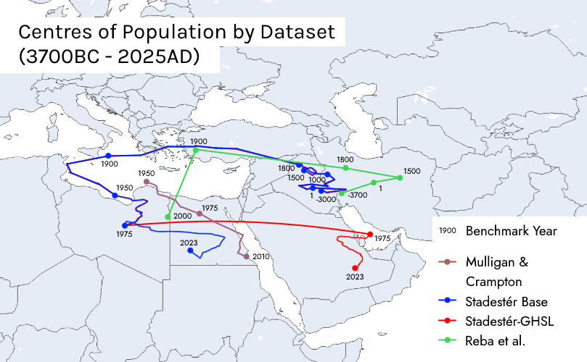

Figure 25. Centres of population comparison between GHSL, Stadestér, Mulligan and Crampton, and Reba et al. over time (3000BC-2025AD).

Testing how much our urban dataset varies from those of respected historical and contemporary estimates is certainly of great value, and is relatively routine in that sense [Durand]. Taking the distance between centres of population or gravity are the primary means by which we have decided to compare not just differences in total populations, but also in urban distribution between datasets.

Unfortunately, Reba is the only long-term global urban dataset with significant coverage prior to 1800AD. We find in general that Stadestér Base’s distance couples relatively tightly with that of Reba et al. (~220km to ~577km, or 1,1-2,8% as measured on the Earth’s great circle), with a maximum separation at 1500AD of ~1.170km, although the urban centre of population is much more stable prior to the Industrial Revolution than the trajectory plotted by Reba.

We do not believe this sort of anchoring can be explained by the Eurocentric biases introduced by Buringh, since there is no sudden discontinuity upon the introduction of Buringh or De Vries in 600AD and 1500AD respectively. There is a marked discontinuity between Stadestér Base and Stadestér-GHSL post-1975, in which GHSL has a dearth of North American and Latin American cities as previously covered due to density cutoffs.

Stadestér Base is on the other hand within (410km to 450km or ~2-2,2%, max = ~935km) as calculated from the UNWPP’s urban centre of gravity between 1950AD and 2010AD [Mulligan and Crampton]. By contrast, GHSL has a discrepancy from the UNWPP’s centre of gravity by ~2.323,52km, or 11,60% as compared to Earth’s radius, and nearly six times that of the discrepancy between Stadestér Base and the UNWPP despite one being a historical dataset, and the other being a modern urban dataset.

A comparison to HYDE (which purports similar data) in terms of spatial distribution was not made since its urban areas are decided by simply allocating urban populations to river valleys before fading into modern built-up areas. This phenomenon may be independently visualised at the HYDE portal [Joyandeh].

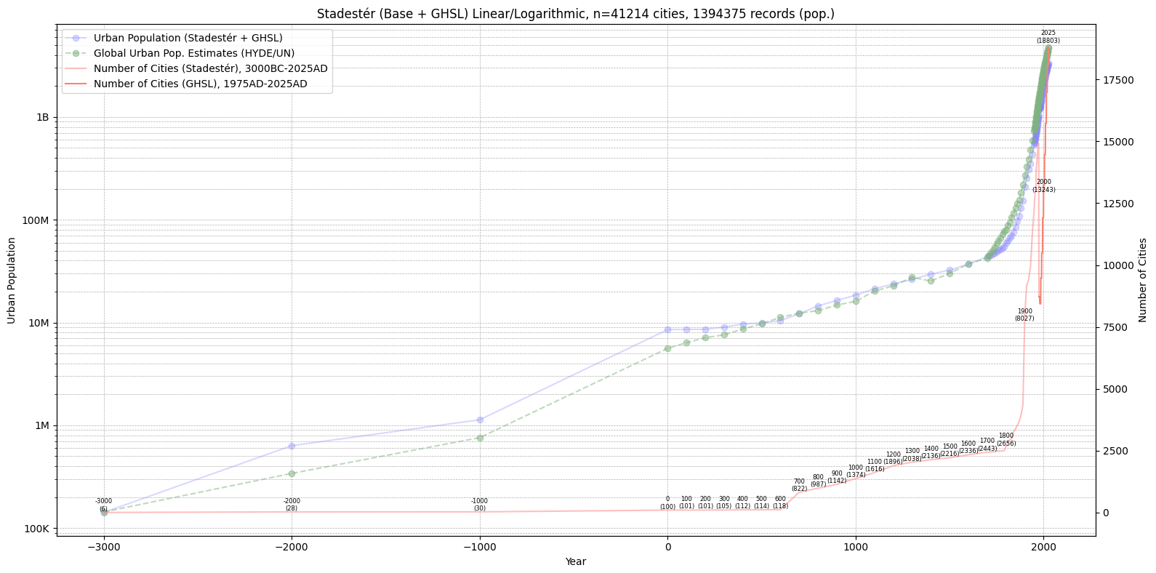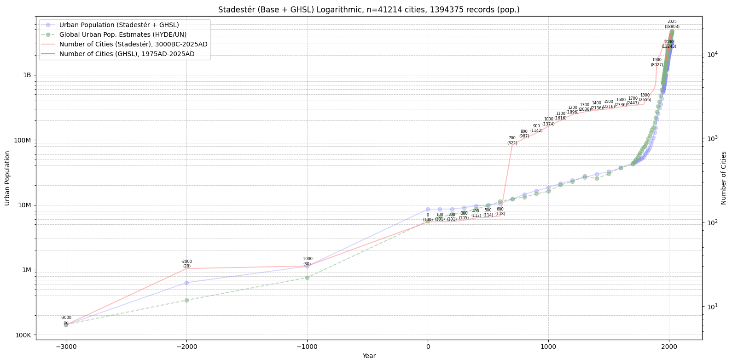

Figure 26. Raw totals of discrete city populations and sample size in Stadestér over time compared to HYDE/UN estimates (3000BC-2025AD).

There are certainly weaknesses in our sample sizes for the deep past - prior to 700AD there are only n=118 cities in Stadestér, mainly from Reba et al. The jump from n=118 to n=822 cities between 600AD-700AD is mainly given by the introduction of Buringh (and later De Vries), meaning the distribution of cities, no matter how discrete, takes on something of a Eurocentric character until ~1800AD, when Populstat affords us a more granular picture.

At the moment, there is not much we can do about this, since historical demographers have long neglected areas outside of Europe, and the fact that the ‘historical demography of Africa and South Asia’ had effectively ‘plummeted in the 1990s’ does not lend itself to confidence [Ittmann et al, p. 10-11]. Nearly 40% of historical demography publications in the journal Population Studies since 1947 have been on the British Isles alone. The Eurocentric ratios of the other major journals of demography are not much better [Reid].

What then, of Central Asia, the pre-Columbian Americas, Africa, East Asia, the Indian Subcontinent, and other such centres of historical urbanism which we are keenly interested in? They will have to wait. After all, there is much correcting to do with Chandler and Modelski’s extant figures to begin with, and we could only ever feel confident in the proxy modelling of other world regions after sourcing their estimates and disaggregating them [Chase-Dunn et al].

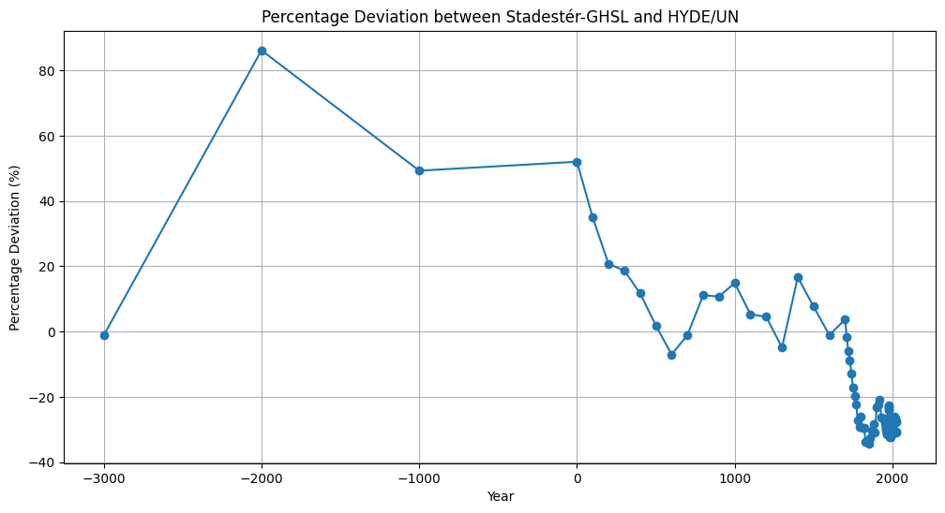

Figure 27. Percentage deviation between Stadestér-GHSL raw sums of city populations and HYDE/UN estimates over time (3000BC-2025AD).

Stadestér’s sums of all city populations consistently deviate by only ~20-30% from HYDE/UN estimations for the time period after 1AD without any calibration when speaking in an equal-interval capacity, although relatively large outliers (from -1,13-86,15%) also exist prior to antiquity.

However, because there are relatively few datapoints of this sort (n=4), overall margins of error as compared to HYDE/UN estimations are fairly small (n=121; M=-17,4%; SD=13%). In log-space, of course, Stadestér’s bottom-up estimates line up remarkably well with established top-down ones that are in common circulation [OWID].

By comparison, current academic models (n=10) of urban land cover (typically based on modern satellite or census data) display a relative mean deviation of 51,9% (CV=71%). [Chakraborty et al]. Since urban land cover is tightly coupled to urban population models (especially in dasymetric mapping and historical or hindcasted proxy models) as well as in verification, it is at some level a representative proxy of what we believe about the size of urban populations themselves [Klein Goldewijk and Verburg][Mennis][Ortman et al].

Meso-Validation, Out-of-Sample Forecasting

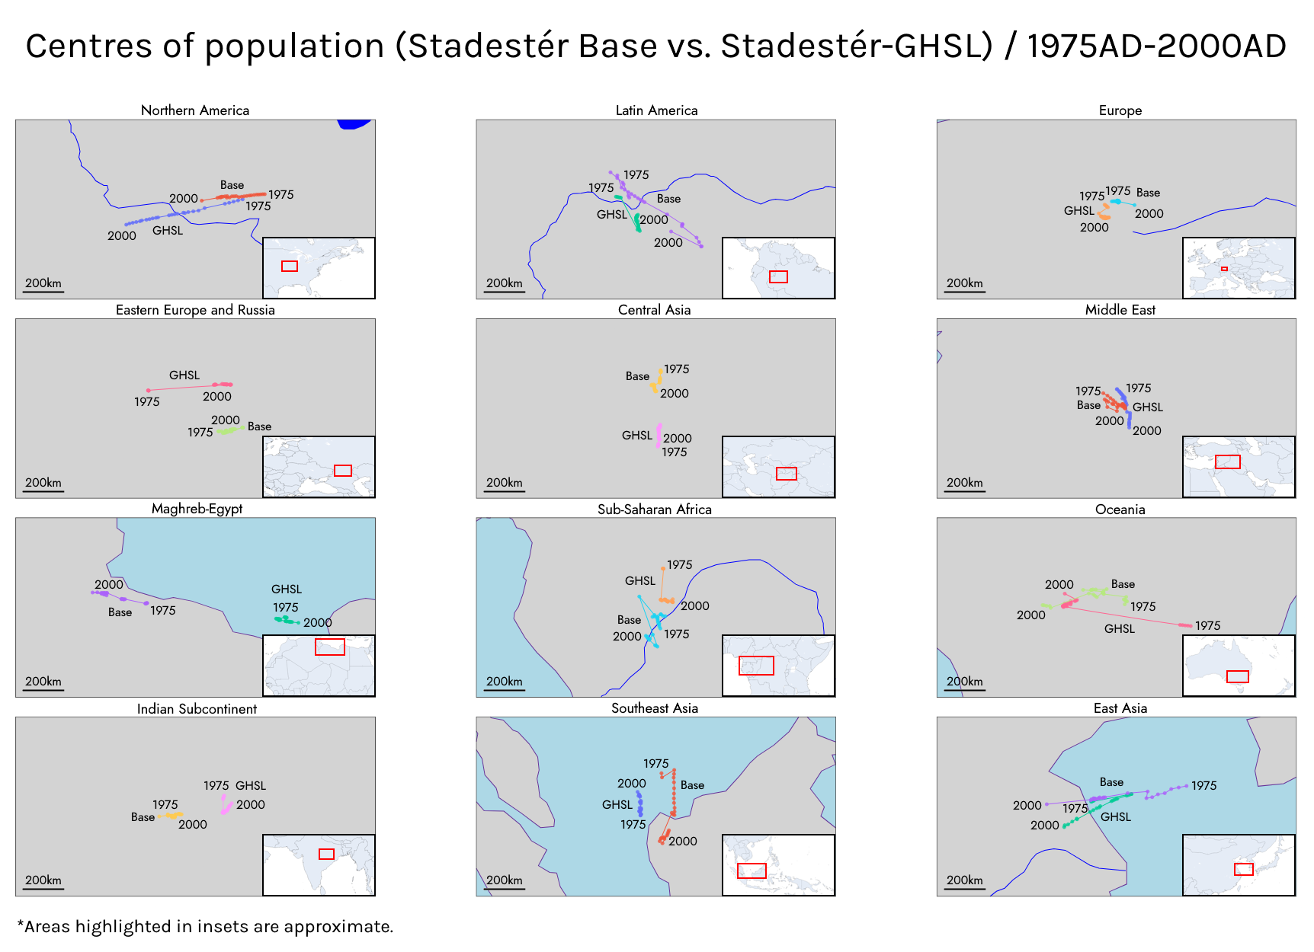

Figure 28. Centre of population comparison between GHSL and Stadestér Base for all world regions (1975AD-2000AD).

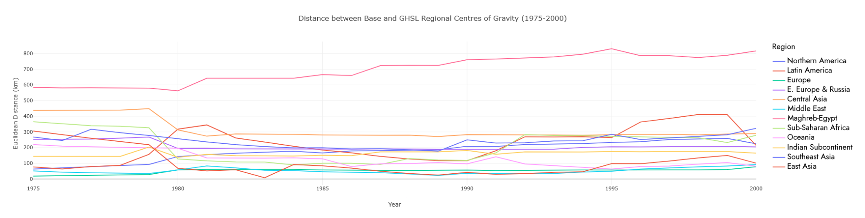

Figure 29. Euclidean distance between GHSL and Stadestér Base for all world regions (1975AD-2000AD).

We also attempted an assessment for the variation in regional centres of population between Stadestér Base and GHSL in terms of urban population. Average deviations between the two models varied from a minimum 51,67km (Europe) to a maximum of 699,47km (Maghreb-Egypt).

For all world regions, discrepancies were relatively tame but moderate (M = 214,23km; SD = 175,86km), with the obvious exception of the Maghreb and Egypt, for whom distances between approximate centres of population diverge rather than converge (M = 699,47km; SD = 88,25km).

This is due to a westwards drift in the base model as compared to an eastwards drift (towards Egypt and the Nile Delta) in GHSL, likely since the definitions of urban centres in Egypt in one of our main constituent sources (Populstat) lists the definition of cities in Egypt as being constant, i.e. ~40.000 inhabitants in 1986’, and many rural conurbations in the Nile Delta were not counted as separate cities by administration [Populstat].

Of course, it is important to keep in mind here the errors relative to the dimension of each region as well. Percentages are the fraction of the value given as compared to the longest geodesic line that fits within a given world region’s boundaries.

Region | Min. Deviation | Max. Deviation | Mean (% Error) | SD (% Error) | Longest Geodesic
Northern America | 63,04 | 258,77 | 178,30 (2,13%) | 58,95 (0,71%) | ~8.359
Latin America | 63,98 | 411,14 | 220,00 (1,79%) | 106,72 (0,87%) | ~12.278
Europe | 18,17 | 77,74 | 51,67 (0,84%) | 14,97 (0,24%) | ~6.120
Eastern Europe & Russia | 189,05 | 267,33 | 207,66 (2,87%) | 25,69 (0,36%) | ~7.241
Central Asia | 207,61 | 448,36 | 313,31 (9,03%) | 63,46 (1,83%) | ~3.470
Middle East | 22,45 | 91,82 | 51,28 (1,38%) | 18,28 (0,49%) | ~3.728
Maghreb-Egypt | 561,87 | 830,42 | 699,47 (13,49%) | 88,25 (1,70%) | ~5.185
Sub-Saharan Africa | 89,62 | 364,87 | 211,97 (2,87%) | 97,14 (1,32%) | ~7.376
Oceania | 63,21 | 219,37 | 125,86 (1,10%) | 48,96 (0,43%) | ~11.395
Indian Subcontinent | 138,48 | 203,40 | 162,55 (3,99%) | 15,95 (0,39%) | ~4.076
Southeast Asia | 177,07 | 323,15 | 243,60 (3,29%) | 40,10 (0,54%) | ~7.404
Eastasia | 7,67 | 305,78 | 105,13 (1,77%) | 85,74 (1,44%) | ~5.954
World (Avg.) | 133,52 | 316,85 | 214,23 (3,80%) | 175,86 (0,86%) | N/A

Figure 30. Comparisons of deviations between Stadestér-Base and Stadestér-GHSL by each world region’s centre of population in kilometres.

Note. Longest geodesic figures are approximate and are the diagonal of the bounding box of the largest contiguous geometry after per-pixel kNN-binning.

If we assume GHSL to be our ground truth model, then mean percentage errors for urban population distributions between Stadestér Base and GHSL varied from 0,84% to a high of 13,49%. Since we derive most modern population estimates past 2000AD from GHSL, our base population data diverges past 2000AD as data becomes scarcer and scarcer when not including either GHS-POP or GHS-UCDB. Fortunately, our main Stadestér Urban raster series merges both, and we therefore recommend its use for gridded population models.

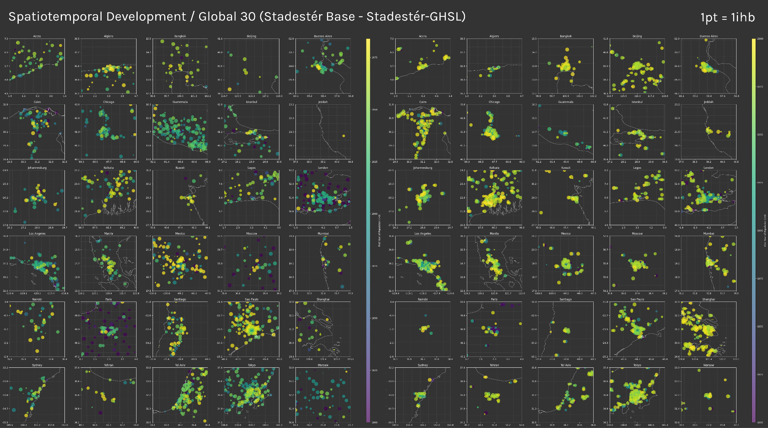

Figure 31. Comparisons of urban growth between Stadestér-Base and Stadestér-GHSL for the Global 30, metro-adjusted (1800AD-2000AD). Population circle sizes come from final year data for the metro-corrected version of Stadestér.

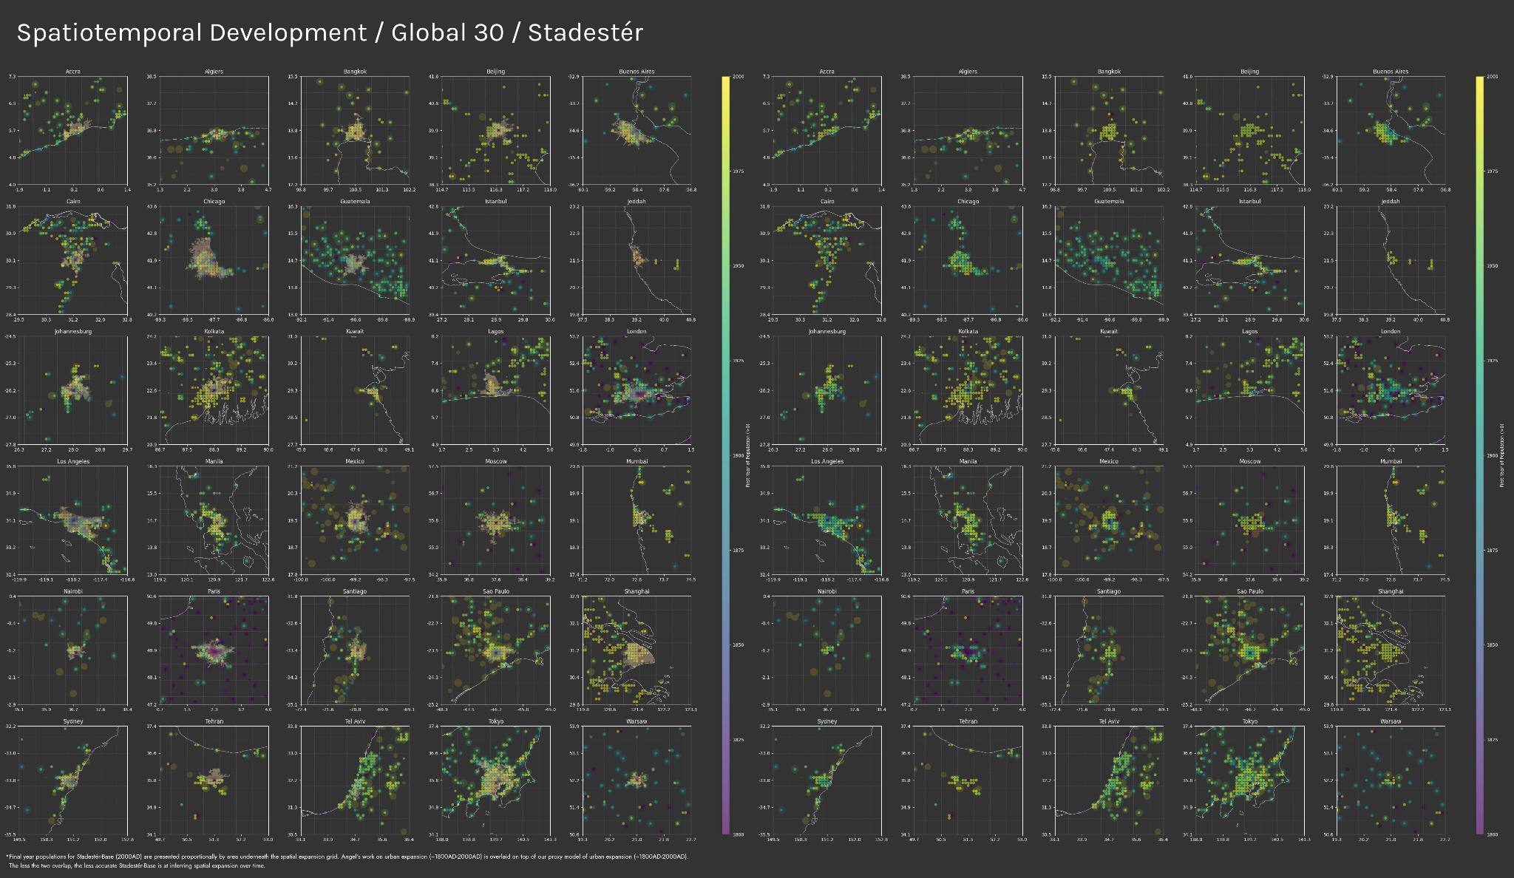

Figure 32. Overlay comparisons of urban growth between Stadestér-Base and the Atlas of Urban Expansion (1800AD-2014AD).

The exceptionally high number (n=41.214) of metropole, suburban, and peri-urban settlements also allow us to carry out spatial expansion comparisons between 1800AD and 2000AD utilising our population buffering model as discussed earlier. Overlay data for ground-truth comparisons of urban expansion were extracted from the Atlas of Urban Expansion’s Historical Data section [Angel].

Since spatial expansion is forecasted only based off the rural substrata rasters mentioned previously in addition to population records starting in 1800AD, urban expansion data in Stadestér between 1800-2000AD are by definition the results of a forecasted proxy model, and we can therefore perform out-of-model sampling and cross-comparisons to the Global 30 as defined by Angel, those cities being Accra, Algiers, Bangkok, Beijing, Buenos Aires, Cairo, Chicago, Guatemala, Istanbul, Jeddah, Johannesburg, Kolkata, Kuwait, Lagos, London, Los Angeles, Manila, Mexico, Moscow, Mumbai, Nairobi, Paris, Santiago, Sao Paulo, Shanghai, Sydney, Tehran, Tel Aviv, Tokyo, and Warsaw.

No specialised data fitting was performed for this area/density model beyond what has already been mentioned. In general, per-pixel visual results overlap tightly with the Atlas of Urban Expansion (Figure 32), and data is of high enough fidelity to visualise global urban expansion patterns. We provide the non-temporally dependent Jaccard indices of each city in Figure 38. Tests of this type are also possible with urban hindcasted models, such as that of Li et al (1870AD-2020AD/2100AD), but we have not performed such peer tests [Li et al].

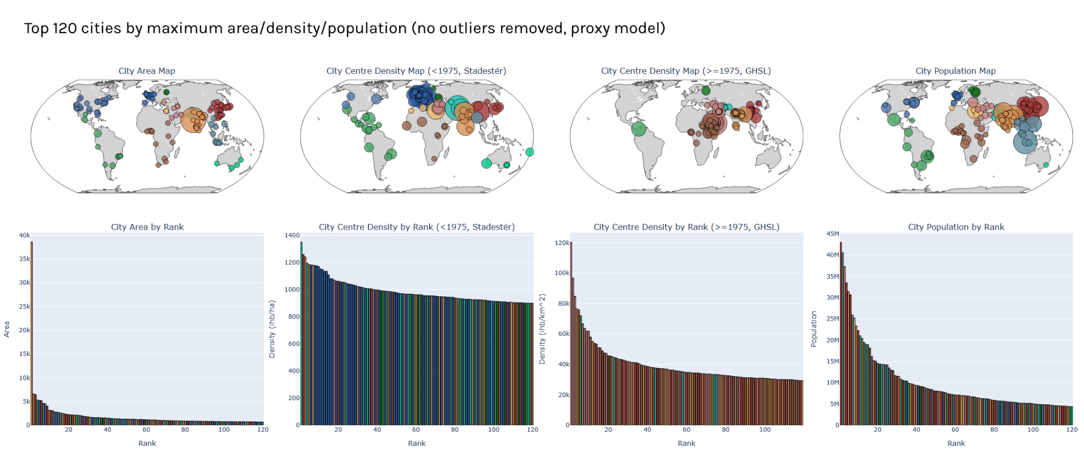

Figure 33. Largest 120 cities globally by maximum area, density, and population, sorted by world region (30000BC-2025AD).

Of course, whilst the proxy model’s underlying area and density assumptions are tempered by the underlying rural substrata in what it is allowed to do, as well as the polycentric nature of Stadestér’s core population data, it would also be helpful to illustrate how it performs in terms of area and density prediction.

There are major problems in defining urban density, and we specifically utilise modelled city centre density here since it was a requirement for the Clark model (in ihb/ha). An obvious problem that arises is that the differing definitions of urban density mean that there is no easy way to cross-compare the accuracy of our proxies of it to some list of the densest cities in the real world [Churchman][Angel et al].

Mumbai also appears as a major outlier in terms of guesstimated area in our models, due principally to its persistent exponential growth as a discrete city from 1800AD-2000AD as compared to other metropoles which were often eventually disaggregated into constituent polycentric suburbs.

Rank | Area (Proxy) | City Centre Density,  <1975, Base | City Centre Density,  >=1975, GHSL | Population
1 | Mumbai | Ghazni | Ar Rujum | Shenzhen
2 | Dhaka | Jiulong | Al Ma'azibah | Jakarta
3 | Shenzhen | Sikandarabad | Al Qal'ah | Dhaka
4 | Cali | Taxila | Jotsoma | Tokyo (GHSL)
5 | Lille | Kozhikode | Karora | Ghaziabad
6 | Tokyo | Katowice | Tiquisio | Shanghai (GHSL)
7 | Jakarta | Banha | Al Jama'im | Manila
8 | Los Angeles | Wandsbek | Sarvestan | Cairo (GHSL)
9 | Hiroshima | Wetter | Zahr al Husa | Kolkata
10 | Hajipur | Essen | Al Ghawl | Seoul (GHSL)
11 | Shanghai (GHSL) | Salerno | Natinga | Karachi
12 | New York (GHSL) | Brussels | Bangarmau | Mumbai (GHSL)
13 | Miami | Stockton-on-Tees | Bike | Sao Paulo (GHSL)
14 | New York (Base) | Cannes | Lintou | Bangkok
15 | Bangkok | Burg | Ath Thahirah | Mexico City
16 | Quezon City | Birmingham | Inticho | Beijing
17 | Kolkata | Lancaster | Pingchang | New York (Base)
18 | Nagoya | Zefat | Nimule | Bengaluru
19 | Seoul (GHSL) | Virovitica | Ar Rawnah | Osaka
20 | Osaka | Nagasaki | N/A | Ho Chi Minh
21 | Buenos Aires | Cobh | Longshui | Moscow (GHSL)
22 | Beijing | Brighton | Aliganj | Lahore
23 | Ghaziabad | Holguin | Toraghundi | Istanbul
24 | Mexico City | Amarapura | Dianjiang | New York (GHSL)
25 | Sao Paulo | Bytom | Al Masaliyah | Buenos Aires
26 | Chicago (GHSL) | Nurnberg | Dhupguri | Los Angeles
27 | Jieyang | Bar-le-Duc | Rongchang | Kinshasa
28 | Houston | Liverpool | Sareyn | Lagos
29 | Suzhou | Massa | Hechuan | Luanda
30 | Johannesburg | Patna | Al Hudayyah | Suzhou
31 | Cairo (GHSL) | Avallon | Neragyatanah | Chennai
32 | London | Elblag | Adan Baraka | Lima
33 | Toronto | Vitoria | Bhola | Jieyang
34 | Sao Paulo | Bayonne | Wusheng | Bogota
35 | San Jose | Perth | Shehong | London (GHSL)
36 | Melbourne | Montreal | Kharameh | Rio de Janeiro (GHSL)
37 | Hangzhou | Fujieda | Togechane | Hajipur
38 | Moscow (GHSL) | Akko | Jalpaiguri | Taipei
39 | Tehran | Brugges | Bugama | Hyderabad
40 | Ho Chi Minh | Agadez | Jingbian | Tehran
41 | Benin City | Braganca | N/A | Paris (GHSL)
42 | Paris | Beograd | Sikandra Rao | Moscow (Base)
43 | Sydney | Huancavelica | Hudur | Shanghai (Base)
44 | Kozhikode | Gilwice | Tulak | Dar-es-Salaam
45 | Kuala Lumpur | Ensenada | Xishui | Bandung
46 | Chicago (Base) | Cacheu | Yuechi | Johannesburg
47 | Phoenix | Montceau | Sandila | Chongqing
48 | Surabaya | Lanzhou | Derudeib | Kuala Lumpur
49 | Washington D.C. | Heidelberg | Bisalpur | Wuhan
50 | Rio de Janeiro (GHSL) | Arbon-Rorsch | Koohanjan | Nanjing
51 | Istanbul | Montbeliard | Gobindaganj | Riyadh
52 | Kochi | Suva | Mojiang Hani | Ahmedabad
53 | Detroit | Le Creusot | Qaraziadin | Nagoya
54 | Dallas-Fort Worth | Sebinkarahis | Uige | London (Base)
55 | Colombo | Chatham | El Hawata | Kozhikode
56 | Lagos | Gardiz | Famenin | Sao Paulo (Base)
57 | Shanghai (Base) | Yarumal | Garasse | Tianjin
58 | Denver | Denain | Khail | Addis Ababa
59 | Moscow (Base) | Panama City | Manakhah | Chicago
60 | Owerri | Ahmadnagar | Yingshan | Khartoum
61 | Seattle | Rostov | Kebkabiya | Surat
62 | Accra | Vancouver | Shahganj | Chengdu
63 | Maharajganj | Krivodol | Ghatampur | Cairo (Base)
64 | Riyadh | Wicklow | Jamame | Alexandria
65 | Onitsha | Oakland | Narus | Baghdad
66 | Chennai | Santos | Bishan | Hangzhou
67 | Montreal | Mannheim | Longquanyi | Surabaya
68 | Nanjing | Jaunpur | Krishnanagar | Pune
69 | Bengaluru | Olesnica | Filtu | Nairobi
70 | Bandung | Chorzow | Meshkan | Santiago
71 | Lima | San Marino | Ad Darumah | Abidjan
72 | Taipei | Ambala | Jais | Amman
73 | Khartoum | Mortherwell | Safipur | Luxor
74 | Luanda | Qabis | Shinkot | Seoul (Base)
75 | Hanoi | Liege | Shahrak | Kabul
76 | Cairo (Base) | Gallivare | Al 'Udayn | Yangon
77 | Dar es-Salaam | Pila | Shamsabad | Shenyang
78 | Lahore | Surgidero | Jalesar | Mumbai (Base)
79 | Hyderabad | Rapperswil | Burka | Accra
80 | Tamluk | Zeila | Kavar | Beijing
81 | Ruhr | Bogazzilyan | Nanxi | Onitsha
82 | Chengdu | Puerto Wilch | Al Mirqab | Miami
83 | Portland | Retalhuleu | Seka | Madrid
84 | Phoenix | Lille | Hilat Ashat | Faisalabad
85 | Dubai | Karachi | Yenice | Hefei
86 | Las Vegas | Bremen | Bitou | Toronto
87 | Karachi | Kalisz | Khayran | Yaounde
88 | Linyi | Kogarh | Pengshui | Ruhr
89 | Tehran | Ahmadabad | Nanbu | Xi'an
90 | Kampala | Thionville | Hamero | Mashhad
91 | Durban | Caracas | Amber | Chicago
92 | Quanzhou | Siegburg | Utraula | Paris (Base)
93 | Santiago | Vancouver | Lezhi | Lucknow
94 | Seoul (Base) | Mexico City | Buram | Kampala
95 | Milan | Polonaruwa | Meichuan | Chattogram
96 | Perth | Artemivsk | Bendaravadi | Rio de Janeiro (Base)
97 | San Diego | Kortrijk | Daying | Zhengzhou
98 | Wuhan | Conde | As Sayyid | Singapore
99 | Rio de Janeiro (Base) | Khiva | Wegeda | Kano
100 | Sacramento | Saint Petersburg | Faridpur | Kochi
101 | Philadelphia | Bridgetown | Kibet | Hanoi
102 | Ponnani | Dubrovnik | Siyana | Kumasi
103 | Chicoutimi | Kampala | Bhinga | Rawalpindi
104 | Manchester | Zary | Wereta | Saint Petersburg
105 | Orlando | Lens | Kattapanna | Philadelphia
106 | Shenyang | Cazin | Tongrim | Jeddah
107 | Mumbai | Shenyang | Sahabad | Hong Kong
108 | London | Aachen | Weixin | Mogadishu
109 | Kollam | Ait Melloul | Chhibramau | Colombo
110 | Saint Petersburg | Barauni | Kangdong | San Jose
111 | Brisbane | Shizuoka | Soku | Santo Domingo
112 | Jeddah | Johannesburg | Hardoi | Harbin
113 | Cape Town | Gorna Orjach | Aleta Wendo | Casablanca
114 | Xi'an | Kitakyushu | Hargele | Dubai
115 | Baghdad | Leuven | Bolo | Tokyo (Base)
116 | Berlin | Petrozavodsk | El Afweyn | Tianjin
117 | Birmingham | Anamoros | Ed Al Fursan | Douala
118 | Monterrey | Hurstville | Tongjiang | Kanpur
119 | Madrid | Tadjourah | Jhenaidah | Belo Horizonte
120 | Yogyakarta | Butiaba | N/A | Sydney

Note: This is metro-adjusted Stadestér Base, meaning that large metropolitan areas are disaggregated compared to GHSL. GHSL often groups together built-up areas - Shenzhen for instance, is the entirety of the Pearl River Delta. The rank is given by a city’s maximum area/density/population, not that of its last year.

Figure 34. Rank-ordinal tables of the top 120 cities in each category (area, city centre density, population) over the entire time domain.

Despite not being directly comparable due to measurement differences and metro correction, such assessments give us a chance to see whether the conclusions of a model are mostly sensible, in part by regional-level density classifications. The large amount of dense European cities (n=54, 45%) of the Global 120 in Stadestér Base can largely be explained as the legacy of early European industrialisation and urbanisation [Zinkina et al][Lees and Lees].

Region | Area, City Count | Centre Density City Count, <1975, Base | Centre Density City Count, >=1975, GHSL | Population, City Count
Northern America | 25 | 3 | 0 | 9
Latin America | 10 | 14 | 0 | 11
Europe | 10 | 54 | 0 | 6
Eastern Europe & Russia | 2 | 8 | 1 | 3
Central Asia | 2 | 5 | 1 | 5
Middle East | 7 | 5 | 27 | 8
Maghreb-Egypt | 2 | 3 | 0 | 5
Sub-Saharan Africa | 12 | 7 | 31 | 17
Oceania | 4 | 4 | 0 | 1
Indian Subcontinent | 16 | 9 | 29 | 18
Southeast Asia | 9 | 1 | 0 | 10
Eastasia | 21 | 7 | 25 | 27

Figure 35. Table of the number of cities in the top Global 120 per variable listed above.

After 1975AD, our data shows a large-scale migration in the densest cities eastwards towards Africa and Asia (n=31, 25,83%; n=81, 67,5%), which are consistent with other visualisations or uses of GHSL [Smith]. However, the GHSL’s list of densest cities are not generally matched by those of Demographia, which filters only for urban areas with a population >500k [Cox].

Thus it is difficult to say with any confidence how accurate our internal proxy metrics are. From a broad regional standpoint, they certainly seem to align with macrohistorical trends, outliers notwithstanding [Bairoch and Goertz][Stapleton]. At the very least, the results are on the whole not patently absurd - for instance, there remains a low number of cities in Northern America within Stadestér Base which belong to the Global 120 in terms of density (n=3, 2,5%).

These results are not however representative of the final rasters, since Stadestér Urban is additionally filtered over substrata maps informed by population distributions, meaning they reflect the spatially explicit results seen in earlier figures rather than the somewhat abstract intermediate parameters demanded by Clark and associated variant equations (Figure 30, Figure 31).

Micro-Validation, Manual Copychecking

Similar to how many scientific models have data portals in which resulting rasters can be easily inspected (for instance, the HYDE Portal, or the GHSL’s Global Visualisation, or GPW’s Worldview), we decided to embark on the creation of custom data processing and visualisation software in the form of Constele Red [GHSL Global Visualisation][NASA Worldview].

Constele Red is somewhat unique in that it is architecturally a multi-threaded, asynchronous spatiotemporal processing suite with a DAG node editor in addition to performing 3D map visualisation tasks via Maptalks and Codemirror v5 [CodeMirror][Maptalks]. We chose to offer dataflow editing capabilities in Constele Red since we intend on the eventual integration of Stadestér data processing and visualisation to allow for better reproducibility by other researchers.

The visualisation suite, particularly in the form of various mapmodes, was utilised to inform various manual copychecking efforts and to flag various anomalous results in any of Stadestér’s constituent sources.
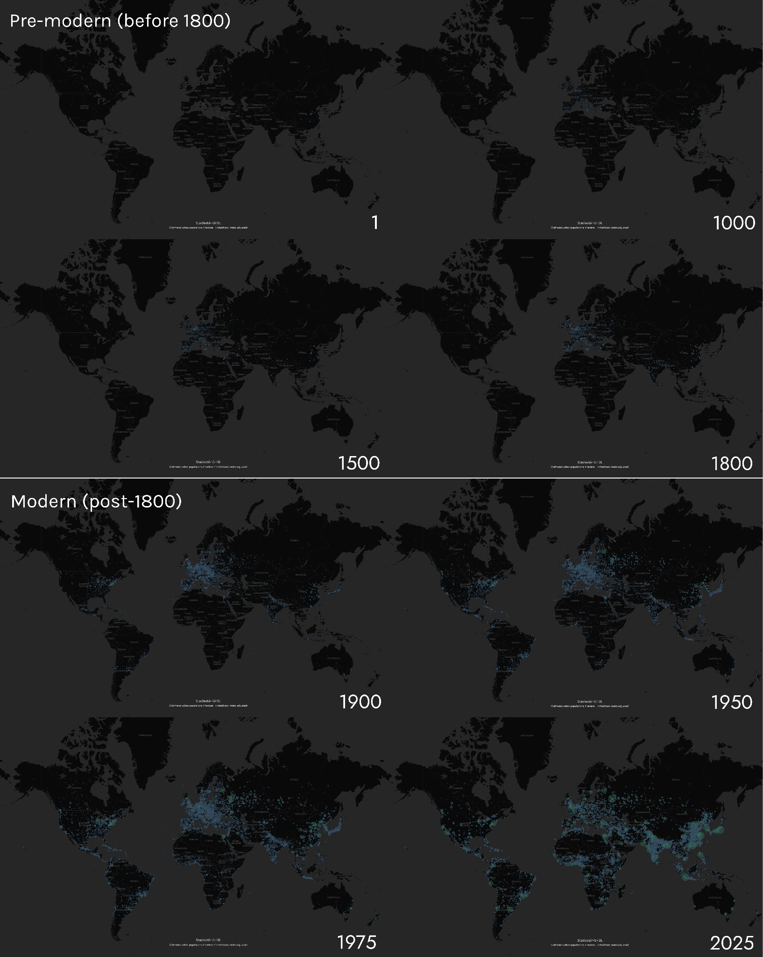

Figure 36. Screenshots of Stadestér-GHSL without labels in Constele Red for benchmark years. 1 hectare = 1 inhabitant, metro adjusted (1AD-2025AD).

Manual copychecking is by its nature something of a last resort, since it is non-systematic. As such, we often utilised elevation heightmaps to visualise GeoPNG rasters produced by Stadestér in addition to viewing raw geolocated population figures. Few of the findings from the field of cartographic labelling are represented in web-native mapping libraries [Edmondson et al][Scheuerman et al].

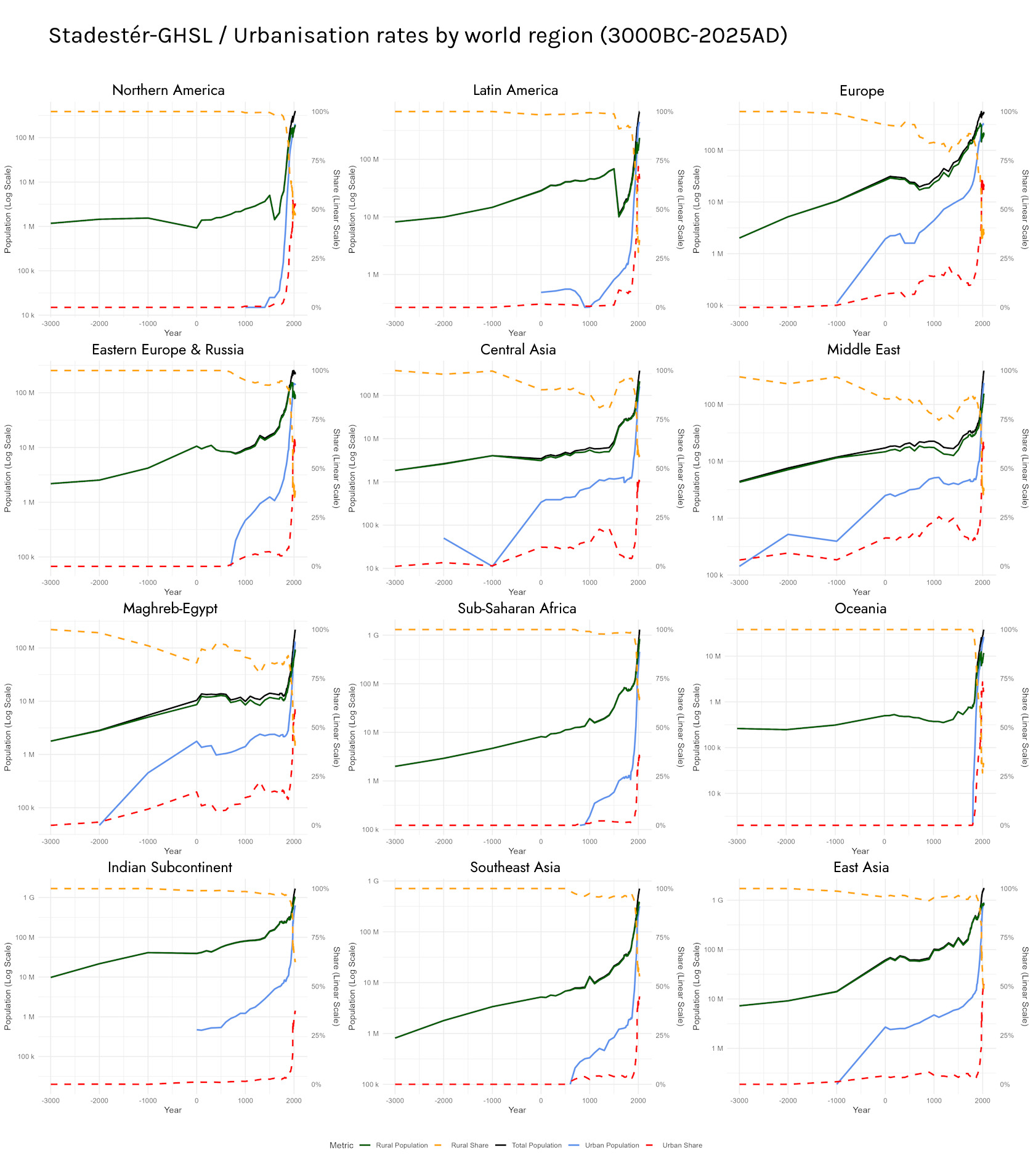

Figure 37. Urbanisation rates by world region in Stadestér-GHSL (3000BC-2025AD).

The high number of cities leads to label crowding, even for earlier years in Stadestér (Figure 35), and so figures typically had to be assessed at very close range.

Figures and auto-generated animations were additionally prepared in advance and programmed in Python/R such that they could serve as an additional form of visualisation for the overall dataset, even though at this stage we must admit that a great deal of code tidying and consolidation is needed before each figure can be accounted for. Still, the individual Node.js, Python, and R files used to generate the graphs and tables in this paper can be found in the linked source repository in line with data and code availability standards [DCAS]. They can also be found in the full datavault version of Stadestér 1.0, since some intermediate files used to produce the results in this paper exceed 100MB.

In general, urbanisation by world region aligns closely with rasters as present in Stadestér Urban with the exception that the rates have been taken from discrete city objects as opposed to consolidated rasters.

[◼] Metro-adjusted / [◼] Non-metro adjusted. Figures are given in thousands.

Year | Accra |  | Algiers |  | Bangkok |  | Beijing |  | Buenos Aires
1 | 0 | 0 | 0 | 0 | 0 | 0 | 0 | 0 | 0 | 0
500 | 0 | 0 | 0 | 0 | 0 | 0 | 0 | 0 | 0 | 0
1000 | 0 | 0 | 0 | 0 | 0 | 0 | 60 | 60 | 0 | 0
1500 | 0 | 0 | 20 | 20 | 0 | 0 | 672 | 672 | 0 | 0
1600 | 0 | 0 | 77 | 77 | 0 | 0 | 707 | 707 | 0 | 0
1700 | 0 | 0 | 100 | 100 | 0 | 0 | 685 | 685 | 3 | 3
1800 | 0 | 0 | 78 | 100 | 45 | 45 | 1.137 | 1.137 | 35 | 35
1850 | 0 | 0 | 29 | 54 | 162 | 162 | 1.648 | 1.648 | 74 | 74
1900 | 17 | 17 | 31 | 97 | 541 | 541 | 1.649 | 1.649 | 672 | 771
1950 | 156 | 167 | 120 | 331 | 778 | 778 | 2.069 | 2.069 | 782 | 3.164
1975 | 1.098 | 1.098 | 1.521 | 1.521 | 3.699 | 3.699 | 5.153 | 5.153 | 8.567 | 8.567
2000 | 2.778 | 2.778 | 2.216 | 2.216 | 8.903 | 8.903 | 10.010 | 10.010 | 11.737 | 11.737
2025 | 5.890 | 5.890 | 3.316 | 3.316 | 19.048 | 19.048 | 18.151 | 18.151 | 14.180 | 14.180
 | Cairo |  | Chicago |  | Guatemala |  | Istanbul |  | Jeddah
1 | 0 | 0 | 0 | 0 | 0 | 0 | 109 | 109 | 0 | 0
500 | 0 | 0 | 0 | 0 | 0 | 0 | 498 | 498 | 0 | 0
1000 | 94 | 114 | 0 | 0 | 0 | 0 | 330 | 330 | 0 | 0
1500 | 360 | 380 | 0 | 0 | 30 | 30 | 204 | 204 | 0 | 0
1600 | 255 | 275 | 0 | 0 | 25 | 25 | 685 | 685 | 0 | 0
1700 | 155 | 175 | 0 | 0 | 31 | 31 | 750 | 750 | 0 | 0
1800 | 171 | 191 | 0 | 0 | 25 | 25 | 560 | 560 | 20 | 20
1850 | 241 | 261 | 59 | 59 | 37 | 37 | 748 | 778 | 26 | 26
1900 | 503 | 597 | 1.671 | 1.671 | 77 | 82 | 862 | 941 | 30 | 30
1950 | 2.974 | 3.296 | 3.889 | 3.889 | 280 | 326 | 391 | 1.050 | 95 | 95
1975 | 7.420 | 7.420 | 4.477 | 4.477 | 1.131 | 1.131 | 5.123 | 5.123 | 480 | 480
2000 | 15.302 | 15.302 | 5.124 | 5.124 | 2.068 | 2.068 | 10.589 | 10.589 | 2.369 | 2.369
2025 | 25.230 | 25.230 | 5.319 | 5.319 | 2.901 | 2.901 | 14.210 | 14.210 | 4.842 | 4.842
 | Johannesburg |  | Kolkata |  | Kuwait |  | Lagos |  | London
1 | 0 | 0 | 0 | 0 | 0 | 0 | 0 | 0 | 31 | 31
500 | 0 | 0 | 0 | 0 | 0 | 0 | 0 | 0 | 35 | 35
1000 | 0 | 0 | 0 | 0 | 0 | 0 | 0 | 0 | 20 | 38
1500 | 0 | 0 | 0 | 0 | 0 | 0 | 0 | 0 | 0 | 61
1600 | 0 | 0 | 0 | 0 | 0 | 0 | 0 | 0 | 0 | 175
1700 | 0 | 0 | 0 | 0 | 0 | 0 | 0 | 0 | 7 | 552
1800 | 0 | 0 | 258 | 368 | 0 | 0 | 0 | 0 | 768 | 864
1850 | 0 | 0 | 329 | 439 | 0 | 0 | 0 | 0 | 0 | 2.321
1900 | 102 | 102 | 615 | 1.010 | 0 | 0 | 38 | 38 | 0 | 4.504
1950 | 89 | 805 | 1.940 | 3.535 | 0 | 0 | 241 | 241 | 0 | 3.343
1975 | 1.820 | 1.820 | 10.922 | 10.922 | 768 | 768 | 2.645 | 2.645 | 7.393 | 7.393
2000 | 4.272 | 4.272 | 18.301 | 18.301 | 1.566 | 1.566 | 7.726 | 7.726 | 7.646 | 7.646
2025 | 8.593 | 8.593 | 23.315 | 23.315 | 3.703 | 3.703 | 12.846 | 12.846 | 10.408 | 10.408
 | Los Angeles |  | Manila |  | Mexico |  | Moscow |  | Mumbai
1 | 0 | 0 | 0 | 0 | 0 | 0 | 0 | 0 | 0 | 0
500 | 0 | 0 | 0 | 0 | 0 | 0 | 0 | 0 | 0 | 0
1000 | 0 | 0 | 0 | 0 | 0 | 0 | 0 | 0 | 0 | 0
1500 | 0 | 0 | 0 | 0 | 0 | 80 | 81 | 82 | 0 | 0
1600 | 0 | 0 | 28 | 28 | 9 | 58 | 106 | 109 | 0 | 0
1700 | 0 | 0 | 31 | 31 | 66 | 82 | 109 | 114 | 0 | 60
1800 | 0 | 0 | 77 | 77 | 107 | 131 | 247 | 259 | 115 | 143
1850 | 2 | 2 | 113 | 113 | 152 | 180 | 346 | 371 | 428 | 583
1900 | 184 | 192 | 207 | 207 | 266 | 370 | 1.088 | 1.135 | 773 | 822
1950 | 1.388 | 2.022 | 955 | 1.010 | 955 | 2.234 | 4.345 | 4.612 | 2.595 | 2.725
1975 | 8.257 | 8.257 | 8.457 | 8.457 | 11.138 | 11.138 | 8.507 | 8.507 | 8.505 | 8.505
2000 | 11.631 | 11.631 | 17.526 | 17.526 | 17.250 | 17.250 | 11.172 | 11.172 | 15.639 | 15.639
2025 | 13.474 | 13.474 | 25.921 | 25.921 | 17.639 | 17.639 | 14.384 | 14.384 | 20.453 | 20.453
 | Nairobi |  | Paris |  | Santiago |  | Sao Paulo |  | Shanghai
1 | 0 | 0 | 0 | 0 | 0 | 0 | 0 | 0 | 100 | 100
500 | 0 | 0 | 0 | 0 | 0 | 0 | 0 | 0 | 100 | 100
1000 | 0 | 0 | 15 | 18 | 0 | 0 | 0 | 0 | 100 | 100
1500 | 0 | 0 | 161 | 174 | 0 | 0 | 0 | 0 | 100 | 100
1600 | 0 | 0 | 230 | 248 | 0 | 0 | 0 | 0 | 31 | 31
1700 | 0 | 0 | 517 | 559 | 13 | 13 | 0 | 0 | 44 | 44
1800 | 0 | 0 | 533 | 601 | 29 | 29 | 12 | 12 | 93 | 93
1850 | 0 | 0 | 953 | 1.314 | 86 | 86 | 16 | 16 | 186 | 186
1900 | 0 | 0 | 1.894 | 2.679 | 280 | 285 | 198 | 225 | 551 | 551
1950 | 138 | 138 | 1.714 | 3.774 | 1.238 | 1.349 | 2.294 | 2.711 | 5.136 | 5.136
1975 | 564 | 564 | 7.398 | 7.398 | 2.826 | 2.826 | 10.645 | 10.645 | 4.557 | 4.557
2000 | 2.586 | 2.586 | 8.371 | 8.371 | 5.191 | 5.191 | 17.018 | 17.018 | 13.812 | 13.812
2025 | 6.646 | 6.646 | 9.328 | 9.328 | 6.634 | 6.634 | 19.485 | 19.485 | 30.679 | 30.679
 | Sydney |  | Tehran |  | Tel Aviv |  | Tokyo |  | Warsaw
1 | 0 | 0 | 0 | 0 | 0 | 0 | 0 | 0 | 0 | 0
500 | 0 | 0 | 0 | 0 | 0 | 0 | 0 | 0 | 0 | 0
1000 | 0 | 0 | 0 | 0 | 0 | 0 | 0 | 0 | 0 | 0
1500 | 0 | 0 | 0 | 0 | 0 | 0 | 0 | 0 | 7 | 7
1600 | 0 | 0 | 0 | 0 | 0 | 0 | 0 | 60 | 25 | 25
1700 | 0 | 0 | 0 | 28 | 0 | 0 | 485 | 685 | 18 | 18
1800 | 2 | 2 | 27 | 27 | 0 | 0 | 485 | 685 | 126 | 126
1850 | 48 | 48 | 0 | 74 | 0 | 0 | 580 | 780 | 162 | 162
1900 | 457 | 479 | 124 | 225 | 0 | 0 | 889 | 1.566 | 686 | 719
1950 | 960 | 1.647 | 1.043 | 1.145 | 50 | 280 | 1.623 | 5.010 | 610 | 757
1975 | 2.254 | 2.254 | 4.152 | 4.152 | 600 | 600 | 24.050 | 24.050 | 1.398 | 1.398
2000 | 3.005 | 3.005 | 6.867 | 6.867 | 1.633 | 1.633 | 30.304 | 30.304 | 1.684 | 1.684
2025 | 4.375 | 4.375 | 9.363 | 9.363 | 2.628 | 2.628 | 33.156 | 33.156 | 2.000 | 2.000

Figure 38. Population tables for the Global 30 (metro vs. no metro adjustment) as compared to Angel and Wikipedia for selected benchmark years (1AD-2025AD),, Thousands.

As is typically the case for datasets of this sort, it is only at the very discrete level that we can both see the impacts metro adjustment (disaggregation) has on Stadestér data when it comes to discrete objects in addition to being able to compare figures given at a particular year to their real-world populations [Yankey et al]. For the urban historian, it is likely best to cross-compare results between both branches of our dataset: the metro-adjusted version for spatial disaggregation, and the non-metro adjusted version if they are only interested in the population records of a given place.

Micro-Validation, Global 30 (City-Level)

So far, the measurements of deviation previously used have assessed errors in global urban population to be on the whole between ~±17,4% (SD=13%), as previously estimated based on comparisons to HYDE/UN global urban population estimates (Figure 27). Regional out-of-sampling errors are similarly constrained between 0,84%-13,49% for modern data that can be substantively verified using modern satellite-based data comparisons (Figure 28, 29).

However, this does not necessarily answer what error rates are for specific cities, nor for the deep past. This is solvable for many of the world’s major cities, such as those in the Global 30 that have already been previously compared to Angel’s Atlas of Urban Expansion for the time period between 1800AD-2014AD. We now undertake a general literature review to see what can be assessed of each of the Global 30’s population over the long run to assess discrete margins of error.

We will mainly be using the non-metro adjusted populations to judge comparable figures. In these assessments, the Ground Truth (GT) model refers to ‘ground truthing’ in social science modelling, which may come from plausible estimates or simulations as defined by DARPA or IBM [DARPA][IBM - Krantz and Jonker][Naugle et al]. In this ML definition, it is perfectly acceptable for the GT to merely mean plausible estimates, which all population figures are to varying degrees - no figure, ancient or modern, reliably counts every inhabitant. Nor is modern data necessarily flawless - differences in how populations are measured and the boundaries of cities lead to a great deal of variation - as much as in pre-modern estimates.

Standard deviations (SDs) when describing the distributions of deviations from GT estimates should be taken with a grain of salt, since there are obviously so many datapoints available for a given urban time-series. They are intended to be used to quantify broad-range estimates of errors across the entire set (Global 30) rather than individual cities.

It is important to set forth some ground rules in how we may come to conclusions on how much Stadestér deviates from the estimated ground truth - deviations are only to be calculated where data both intersects, and where data is not extrapolated (the linear interpolation of years in GT is however fine).

Accra

The highest resolution data for Accra’s population comes from Acheampong, who uses metropolitan figures, as well as various censuses after 1970AD [Acheampong][Brinkhoff]. We thus reconstruct long-run data as follows from Acheampong - 1901AD: 19.396; 1911AD: 39.750; 1921AD: 98.836; 1931AD: 177.140; 1950AD: 274.779; 1955AD: 391.875; 1960AD: 450.842; 1965AD: 529.265; 1970AD: 626.694; 1975AD: 763.337; 1980AD: 899.649; 1985AD: 1.036.081; 1990AD: 1.191.730; 1995AD: 1.405.387; 2000AD: 1.696.510; 2005AD: 1.910.228; 2010AD: 2.123.945; 2015AD: 2.376.455; 2020AD: 2.512.708; 2025AD (projected): 2.784.435.

Brinkhoff cites the Ghana Statistical Service for 1970AD, 1984AD, 2000AD, 2010AD, and 2021AD (metro), and its population data is recorded respectively - 624.091, 969.195, 1.658.937, 2.070.463, 5.445.692. Where possible, we will use Brinkhoff’s figures to construct the following table of selected years.

 | 1 | 500 | 1000 | 1500 | 1600 | 1700 | 1800 | 1850 | 1900 | 1950 | 1975 | 2000 | 2025
STAD |  |  |  |  |  |  |  |  | 17 | 167 | 1.098 | 2.778 | 5.890
GT |  |  |  |  | <1 | ~3-4 | ~12 | ~15 | ~18-20 | 275 | 763 | 1.658 | 5.445
STAD = Stadestér, GT = Ground Truth (Acheampong, Brinkhoff); Thousands

Since we are counting modern boundaries, we have also included earlier sources in our Ground Truth, such as assertions of precolonial populations in areas that are now considered Accra, i.e. Amanfro [Rönnbäck][Quayson p. 48][The Metropole]. Of course, as Acheampong notes, ‘the administrative boundary of AMA has changed over the years, which makes it difficult to identify population trends’.

This comes to a slight deviation (M=13,1%-15,0%; SD=37,5%-38,7%).

Algiers

The habitations of Algiers are somewhat better queried. A great deal of work has been done on the precolonial populations of that city by Cresti [Cresti]. We take a household as mentioned by Cresti to refer to ~4 inhabitants. We must of course clarify our sources prior to 1500AD - for 1AD we know that Icosium was a Roman veterans’ colony in which 3.000 veterans were settled [Plinius, NH Book 3, 19][Kofoid and Kofoid, p. 51]. The later figure was allegedly asserted by Theodor Mommsen according to Wikipedia, but we cannot take Wikipedia’s word for it. This figure (at the very least the ballpark for it) is additionally attested to by Bowman and Wilson’s work on Roman Settlement, Urbanization, and Population [Wikipedia][Bowman and Wilson p. 184].

For figures after the 1800s, we take our numbers from Çelik, who lists populations as follows: 1839AD: ~48.000, 1896AD: ~120.000, 1926AD: ~212.000 [Celik], as well as the UN’s WUP from 2018 [UN].

 | 1 | 500 | 1000 | 1500 | 1600 | 1700 | 1800 | 1850 | 1900 | 1950 | 1975 | 2000 | 2025
STAD |  |  |  | 20 | 77 | 100 | 100 | 54 | 97 | 331 | 1.521 | 2.216 | 3.316
GT | ~3 | ~15 | <1 | ~12 | ~48,8 | ~50 | ~30-35 | ~60 | ~120 | 516 | 1.507 | 2.141 | 3.004
STAD = Stadestér, GT = Ground Truth (Plinius, Bowman and Wilson, Cresti, Celik, UN WUP 2018); Thousands. Dates for 1AD-500AD are for Icosium, dates >1000AD are for Algiers.

This deviation is moderate (M=36-40,8%; SD=70-77,2%), with Stadestér being somewhat less accurate in earlier years.

Bangkok

Despite Bangkok’s long and storied past since the 1400s, population records and estimates prior to the 1850s are relatively rare. Bunnag et al. gives it this discouraging note: ‘It is striking how great the importance of demography for Siam’s history [sic], yet how limited the body of population data is that can be drawn upon in historical research, prior to unhelpful qualitative suggestions of how figures could be estimated [Bunnag et al].

That has never stopped us before of course, and we are not in favour of papers suffixed with the word ‘Towards’ in any case, since they are ‘towards’ something, and never actually solve the problem stated. Since 1919, routine censuses have been taken of the place, and we will use this as our ground truth in addition to compilations by Sternstein for 1850AD [Ouyyanont and Porphant, p. 242], or ~350.000-400.000. Prior to this, our estimates come from Kulachol who gives the population in the 1820s as being 50.000-80.000, the lower figure which we shall use for 1800AD [Kulachol]. The contemporary area of this mandala is given as being 414ha, or 120,77-193,24ihb/ha.

It just so happens we know what the size of Bangkok in the preceding centuries was as documented both by Van Roy and La Loubere [Van Roy][La Loubere]. La Loubere gives an estimate of ~41ha (1691). Van Roy, whose work is decidedly not from the 1600s, gives the following areas. Pre-1782: 210ha; 1782-1785: 430ha. Since we already have our figure for 1800AD we need not work on it. This yields the following population estimates of 4.952-7.923 for 1600AD, the lower figure being preferable, and 25.361-40.580 for 1700AD, the lower figure again being more plausible. After 1950AD, we again use the WUP. For 2025AD, we use the metropolitan figure given by Metro Futures [De La Haye et al]. This yields the following table:

 | 1 | 500 | 1000 | 1500 | 1600 | 1700 | 1800 | 1850 | 1900 | 1950 | 1975 | 2000 | 2025
STAD |  |  |  |  |  |  | 45 | 162 | 541 | 778 | 3.699 | 8.903 | 19.048
GT |  |  |  |  | ~5 | ~25 | 50 | ~375 | ~550 | 1.360 | 3.842 | 6.395 | 20.307
STAD = Stadestér, GT = Ground Truth (La Loubere, Van Roy, Kulachol, Sternstein, UN WUP 2018, Metro Futures); Thousands.

This deviation is slight (M=-11,7%; SD=31,1%).

Beijing

As one of the world’s foremost cities, Beijing’s demographic history is well-documented, but not very well-sourced. Wikipedia provides the longest running time-series for Beijing’s historical population, but the issue is that it provides no source for them. We thus take our estimates from The Population History of China (1368-1953) by Cao as well as the UN’s WUP (2018). For 1000AD, the estimate given is ~60.000-70.000, with the population falling to 144.000 in 1644AD during the Ming-Qing transition, and rebounding to 539.000 in 1647AD. The population in the census of 1881-1882 is shown as being 776.111 [Han, p. 137, 230-235].

Otherwise, Cao lists the population as being ~900.000 for 1480AD-1500AD, rising to 1 million by 1600AD, and being 987.000 in 1781AD [Cao p. 301, 363]. This is the same population listed for 1800AD by van Zanden [Xu et al]. In 1900AD, Beijing’s population was Some other supplemental figures are from The Cambridge Economic History of China by Ma and von Glahn, who cites the figures of 200.000 for 930AD, 400.000 for 1207AD, 750.000 for 1700AD [Ma and von Glahn, p. 320, 535]. The figures can be pushed somewhat further if we accept CNU’s estimates for pre-930AD, namely ~70.685 in 1AD and ~170.000 in 500AD [CNU]. In 1913AD, the population was 727.863 [Gamble and Burgess, p. 94]. For benchmark years where data is missing, we now apply linear interpolation.

 | 1 | 500 | 1000 | 1500 | 1600 | 1700 | 1800 | 1850 | 1900 | 1950 | 1975 | 2000 | 2025
STAD |  |  | 60 | 672 | 707 | 685 | 1.137 | 1.648 | 1.649 | 2.069 | 5.153 | 10.010 | 18.151
GT | ~71 | ~170 | 60-70 | 900 | 1.000 | 750 | 987 | ~858 | 728 | 1.671 | 4.828 | 10.285 | 22.596
STAD = Stadestér, GT = Ground Truth (Han, Cao, Xu et al, Ma and von Glahn, Gamble and Burgess, CNU, UN WUP 2018); Thousands.

With the exception of 1850-1900AD, Stadestér’s accuracy here is not all that bad (M=14,4-16,2%; SD=44,32-45,23%).

Buenos Aires

Unlike the somewhat absurd digging that old cities require, Buenos Aires is a new city, founded in 1580AD, and we must thus get 1600AD and 1700AD out of the way first. In 1590AD, the population was sort of a joke - sixty men and Juan de Garay (61) [Tapson]. In 1744AD, the population is stated as being a much more substantive 11.600, and the population in 1771AD is 20.207 [Vicario], increasing to 90.000 by 1855AD [Sanchez]. After this, routine censuses were carried out - the population reaching 663.854 in 1895AD, 1.575.814 in 1914AD, and after 1950AD, we use the UN WUP 2018 as a rule [INDEC]. Like always, intermediate results are linearly interpolated.

 | 1 | 500 | 1000 | 1500 | 1600 | 1700 | 1800 | 1850 | 1900 | 1950 | 1975 | 2000 | 2025
STAD |  |  |  |  |  | 3 | 35 | 74 | 771 | 3.164 | 8.567 | 11.737 | 14.180
GT |  |  |  |  | <1 | 8 | 44 | 86 | 903 | 5.166 | 9.143 | 12.504 | 15.752
STAD = Stadestér, GT = Ground Truth (Tapson, Sanchez, Vicario, INDEC, UN WUP 2018); Thousands.

In general, Stadestér underestimates as compared to our ground truth, but irregularities are far more constrained (M=-21,6%; SD=18,3%).

Cairo
The story of Cairo as a distinct city is far younger than the story of Egypt as an ancient civilisation. Babylon Fortress was assessed as being able to hold 1.000 men when first constructed in 300AD (8ha), but the city soon took on a civilian nature [Cooper][Sheehan et al]. Its growth must have been steady, for by the Council of Chalcedon in 451AD, it had gained itself a bishop, and mere fortresses do not typically gain bishops [Worp]. What is now Cairo was then conquered in September 641AD by Amr ibn al-As, by which time the Tubinger Atlas des Vorderen Orients (TAVO) lists various settlements around Cairo as major settlements [TAVO, B VII 2]. Al-Fustat’s population continued to increase - it was assessed at 120.000 in 800AD, increasing to 150.000-300.000 by 1000AD [Kjeilen][Nooraddin][Yagur].

The population was tempered by the plague, which killed roughly ~90.000 of the city’s population. In 1500AD, the population was again stated at 270.000 [Borsch][Christ], increasingly slightly to 300.000 by 1600AD, the population remaining much the same by 1700AD. By 1798AD, its population had virtually not budged due to ‘a series of plagues, famines, brutal economic exploitation and factional strife’, standing at 263.700 during the French campaign in Egypt [Winter p. 220]. The population increased to 256.679 by 1846AD according to Jomard, and by 1897AD the population was 570.062, cholera notwithstanding [McCarthy p. 8, 27]. The remaining years come from the UN WUP 2018.

 | 1 | 500 | 1000 | 1500 | 1600 | 1700 | 1800 | 1850 | 1900 | 1950 | 1975 | 2000 | 2025
STAD |  |  | 114 | 380 | 275 | 175 | 191 | 261 | 597 | 3.296 | 7.420 | 15.302 | 25.230
GT |  | ~40-50 | ~150-  300 | 270 | 300 | 300 | 264 | 257 | 570 | 2.494 | 6.450 | 13.626 | 23.074
STAD = Stadestér, GT = Ground Truth (Cooper, Sheehan et al, Kjeilen, Nooraddin, Yagur, Winter, McCarthy, UN WUP 2018); Thousands.

Here, deviations are slight, though present (M=-2,3-1,3%; SD=24,8-28,6%).

Chicago

Chicago is one of those cities for which there is not much speculation, as there are consistent decennial US censuses [US Census]. Metro populations are non-comparable here, since agglomerations in Stadestér-Base are not always equivalent to metropolitan areas. In this case, Stadestér-Base uses county subdivisions (Cook County) [FRED].

 | 1 | 500 | 1000 | 1500 | 1600 | 1700 | 1800 | 1850 | 1900 | 1950 | 1975 | 2000 | 2025
STAD |  |  |  |  |  |  |  | 59 | 1.671 | 3.889 | 4.477 | 5.124 | 5.319
GT |  |  |  |  |  |  |  | 30 | 1.699 | 3.621 | 5.398 | 5.376 | 5.182
STAD = Stadestér, GT = Ground Truth (US Census, FRED); Thousands.

Disregarding 1850AD which is a clear (but manageable) outlier, and to a limited extent 1975AD (which is covered anyway by GHS-POP for that year, since we are only comparing figures to Stadestér-Base), Stadestér is slightly higher than the GT scenario (M=13,9%; SD=37,8%).

Guatemala

As is the norm in Stadestér-Base, pre-Columbian Latin American settlements are listed separately from those after the Spanish conquest, and so we will be focused here on the history of Guatemala after 1500AD, and it was first in 1527AD that the city was founded. The early population of the city is well-attested to by Lutz’s Santiago de Guatemala, 1541-1773 [Lutz][Fendler]. The population is thus stated as being ~6.150 in 1599AD, and ~15.900 in 1699AD. The population increased to 12.354 in 1769AD, before declining to 7.000-8.000 in 1800AD [Borah]. In 1850AD, it was contemporaneously estimated at 40.000 by Baily [Baily], which had roughly more than doubled by the 1911 Encyclopaedia Britannica listed its 1905AD population as 97.000 [Encyclopaedia Britannica].

Populations between 1500AD-1800AD are not comparable for Stadestér-Base, since they include La Antigua Guatemala, whose population history is simply recorded separately - Lutz puts it at 6.655 in 1600AD, 30.000 in 1700AD, and the population of La Antigua Guatemala is widely believed to be 10.000-17.500 (25.000 total) by 1800AD, but for the former figure I could not find a scholarly source [Jickling][Lutz][Woodward]. We now add these to our preceding estimates.

 | 1 | 500 | 1000 | 1500 | 1600 | 1700 | 1800 | 1850 | 1900 | 1950 | 1975 | 2000 | 2025
STAD |  |  |  | 30 | 25 | 31 | 25 | 35 | 77 | 280 | 1.131 | 2.068 | 2.901
GT |  |  |  |  | 13 | ~30-46 | 24,5-  25,5 | ~40 | 97 | 361 | 1.053 | 1.973 | 3.230
STAD = Stadestér, GT = Ground Truth (Lutz, Fendler, Borah, Bailey, Jickling, Woodward, Encyclopaedia Britannica, UN WUP 2018); Thousands.

With the exception of 1500AD, which we will drop since deviations may only be evaluated for intersecting years, there exists a slightly persistent underestimation for Stadestér-Base (M=-8,8 to -5,2%; SD=14,1-21,2%).

Istanbul

Perhaps no city on this list, outside of Rome, has had its historical populations so thoroughly estimated. The numbers until 1500AD are taken from The Cambridge Companion to Constantinople and The Oxford Handbook of Byzantine Studies. Prior to 324AD, it was estimated that the population of Byzantion was 25.000, increasing to around ~430.000-450.000 prior to the Nika Riots, and declining to 400.000-750.000 in 541AD, of which we shall use the lower point [Kaldellis p. 51-52]. By the late 600s, the population had declined to 70.000, from which it supposedly rebounded to a maximum of 300.000-400.000 by 1081AD according to Stathakopoulous, a figure which remained steady until the Latin occupation in 1204AD [Stathakopoulous p. 312-313]. Kaldellis prefers the lower figures.

By 1261AD, the population had again shrunk due to the Latin occupation, traditionally stated to be 50.000-100.000. Surely something of this magnitude could have happened, foreign travellers of the period consistently reported the city to be ‘half empty’ [Berger p. 45]. By the onset of the Black Death, the population had recovered somewhat, perhaps to 140.000 in 1340AD given an urban mortality of 50%. By 1400AD, the population stood at just 70.000, and even fewer still by 1453AD: just 40.000-50.000 [Stathakopoulous p. 314].

By 1480 the population had again rebounded to 60.000-70.000 [Ehrlich]. After the Ottoman takeover, somewhat routine censuses existed in the city - by 1540AD, the number of Greek households increased by 46,23%, the number of Armenians by 317%, the number of Jews by 92,4%, and the number of Europeans in Galata by 28,31%. The population that seems to be most corroborated is that of 400.000 between 1520AD and 1535AD, increasing to 540.000-600.000 around 1600AD. By 1700AD, various jizya records put at ~500.000-700.000 according to Mantran [Öz][Ugur]. We will accept the lower numbers for reasons soon discussed.

In 1800AD, the city was still constrained inside the Theodosian Walls. By 1794AD, the population stood at 426.000 according to Nüfus, reaching 359.089 in 1829AD, 490.000-796.000 by 1864-1875AD, 606.000-722.000 by 1877AD, 895.000 in 1894AD, 1.116.946 from 1896-1897AD, 1.159.000 in 1901AD, and 1.600.000 during World War I (1914-1916AD) [Karpat].

Why we prefer the lower figures for the period from 1520AD to 1794AD is primarily due to the fact that Ottoman censuses and jizya records almost always counted Muslims and non-Muslims (and very often men vs the total population) separately, and almost always only the total number of households and/or dwellings/neighbourhoods. This lead to a great deal of speculation, but the high figures simply do not align with the city’s known 19th and 20th-century trajectory.

From here on the population figures given can use the UN WUP 2018.

 | 1 | 500 | 1000 | 1500 | 1600 | 1700 | 1800 | 1850 | 1900 | 1950 | 1975 | 2000 | 2025
STAD | 109 | 498 | 330 | 204 | 685 | 750 | 560 | 778 | 941 | 1.050 | 5.123 | 10.589 | 14.210
GT | 25 | 371 | 250-  330 | 210-  220 | 540-  600 | 500 | 426 | 426-  583 | 1.148 | 967 | 3.600 | 8.744 | 16.237
STAD = Stadestér, GT = Ground Truth (Kaldellis, Stathakopoulous, Berger, Ehrlich, Öz Ugur, Kazpat, UN WUP 2018); Thousands.

With the exception of 1AD, whose figure of 25.000 we cannot positively affirm, since it is extrapolated, and the city was founded in 667BC, the deviation is moderately biased upwards (M=16,5-24,6%; SD=21,8-27,4%).

Jeddah

Fortunately some very good individual work has been done on the various cities of the Islamic World; in the case of Jeddah, this work lays with Hartmann and Ann Marr. In 500AD and 1000AD the city was an unwalled town, with a male population estimated at 5.000. Unless the city had a very great gender imbalance in those days, the population may be stated to stand at 9.000-10.000. In 1814AD, the population was described as standing at 12.000-15.000 [Bosworth p. 222-223]. By 1911AD, Britannica documents this population as being estimated at 20.000, and its population in the years since are well-documented.

Unfortunately the interceding years do not have a great deal written about them given the relatively low population of Jeddah in those days.

 | 1 | 500 | 1000 | 1500 | 1600 | 1700 | 1800 | 1850 | 1900 | 1950 | 1975 | 2000 | 2025
STAD |  |  |  |  |  |  | 20 | 26 | 30 | 95 | 480 | 2.369 | 4.842
GT |  | 5 | 5 | 11-13 | 11-14 | 12-14 | 12-15 | 15-17 | 20-30 | 119 | 594 | 2.509 | 5.022
STAD = Stadestér, GT = Ground Truth (Bosworth, Hartmann and Ann Marr, Britannica, UN WUP 2018); Thousands.

Here, Stadestér contains a somewhat slight upwards bias (M=5,4-20,2%; SD=26,1-35%).

Johannesburg

The modern population of Johannesburg is defined by the Witwatersrand Gold Rush, which began in 1886AD, at which time the population was 400 [Pretorius]. As such, the modern population of the city becomes incredibly easy to construct. By 1890AD, its population had increased to 25.000, swelling to 155.642 by April 1904AD [Britannica]. After this, we use the UN WUP 2018 as previously discussed.

 | 1 | 500 | 1000 | 1500 | 1600 | 1700 | 1800 | 1850 | 1900 | 1950 | 1975 | 2000 | 2025
STAD |  |  |  |  |  |  |  |  | 102 | 805 | 1.820 | 4.272 | 8.593
GT |  |  |  |  |  |  |  |  | 118 | 911 | 1.498 | 3.046 | 6.445
STAD = Stadestér, GT = Ground Truth (Pretorius, Britannica, UN WUP 2018); Thousands.

Once again, we see a slight but consistent deviation (M=14%, SD=22,5%).

Kolkata

The modern history of Kolkata first began in the 1690s with the consolidation of Kalikata, Gobindapur, and Sutanuti. At this point, it could not have been spoken of as a city, but a mere collection of villages, whose population was quite migratory - Kalikata likely had no settled population in 1690AD [Cotton p. 11].

It is in 1706AD that the first good proxies of Calcutta’s population can be taken - land use, described in acres to the hundreths. 132,74 acres of houses of a total settled area of 161,48 acres. It is just as well, of course: in 1752AD we know there stood 9.451 houses on 1.805,76 acres of land, or 5,23 houses on an acre, and the assumption in 1752AD was that of 8 persons to a house, i.e. 41,84 persons/acre.

Thus we would arrive at a 1700-1704AD population on the order of 5.000-5.553, with Alexander Hamilton of Calcutta placing the population in 1710AD at 12.000 [Deb Roy p. 247, 249, 256]. In 1800AD, the population was then estimated at 500.000. An 1837 census of the city records its population as standing at 406.700, should suburbs be included [Routledge p. 35]. The Census of 1901 and 1911 respectively record Calcutta’s population in 1872AD as 721.512, in 1900AD as 987.045, and in 1911AD as standing at 1.043.307 [O’Malley p. 8]. The rest of the figures are accorded to by the UN’s WUP 2018 until 2025AD, due to the city’s recent intense urbanisation [Chandramouli].

 | 1 | 500 | 1000 | 1500 | 1600 | 1700 | 1800 | 1850 | 1900 | 1950 | 1975 | 2000 | 2025
STAD |  |  |  |  |  |  | 368 | 439 | 1.010 | 3.535 | 10.922 | 18.301 | 23.315
GT |  |  |  |  |  | 5-12 | 500 | 524 | 987 | 4.604 | 8.166 | 13.097 | 20.534
STAD = Stadestér, GT = Ground Truth (Cotton, Deb Roy, Routledge, O’Malley, UN WUP 2018, Chandramouli); Thousands.

Here, our deviations are not much pronounced (M=3,3%; SD=24,9%).

Kuwait

For such modern Middle Eastern and North African cities, Bosworth recommends those works by Dumper, for which the entry on Kuwait City is written by Turner. That ever industrious Danish explorer, Carstin Niebuhr, had apparently travelled to the city in 1760AD, alleging its population at 10.000. In 1700AD, it was certainly not 10.000, but a small fishing village, whose population may have been <2.000-5.000 [Turner p. 229-230][Al-Loughani]. By 1800AD, its population reached ~15.000, and by 1850AD, 25.000.

In 1904AD, Lorimer (whose work Gazetteer of the Persian Gulf, Oman and Central Arabia functions as a de-facto census in all but name), placed Kuwait’s population at 35.000 [Lorimer p. 1051]. After this date, we use the figures given to us by the UN WUP 2018.

 | 1 | 500 | 1000 | 1500 | 1600 | 1700 | 1800 | 1850 | 1900 | 1950 | 1975 | 2000 | 2025
STAD |  |  |  |  |  |  |  |  |  |  | 768 | 1.566 | 3.703
GT |  |  |  |  |  | <2-5 | 15 | 25 | 35 | 63 | 688 | 1.300 | 3.405
STAD = Stadestér, GT = Ground Truth (Al-Loughani, Turner, Lorimer, UN WUP 2018); Thousands.

The deviation here is slightly biased upwards, if not by much (M=13,6%; SD=5%).

Lagos

Lagos has an older history than one would believe, being significantly inhabited as early as the 1400s [George]. We know little of its population then - only that its population is best enumerated in the years after 1866AD - 25.083 in that year, 32.508 in 1891AD, 38.387 in 1901AD, 73.766 in 1911AD, 99.700 in 1921AD, 126.000 in 1931AD, and 230.250 in 1951AD [Ugboajah p. 13]. It is here that the limits of historical demography begin to show themselves.

Forgive us then, if the proxies are not nearly as delicate. In 1850AD, Lagos’s urban area was assessed to be 21,44% of what it was in 1900AD. This implies a population of 8.230 in 1850AD, immediately prior to the Reduction of Lagos [Olukoju p. 7]. Its population was in all likelihood 2.000-3.000 based on the history of its urban expansion in 1600AD-1700AD; its population as stated must have been at least 7.000 (including the slave population) in the 1800s [Bigon]. It is reasonable to then suggest that its population was likely ~1.000 in 1500AD, and <1.000 in the 1400s.

Perhaps some later scholar can illuminate us on what the population of Eko really was, for these are informed guesstimates. In the sense of calculating margins of error, only population figures after 1900AD are truly relevant.

 | 1 | 500 | 1000 | 1500 | 1600 | 1700 | 1800 | 1850 | 1900 | 1950 | 1975 | 2000 | 2025
STAD |  |  |  |  |  |  |  |  | 38 | 241 | 2.645 | 7.726 | 12.846
GT |  |  |  | <1 | 2 | 3 | 7+ | 8-20 | 38 | 325 | 1.890 | 7.281 | 17.156
STAD = Stadestér, GT = Ground Truth (George, Ugboajah, Olukoju, Bigon, UN WUP 2018); Thousands.

Here, Stadestér is a good fit for overlapping years (M=-1%, SD=24,2%).

London

No such radical reassessments are warranted for London, whose population history is covered with quite some frequency. The city was first founded in 47AD during Roman times, before which its population must have been less than 5.000 [Wallace p. 9]. In 60AD this population climbed to 30.000, then to 45.000-50.000 by 200AD [Cox]. In 407AD, Lambert estimates that its population had fallen to half its Roman level, or 17.500, increasing to 18.000 by 1086AD at the time of the Domesday Book [Lambert].

Cox’s Demographia, who cites Weinreb and Hibbert’s The London Encyclopedia then states the figure to increase to 20.000-25.000 by 1200AD, 40.000-50.000 by 1340AD on the eve of the Plague, which killed between 25-50% of the population, a third is the figure traditionally cited, after all, a third of the City of London became uninhabited [Wallace p. 17-18]. By 1349AD then, its population would have been reduced to ~29.700, which by 1377AD could plausibly have stood at 40.000, which though a figure appearing only in pop history, is certainly plausible [Mortimer]. By 1500AD the population of London had rebounded to perhaps 60.000-70.000 as written by Wallace, and it is starting in 1550AD that professional estimates become available.

CamPop notes that the city contained ~80.000 in 1550AD (Krylova and Earn put this at 120.000, and their estimates are somewhat more granular). By 1600AD, Weinreb and Hibbert write that it was probably 200.000, in 1650AD 350.000-400.000, and both Krylova and Earn and Tellier write in 1700AD that it first exceeded 490.000-500.000 [Tellier p. 227][Krylova and Earn]. From then on, routine estimations, then censuses (starting in 1785AD) become available.

The population increased to 660.000 by 1735AD, 670.000 in 1745AD, 675.000 in 1750AD, 680.000 in 1755AD, 730.000 in 1775AD, 859.234 in 1785AD, and 1.007.703 in 1795AD, settling at just above a million (1.096.784) by 1800AD, after which its population is assured. In 1851AD its population was 2.651.939, increasing to 6.509.889 by 1901AD. At this point, we use the UN WUP 2018.

 | 1 | 500 | 1000 | 1500 | 1600 | 1700 | 1800 | 1850 | 1900 | 1950 | 1975 | 2000 | 2025
STAD | 31 | 35 | 38 | 61 | 175 | 552 | 864 | 2.321 | 4.504 | 3.343 | 7.393 | 7.646 | 10.408
GT | <5 | 10-17 | 18 | 60-70 | 200 | 490-  500 | 1.097 | 2.652 | 6.510 | 8.361 | 7.124 | 7.273 | 9.841
STAD = Stadestér, GT = Ground Truth (Wallace, Cox, Lambert, Wallace, Mortimer, Tellier, Krylova and Earn, UN WUP 2018); Thousands.

Earlier years are unfortunately quite off, leading to various wild swings (M=47,1-59,5%; SD=141-151%), and this is the first great fault of the model we run into, improving only in 1500AD.

Los Angeles

As a recent city, Los Angeles’s population is not hard to figure. It was founded in 1781AD with a population of 44 settlers, a figure which increased to ~650 by 1820AD [LA Almanac][Guinn p. 63]. Census data becomes available starting in 1850AD, with LA’s population recorded at 1.610, climbing to 170.298 by 1900AD (within LA County) [Hunt p. 4]. By 1950AD, this population had been substantially disaggregated, leaving 1.970.358 within the confines of LA County [LA Almanac].

The metropolitan area sprawled with the onset of suburbanisation. From 1975AD, we use the more expansive UN WUP numbers which aligns with the agglomeration of Los Angeles as traditionally defined.

 | 1 | 500 | 1000 | 1500 | 1600 | 1700 | 1800 | 1850 | 1900 | 1950 | 1975 | 2000 | 2025
STAD |  |  |  |  |  |  |  | 2 | 184 | 1.388 | 8.257 | 11.631 | 13.474
GT |  |  |  |  |  |  | <1 | 2 | 170 | 1.970 | 8.926 | 11.798 | 12.678
STAD = Stadestér, GT = Ground Truth (LA Almanac, Guinn, Hunt, US Census, UN WUP 2018); Thousands.

As Los Angeles is a new city, we find very little overall bias (M=-4%; SD=12,5%).

Manila

In 1500AD, the precolonial population of Maynila probably stood at ~2.000, and by 1570AD the population of Maynila, Tondo and other settlements probably numbered ~43.000 [Pante p. 82, 84]. The population remained much the same in 1600AD - 20.000 Indios, 20.000 Chinese, and just 1.000 Spanish, a total of 41.000 [Hawkley]. 36.000 is the figure given by Newson, whose work on historical Filipino demography is exceptionally complete. By 1700AD, the population was 32.000-50.000, and the population by 1825AD 115.000-120.000 [Newson p. 132].By 1876AD, this had increased to 93.595, 176.777 by 1887AD, and 219.928 by 1903AD [Britannica]. For the period after 1950AD, we use GHS-POP with metro boundaries as used by CASA, UCL [Smith].

 | 1 | 500 | 1000 | 1500 | 1600 | 1700 | 1800 | 1850 | 1900 | 1950 | 1975 | 2000 | 2025
STAD |  |  |  |  | 28 | 31 | 77 | 113 | 207 | 1.010 | 8.457 | 17.526 | 25.921
GT |  |  |  | ~2 | 36-41 | 32-50 | 98-106 | 104-  107 | 220 | 1.544 | 11.300 | 18.300 | 24.800
STAD = Stadestér, GT = Ground Truth (Pante, Hawkley, Newson, Britannica, UN WUP 2018, GHS-POP/UCL); Thousands.

The deviation for Manila is slightly underestimated (M=-11,5% to -17,4%; SD=12,2-13,7%).

Mexico

When we speak of Mexico City, it is only Mexico-Tenochtitlan and Mexico City that are included as being in common in Stadestér, and so comparisons should be made to that entity. Upon the eve of Spanish conquest in 1519AD, Berdan writes the population likely numbered 150.000-200.000 (including neighbouring settlements). The city was traditionally believed to have been settled in 1325AD, meaning that it must have a more established population history than that [Berdan p. 8-14]. It seems to be that for nearly all historians, populations exist in a post-colonial or post-conquest sense, almost as though Tenochtitlan only started to exist as soon as Cortez envisaged it rising out of the waters of Lake Texcoco.

This then, is an infuriating business. Fortunately, there do exist certain estimates - in 1325AD, the population was estimated as being ~3.000 with 29 calpulli [Gutiérrez p. 504]. We know more of its political history. In 1391AD, Huitzilihuitl ascended to the throne and the status of Tenochtitlan was somewhat increased, and it was only in 1427AD that the Triple Alliance was formed, bringing in Tetzcoco and Tlacopan.

The urban hydrology and growth of the settlement before the Spanish conquest was modelled by González-Rul as cited by Cordova, with fractions of urban area (compared to their 1519AD boundaries) given as follows: 2,465% in 1325AD, 8,172% in 1404AD, 12,110% in 1428AD, and 81,32% by 1446AD (area over intersection) [Cordova p. 301, 306]. Unlike what is commonly suggested, the city never truly sat on solid ground - only on chinampas and tlateles. The various floods in any case would not have reduced the population of Tenochtitlan [Montero-Rosado et al].

We thus estimate the pre-Spanish population as follows. 1325AD: ~3.000, 1404AD: ~13.000-14.000, 1428AD: ~18.000-20.000, 1446AD: ~121.980. This may seem drastic, but we know that it was under Itzcoatl’s reign from 1427AD-1440AD that the city likely achieved its greatest period of urban growth [Berdan p. 103][Gutiérrez p. 496].

Now, one turns to the population of Mexico City after the Spanish conquest. In 1570AD, assuming that each Amerindian labourer had 3 dependents, the city may have hit a low of 62.000 in the 1570s. By 1646AD it is likely the population stood at just 118.000 - 48.000 Europeans and 70.000 Amerindians [Boyer], remaining about the same in 1700AD at ~100.000 [Pineo]. In 1790-1794AD, it was probably ~104.760 based off the Revillagigedo census [Ragsdale et al. p. 5]. In 1811AD, the population had increased slightly to 113.000 immediately prior to independence [Klein p. 67-68]. By 1870AD, Mexico City could probably have been said to be home to ~250.000-310.000 inhabitants, tripling to 934.463 by 1900-1910AD [Johns p. 41][INEGI p. 28].

 | 1 | 500 | 1000 | 1500 | 1600 | 1700 | 1800 | 1850 | 1900 | 1950 | 1975 | 2000 | 2025
STAD |  |  |  | 80 | 58 | 82 | 131 | 180 | 370 | 2.234 | 11.138 | 17.250 | 17.639
GT |  |  |  | 143-  180 | 84 | 100 | 109 | 204-  243 | 934 | 3.365 | 10.734 | 18.457 | 22.752
STAD = Stadestér, GT = Ground Truth (Berdan, Gutiérrez, Cordova, Montero-Rosado, Boyer, Pineo, Ragsdale, Klein, Johns, INEGI, UN WUP 2018); Thousands.

Here, our historical estimates for Mexico City are mainly underestimated (M=-20,4% to -23%; SD=22,9-23,8%).

Moscow

Of all the cities on this list, it is perhaps the Muscovites that have least documented their own city’s early history. The story of Moscow is that of the ever-expanding circumference of its Kremlin and various walls. No censuses were carried out of the place until the 1800s. Whether or not Russian cities like Moscow constituted a city prior to 1500AD at all has been challenged by some [Bater p. 212][Footnote: Shaw also makes the assertion that some historians hold this opinion with regards to Moscow specifically].

We can attempt a recounting of its early population as follows. In 1600AD, Moscow had 80.000-100.000, a midpoint of 90.000 inhabitants [Shaw p. 298-299]. Sigismund von Herberstein reported a population of 41.500 adult males (~83.000 inhabitants) in 1557AD. The population was reduced to ~30.000 when the Crimean Tatars sacked Moscow, ‘burning everything but the Kremlin’ in 1571AD [French and Ioffe].

At this point we must remember that there were a great deal of wooden hovels beyond the wall which constituted various posady which could be sheltered in the kreml’ in times of war. Our walled estimates come from the Großer Historischer Weltatlas, Zweiter Teil, Mittelalter [Engel et al. p. 64-65]. Engel et al. report the expansion of the walled area in 1557AD to be 106ha, meaning that 783,01 inhabitants would have been associated with every walled hectare of Moscow. They of course did not live within the walls, but were merely associated with them.

From 950AD-1156AD, the walls encompassed 2,36ha, the kreml’ encompassing 12,7ha in 1156AD, rising slightly to 18,7ha by 1339-1340AD, doubling to 32,9ha by 1367AD, and by the time of Shaw’s estimates, they were what was already stated. This yields population the respective population figures of ~2.000 prior to 1156AD, ~9.000-10.000 (1156AD), ~15.000 (1340AD), and finally ~25.000-30.000 (1367AD). By 1400AD, it might have achieved a population of ~50.000 [Lambert].

Colton helps us fill in the gaps since 1600AD by providing a handy estimate of what its population might have been, namely ~200.000 by 1650AD, stagnating until 1700AD, before a decline due to the reassignment of capital status to Saint Petersburg, after which time Moscow’s population drops to 140.000-150.000 in 1725AD, rebounding to ~175.000 in 1790AD [Colton]. In 1805AD, Moscow’s population was then recorded as 216.953 [Lyall p. 530], increasing to 270.200 in 1811AD [Blackwell p. 97], decreasing to 251.000 by the time of the September fire in 1812AD, dropping to ~10.000 in its immediate aftermath.

The population series is then as follows, with figures from Colton unless mentioned otherwise: 306.000 (1830AD), 337.000 (1852AD), 377.800 (1858AD, Blackwell), 364.000 (1862AD), 602.000 (1871AD), 753.000 (1871AD), 1.039.000 (1897AD), 1.346.000 (1907AD), 1.618.000 (1912AD), 1.984.000 (1915AD, November), 2.017.000 (1917AD, February), 1.854.000 (1917AD, September), 1.716.000 (1918AD, April), 1.550.000 (1919AD), 1.027.000 (1920AD, August), with the population converging to modern data in the years since.

We now assemble our population time-series in a likewise manner to the cities that came before.

 | 1 | 500 | 1000 | 1500 | 1600 | 1700 | 1800 | 1850 | 1900 | 1950 | 1975 | 2000 | 2025
STAD |  |  |  | 82 | 109 | 114 | 259 | 371 | 1.135 | 4.612 | 8.507 | 11.172 | 14.384
GT |  |  | ~2 | ~71 | ~80-  100 | ~200 | 217 | 337 | 1.039 | 5.356 | 7.623 | 10.005 | 12.731
STAD = Stadestér, GT = Ground Truth (Shaw, French and Ioffe, Engel et al., Lambert, Colton, Lyall, Blackwell, UN WUP 2018); Thousands.

The deviation for Moscow is also relatively slight, though it should be warned that the volatility in earlier years is moderate (M=4,3-7%; SD=16,5-20,7%).

Mumbai

We must start with Bombay before the British, as that is the most difficult part of this enterprise - British bureaucrats kept notoriously thorough records. The easiest part of this is the Portuguese period, in which 10.000 people lived on Salsette Island in 1553AD [Da Cunha, p. 154]. The population thus prior must have been considerably less than that, not including Bassein. When the Portuguese had arrived in 1530AD, the Seven Islands of Bombay ‘consist[ed] of about 400 houses, both large and small, and with a population of between five and ten thousand made up of the Koli, Bhandari, and Panchkhalasi castes only’ [Ranganathan p. 58, 65].

From the qualitative descriptions Narayan later gives, we can infer that the population in 1295AD was perhaps ~5.000, increasing to ~7.000-8.000 by the time of the Portuguese arrival (the description Da Cunha gives is after the arrival of an additional 3.000 converts), [Da Cunha, p. 152]. Prior to this, the population was marginal, and if we assume the castes to be of equal proportion, the population likely fluctuated between 1.000-2.000 from the time of the first villages in 200BC to 1000AD [Chhabria p. 1112]. The population before 200BC must have been marginal, less than 1.000, though archaeological finds would suggest its existence since at least 1000-950BC [Gupta][Raghavan].
The population history of the city since 1661 is much better known: 10.000 (1661AD), 15.000 (1664AD), 60.000 (1673AD), 16.000 (1718AD), 70.000 (1744AD), 60.000-140.000 (1764AD), 113.726 (1780AD), 235.000 (1812AD), 180.000 (1814AD), 229.000 (1830AD), 236.000 (1836AD), 644.605 (1872AD) 773.196 (1881AD), 821.764 (1891AD) [Da Cunha p. 348]. In 1901AD, the population was recorded by census at 812.912.

 | 1 | 500 | 1000 | 1500 | 1600 | 1700 | 1800 | 1850 | 1900 | 1950 | 1975 | 2000 | 2025
STAD |  |  |  |  |  | 60 | 143 | 583 | 822 | 2.725 | 8.505 | 15.639 | 20.453
GT | <1 | 1-2 | 2 | 6-7 | 10 | 34 | 190 | 395 | 813 | 3.089 | 7.685 | 16.147 | 22.089
STAD = Stadestér, GT = Ground Truth (Chhabria, Da Cunha, Raganathan, UN WUP 2018); Thousands.

Here, deviations are relatively slight (M=11,1%; SD=31,7%).

Nairobi

Prior to settlement, Nairobi was occupied by the Maasai whose pastoralist population implied a mobile population before the city’s founding in 1899AD. By 1902AD it had a population of 5.000, by 1906AD some 11.000, and by 1910AD some 16.000 [Owen][Aiyar p. 42]. The place is a new city, and thus its accounting becomes quite simple, rising to 24.000 by 1921AD [Juuti et al]. After this we use the UN WUP 2018.

 | 1 | 500 | 1000 | 1500 | 1600 | 1700 | 1800 | 1850 | 1900 | 1950 | 1975 | 2000 | 2025
STAD |  |  |  |  |  |  |  |  |  | 138 | 564 | 2.586 | 6.646
GT |  |  |  |  |  |  |  |  | 5 | 137 | 677 | 2.214 | 5.767
STAD = Stadestér, GT = Ground Truth (Owen, Aiyar, Juuti et al, UN WUP 2018); Thousands.

Since Nairobi is a modern city, discrepancies are very slight (M=4%, SD=13,5%).

Paris

Refounded as a civitas in 52BC, by 1AD-100AD, the traditional figure cited for Lutetia’s population is ~5.000-8.000 within 94,69ha, a figure which comes from Bekker-Nielsen [Milligan][Bowman and Wilson p. 188]. This population had certainly declined to the conservatively lower end of this by 308AD-380AD, perhaps 6.000-7.000 as judged by the size of the new enclosure [Pessoa p. 256-257].

At its nadir in 500AD, it might have plausibly reached ~3.000, but this is the minimum figure I have seen anywhere [Tapia]. Wikipedia lists Paris’s population as 30.000 in 510AD. That is almost certainly false, since Lutetia could not have contained more than 10.000 people at most. Perhaps somewhere in the mix, the two were confused and a clerical error made.

By 1000AD, its population was estimated at 50.000, increasing to 100.000 by 1200AD, and >200.000 by 1300AD. By 1329AD, it stood at ~250.000-290.000 [Arnoux p. 1][Gallois p. 357]. This of course declined during the Plague, but by how much? Tuchman states the death rate was 800/day at its peak, and that it killed 50.000 or ‘half the population’, and Olea and Christakos write that it lasted from the end of August 1348 to the Winter of 1349-1350, or ‘close to a year and a half’ [Tuchman p. 2][Olea and Christakos p. 299]. Such a long duration really would suggest a high mortality.

Perhaps the population of Paris by 1350AD was ~125.000 as we might guess from Tuchman as extrapolated to the figures most established these days. By 1400AD however, it had been revived - the population now stood at 275.000, though it declined by 1500AD in the wake of the Hundred Years’ War back to 225.000 [Burke p. 119]. It is finally here that modern figures become available thanks to the tireless work of Biraben and Blanchet, who also have year-by-year estimations starting then, but we shall use the second-hand estimates that they found reliable.

In 1565AD, the population stood at 294.000, falling to 220.000 by the end of the siege of 1590. In 1636AD, the population was likely 440.000, increasing only slightly to 480.000 in 1684AD, and by 1767AD, ~600.000. In 1792AD, after the Revolution, the population was enumerated at 608.782, 616.693 (1795AD), 547.726 (1801AD) [Biraben p. 183]. After this, routine censuses become available - in 1851AD the population was now 1.053.262, increasing to 2.714.068 by 1901AD [Cox]. After 1950AD, we use the UN WUP 2018.

 | 1 | 500 | 1000 | 1500 | 1600 | 1700 | 1800 | 1850 | 1900 | 1950 | 1975 | 2000 | 2025
STAD |  |  | 18 | 174 | 248 | 559 | 601 | 1.314 | 2.679 | 3.774 | 7.398 | 8.371 | 9.328
GT | ~6-7 | 3 | 50 | 225 | 268 | 503 | 548 | 1.053 | 2.714 | 6.283 | 8.558 | 9.737 | 11.347
STAD = Stadestér, GT = Ground Truth (Bowman and Wilson, Pessoa, Tapia, Arnoux, Gallois, Tuchman, Olea and Christakos, Burke, Biraben, Demographia, UN WUP 2018); Thousands.

With the exception of 1000AD for which little data for the city of Paris was known, discrepancies are slight (M=-12,3%; SD=23,6%).

Santiago

The early history of Santiago de Chile was preceded by those of its native inhabitants in the Napocho Valley, who numbered ~8.000-10.000 according to Mackenna and de Olivares. In 1549AD, 8 years after the founding of the city, the population was estimated at 500 Spaniards, and including mestizos and Amerindians, 1.000. By 1553AD, this had increased to at least 1.500, and by 1575AD, the population was 2.500 [Braman].

The population in 1600AD could not have been more than 5.000 [Johnson and Carmagnani]. To use only the confirmed populations from the Bishopric of Santiago between 1700-1835AD, the population in 1700AD was at least 20.100, increasing to 37.084 by 1758AD, and 34.492 by 1767AD. One refers the lower numbers since the Bishopric of Santiago encompasses slightly more than the boundaries of Santiago de Chile [Carmagnani p. 183]. The population in 1813AD was likely 69.101, and 129.639 by 1854AD. In 1865AD, the population was then 168.553 [Lavados and Chamudes p. 51][Censo Jeneral 1866, p. 168]. By 1907AD, the population had reached 332.724, and the city was now in the territory of routine censuses [Censo chileno de 1907].

 | 1 | 500 | 1000 | 1500 | 1600 | 1700 | 1800 | 1850 | 1900 | 1950 | 1975 | 2000 | 2025
STAD |  |  |  |  |  | 13 | 29 | 86 | 285 | 1.349 | 2.826 | 5.191 | 6.634
GT |  |  |  |  | 5 | 20 | 59 | 124 | 305 | 1.322 | 3.138 | 5.658 | 6.999
STAD = Stadestér, GT = Ground Truth (Braman, Johnson and Carmagnani, Carmagnanio, Lavados and Chamudes, Censo Jeneral, Censo chileno de 1907, UN WUP 2018); Thousands.

Santiago’s population, especially during the colonial period is relatively underestimated (M=-18,1%; SD=17,2%).

Sao Paulo

Founded in 1554AD, the population of early Sao Paulo is recorded as being 140 hearths, which judging from its correspondence to total population, would imply at least 1 ‘hearth’ (or household) per 13,21 inhabitants (including slaves and Amerindians). Thus the population of Sao Paulo in 1570AD was probably no more than 1.800-2.000, increasing to 2.000 by 1583AD, and maintaining that population until 1590AD, when it had at least 3.700 inhabitants. By 1672AD, this had increased to a healthy 11.500 [Carrara p. 7, 12, 14]. Detailed distributions of Brazilian population start to become available starting in the 1770s [Alden].

The trouble is that this data is mainly distributed by captaincy. Kuznesof writes that this had again decreased to 6.000 (900 households) by 1765AD, before rebounding to 11.300 by 1802AD, and 14.000 by 1836AD [Kuznesof]. In 1872AD, the population was then recorded at 50.113, and by 1886AD, this had increased to 74.893 [Vidal and Klein p. 263]. In 1890AD, it had barely budged to 63.934, but by 1902AD, the population was then estimated at 332.000 as recorded by Britannica [Britannica]. Vidal and Klein give a figure of 281.256 (1900AD), increasing to 430.069 (1910AD), 654.578 (1920AD), 989.396 (1930AD), 1.164.067 (1934AD), 1.480.116 (1940AD), and 1.800.863 (1945AD).

For the purposes of this study, we will use the latter estimates, along with those of the UN WUP 2018 from 1950AD onwards.

 | 1 | 500 | 1000 | 1500 | 1600 | 1700 | 1800 | 1850 | 1900 | 1950 | 1975 | 2000 | 2025
STAD |  |  |  |  |  |  | 12 | 16 | 225 | 2.711 | 10.645 | 17.018 | 19.485
GT |  |  |  |  | ~5 | 10 | 11 | 28 | 281 | 2.334 | 9.614 | 17.014 | 22.990
STAD = Stadestér, GT = Ground Truth (Carrara, Alden, Kuznesof, Vidal and Klein UN WUP 2018); Thousands.

Although early data for Sao Paulo is lacking for Stadestér, deviations are otherwise slight (M=-6%; SD=19,5%).

Shanghai

Founded in 751AD in Songjiang District as a garrison town, Shanghai’s population at its outset could not have been any more than perhaps ~1.000-5.000 [Guan p. 16]. Its actual civilian counterpart was founded in 991AD and grew to 12.000 by the early 1100s, swelling to 250.000 by 1127AD after the fall of Kaifeng to Jurchen invaders [GWU, Quan et al]. This increased to 300.000 by 1292AD [Guan p. 17], and the last clear portrait of Shanghai’s population is in 1580AD, by which point it had shrunk back down to just 100.000 inhabitants [Cao p. 335].

The growth rate from that point onwards is documented by Cheung et al., who records 0,22% annual growth to 1722AD, and 0,42% annual growth to 1861AD [Cheung et al. p. 5-6]. This would imply a population in 1600AD of ~105.000, in 1700AD of ~130.000, and in 1800AD of ~192.000. At this point, the population of the city becomes well-documented - Henriot et al’s The Population of Shanghai (1865-1953) gives the population of Shanghai in 1844AD as stranding at just 289.323, swelling to ~600.000 in 1910AD. By 1929AD, the population stood at 961.846 [Henriot et al. p. 15]. After this, we use the population figures given by the UN WUP.

 | 1 | 500 | 1000 | 1500 | 1600 | 1700 | 1800 | 1850 | 1900 | 1950 | 1975 | 2000 | 2025
STAD | 100 | 100 | 100 | 100 | 31 | 44 | 93 | 186 | 551 | 5.136 | 4.557 | 13.812 | 30.679
GT |  |  | ~9-10 | ~156 | ~105 | ~130 | 192 | 318 | 553 | 4.288 | 5.658 | 14.247 | 30.482
STAD = Stadestér, GT = Ground Truth (Guan, Quan et al, Cao, Cheung et al, Henriot et al, UN WUP 2018); Thousands.

Shanghai is our second large-scale failure (after London) due to issues prior to 1000AD, leaving us with heavy deviations (M=62,2%; SD=283%).

Sydney

Sydney’s population is particularly well-documented, being a new city, and Australian statistics track this well. In 1796AD, it had 2.953 inhabitants, and time-series data is recorded as such: 10.815 (1828AD), 16.232 (1833AD), 19.729 (1836AD), 29.973 (1841AD), 38.358 (1846AD), 44.240 (1851AD), 53.358 (1856AD), 629.503 (1911AD), 1.863.217 (1954AD) [Australian Bureau of Statistics][Census 1856]. After 1950AD, we use the UN WUP 2018.

 | 1 | 500 | 1000 | 1500 | 1600 | 1700 | 1800 | 1850 | 1900 | 1950 | 1975 | 2000 | 2025
STAD |  |  |  |  |  |  |  | 48 | 479 | 1.647 | 2.254 | 3.005 | 4.375
GT |  |  |  |  |  |  | ~4 | 44 | 489 | 1.690 | 3.118 | 3.780 | 5.185
STAD = Stadestér, GT = Ground Truth (Australian Bureau of Statistics, Census 1856, UN WUP 2018); Thousands.

As Sydney is a newer city, Stadestér’s fit is very stable (M=-9,9%; SD=12,5%).

Tehran

Tehran is one of those cities for which it is easier to find references. Bosworth mentions that it must have been founded before 1116AD, and that is certainly the case - Holliday mentions that it was inhabited 8kya and called Cheshmeh Ali at the time of the First Shi’i Imam, a village on the northern outskirts of Ray. At this point, it was nothing more than a village, and the first references to Tehran occurred between 874-885AD [Bosworth p. 504][Holliday, p. 348].

By the time of the Mongol invasion, it had 12 quarters, being a considerable town. The city had no walls, and it was still known for being a predominantly agricultural village. Its population in 1000AD therefore could not have been more than 3.000, increasing to perhaps ~6.000 by the time of the Mongol invasions assuming 500 per quarter. It is mentioned as a particularly large village from 1258-1336AD [TAVO B VIII 15]. In 1627AD, Herbert states it had approximately 3.000 houses, and assuming 4-8 inhabitants per house, this would give it a population of ~12.000 [Britannica]. It could not have been much more than this - in 1796AD, Bosworth (citing Olivier) remarks that it did not exceed more than 15.000.

By 1836AD, this population had exploded to ~80.000 under half a century of Qajar rule, exceeding ~100.000 by the 1890s, a figure which increased to 212.000 by 1922AD, and 540.000 by 1940AD [Amanat p. 12][Holliday p. 349]. After this, we use the population figures given by the UN WUP.

 | 1 | 500 | 1000 | 1500 | 1600 | 1700 | 1800 | 1850 | 1900 | 1950 | 1975 | 2000 | 2025
STAD |  |  |  |  |  | 28 | 27 | 74 | 225 | 1.145 | 4.152 | 6.867 | 9.363
GT |  |  | ~3 | ~9-10 | ~12 | 13 | 15 | 85 | ~137 | 1.041 | 4.273 | 7.128 | 9.730
STAD = Stadestér, GT = Ground Truth (Bosworth, Holliday, TAVO, Britannica, Amanat, UN WUP 2018); Thousands.

The discrepancy here is moderate (M=27,2%; SD=39,4%).

Tel Aviv

Tel Aviv is a new city when treated separately from Jaffa, founded entirely after the 19th century in 1909AD with a housing association consisting of 60 plots, i.e. ~180-240 inhabitants at most. In 1914AD, this had grown to 2.000 inhabitants, in 1915AD 2.679, and in April 1925AD, some 20.000 [Dumper p. 352][Tel Aviv Census]. By 1937AD, this had risen to 150.000, and by 1939AD 160.000. Immediately after the end of World War II in 1945AD, it was 166.660 [Village Statistics].

 | 1 | 500 | 1000 | 1500 | 1600 | 1700 | 1800 | 1850 | 1900 | 1950 | 1975 | 2000 | 2025
STAD |  |  |  |  |  |  |  |  |  | 280 | 600 | 1.633 | 2.628
GT |  |  |  |  |  |  |  |  |  | 418 | 1.186 | ~1.900 | ~2.800
STAD = Stadestér, GT = Ground Truth (UN WUP 2018, GHS-POP); Thousands.

The deviation here is moderate (M=-25,6%; SD=16,8%), probably due to changing administrative boundaries between 1948-1950AD.

Tokyo

The historical population of Edo prior to the city’s reinvention as Tokyo is taken to be one of traditional figures - in 1530AD, prior to its formal settlement, it could be estimated at 10.000, and was likely similar in 1500AD [Harada]. In 1700AD, it apparently stood at just shy of 1.000.000, perhaps ~900.000 or so [Hall p. 51].

Even so, Japanese demographics are surprisingly well-documented by Wikipedia prior to the Meiji Restoration, and here Saito writes that the population was ~430.000 in 1650AD, 1.220.000 in 1750AD, 1.150.000 in 1850AD, and 595.905 by 1873AD [Saito p. 48-63]. Of course we must bear in mind that this includes various changes in administrative boundaries. In 1900AD, the population stood at 1.947.300 [Tokyo Metropolitan Government].

 | 1 | 500 | 1000 | 1500 | 1600 | 1700 | 1800 | 1850 | 1900 | 1950 | 1975 | 2000 | 2025
STAD |  |  |  |  | 60 | 685 | 685 | 780 | 1.566 | 5.010 | 24.050 | 30.304 | 33.156
GT |  |  |  | ~10 | 290 | ~900 | ~1.185 | 1.150 | 1.947 | 11.275 | 26.615 | 34.450 | 37.036
STAD = Stadestér, GT = Ground Truth (Harada, Hall, Saito, Tokyo Metropolitan Government, UN WUP 2018); Thousands.

For Tokyo, discrepancies are relatively high since Stadestér consistently underestimates GT, likely due to the effects of greater disaggregation (M=-31,7%; SD=26,8%).

Warsaw

For nearly of all Warsaw’s history, its population has been documented - at the very least by registers under the Commonwealth. The city is first mentioned in 1313AD. In 1500AD, its population was 4.500, increasing to 20.000 by 1596AD-1600AD. By 1611AD, the population had presumably declined somewhat and stood again at ~14.000. From the late 16th century (1550s-1600AD), the population was assessed at ~10.000 [Davies p. 271, 294, 310]. In 1655AD, it was 18.000, and after the end of The Deluge in 1666AD, it was just ~6.000 [YIVO]

By 1754AD, the city had recovered from its earlier disasters between The Deluge and the early 1700s, and the population was 24.000, increasing to 115.000 by 1792AD [Kobielski]. By the end of the Napoleonic Wars, it was 81.250, and in 1833AD, it was ~138.746 [Wronski]. By 1850AD it was 163.375, increasing to 383.000 by 1882AD, and by 1903AD, the population stood at 756.000 [Leszczynska][Dawson and Davies][Footnote: Lesczynska does not provide the raw census figures for 1850AD and 1882AD, these were fetched second-hand from YIVO].

After 1950AD, we use the UN WUP 2018 to establish a consistent baseline.

 | 1 | 500 | 1000 | 1500 | 1600 | 1700 | 1800 | 1850 | 1900 | 1950 | 1975 | 2000 | 2025
STAD |  |  |  | 7 | 25 | 18 | 126 | 162 | 719 | 757 | 1.398 | 1.684 | 2.000
GT |  |  |  | 4-5 | 20 | ~24 | ~103 | 163 | 756 | 768 | 1.444 | 1.666 | 1.800
STAD = Stadestér, GT = Ground Truth (Davies, YIVO, Kobielski, Wronski, Dawson and Davies, UN WUP 2018); Thousands.

For Warsaw, deviations are slight (M=3,9-10%; SD=17,7-25,6%).

City | Lower M | Upper M | Lower SD | Upper SD | Jaccard Index
Accra | 13,1% | 15,0% | 37,5% | 38,7% | 0,375
Algiers | 36% | 40,8% | 70% | 77,2% | 0,277
Bangkok | -11,7% | -11,7% | 31,1% | 31,1% | 0,580
Beijing | 14,4% | 16,2% | 44,32% | 45,23% | 0,421
Buenos Aires | -21,6% | -21,5% | 18,3% | 18,3% | 0,545
Cairo | -2,3% | -1,3% | 24,8% | 28,6% | 0,493
Chicago | 13,9% | 13,9% | 37,8% | 37,8% | 0,529
Guatemala | -8,8% | -5,2% | 14,1% | 21,2% | 0,415
Istanbul | 16,5% | 24,6% | 21,8% | 27,4% | 0,440
Jeddah | 5,4% | 20,2% | 26,1% | 35% | 0,347
Johannesburg | 14% | 14% | 22,5% | 22,5% | 0,628
Kolkata | 3,3% | 3,3% | 24,9% | 24,9% | 0,403
Kuwait | 13,6% | 13,6% | 5% | 5% | 0,492
Lagos | -1% | -1% | 24,2% | 24,2% | 0,346
London | 47,1% | 59,5% | 141% | 151% | 0,625
Los Angeles | -4% | -4% | 12,5% | 12,5% | 0,713
Manila | -17,4% | -11,5% | 12,2% | 13,7% | 0,506
Mexico | -23% | -20,4% | 22,9% | 23,8% | 0,542
Moscow | 4,3% | 7% | 16,5% | 20,7% | 0,524
Mumbai | 11,1% | 11,1% | 31,7% | 31,7% | 0,401
Nairobi | 4% | 4% | 13,5% | 13,5% | 0,449
Paris | -12,3% | -12,3% | 23,6% | 23,6% | 0,584
Santiago | -18,1% | -18,1% | 17,2% | 17,2% | 0,482
Sao Paulo | -6% | -6% | 19,5% | 19,5% | 0,615
Shanghai | 62,2% | 62,2% | 283% | 283% | 0,573
Sydney | -9,9% | -9,9% | 12,5% | 12,5% | 0,653
Tehran | 27,2% | 27,2% | 39,4% | 39,4% | 0,316
Tel Aviv | -25,6% | -25,6% | 16,8% | 16,8% | 0,439
Tokyo | -31,7% | -31,7% | 26,8% | 26,8% | 0,687
Warsaw | 3,9% | 10% | 17,7% | 25,6% | 0,478
Total (Avg.) | 2,66% | 3,91% | 37,47% | 39,35% | 0,532

Figure 39. Mean deviations and Jaccard indices for each of the Global 30 for population and spatial expansion.

Out of our sample of 30 literature reviews, Stadestér failed 2 of them for the deep past, namely those of London and Shanghai, which deviated massively from accepted scholarly estimates (M=47,1%-59,5%; SD=141-151%) and (M=62,2%; SD=283%) respectively. Even including these outliers, average deviations across all 30 cities were relatively low, albeit with a moderately large spread.

The Jaccard indices between Angel’s map of spatial expansion and Stadestér’s proxied spatial expansion between 1800AD-2000AD are also a tight fit at M=0,532 considering the difference in spatial resolution - Stadestér has a 5-arcmin resolution, and Angel’s resolution as evaluated is at 30-arcsec [Smith et al].

Margins of Error

At a global level we estimate that our deviations are consistently off by perhaps 20-30% from period-appropriate estimates (M=-17,4%; SD=13%, n=121), whilst this varies regionally from a low of (M=0,84%; SD=0,24%) in Europe to a high of (M=13,49%; SD=1,70%) in terms of regional-level spatial deviations (n=12).

At the most granular level of individual cities, we estimate that Stadestér is off by 20-30% on average, even if overall means and standard deviations are nominally lower (M=2,66-3,91%; SD=37,47%; min=31,7%; max=62,2%).

Results

Note. For a complete listing of supplementary tables, datasets, and software, view the Appendix.

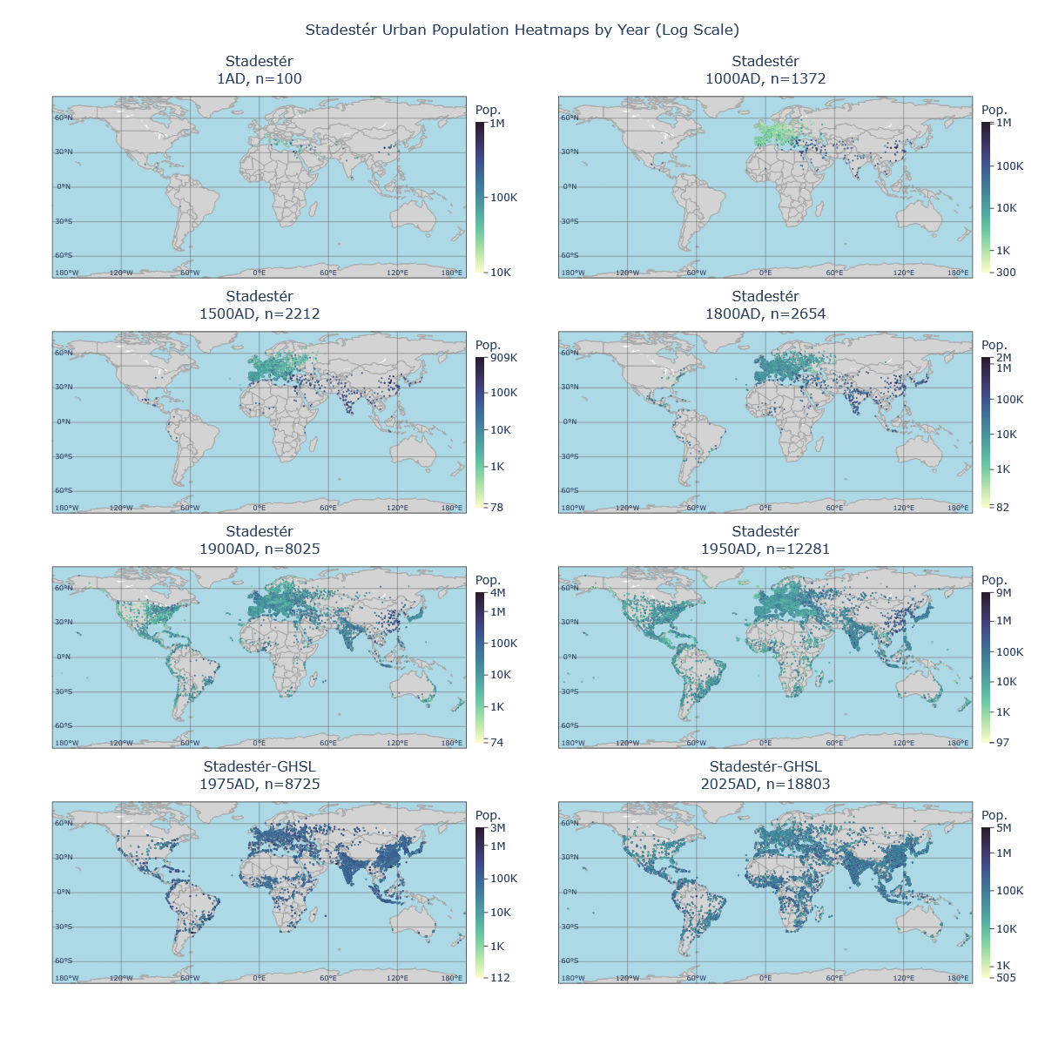
Figure 40. Urban gridcell heatmap for selected benchmark years in Stadestér-GHSL, metro adjusted (1AD-2025AD).

Historical maps and data have been constructed for urban, rural, and total populations and estimates, including discrete city-by-city objects in JSON format, for all ~41.000 cities. In addition, maps are at a consistent 5-arcmin resolution with global coverage, and are generated at 1000-year intervals from 10000BC-1AD, at 100-year intervals from 1AD-1700AD, at 10-year intervals from 1700AD-1950AD, and at 1-year intervals annually since to the Present (2025AD). All raster series are available from 10000BC-2025AD.

This was chosen to match the resolution provided by HYDE so that Stadestér could act as a supplement/alternative to its data, particularly for urban areas. Discontinuities between Stadestér Base and Stadestér-GHSL are deliberately smoothed over by performing a partial union for Stadestér Base data, where if a particular pixel is empty, base data is used to write to that pixel instead.

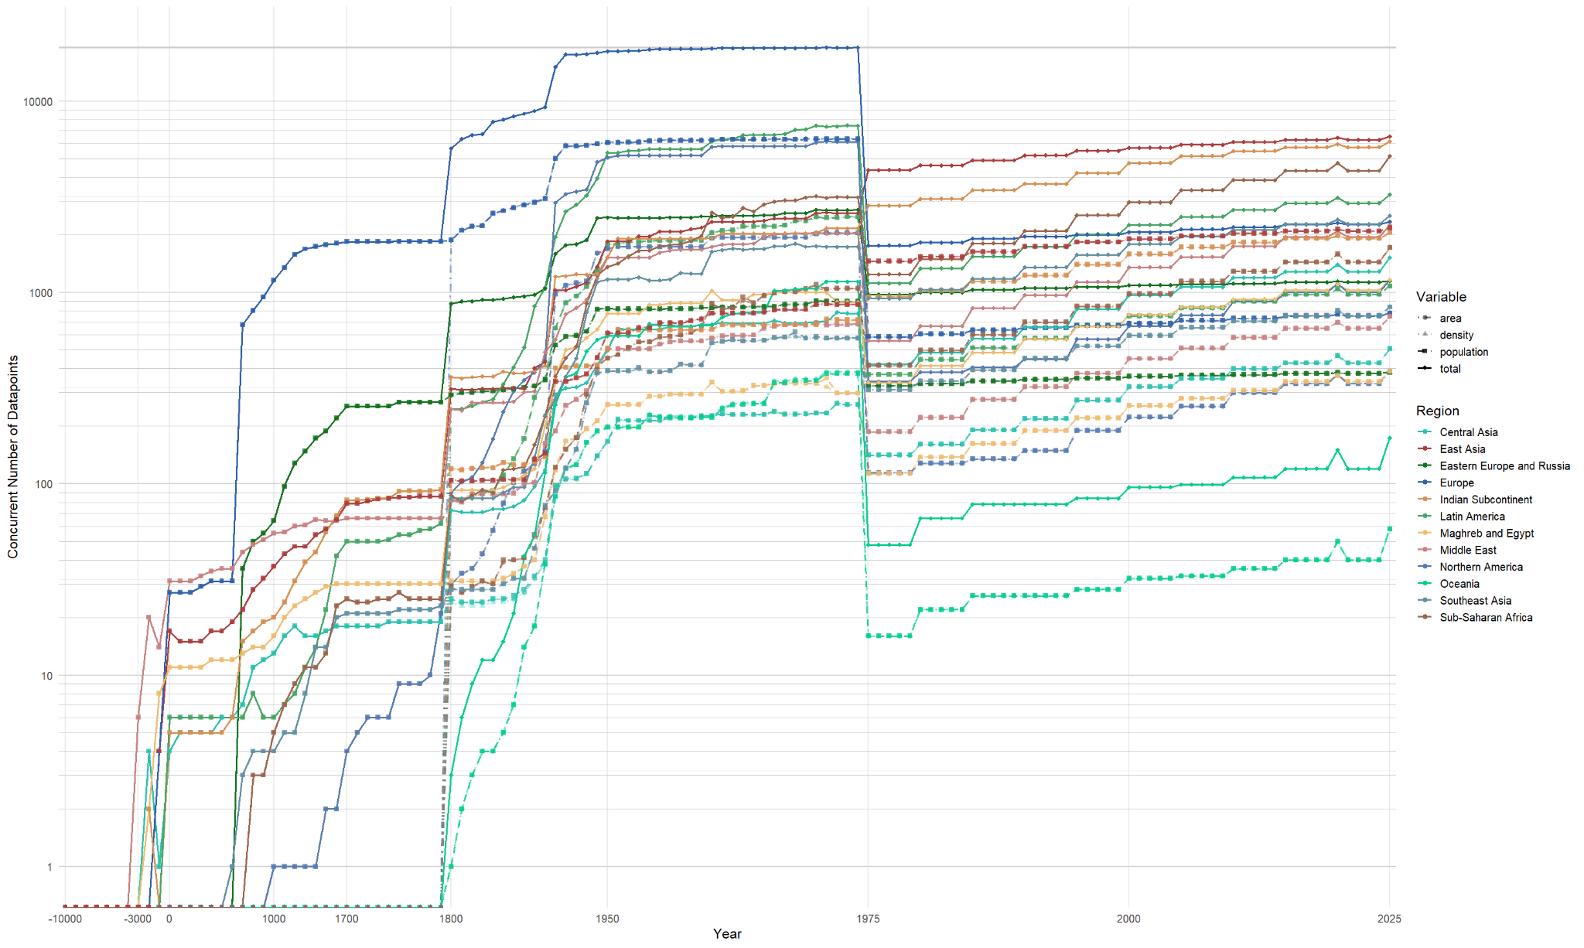

Figure 41. Number of datapoints for area/density/population per world region (3000BC-2025AD).

In terms of discrete cities, data on area, density, and population is provided at annual resolution, especially after 1800AD, and are matched to modern satellite-based data from GHSL post-1975AD. Input models such as that used for LUH2/KK10 are presented separately and given in supplemental materials. 30.019 of these cities are given in Stadestér Base and a additional 11.195 in Stadestér-GHSL, making this dataset a nearly 17-24x increase in size over previous peer datasets such as Reba et al.

For comparison, the UN WUP includes only 1.860 settlements, though these are filtered for urban areas with a population >300.000, and only to 2018AD, whereas our data runs until 2025AD (albeit using GHSL projections) [UN WUP 2018]. There is a qualitative difference too - it encodes areal as well as density proxies, even if these proxies are intrinsically modelled for periods prior to 1975AD.

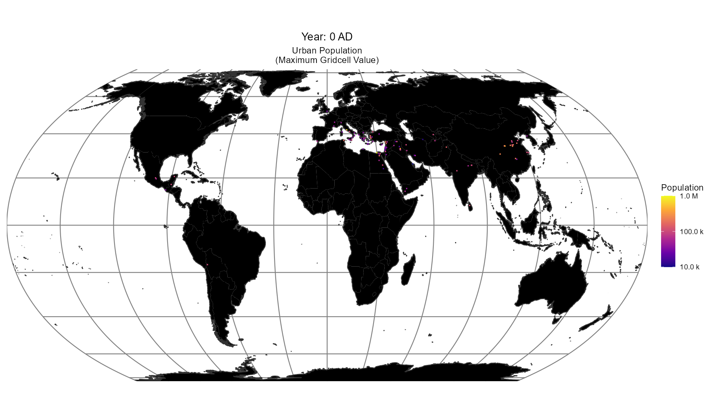 | 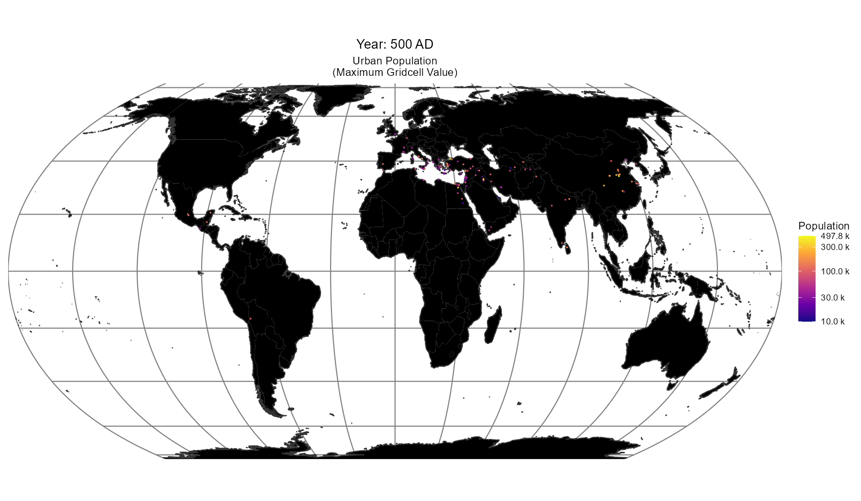
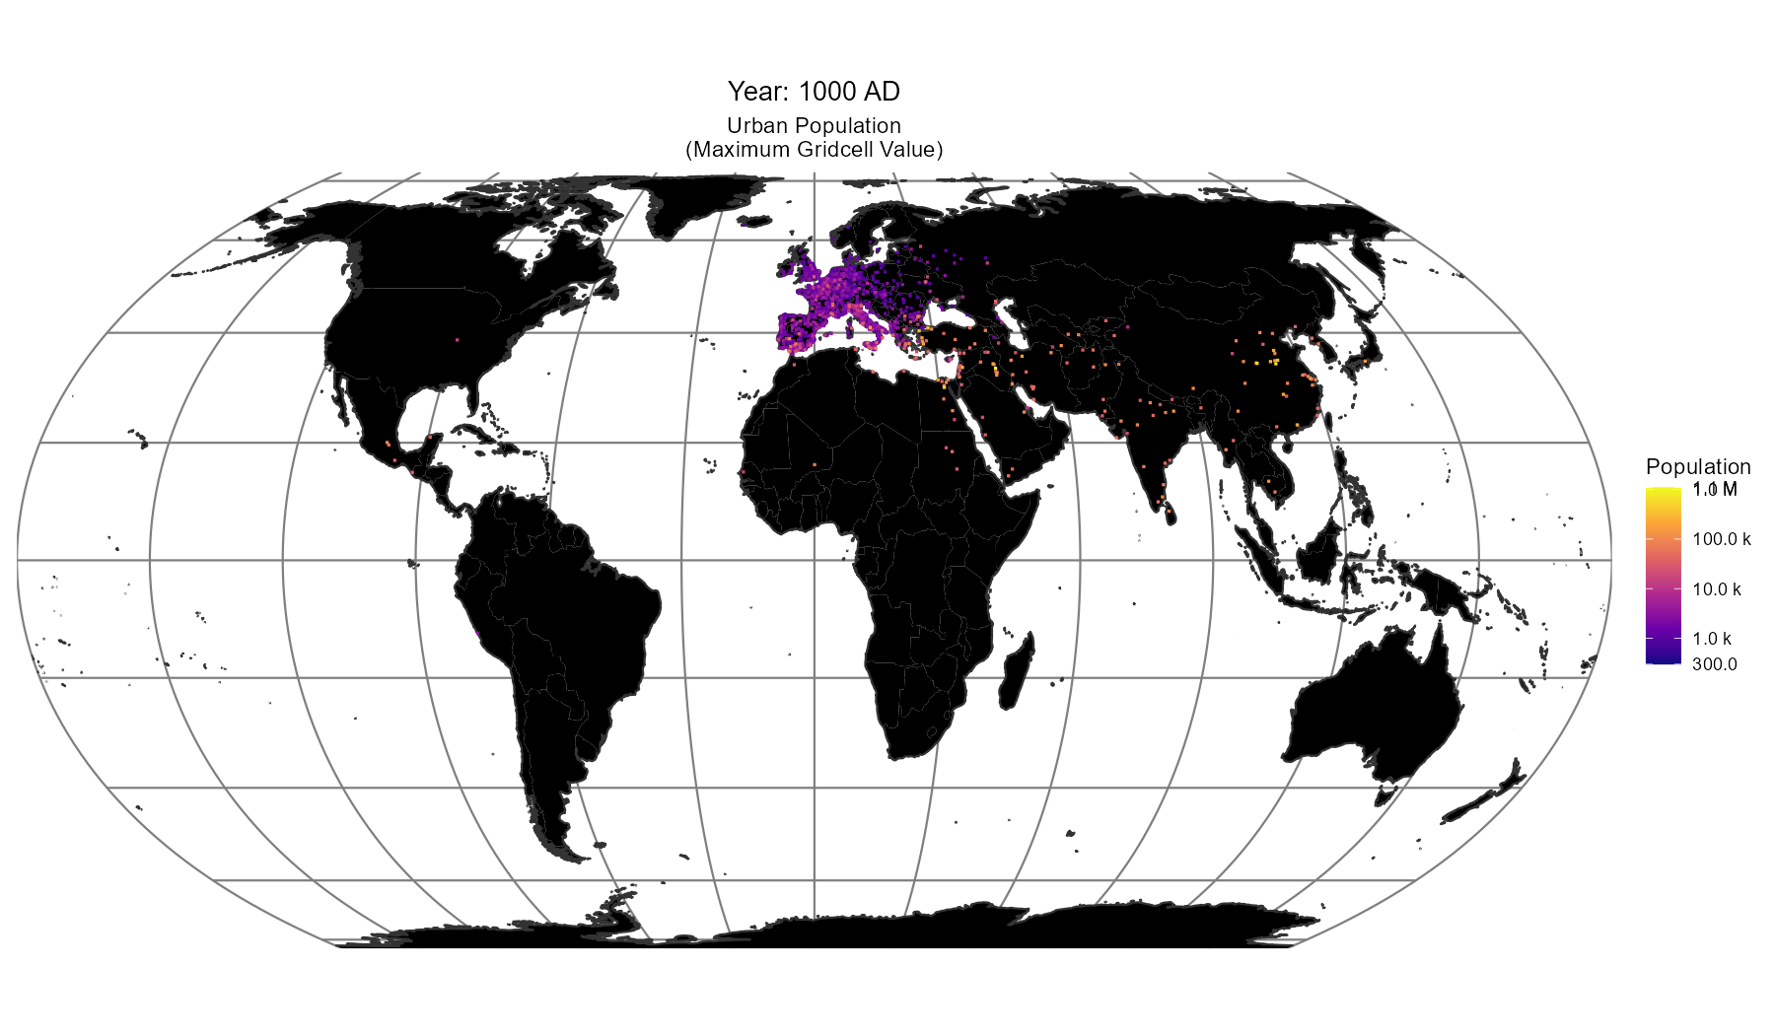 | 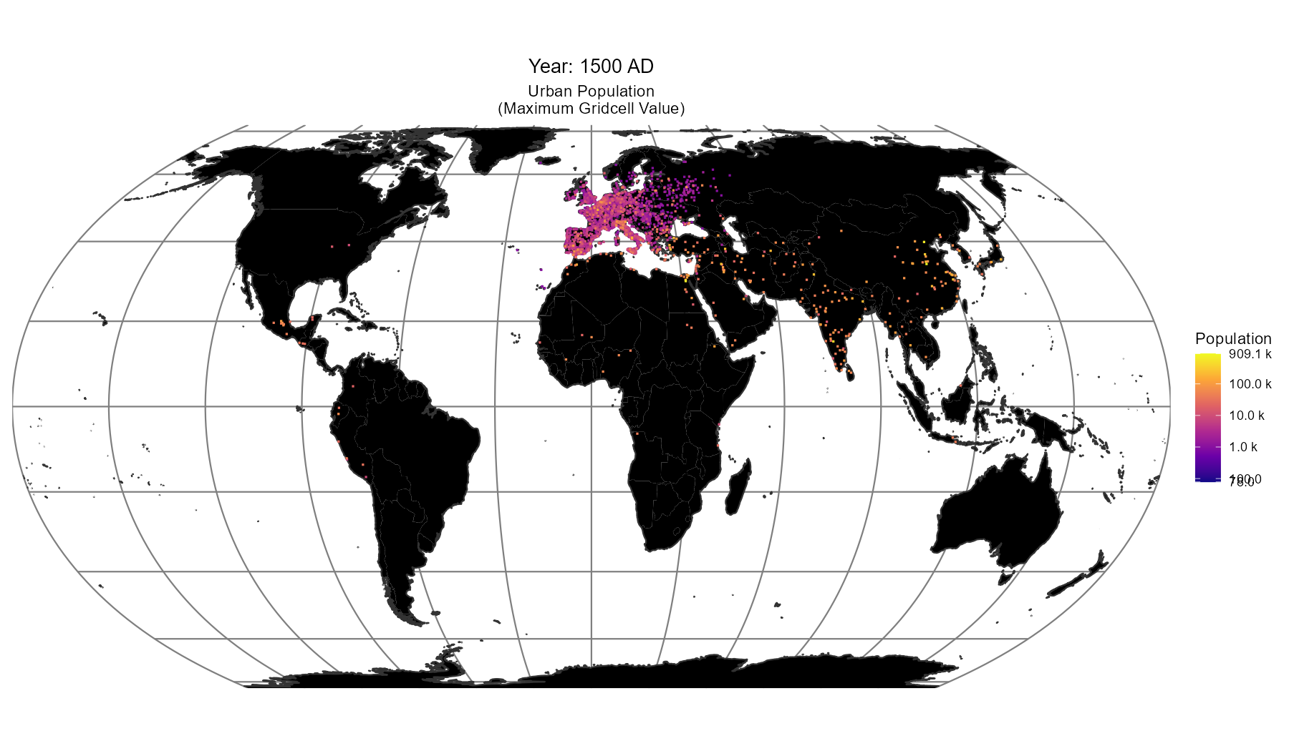
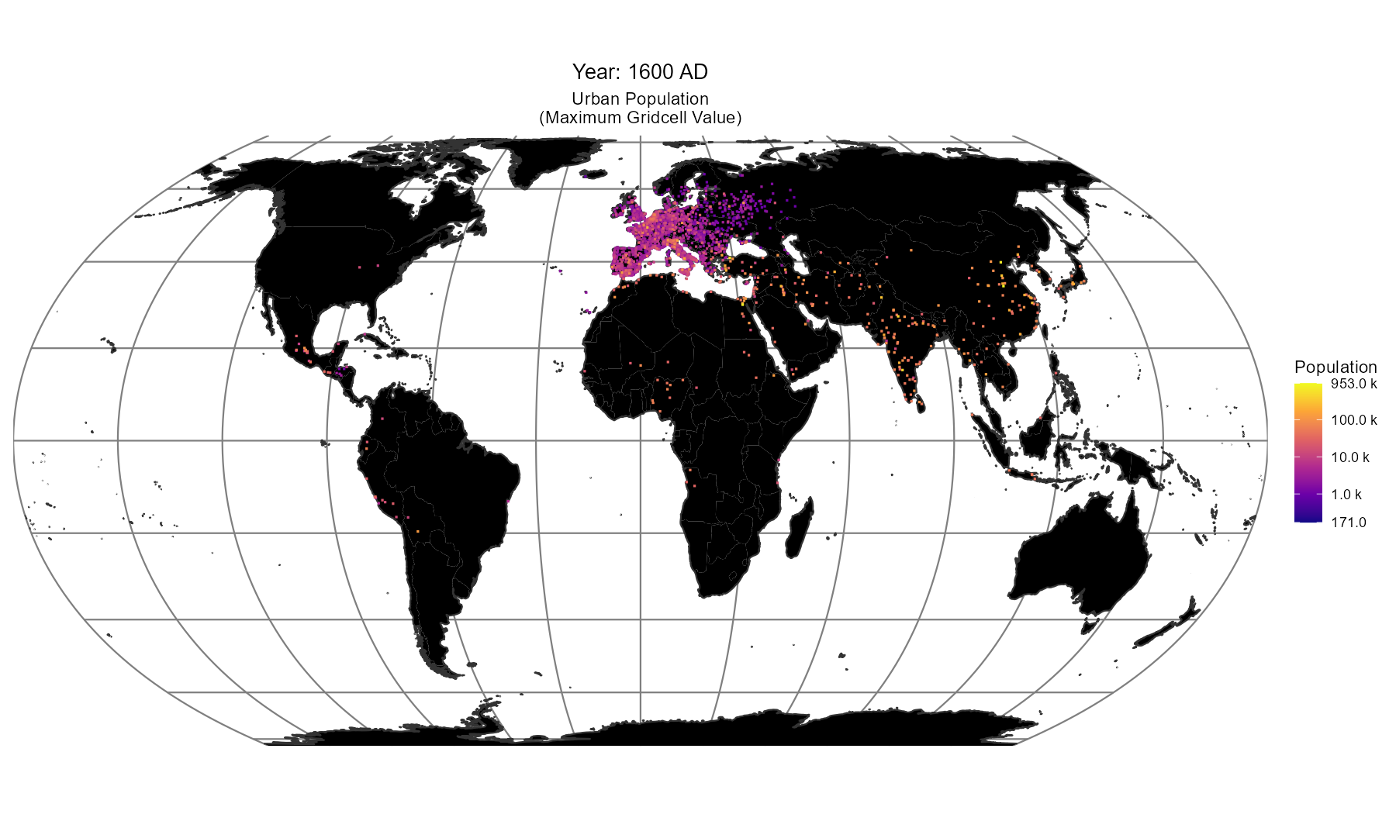 | 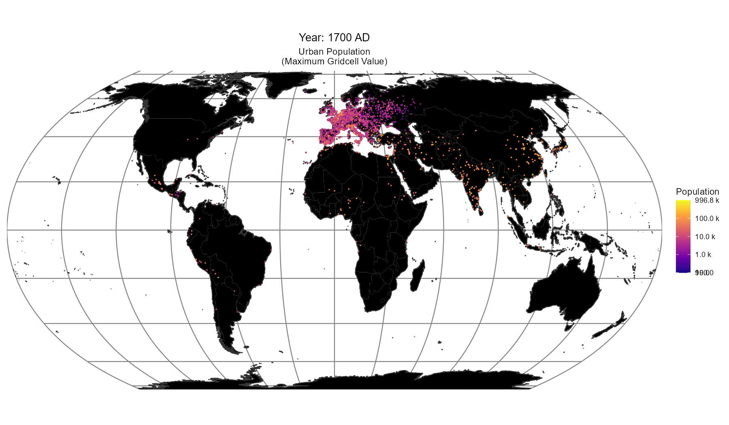
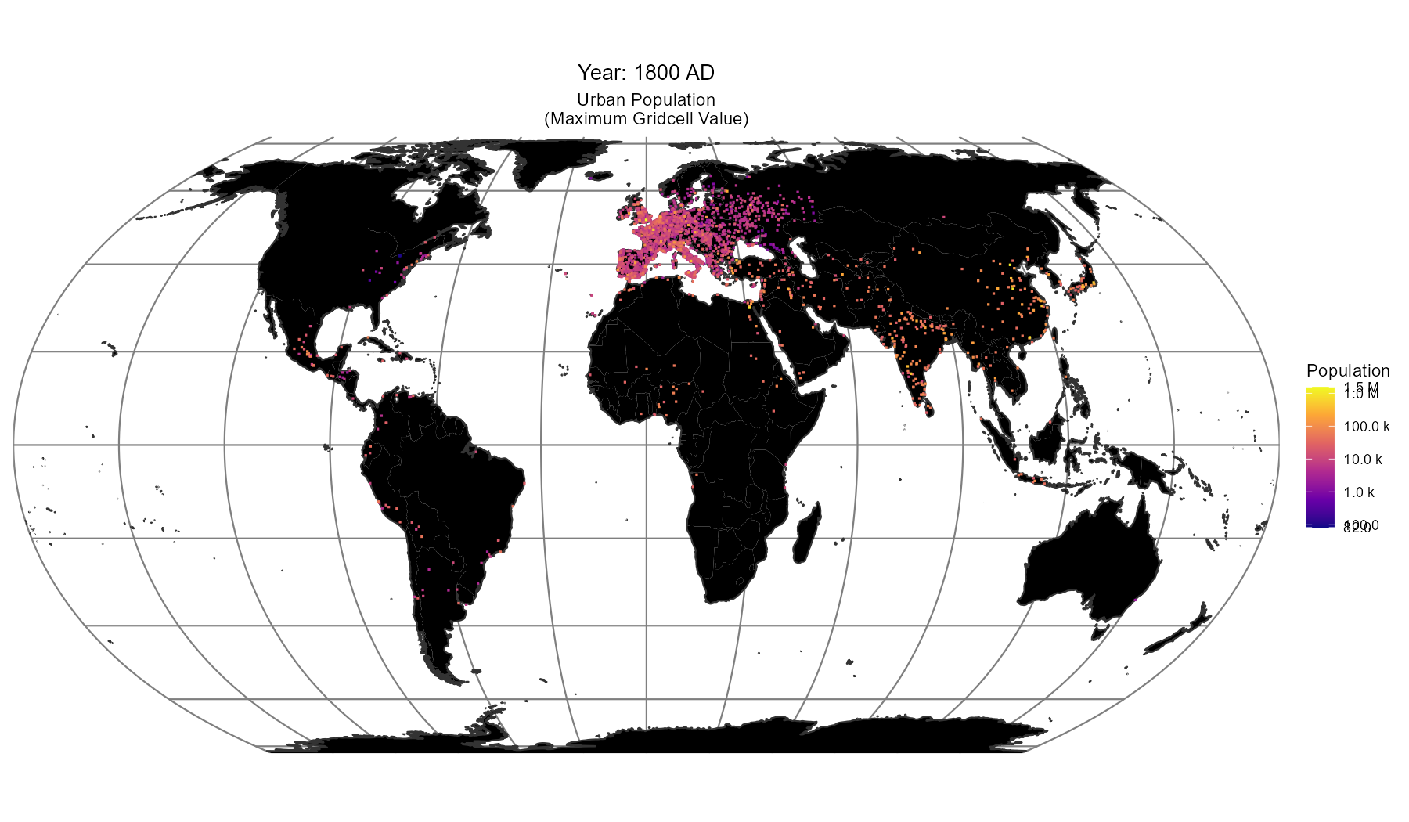 | 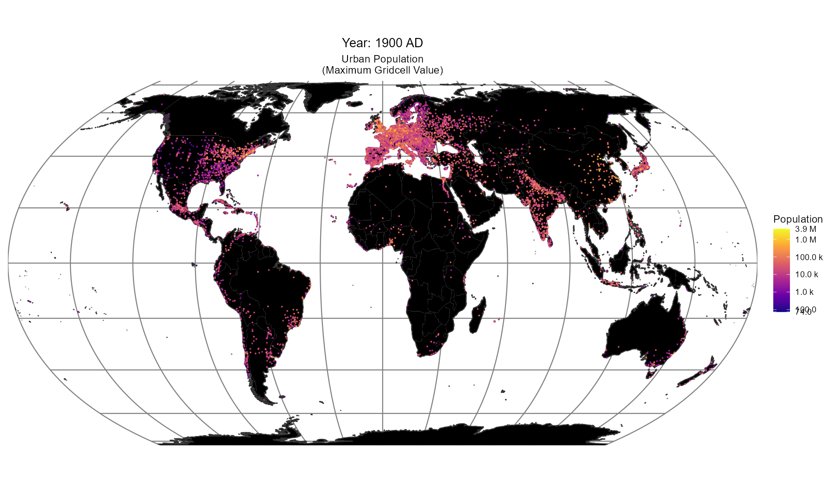

Figure 42. Urban population heatmaps from generated rasters for selected benchmark years (1AD-1900AD).

Certainly we hope that plenty of the internal models as used in the construction of this dataset will be useful to others. There are for instance, a great deal of hindcast models for historical urban expansion [Haslauer et al][Uhl et al][Goldstein et al]. We would like to think that our model of historical forecasting is a somewhat original and more generally-applicable choice since it allows for out-of-sample testing and is generally applicable to all locations so long as a population history of that place exists.

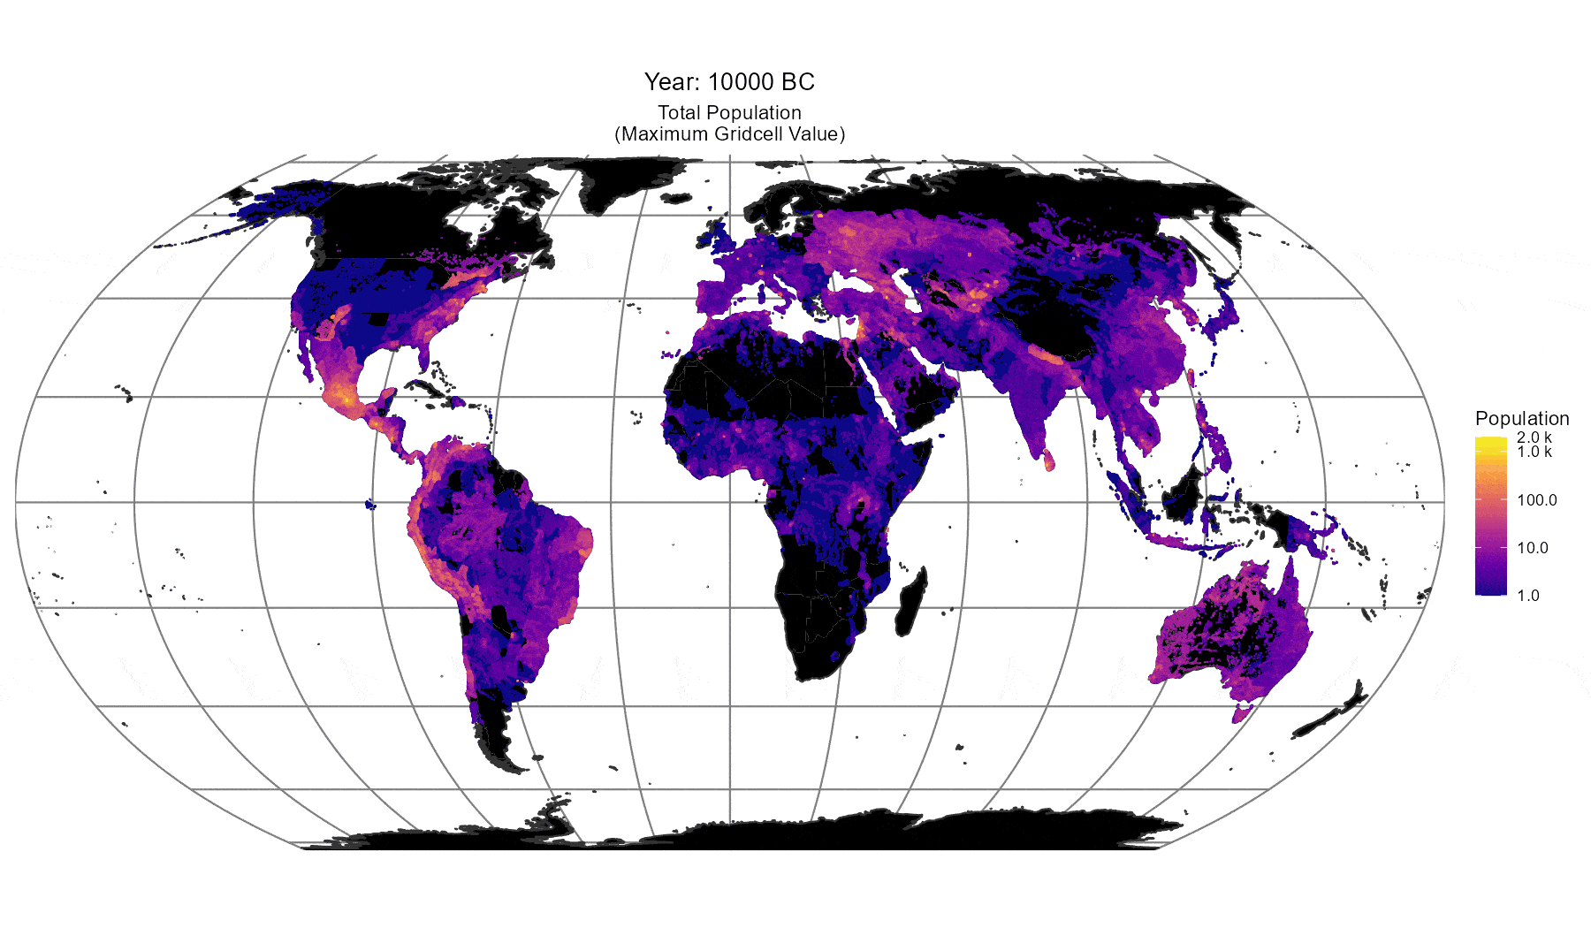

Figure 43. Animated heatmap of global population as modelled by Stadestér (10000BC-2025AD).

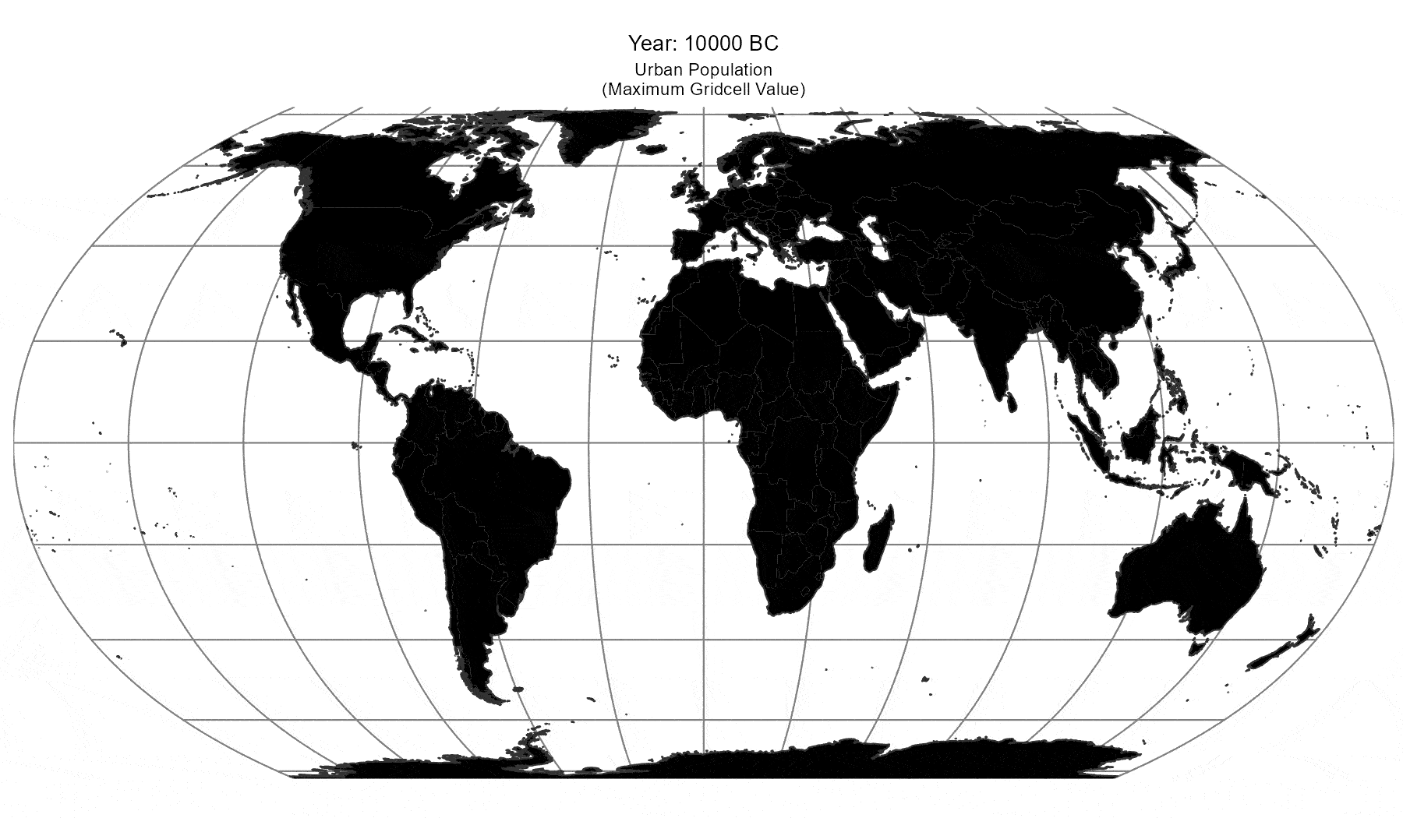

Figure 44. Animated heatmap of urban populations as modelled by Stadestér (10000BC-2025AD).

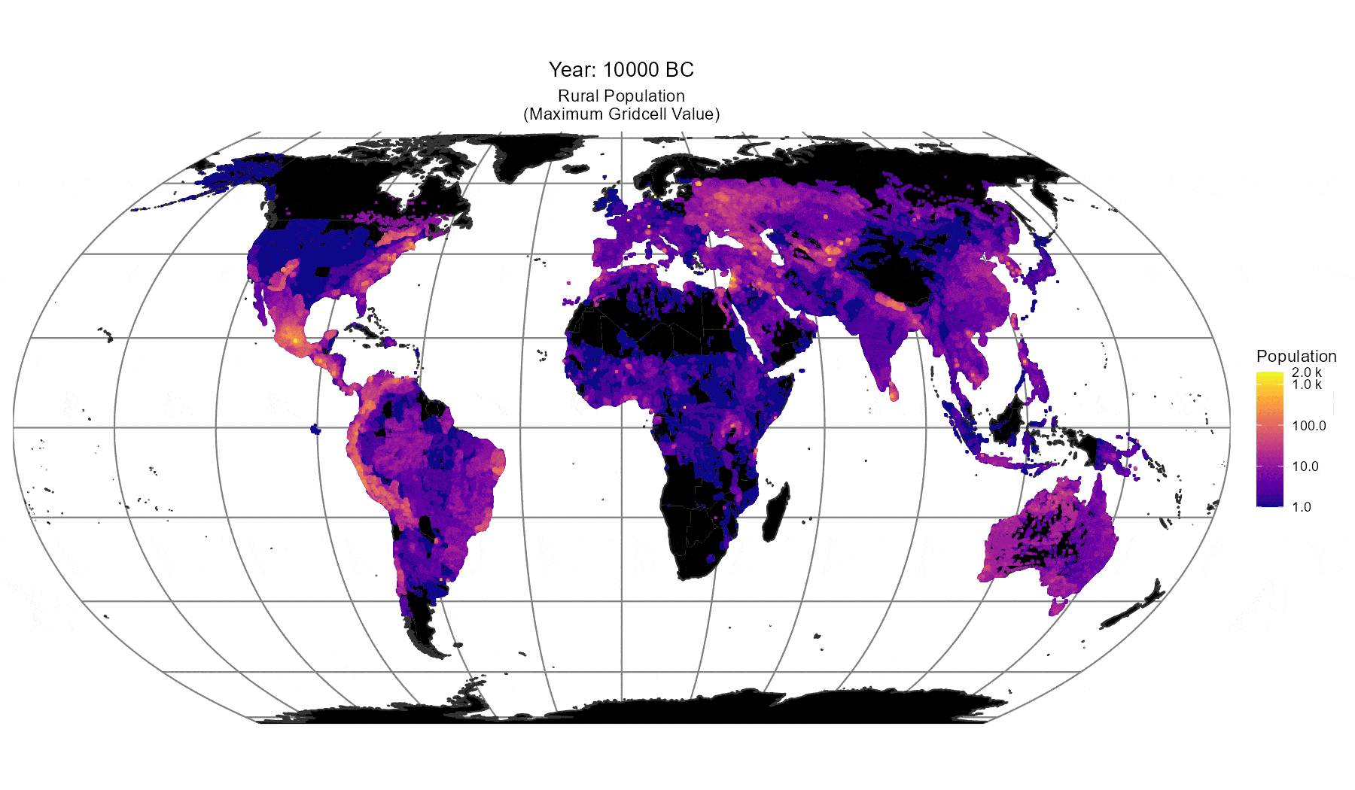

Figure 45. Animated heatmap of rural and peri-urban populations as modelled by Stadestér (10000BC-2025AD).

We have also produced time-series animations of Stadestér’s models of total population (Figure 43), urban population (Figure 44), and rural population (Figure 45) to help visualise population changes, the R code for which is included in the source repository. Note that scales are relative to the minimum and maximum populations of all cells for that specific year. If these animations do not render on your device, consider clicking on the link by Figure n.

Additionally, Stadestér is granular enough such that it is capable of visualising losses in urbanisation due to historical events such as plagues or wars, should their effects be pronounced enough, such as those of the Tokaido Belt during World War II or the depopulation of Central Europe in the Thirty Years’ War become visually apparent [PAA Confex][Gierok p. 14-15]. We would like to caution, however, that such data is not fine-grained enough for population analysis at a yearly-resolution, but only the event as a whole.

It is of course always possible that some better project than this exists for the same purpose outside of the sources we have named here. However, to our knowledge, this is the largest extant historical dataset for urban, rural, and global population. Regional gridded datasets (i.e. for China, Spain, or the United States) also exist, but are typically focused only on the recent past (1700s/1800s-2025AD) [Zhang et al][Goerlich][Ahn et al].

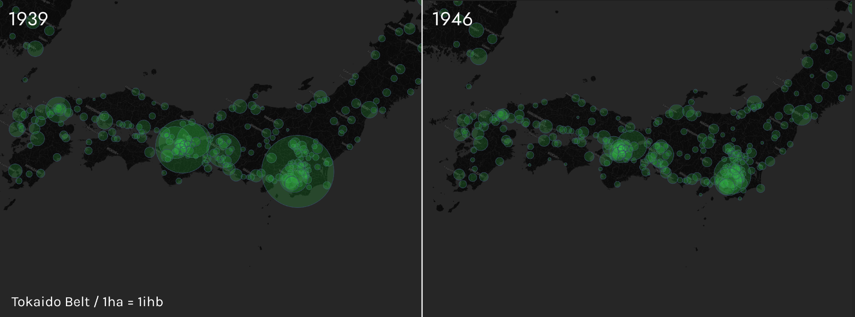

Figure 46. Map of urban population shrinkage in the Tokaido Belt during World War II, Stadestér (1939AD, 1946AD).

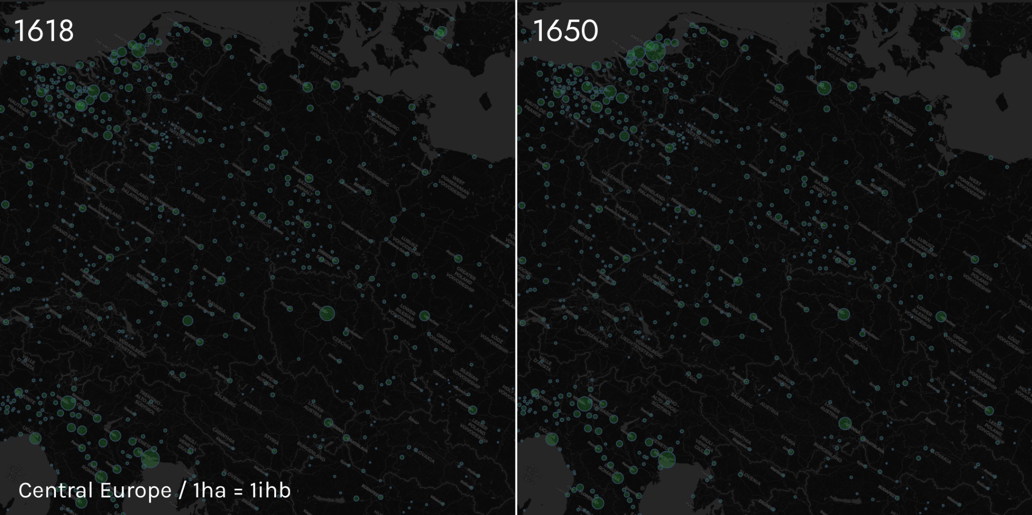

Figure 47. Map of urban population shrinkage in Central Europe due to the Thirty Years’ War, Stadestér (1618AD, 1650AD).

The contents of Stadestér as a complete dataset are as follows, excluding raw input and intermediate data, which is also provided in the appendix. An asterisk denotes a dataset which is available at the HYDE resolution previously discussed, whereas no asterisk indicates annual 1-year resolution.

- Global Population Rasters (~10000BC-2025AD)*
- Global Rural Rasters (~10000BC-2025AD)*
- Global Urban Rasters (~3000BC-2025AD)*

- Metro-adjusted (GHSL), JSON and Rasters
- Metro-adjusted (Non-GHSL), JSON and Rasters
- Non-metro adjusted (GHSL), JSON and Rasters
- Non-metro adjusted (Non-GHSL), JSON and Rasters

For most users of our dataset interested in the distribution of urban population, we recommend utilising the main metro-adjusted Stadestér-GHSL version of our data, whereas non-metro adjusted versions are preferable for discrete urban population histories. JSON files include area and density proxies.

Limitations

A brief retelling of our flaws and faults are in order. With a database as vast as this, it has obviously proven a great challenge to systematically flag every stray pixel or population result, and there may exist the occasional edge case for merging or scraping logic, which mainly uses concurrent distance-based clustering in a literal sense [van de Velden et al].

The most significant outliers we discovered in our manual copychecking of the dataset are as follows:

- The overstatement of the population of Barrow, Alaska in 1900AD (where it is listed as ~53.000), when the population should be no more than 658 [Rogers p. 3],
- An overlooked outlier mask for Jakarta in our population rasters which causes anachronistically high population for the region due to HYDE (though this is not present in our principal urban datasets),
- Bristol being duplicated after 1500AD due to the incorrect coordinates being transcribed for the city for de Vries,
- Cincinnati being registered as a city prior to 1800AD with 10.000 inhabitants due to errors with Reba et al’s transcription, as the Fort Ancient culture was not known to be in the immediate vicinity of the city [Moore],
- Certain scraping issues with individual British nations (i.e. Scotland, Wales, Northern Ireland) for Populstat, sometimes resulting in their exclusion. This had to be manually fixed.

What can we learn from the outliers we encountered in our research? We can at least infer that their qualitative nature should tell us that outliers in Stadestér are generally not as severe as those found in HYDE/Reba et al, and that more importantly, they are not meaningful enough to affect the overall distribution of regional population. This is also quantitatively likely to be the case (Margins of Error).

Known Inaccuracies

There are also several regional inaccuracies present within the KK10/LUH2 fallback model that we used for Stadestér Rural where outliers were present. These mainly come down to overestimations of population in historically sparse areas, and we feel the need to disclose them here since we have not yet begun the task of reliably calibrating their regional populations.

Only Siberia is seriously affected by this issue (having an erroneous pre-Russian population of 4M as compared to ~900k-1,2M), but there may be smaller regional pockets in which ahistorically high populations may persist. The root of the problem is due to imprecision in our OCR/graph extraction software (due to clumping and zoning issues) regarding Nelson as opposed to any issues with the technique itself [Taghva et al].

Additionally, our work on modelling Native American populations is preliminary and should be treated as such, though it represents a likely improvement over HYDE or other historically gridded population models.

Metro-Adjustment Algorithms

One must also be careful in how the spatial disaggregation of otherwise agglomerative effects should be interpreted, since formal metropolitan administrative divisions do not always neatly align with agglomerations. Suburbs and the metros they belonged to were determined via semantic analysis of Populstat tables after proximity merging.

Because of WGM merging (Definition 2), populations in metro-adjusted datasets when analysed discretely (instead of as a raster) may fluctuate heavily year-by-year, and this must be kept in-mind when using the non-raster data from the recommended dataset. Additionally, agglomerative definitions are quite subjective, even if Lahmeyer typically encoded such relations based on modern census definitions [Bosker et al. p. 7].

Conclusion

‘Most of the books and papers mentioned so far have been written by people who were not trained as historical demographers … this is not chance: very few [...] are interested in population figures except at a parochial level. What they like best is writing papers - long papers, on small subjects, with no conclusions’. - McEvedy and Jones (p. 358).
Much work remains to be done. In particular, we wish to embark on a systematic reassessment of Chandler and Modelski, whose ‘issues … are well known to scholars of urban and demographic history. And so, ‘What can be done?’. The answer is naturally to build a better dataset, starting with the cities of antiquity, yet such work has not been achieved in the archaeological field [Fernández-Götz and Smith p. 240].

We hope that Stadestér 1.0 represents at least a stepping stone on that path towards better data, and we encourage the reader to embark on this great compilation of data, with a reputable source or estimate for each figure, for we are amateurs too.

There are also additional supplemental datasets that we have linked in the appendix for your use - Velkscala 0.7 which we mentioned in our rural substrata modelling, as well as Eoscala 1.2 which contains gridded GDP PPP estimations per gridcell based on Maddison Project and Global GDP disaggregation, LU/Population variables, and rolling OLS regression. Eoscala 1.2 is currently a pilot project, and so we would advise one to avoid it until future work on Velkscala 1.0/Eoscala 1.5 can be achieved [Kätzchen].

Production repositories for both Constele Red and Stadestér are located on GitHub if one is inclined to use the latest versions of each dataset/application [Constele Red][Stadestér]. To reproduce these results from original input datasets, call console generateMetroCorrectedBase() or console generateNonMetroCorrectedBase() depending on the version you would like to reproduce. We also provide static mirror versions of both Constele Red and Stadestér 1.0 as-is for end-use if you do not feel like manually installing or configuring dependencies.

It is highly unlikely that this body of work will ever amount to much in interest or profit, apart from perhaps saving some poor researcher in the next century a couple of months. And if that is the case, then we are glad to have done it.

Appendix

Sources

[WIP] - Recall that some of the tables need to have their sources properly cited in their respective columns.

- urban modeling- angel, bairoch, clark, paiscuti & chase dunn, stanilov & sykora, GHS-POP
- urban data- chandler, modelski, reba et al, populstat, devries, buringh, GHSL, wikipedia + nominatim/OSM/ancient locations/google maps for geolocation
- rural data- HYDE3.3/3.2, kaplan & krumhardt + LUH2, mcevedy and jones, denevan, snow, alchon, thornton, peros, milner
- some regional calibration for rural data came from HYDE/OWID/nelson
- global population - [1] Woytinski and Woytinski 1950, Winkler-Prins 1950, Clark 1967 Lower, Clark 1967 Upper, Tuve 1970, Winkler Prins 1970, McEvedy and Jones 1978, Durand 1974 Lower, Durand 1974 Upper, Durand 1977 Lower, Durand 1977 Upper, McEvedy and Jones 1978, Biraben 1980, Richards 1980, Griger 1980, Merrick et al. 1986, Eric 1987, Bogue 1985, Demeny 1988, Stern K. 1990, United Nations 1990, WRI 1990, Kapitsa 1997, Liu and Jiang 1997, Kremer 1993, Klein Goldewijk and Battjes 1995, Maddison 2001, PRB 1973-2016, HYDE 2010-2020, UN 2015, UN 2019-2023, US Census Bureau 2017, Macrotrends 2025, and Gapminder were principally used as the main sources of estimation for global population over the long run, subject to geometric mean merging over their respective domains.

Footnotes and Technical Sources.
[WIP] - Links to files and repositories about here

Note that tables below treat Stadestér Base and GHSL cities separately, meaning that if a city only has population entries after 1975AD, it is highly likely to belong to GHSL rather than Stadestér Base.

Actual raster data (i.e. in Stadestér Urban) treats both cases as persistent.

[◼] GHSL / [◼] Stadestér Base. Population figures are given in thousands.

 | Name |  | Population |  |  |  |  |  |  |  | Max. (km^2)
# | Current | Hist. | 0 | 1000 | 1500 | 1800 | 1900 | 1950 | 1975 | 2025 | Area | Density
1 | Karachi |  | 0 | 0 | 0 | 0 | 0 | 0 | 4.538 | 21.032 | 834 | 25.218
2 | Lahore; Sheikhupura; Ferozewala |  | 0 | 0 | 0 | 0 | 0 | 0 | 4.315 | 14.305 | 898 | 15.930
3 | Kabul; Paghman |  | 0 | 0 | 0 | 0 | 0 | 0 | 723 | 6.255 | 371 | 16.859
4 | Faisalabad |  | 0 | 0 | 0 | 0 | 0 | 0 | 1.075 | 5.677 | 326 | 17.413
5 | Rawalpindi; Islamabad |  | 0 | 0 | 0 | 0 | 0 | 0 | 794 | 4.914 | 550 | 8.934
6 | Tashkent |  | 0 | 0 | 0 | 0 | 0 | 0 | 2.155 | 3.875 | 598 | 6.479
7 | Drigh Road Cantonment |  | 0 | 0 | 0 | 0 | 114 | 1.005 | 0 | 0 | 473 | 13.924
8 | Peshawar |  | 0 | 0 | 0 | 0 | 0 | 0 | 778 | 3.497 | 508 | 6.885
9 | Gujranwala |  | 0 | 0 | 0 | 0 | 0 | 0 | 749 | 3.109 | 231 | 13.458
10 | Multan |  | 0 | 0 | 0 | 0 | 0 | 0 | 778 | 2.970 | 268 | 11.710
11 | Hyderabad; Kotri |  | 0 | 0 | 0 | 0 | 0 | 0 | 874 | 2.956 | 144 | 20.531
12 | Almaty |  | 0 | 0 | 0 | 0 | 0 | 0 | 858 | 2.316 | 331 | 6.996
13 | Lahore | Lahaur, Lâhawr | 0 | 0 | 254 | 80 | 200 | 832 | 0 | 0 | 265 | 17.474
14 | Sialkot |  | 0 | 0 | 0 | 0 | 0 | 0 | 445 | 1.831 | 180 | 11.723
15 | To`skent | Tashkent, Ta`skent, Toshkent | 0 | 0 | 0 | 0 | 160 | 710 | 0 | 0 | 163 | 34.036
16 | Tashkent |  | 0 | 0 | 0 | 30 | 178 | 787 | 0 | 0 | 213 | 16.503
17 | Herat |  | 0 | 0 | 0 | 0 | 0 | 0 | 184 | 1.489 | 88 | 16.922
18 | Dushanbe |  | 0 | 0 | 0 | 0 | 0 | 0 | 482 | 1.472 | 183 | 8.242
19 | Bishkek |  | 0 | 0 | 0 | 0 | 0 | 0 | 565 | 1.428 | 198 | 7.213
20 | Mardan |  | 0 | 0 | 0 | 0 | 0 | 0 | 181 | 1.291 | 215 | 6.978
21 | Shymkent |  | 0 | 0 | 0 | 0 | 0 | 0 | 242 | 1.240 | 240 | 5.165
22 | Sargodha |  | 0 | 0 | 0 | 0 | 0 | 0 | 374 | 1.128 | 82 | 15.275
23 | Astana |  | 0 | 0 | 0 | 0 | 0 | 0 | 225 | 1.128 | 163 | 6.921
24 | Ashgabat |  | 0 | 0 | 0 | 0 | 0 | 0 | 226 | 1.079 | 123 | 8.771
25 | Mingora; Saidu Sharif |  | 0 | 0 | 0 | 0 | 0 | 0 | 149 | 973 | 112 | 10.224
26 | Quetta |  | 0 | 0 | 0 | 0 | 0 | 0 | 213 | 969 | 151 | 6.455
27 | Namangan |  | 0 | 0 | 0 | 0 | 0 | 0 | 161 | 928 | 231 | 4.017
28 | Samarqand |  | 0 | 0 | 0 | 0 | 0 | 0 | 364 | 893 | 219 | 4.076
29 | Kandahar |  | 0 | 0 | 0 | 0 | 0 | 0 | 89 | 873 | 92 | 9.486
30 | Faisalâbâd | Lâyalpur, Lyallpur | 0 | 0 | 0 | 0 | 0 | 168 | 0 | 0 | 135 | 14.901
31 | Sukkur |  | 0 | 0 | 0 | 0 | 0 | 0 | 220 | 826 | 62 | 13.399
32 | Almaty | Alma-Ata, Dzhetysu, Vjernyj, Werny | 0 | 0 | 0 | 0 | 24 | 291 | 0 | 0 | 100 | 18.162
33 | Gujrat |  | 0 | 0 | 0 | 0 | 0 | 0 | 235 | 802 | 68 | 12.004
34 | Abbottabad |  | 0 | 0 | 0 | 0 | 0 | 0 | 123 | 801 | 107 | 8.158
35 | Andijon |  | 0 | 0 | 0 | 0 | 0 | 0 | 217 | 793 | 183 | 4.333
36 | Nowshera |  | 0 | 0 | 0 | 0 | 0 | 0 | 100 | 772 | 119 | 6.488
37 | Fergana; Margilan |  | 0 | 0 | 0 | 0 | 0 | 0 | 173 | 759 | 216 | 3.516
38 | Bahawalpur |  | 0 | 0 | 0 | 0 | 0 | 0 | 224 | 739 | 83 | 9.394
39 | Mazar i sharif |  | 0 | 0 | 0 | 0 | 0 | 0 | 230 | 738 | 61 | 12.096
40 | Sahiwal |  | 0 | 0 | 0 | 0 | 0 | 0 | 191 | 694 | 77 | 10.683
41 | Taxila; Wah |  | 0 | 0 | 0 | 0 | 0 | 0 | 55 | 693 | 140 | 5.075
42 | Jhang |  | 0 | 0 | 0 | 0 | 0 | 0 | 327 | 485 | 56 | 13.467
43 | Okara |  | 0 | 0 | 0 | 0 | 0 | 0 | 183 | 679 | 36 | 19.619
44 | Mansura | Brahmanabad | 0 | 65 | 65 | 65 | 111 | 344 | 0 | 0 | 61 | 34.176
45 | Rahim Yar Khan |  | 0 | 0 | 0 | 0 | 0 | 0 | 0 | 653 | 66 | 11.155
46 | Bannu |  | 0 | 0 | 0 | 0 | 0 | 0 | 98 | 637 | 163 | 6.331
47 | Larkana |  | 0 | 0 | 0 | 0 | 0 | 0 | 171 | 634 | 36 | 18.972
48 | Kabul | Kâbol | 0 | 0 | 25 | 51 | 70 | 169 | 0 | 0 | 72 | 22.167
49 | Jalalabad |  | 0 | 0 | 0 | 0 | 0 | 0 | 62 | 618 | 122 | 5.546
50 | Kasur |  | 0 | 0 | 0 | 0 | 0 | 0 | 236 | 553 | 36 | 17.607
51 | Hyderâbâd | Haiderâbâd | 0 | 0 | 0 | 0 | 68 | 230 | 0 | 0 | 60 | 17.435
52 | Qaraghandy | Karaganda | 0 | 0 | 0 | 0 | 0 | 281 | 0 | 0 | 46 | 15.218
53 | Multân | Mooltan | 0 | 0 | 34 | 30 | 86 | 232 | 0 | 0 | 61 | 23.151
54 | Swabi |  | 0 | 0 | 0 | 0 | 0 | 0 | 0 | 524 | 105 | 5.266
55 | Dera Ghazi Khan |  | 0 | 0 | 0 | 0 | 0 | 0 | 83 | 508 | 64 | 15.352
56 | Qarshi |  | 0 | 0 | 0 | 0 | 0 | 0 | 132 | 512 | 149 | 3.551
57 | Shahkot; Khurrianwala |  | 0 | 0 | 0 | 0 | 0 | 0 | 0 | 504 | 73 | 7.680
58 | Osh |  | 0 | 0 | 0 | 0 | 0 | 0 | 254 | 481 | 84 | 5.777
59 | Bi`skek | Bishkek, Frunze, Pishpek | 0 | 0 | 0 | 0 | 8 | 156 | 0 | 0 | 69 | 15.010
60 | Mansehra |  | 0 | 0 | 0 | 0 | 0 | 0 | 82 | 474 | 84 | 7.807
61 | Kohat |  | 0 | 0 | 0 | 0 | 0 | 0 | 81 | 465 | 67 | 6.947
62 | Shabqadar |  | 0 | 0 | 0 | 0 | 0 | 0 | 0 | 454 | 126 | 6.927
63 | Karâchi (agglomeration) |  | 0 | 0 | 0 | 0 | 20 | 0 | 0 | 0 | 7 | 401.910
64 | Jhelum |  | 0 | 0 | 0 | 0 | 0 | 0 | 71 | 433 | 52 | 9.231
65 | Sadiqabad |  | 0 | 0 | 0 | 0 | 0 | 0 | 58 | 433 | 48 | 9.656
66 | Haripur |  | 0 | 0 | 0 | 0 | 0 | 0 | 85 | 432 | 61 | 12.144
67 | Du`sanbe | Dju`sambe, Dushanbe, Dyushambe (until 1929), Stalinabad (1929-1961) | 0 | 0 | 0 | 0 | 0 | 153 | 0 | 0 | 56 | 10.733
68 | Aktobe |  | 0 | 0 | 0 | 0 | 0 | 0 | 110 | 421 | 92 | 4.733
69 | Landhi Korangi |  | 0 | 0 | 0 | 0 | 0 | 0 | 0 | 0 | 25 | 17.003
70 | Hafizabad |  | 0 | 0 | 0 | 0 | 0 | 0 | 121 | 417 | 30 | 15.131
71 | Daska |  | 0 | 0 | 0 | 0 | 0 | 0 | 118 | 408 | 31 | 14.695
72 | Kamoke |  | 0 | 0 | 0 | 0 | 0 | 0 | 115 | 397 | 41 | 13.913
73 | Joharabad; Khushab |  | 0 | 0 | 0 | 0 | 0 | 0 | 80 | 376 | 51 | 12.095
74 | Chiniot |  | 0 | 0 | 0 | 0 | 0 | 0 | 142 | 314 | 21 | 19.903
75 | Charsadda |  | 0 | 0 | 0 | 0 | 0 | 0 | 129 | 384 | 50 | 9.102
76 | Dera Ismail Khan |  | 0 | 0 | 0 | 0 | 0 | 0 | 0 | 382 | 63 | 6.591
77 | Raiwind |  | 0 | 0 | 0 | 0 | 0 | 0 | 0 | 379 | 64 | 10.822
78 | Muzaffargarh |  | 0 | 0 | 0 | 0 | 0 | 0 | 163 | 336 | 62 | 10.239
79 | Pakpattan |  | 0 | 0 | 0 | 0 | 0 | 0 | 123 | 338 | 29 | 17.568
80 | Râwalpindi | Raulpindi | 0 | 0 | 0 | 0 | 86 | 188 | 0 | 0 | 20 | 78.655
81 | Gujrânwâla | Gûjrânwâlah, Gajranwala, Goojranwalla | 0 | 0 | 0 | 0 | 29 | 117 | 0 | 0 | 41 | 17.506
82 | Peshâwar (agglomeration) |  | 0 | 0 | 0 | 0 | 94 | 173 | 0 | 0 | 34 | 16.791
83 | Jizzakh |  | 0 | 0 | 0 | 0 | 0 | 0 | 200 | 357 | 101 | 3.535
84 | Ghazni |  | 0 | 0 | 0 | 0 | 0 | 0 | 355 | 89 | 23 | 17.763
85 | Mirpur Khas |  | 0 | 0 | 0 | 0 | 0 | 0 | 110 | 348 | 29 | 14.216
86 | Khost |  | 0 | 0 | 0 | 0 | 0 | 0 | 0 | 339 | 128 | 3.267
87 | Karaganda |  | 0 | 0 | 0 | 0 | 0 | 0 | 327 | 304 | 63 | 5.643
88 | Takht Bhai; Jalala; Shergarh |  | 0 | 0 | 0 | 0 | 0 | 0 | 0 | 333 | 93 | 7.467
89 | Gojra |  | 0 | 0 | 0 | 0 | 0 | 0 | 92 | 333 | 26 | 13.849
90 | Muridke |  | 0 | 0 | 0 | 0 | 0 | 0 | 106 | 328 | 40 | 10.818
91 | Yar Hussain; Colonel Sher Kalay; Turlandi |  | 0 | 0 | 0 | 0 | 0 | 0 | 0 | 328 | 71 | 6.501
92 | Narowal |  | 0 | 0 | 0 | 0 | 0 | 0 | 68 | 321 | 30 | 14.554
93 | Jaranwala |  | 0 | 0 | 0 | 0 | 0 | 0 | 94 | 318 | 24 | 14.489
94 | Wazirabad |  | 0 | 0 | 0 | 0 | 0 | 0 | 71 | 317 | 45 | 10.297
95 | Burewala |  | 0 | 0 | 0 | 0 | 0 | 0 | 74 | 314 | 40 | 10.114
96 | Taloqan |  | 0 | 0 | 0 | 0 | 0 | 0 | 0 | 307 | 40 | 7.687
97 | Jacobabad |  | 0 | 0 | 0 | 0 | 0 | 0 | 0 | 305 | 27 | 12.255
98 | Mandi Bahauddin |  | 0 | 0 | 0 | 0 | 0 | 0 | 70 | 304 | 34 | 9.742
99 | Nukus |  | 0 | 0 | 0 | 0 | 0 | 0 | 166 | 290 | 74 | 4.049
100 | Nawabshah |  | 0 | 0 | 0 | 0 | 0 | 0 | 91 | 298 | 27 | 11.859
101 | Qoqand |  | 0 | 0 | 0 | 0 | 0 | 0 | 102 | 297 | 81 | 3.662
102 | Pavlodar |  | 0 | 0 | 0 | 0 | 0 | 0 | 195 | 263 | 61 | 5.220
103 | Semey |  | 0 | 0 | 0 | 0 | 0 | 0 | 228 | 292 | 91 | 4.400
104 | Samarqand | Samarkand, Afrosiab, Maracanda | 100 | 80 | 60 | 50 | 60 | 158 | 0 | 0 | 3 | 105.174
105 | Shikarpur |  | 0 | 0 | 0 | 0 | 0 | 0 | 82 | 284 | 18 | 17.755
106 | Shahrisabz |  | 0 | 0 | 0 | 0 | 0 | 0 | 0 | 283 | 87 | 3.257
107 | Khanewal |  | 0 | 0 | 0 | 0 | 0 | 0 | 80 | 275 | 46 | 7.815
108 | Hazro; Ghorghushti |  | 0 | 0 | 0 | 0 | 0 | 0 | 0 | 281 | 73 | 3.879
109 | Symkent | Shymkent, Chimkent, Isfidshab | 0 | 0 | 0 | 0 | 12 | 110 | 0 | 0 | 34 | 17.388
110 | A`sgabat | Ashgabat, A`schabad, Ashkhabad, Poltoratsk (from 1919-1927) | 0 | 0 | 0 | 0 | 25 | 137 | 0 | 0 | 29 | 16.948
111 | Kunduz |  | 0 | 0 | 0 | 0 | 0 | 0 | 227 | 265 | 39 | 11.348
112 | Kostanay |  | 0 | 0 | 0 | 0 | 0 | 0 | 256 | 163 | 42 | 6.640
113 | Râwalpindi Cantonment |  | 0 | 0 | 0 | 0 | 0 | 0 | 0 | 0 | 19 | 15.875
114 | Khanpur |  | 0 | 0 | 0 | 0 | 0 | 0 | 0 | 264 | 28 | 10.974
115 | Urgench |  | 0 | 0 | 0 | 0 | 0 | 0 | 110 | 261 | 66 | 3.959
116 | Aktau |  | 0 | 0 | 0 | 0 | 0 | 0 | 0 | 260 | 53 | 4.896
117 | Dadu |  | 0 | 0 | 0 | 0 | 0 | 0 | 92 | 253 | 16 | 17.160
118 | Semey | Semipalatinsk | 0 | 0 | 0 | 0 | 28 | 127 | 0 | 0 | 23 | 20.994
119 | Muzaffarabad |  | 0 | 0 | 0 | 0 | 0 | 0 | 0 | 237 | 26 | 9.754
120 | Vehari |  | 0 | 0 | 0 | 0 | 0 | 0 | 56 | 241 | 30 | 8.423

Figure 48. Table of the 120 largest cities by maximum population, alongside area/density/population statistics, Central Asia.

[◼] GHSL / [◼] Stadestér Base. Population figures are given in thousands.

 | Name |  | Population |  |  |  |  |  |  |  | Max. (km^2)
# | Current | Hist. | 0 | 1000 | 1500 | 1800 | 1900 | 1950 | 1975 | 2025 | Area | Density
1 | Shenzhen; Guangzhou; Foshan |  | 0 | 0 | 0 | 0 | 0 | 0 | 2.142 | 42.988 | 6.454 | 6.661
2 | Tokyo; Yokohama |  | 0 | 0 | 0 | 0 | 0 | 0 | 24.050 | 33.156 | 5.191 | 6.453
3 | Shanghai |  | 0 | 0 | 0 | 0 | 0 | 0 | 4.557 | 30.679 | 3.128 | 9.808
4 | Seoul; Incheon |  | 0 | 0 | 0 | 0 | 0 | 0 | 10.122 | 22.262 | 2.282 | 12.475
5 | Beijing |  | 0 | 0 | 0 | 0 | 0 | 0 | 5.153 | 18.151 | 2.179 | 8.803
6 | Osaka; Kobe; Kyoto |  | 0 | 0 | 0 | 0 | 0 | 0 | 14.335 | 12.654 | 2.246 | 6.915
7 | Suzhou |  | 0 | 0 | 0 | 0 | 0 | 0 | 1.788 | 11.540 | 1.802 | 6.404
8 | Jieyang |  | 0 | 0 | 0 | 0 | 0 | 0 | 1.304 | 10.579 | 1.961 | 5.395
9 | New Taipei |  | 0 | 0 | 0 | 0 | 0 | 0 | 3.723 | 9.687 | 972 | 9.966
10 | Shanghai | Shang-hai | 100 | 100 | 100 | 93 | 551 | 5.136 | 0 | 0 | 1.198 | 39.973
11 | Chongqing |  | 0 | 0 | 0 | 0 | 0 | 0 | 1.523 | 8.450 | 653 | 12.940
12 | Wuhan |  | 0 | 0 | 0 | 0 | 0 | 0 | 1.729 | 8.079 | 772 | 10.466
13 | Nanjing |  | 0 | 0 | 0 | 0 | 0 | 0 | 1.753 | 8.061 | 1.012 | 7.965
14 | Nagoya |  | 0 | 0 | 0 | 0 | 0 | 0 | 6.087 | 7.722 | 2.401 | 3.355
15 | Tianjin |  | 0 | 0 | 0 | 0 | 0 | 0 | 2.603 | 7.331 | 671 | 11.999
16 | Chengdu |  | 0 | 0 | 0 | 0 | 0 | 0 | 2.806 | 5.610 | 880 | 8.907
17 | Hangzhou |  | 0 | 0 | 0 | 0 | 0 | 0 | 1.110 | 6.387 | 1.547 | 5.497
18 | Sõul | Seoul, Keijo, Kyõngsong | 0 | 0 | 125 | 192 | 211 | 1.537 | 0 | 0 | 785 | 19.512
19 | Shenyang |  | 0 | 0 | 0 | 0 | 0 | 0 | 3.863 | 6.175 | 748 | 11.960
20 | Beijing | Peking, Pei-ching, Peiping, Khanbalik | 0 | 60 | 672 | 1.137 | 1.649 | 2.069 | 0 | 0 | 354 | 68.609
21 | Hefei |  | 0 | 0 | 0 | 0 | 0 | 0 | 1.345 | 5.646 | 606 | 9.317
22 | Xi'an |  | 0 | 0 | 0 | 0 | 0 | 0 | 1.562 | 5.299 | 691 | 7.947
23 | Zhengzhou |  | 0 | 0 | 0 | 0 | 0 | 0 | 976 | 5.126 | 642 | 8.671
24 | Hong Kong |  | 0 | 0 | 0 | 0 | 0 | 0 | 2.876 | 4.808 | 220 | 22.196
25 | Harbin |  | 0 | 0 | 0 | 0 | 0 | 0 | 1.720 | 4.592 | 471 | 9.749
26 | Tôkyô | Edo, Yedo, Yeddo, Tokio | 0 | 0 | 0 | 485 | 889 | 1.623 | 0 | 0 | 302 | 101.447
27 | Tianjin | Tientsin, T'ien-chin | 0 | 0 | 0 | 130 | 930 | 2.089 | 0 | 0 | 578 | 17.103
28 | Taiyuan |  | 0 | 0 | 0 | 0 | 0 | 0 | 778 | 4.332 | 367 | 11.804
29 | Wenzhou |  | 0 | 0 | 0 | 0 | 0 | 0 | 1.968 | 3.838 | 546 | 7.662
30 | Urumqi |  | 0 | 0 | 0 | 0 | 0 | 0 | 941 | 3.974 | 355 | 11.195
31 | Jinan |  | 0 | 0 | 0 | 0 | 0 | 0 | 1.271 | 3.825 | 562 | 7.897
32 | Beijiao | North Point | 0 | 0 | 0 | 0 | 192 | 1.560 | 0 | 0 | 404 | 12.060
33 | Busan |  | 0 | 0 | 0 | 0 | 0 | 0 | 2.427 | 3.263 | 378 | 10.611
34 | Dalian | Dairen, Luda, Luda, Lu-ta, Talien, T'alien, Dalnji, Dalny | 0 | 0 | 0 | 0 | 0 | 633 | 0 | 0 | 424 | 14.269
35 | Nanning |  | 0 | 0 | 0 | 0 | 0 | 0 | 584 | 3.696 | 256 | 14.436
36 | Qingdao |  | 0 | 0 | 0 | 0 | 0 | 0 | 901 | 3.683 | 589 | 6.830
37 | Nanchang |  | 0 | 0 | 0 | 0 | 0 | 0 | 1.028 | 3.641 | 506 | 9.428
38 | Dalian |  | 0 | 0 | 0 | 0 | 0 | 0 | 1.555 | 3.600 | 516 | 8.395
39 | Changchun |  | 0 | 0 | 0 | 0 | 0 | 0 | 1.881 | 3.520 | 411 | 12.129
40 | Quanzhou |  | 0 | 0 | 0 | 0 | 0 | 0 | 886 | 3.385 | 801 | 4.509
41 | Changsha |  | 0 | 0 | 0 | 0 | 0 | 0 | 1.230 | 3.247 | 429 | 8.662
42 | Kunming |  | 0 | 0 | 0 | 0 | 0 | 0 | 512 | 3.218 | 362 | 8.962
43 | Shijiazhuang |  | 0 | 0 | 0 | 0 | 0 | 0 | 1.003 | 3.100 | 494 | 7.890
44 | Shenyang | Mukden, Shen-yang, Fengtien, Moukden | 0 | 0 | 125 | 200 | 123 | 1.593 | 0 | 0 | 11 | 342.112
45 | Ningbo |  | 0 | 0 | 0 | 0 | 0 | 0 | 344 | 2.953 | 523 | 5.647
46 | Fuzhou |  | 0 | 0 | 0 | 0 | 0 | 0 | 918 | 2.880 | 260 | 11.252
47 | Guangzhou | Canton, Kwangchow, Kuang-chou, Kanton | 0 | 200 | 175 | 777 | 659 | 1.488 | 0 | 0 | 185 | 44.409
48 | P'yongyang |  | 0 | 0 | 0 | 0 | 0 | 0 | 1.453 | 2.868 | 228 | 13.095
49 | Wuhan | Hankow, Hankou, Wu-han, Wuchang | 0 | 85 | 68 | 159 | 817 | 1.419 | 0 | 0 | 209 | 31.041
50 | Changzhou |  | 0 | 0 | 0 | 0 | 0 | 0 | 347 | 2.773 | 613 | 4.735
51 | Chongqing | Chungking, Ch'ung-ch'ing, Yu, Tchongking, Pahsien | 0 | 0 | 0 | 53 | 438 | 1.332 | 0 | 0 | 364 | 15.965
52 | Guiyang |  | 0 | 0 | 0 | 0 | 0 | 0 | 1.009 | 2.758 | 302 | 9.255
53 | Lanzhou |  | 0 | 0 | 0 | 0 | 0 | 0 | 1.176 | 2.689 | 250 | 10.758
54 | Tangshan |  | 0 | 0 | 0 | 0 | 0 | 0 | 722 | 2.651 | 455 | 5.827
55 | Nantong |  | 0 | 0 | 0 | 0 | 0 | 0 | 472 | 2.609 | 658 | 5.488
56 | Yokohama |  | 0 | 0 | 0 | 0 | 238 | 901 | 0 | 0 | 341 | 19.584
57 | Ôsaka |  | 0 | 0 | 0 | 324 | 644 | 0 | 0 | 0 | 201 | 66.806
58 | Daegu |  | 0 | 0 | 0 | 0 | 0 | 0 | 1.512 | 2.300 | 289 | 9.564
59 | Putian |  | 0 | 0 | 0 | 0 | 0 | 0 | 353 | 2.463 | 453 | 5.437
60 | Taichung |  | 0 | 0 | 0 | 0 | 0 | 0 | 1.488 | 2.318 | 313 | 7.750
61 | Pusan | Busan, Fusan, Husan | 0 | 0 | 0 | 28 | 69 | 536 | 0 | 0 | 374 | 24.974
62 | Harbin | Ha'erbin, Ha-erh-pin, Pinkiang, Pingkiang, Charbin, Kharbin | 0 | 0 | 0 | 0 | 41 | 921 | 0 | 0 | 148 | 72.684
63 | Kaohsiung |  | 0 | 0 | 0 | 0 | 0 | 0 | 1.520 | 2.295 | 375 | 6.169
64 | Fukuoka |  | 0 | 0 | 0 | 0 | 0 | 0 | 1.834 | 2.213 | 450 | 5.137
65 | Zhuhai; Macau |  | 0 | 0 | 0 | 0 | 0 | 0 | 309 | 2.253 | 274 | 16.268
66 | Taiyuan | Taiyuan, Yanggu, Yangku, T'ai-yuan | 0 | 31 | 61 | 40 | 274 | 408 | 0 | 0 | 272 | 25.083
67 | Wuhu |  | 0 | 0 | 0 | 0 | 0 | 0 | 374 | 2.138 | 197 | 10.853
68 | Handan |  | 0 | 0 | 0 | 0 | 0 | 0 | 245 | 2.100 | 251 | 8.366
69 | Hohho |  | 0 | 0 | 0 | 0 | 0 | 0 | 821 | 2.030 | 315 | 8.985
70 | Sapporo |  | 0 | 0 | 0 | 0 | 0 | 0 | 1.506 | 1.931 | 353 | 6.112
71 | Nunjiang | Nenjiang | 0 | 100 | 150 | 50 | 260 | 1.180 | 0 | 0 | 257 | 18.250
72 | Yinchuan |  | 0 | 0 | 0 | 0 | 0 | 0 | 247 | 1.913 | 253 | 7.562
73 | Lanzhou | Lanchow, Kao lan, Gaolan, Lan-chou | 0 | 17 | 22 | 84 | 295 | 293 | 0 | 0 | 38 | 1.388.817
74 | Xiamen City |  | 0 | 0 | 0 | 0 | 0 | 0 | 461 | 1.677 | 186 | 11.860
75 | T'aipei | Taibei, Tai-pei, Taipeh, Taihôku, Thaipefu | 0 | 0 | 0 | 0 | 43 | 542 | 0 | 0 | 211 | 30.148
76 | Luoyang |  | 0 | 0 | 0 | 0 | 0 | 0 | 761 | 1.604 | 355 | 5.332
77 | Xi'an | Sian, Hsi-an, Chang'an, Sianfu, Si-ngan, Singan-fu, Siking, Ch'ang-an | 420 | 600 | 126 | 224 | 251 | 581 | 0 | 0 | 169 | 21.213
78 | Qingdao | Tsingtao, Ch'ing-tao, Tsingtau | 0 | 0 | 0 | 0 | 800 | 897 | 0 | 0 | 43 | 42.395
79 | Xuchang |  | 0 | 0 | 0 | 0 | 0 | 0 | 248 | 1.822 | 352 | 6.861
80 | P'yõngyang |  | 43 | 60 | 60 | 67 | 109 | 689 | 0 | 0 | 215 | 18.250
81 | Anyang |  | 0 | 0 | 0 | 0 | 0 | 0 | 488 | 1.737 | 209 | 8.309
82 | Huaiyin District |  | 0 | 0 | 0 | 0 | 0 | 0 | 360 | 1.717 | 203 | 9.358
83 | Zibo |  | 0 | 0 | 0 | 0 | 0 | 0 | 540 | 1.680 | 429 | 5.350
84 | Zibo | Zhangdian, Changtien, Chang-tien, Tzepo, Tzupo, Tzu-po | 0 | 0 | 0 | 0 | 0 | 0 | 0 | 0 | 170 | 11.329
85 | Chengdu | Chengtu, Ch'eng-tu | 248 | 75 | 78 | 109 | 335 | 779 | 0 | 0 | 177 | 21.468
86 | Baotou |  | 0 | 0 | 0 | 0 | 0 | 0 | 725 | 1.645 | 235 | 8.138
87 | Fushun | Funan, Fu-shun | 0 | 0 | 0 | 0 | 0 | 579 | 0 | 0 | 125 | 34.150
88 | Ulaanbaatar |  | 0 | 0 | 0 | 0 | 0 | 0 | 238 | 1.634 | 235 | 6.954
89 | Kunming | K'un-ming, Yunnan | 0 | 0 | 50 | 46 | 59 | 465 | 0 | 0 | 202 | 17.859
90 | Xuzhou |  | 0 | 0 | 0 | 0 | 0 | 0 | 924 | 1.310 | 258 | 8.404
91 | Linyi |  | 0 | 0 | 0 | 0 | 0 | 0 | 355 | 1.555 | 829 | 4.429
92 | Jilin City |  | 0 | 0 | 0 | 0 | 0 | 0 | 1.147 | 1.475 | 139 | 14.636
93 | Yichang |  | 0 | 0 | 0 | 0 | 0 | 0 | 213 | 1.573 | 156 | 10.085
94 | Datong |  | 0 | 0 | 0 | 0 | 0 | 0 | 705 | 1.572 | 223 | 7.117
95 | Zhangzhou |  | 0 | 0 | 0 | 0 | 0 | 0 | 327 | 1.536 | 417 | 7.786
96 | Daejeon |  | 0 | 0 | 0 | 0 | 0 | 0 | 454 | 1.504 | 204 | 8.961
97 | Anshan |  | 0 | 0 | 0 | 0 | 0 | 0 | 1.009 | 1.496 | 191 | 9.806
98 | Ganzhou |  | 0 | 0 | 0 | 0 | 0 | 0 | 70 | 1.477 | 150 | 9.846
99 | Taizhou |  | 0 | 0 | 0 | 0 | 0 | 0 | 115 | 1.395 | 334 | 8.870
100 | Cixi |  | 0 | 0 | 0 | 0 | 0 | 0 | 0 | 1.459 | 339 | 6.606
101 | Changchun | Hsinking, Ch'ang-ch'un, Xinjing | 0 | 0 | 0 | 85 | 85 | 720 | 0 | 0 | 128 | 32.204
102 | Jinan | Tsinan, Chi-nan | 0 | 0 | 0 | 65 | 217 | 657 | 0 | 0 | 165 | 17.896
103 | Gwangju |  | 0 | 0 | 0 | 0 | 0 | 0 | 547 | 1.428 | 190 | 9.295
104 | Xiuying District |  | 0 | 0 | 0 | 0 | 0 | 0 | 378 | 1.374 | 212 | 7.249
105 | Anshan | An-shan | 0 | 0 | 0 | 0 | 0 | 319 | 0 | 0 | 169 | 16.661
106 | Liuzhou |  | 0 | 0 | 0 | 0 | 0 | 0 | 589 | 1.318 | 220 | 7.324
107 | Zhengzhou | Chengchow, Cheng-chou, Chenghsien | 100 | 150 | 175 | 190 | 195 | 328 | 0 | 0 | 122 | 25.936
108 | Xuzhou | Suchow, Pengcheng, Hsu-chou, Suchowfu, Suchou, Tongshan, T'ung-shan | 0 | 0 | 58 | 75 | 94 | 353 | 0 | 0 | 163 | 18.249
109 | Qiqihar | Tsitsihar, Qiqiha'er, Chichihaerh, Ch'i-ch'i-ha-erh, Lungkiang | 0 | 0 | 0 | 0 | 30 | 243 | 0 | 0 | 158 | 44.174
110 | Binhai New Area; Jinnan |  | 0 | 0 | 0 | 0 | 0 | 0 | 450 | 1.429 | 383 | 4.225
111 | Shijiazhuang | Shihkiachwang, Shih-chia-chuang | 0 | 0 | 0 | 0 | 0 | 268 | 0 | 0 | 134 | 17.410
112 | Xining |  | 0 | 0 | 0 | 0 | 0 | 0 | 496 | 1.424 | 146 | 11.391
113 | Guiyang | Kweiyang, Kuei-yang | 0 | 0 | 16 | 65 | 95 | 254 | 0 | 0 | 168 | 17.243
114 | Tobata |  | 0 | 0 | 0 | 0 | 0 | 85 | 0 | 0 | 166 | 24.961
115 | Nagoya |  | 0 | 0 | 0 | 91 | 126 | 526 | 0 | 0 | 85 | 70.216
116 | Nara |  | 0 | 0 | 0 | 0 | 0 | 0 | 1.329 | 958 | 392 | 3.500
117 | Kôbe | Hiogo (as a part of it) | 0 | 0 | 0 | 21 | 239 | 682 | 0 | 0 | 145 | 30.540
118 | Hiroshima |  | 0 | 0 | 0 | 0 | 0 | 0 | 1.233 | 1.150 | 343 | 4.414
119 | Kaifeng |  | 0 | 0 | 0 | 0 | 0 | 0 | 421 | 1.296 | 193 | 7.509
120 | Senda |  | 0 | 0 | 0 | 0 | 0 | 0 | 783 | 1.270 | 298 | 4.285

Figure 49. Table of the 120 largest cities by maximum population, alongside area/density/population statistics, East Asia.

[◼] GHSL / [◼] Stadestér Base. Population figures are given in thousands.

 | Name |  | Population |  |  |  |  |  |  |  | Max. (km^2)
# | Current | Hist. | 0 | 1000 | 1500 | 1800 | 1900 | 1950 | 1975 | 2025 | Area | Density
1 | Moscow; Balashikha; Mytishchi; Khimki; Korolyov; Lyubertsy; Krasnogorsk; Shchyolkovo; Dolgoprudny; Pushkino |  | 0 | 0 | 0 | 0 | 0 | 0 | 8.507 | 14.384 | 1.545 | 9.366
2 | Moskva | Moscow | 0 | 0 | 81 | 247 | 1.088 | 4.345 | 0 | 0 | 1.188 | 18.996
3 | Saint Petersburg |  | 0 | 0 | 0 | 0 | 0 | 0 | 3.654 | 4.879 | 550 | 8.871
4 | St Petersburg |  | 0 | 0 | 0 | 245 | 1.291 | 3.010 | 0 | 0 | 379 | 19.088
5 | Kyiv |  | 0 | 0 | 0 | 0 | 0 | 0 | 1.936 | 2.575 | 422 | 7.286
6 | Minsk |  | 0 | 0 | 0 | 0 | 0 | 0 | 1.073 | 2.094 | 245 | 8.590
7 | Kyjiv | Kiev, Kiïv, Kyyiv | 0 | 44 | 40 | 20 | 257 | 938 | 0 | 0 | 308 | 17.390
8 | Kharkiv |  | 0 | 0 | 0 | 0 | 0 | 0 | 1.411 | 1.284 | 238 | 7.051
9 | Ni`'znij Novgorod |  | 0 | 0 | 55 | 13 | 94 | 794 | 0 | 0 | 259 | 17.579
10 | Yekaterinburg |  | 0 | 0 | 0 | 0 | 0 | 0 | 1.420 | 1.102 | 208 | 8.229
11 | Charkiv | Charkov, Kharkov | 0 | 0 | 0 | 10 | 188 | 861 | 0 | 0 | 251 | 18.096
12 | Nizhny Novgorod |  | 0 | 0 | 0 | 0 | 0 | 0 | 1.318 | 1.190 | 232 | 6.454
13 | Novosibirsk |  | 0 | 0 | 0 | 0 | 0 | 0 | 1.236 | 1.343 | 281 | 6.211
14 | Novosibirsk | Novonikolayevsk | 0 | 0 | 0 | 0 | 0 | 595 | 0 | 0 | 136 | 12.798
15 | Omsk |  | 0 | 0 | 0 | 0 | 0 | 0 | 1.114 | 869 | 250 | 5.334
16 | Minsk | Měneskъ, Mińsk Litewski, Mińsk Białoruski | 0 | 0 | 4 | 13 | 136 | 614 | 0 | 0 | 195 | 14.869
17 | Belgrade |  | 0 | 0 | 0 | 0 | 0 | 0 | 815 | 1.201 | 195 | 6.286
18 | Samara |  | 0 | 0 | 1 | 4 | 92 | 575 | 0 | 0 | 223 | 17.453
19 | Odesa |  | 0 | 0 | 0 | 0 | 0 | 0 | 1.065 | 978 | 176 | 8.599
20 | Kazan |  | 0 | 0 | 0 | 0 | 0 | 0 | 958 | 1.127 | 248 | 5.396
21 | Dnipro |  | 0 | 0 | 0 | 0 | 0 | 0 | 966 | 762 | 204 | 5.493
22 | Samara |  | 0 | 0 | 0 | 0 | 0 | 0 | 1.049 | 943 | 146 | 7.994
23 | Jekaterinburg |  | 0 | 0 | 0 | 9 | 45 | 611 | 0 | 0 | 189 | 15.368
24 | Rostov-on-Don |  | 0 | 0 | 0 | 0 | 0 | 0 | 1.028 | 1.029 | 193 | 7.132
25 | Miensk | Minsk, Mensk | 0 | 0 | 0 | 13 | 94 | 349 | 0 | 0 | 190 | 14.871
26 | Beograd | Belgrad, Belgrade, Belgrado, Singidunum | 0 | 4 | 28 | 20 | 33 | 377 | 0 | 0 | 1 | 2.500.874
27 | Sofia |  | 0 | 0 | 0 | 0 | 0 | 0 | 817 | 1.068 | 201 | 6.016
28 | Volgograd | Caricyn, Tsaritsyn, Zaryzin; from 1925-1961: Stalingrad | 0 | 0 | 0 | 4 | 65 | 497 | 0 | 0 | 217 | 17.823
29 | Donetsk |  | 0 | 0 | 0 | 0 | 0 | 0 | 896 | 691 | 221 | 4.641
30 | Chelyabinsk |  | 0 | 0 | 0 | 0 | 0 | 0 | 956 | 809 | 228 | 6.081
31 | Ufa |  | 0 | 0 | 0 | 0 | 0 | 0 | 859 | 872 | 124 | 8.086
32 | Odesa | Odessa | 0 | 0 | 1 | 5 | 418 | 606 | 0 | 0 | 171 | 12.839
33 | Novokuzneck | Novokuznetsk, Kuzneck, Kuzneck-Sibirski, Stalinsk | 0 | 0 | 0 | 0 | 3 | 292 | 0 | 0 | 111 | 24.604
34 | Voronezh |  | 0 | 0 | 0 | 0 | 0 | 0 | 893 | 864 | 183 | 5.852
35 | Omsk |  | 0 | 0 | 0 | 0 | 49 | 426 | 0 | 0 | 151 | 19.673
36 | Donec'k | Donets'k, Stalino, Juzovka | 0 | 0 | 0 | 0 | 35 | 256 | 0 | 0 | 100 | 26.257
37 | Sredets |  | 0 | 5 | 6 | 43 | 174 | 708 | 0 | 0 | 98 | 18.223
38 | Kazan' | Kasan | 0 | 1 | 13 | 41 | 131 | 513 | 0 | 0 | 106 | 24.351
39 | Perm' |  | 0 | 0 | 0 | 6 | 46 | 445 | 0 | 0 | 148 | 43.172
40 | Saratov |  | 0 | 0 | 0 | 0 | 0 | 0 | 824 | 761 | 151 | 6.144
41 | `'Cel'abinsk | Chelyabinsk | 0 | 0 | 0 | 0 | 26 | 383 | 0 | 0 | 110 | 17.384
42 | Dnipropetrovs'k | Dnepropetrovs'k, Dniepropetrovsk, Dnjepropetrovsk, Ekatrinoslav, Jekatrinoslav | 0 | 0 | 1 | 8 | 120 | 401 | 0 | 0 | 131 | 17.727
43 | Ufa |  | 0 | 0 | 0 | 9 | 50 | 262 | 0 | 0 | 145 | 18.826
44 | Zaporizhzhia |  | 0 | 0 | 0 | 0 | 0 | 0 | 671 | 625 | 193 | 5.015
45 | Sofija | Sofia, Sredec | 0 | 0 | 25 | 45 | 56 | 457 | 0 | 0 | 55 | 74.696
46 | Saratov |  | 0 | 0 | 5 | 18 | 116 | 395 | 0 | 0 | 103 | 15.896
47 | Krasnodar |  | 0 | 0 | 0 | 0 | 0 | 0 | 751 | 754 | 224 | 6.054
48 | Volgograd |  | 0 | 0 | 0 | 0 | 0 | 0 | 751 | 633 | 154 | 5.241
49 | Lviv |  | 0 | 0 | 0 | 0 | 0 | 0 | 634 | 604 | 102 | 8.185
50 | Makhachkala |  | 0 | 0 | 0 | 0 | 0 | 0 | 246 | 741 | 127 | 6.782
51 | Vorone`'z | Voronezh | 0 | 0 | 2 | 18 | 83 | 374 | 0 | 0 | 98 | 18.031
52 | Krasnojarsk | Krasnoyarsk, Krasny Jar | 0 | 0 | 0 | 0 | 27 | 279 | 0 | 0 | 141 | 13.091
53 | Kryvyi Rih |  | 0 | 0 | 0 | 0 | 0 | 0 | 672 | 471 | 160 | 4.903
54 | Sverdlovs'k |  | 0 | 0 | 0 | 0 | 0 | 89 | 0 | 0 | 58 | 17.807
55 | Tula |  | 0 | 0 | 0 | 0 | 0 | 0 | 713 | 307 | 96 | 7.582
56 | Barnaul |  | 0 | 0 | 0 | 0 | 0 | 0 | 644 | 446 | 127 | 6.469
57 | Krasnoyarsk |  | 0 | 0 | 0 | 0 | 0 | 0 | 607 | 560 | 105 | 8.241
58 | Izhevsk |  | 0 | 0 | 0 | 0 | 0 | 0 | 525 | 584 | 110 | 6.373
59 | Vladivostok |  | 0 | 0 | 0 | 0 | 0 | 0 | 587 | 437 | 103 | 7.520
60 | Yaroslavl |  | 0 | 0 | 0 | 0 | 0 | 0 | 575 | 525 | 117 | 5.897
61 | Tyumen |  | 0 | 0 | 0 | 0 | 0 | 0 | 325 | 628 | 152 | 4.538
62 | Kryvyi Rih | Krivij Rig, Krivoi Rog | 0 | 0 | 0 | 3 | 19 | 278 | 0 | 0 | 111 | 14.364
63 | L'viv | Lviv, Lvov, L'vov, Lwów, Lemberg | 0 | 3 | 12 | 42 | 189 | 369 | 0 | 0 | 66 | 17.905
64 | Chi?in?u |  | 0 | 0 | 0 | 0 | 0 | 0 | 501 | 451 | 101 | 6.081
65 | Khabarovsk |  | 0 | 0 | 0 | 0 | 0 | 0 | 515 | 538 | 167 | 4.723
66 | Orenburg |  | 0 | 0 | 0 | 0 | 0 | 0 | 470 | 406 | 100 | 6.901
67 | Homel |  | 0 | 0 | 0 | 0 | 0 | 0 | 320 | 571 | 75 | 7.617
68 | Ryazan |  | 0 | 0 | 0 | 0 | 0 | 0 | 479 | 427 | 105 | 5.548
69 | Jaroslavl' | Yaroslavl' | 0 | 0 | 3 | 22 | 79 | 351 | 0 | 0 | 66 | 22.166
70 | Penza |  | 0 | 0 | 0 | 0 | 0 | 0 | 481 | 436 | 101 | 5.934
71 | Kirov |  | 0 | 0 | 0 | 0 | 0 | 0 | 508 | 289 | 61 | 9.440
72 | Tula |  | 0 | 0 | 2 | 42 | 115 | 304 | 0 | 0 | 56 | 17.332
73 | Kemerovo |  | 0 | 0 | 0 | 0 | 0 | 0 | 490 | 431 | 118 | 4.657
74 | Tomsk |  | 0 | 0 | 0 | 0 | 0 | 0 | 469 | 466 | 78 | 7.768
75 | Astrakhan |  | 0 | 0 | 0 | 0 | 0 | 0 | 479 | 520 | 156 | 3.733
76 | Krasnodar |  | 0 | 0 | 0 | 4 | 70 | 249 | 0 | 0 | 90 | 13.852
77 | Irkutsk |  | 0 | 0 | 0 | 0 | 0 | 0 | 459 | 435 | 101 | 5.793
78 | Naberezhnye Chelny |  | 0 | 0 | 0 | 0 | 0 | 0 | 56 | 499 | 107 | 5.418
79 | Mykolaiv |  | 0 | 0 | 0 | 0 | 0 | 0 | 388 | 412 | 94 | 5.883
80 | I`'zevsk | Ustinov, Izhevsk, I`'zevskij, I`'zevski Zavod | 0 | 0 | 0 | 7 | 40 | 226 | 0 | 0 | 79 | 12.022
81 | Tver |  | 0 | 0 | 0 | 0 | 0 | 0 | 467 | 339 | 80 | 6.308
82 | Irkutsk |  | 0 | 0 | 0 | 11 | 52 | 289 | 0 | 0 | 70 | 16.298
83 | Chabarovsk | Chabarovka | 0 | 0 | 0 | 0 | 24 | 252 | 0 | 0 | 59 | 16.332
84 | Vladivostok |  | 0 | 0 | 0 | 0 | 47 | 244 | 0 | 0 | 64 | 13.232
85 | Luhansk |  | 0 | 0 | 0 | 0 | 0 | 0 | 428 | 342 | 87 | 5.793
86 | Cheboksary |  | 0 | 0 | 0 | 0 | 0 | 0 | 348 | 438 | 100 | 5.459
87 | Ivanovo |  | 0 | 0 | 0 | 0 | 0 | 0 | 472 | 368 | 80 | 6.202
88 | Mariupol |  | 0 | 0 | 0 | 0 | 0 | 0 | 473 | 363 | 136 | 3.739
89 | Rostov | Rostov-Velikij, Rostov-Jaroslavski | 0 | 6 | 9 | 5 | 0 | 17 | 0 | 0 | 8 | 5.664.935
90 | Barnaul |  | 0 | 0 | 0 | 0 | 34 | 195 | 0 | 0 | 60 | 13.833
91 | Murmansk |  | 0 | 0 | 0 | 0 | 0 | 0 | 384 | 273 | 75 | 6.324
92 | Mariupol' | `Zdanov, Zhdanov | 0 | 0 | 0 | 3 | 36 | 255 | 0 | 0 | 73 | 16.165
93 | Ulyanovsk |  | 0 | 0 | 0 | 0 | 0 | 0 | 325 | 378 | 101 | 5.010
94 | Novokuznetsk |  | 0 | 0 | 0 | 0 | 0 | 0 | 432 | 289 | 64 | 7.200
95 | Ivanovo |  | 0 | 0 | 0 | 14 | 57 | 307 | 0 | 0 | 56 | 14.945
96 | Kaliningrad |  | 0 | 0 | 0 | 0 | 0 | 0 | 317 | 438 | 102 | 4.512
97 | Astrachan' | Astrakhan, Khadzhi-Tarkhan | 0 | 42 | 42 | 27 | 124 | 269 | 0 | 0 | 42 | 45.737
98 | Vladimir |  | 0 | 0 | 0 | 0 | 0 | 0 | 393 | 227 | 49 | 8.846
99 | Rajon Swerdlowski; Rajon Kirow; Leninrajon |  | 0 | 0 | 0 | 0 | 0 | 0 | 379 | 286 | 81 | 5.926
100 | Codru |  | 0 | 0 | 1 | 15 | 104 | 217 | 0 | 0 | 53 | 11.594
101 | Chisinâu | Kishinev, Ki`sin'ov | 0 | 0 | 0 | 0 | 122 | 135 | 0 | 0 | 40 | 37.223
102 | Kemerovo | `'S`'ceglovsk, Shcheglovsk | 0 | 0 | 0 | 0 | 0 | 202 | 0 | 0 | 45 | 12.336
103 | Penza |  | 0 | 0 | 0 | 14 | 63 | 206 | 0 | 0 | 56 | 15.973
104 | Sarajevo |  | 0 | 0 | 0 | 0 | 0 | 0 | 372 | 236 | 94 | 6.092
105 | Podolsk |  | 0 | 0 | 0 | 0 | 0 | 0 | 252 | 414 | 96 | 4.635
106 | Makijivka | Makiyivka, Makiïvka, Makaevka, Dmitrijevsk, Dmitriyevsk | 0 | 0 | 0 | 0 | 0 | 287 | 0 | 0 | 37 | 12.850
107 | Skopje |  | 0 | 0 | 0 | 0 | 0 | 0 | 355 | 403 | 95 | 4.764
108 | Arkhangelsk |  | 0 | 0 | 0 | 0 | 0 | 0 | 395 | 213 | 69 | 5.997
109 | Ul'janovsk |  | 0 | 0 | 0 | 13 | 43 | 155 | 0 | 0 | 54 | 15.709
110 | Ulan-Ude |  | 0 | 0 | 0 | 0 | 0 | 0 | 363 | 245 | 90 | 4.787
111 | Mahilio? |  | 0 | 0 | 0 | 0 | 0 | 0 | 268 | 399 | 76 | 5.420
112 | R'azan' | Ryazan | 0 | 2 | 2 | 9 | 46 | 125 | 0 | 0 | 56 | 16.607
113 | Vinnytsia |  | 0 | 0 | 0 | 0 | 0 | 0 | 299 | 356 | 69 | 6.236
114 | Orenburg |  | 0 | 0 | 0 | 6 | 77 | 208 | 0 | 0 | 64 | 13.737
115 | Brest |  | 0 | 0 | 0 | 0 | 0 | 0 | 152 | 398 | 70 | 6.154
116 | Hrodna |  | 0 | 0 | 0 | 0 | 0 | 0 | 193 | 395 | 55 | 7.188
117 | Mykolajiv | Mykolayiv, Mikolaiv, Nikolaev, Nikolajev, Nikolayev, Verchnoleninsk, Verkhnoleninsk | 0 | 0 | 0 | 4 | 94 | 193 | 0 | 0 | 59 | 13.408
118 | Magnitogorsk |  | 0 | 0 | 0 | 0 | 0 | 0 | 301 | 352 | 129 | 4.066
119 | Ni`'znij Tagil | Nizhnii Tagil | 0 | 0 | 0 | 5 | 31 | 246 | 0 | 0 | 54 | 14.314
120 | Smolensk |  | 0 | 0 | 0 | 0 | 0 | 0 | 314 | 280 | 53 | 7.423

Figure 50. Table of the 120 largest cities by maximum population, alongside area/density/population statistics, Eastern Europe and Russia.

[◼] GHSL / [◼] Stadestér Base. Population figures are given in thousands.

 | Name |  | Population |  |  |  |  |  |  |  | Max. (km^2)
# | Current | Hist. | 0 | 1000 | 1500 | 1800 | 1900 | 1950 | 1975 | 2025 | Area | Density
1 | London; Westminster; City of London |  | 0 | 0 | 0 | 0 | 0 | 0 | 7.393 | 10.408 | 1.649 | 6.312
2 | Paris; Argenteuil; Saint-Denis; Boulogne-Billancourt; Montreuil |  | 0 | 0 | 0 | 0 | 0 | 0 | 7.398 | 9.328 | 1.421 | 6.565
3 | London | Londinium | 31 | 20 | 0 | 768 | 0 | 0 | 0 | 0 | 725 | 54.898
4 | Madrid; M�stoles; Legan�s; Alcorc�n; Fuenlabrada; Getafe; Parla; Alcobendas |  | 0 | 0 | 0 | 0 | 0 | 0 | 2.947 | 5.680 | 680 | 8.504
5 | Wetter (Ruhr) |  | 0 | 0 | 0 | 0 | 766 | 1.893 | 0 | 0 | 488 | 11.187
6 | Paris | Lutetia (Lutetia Parisiorum), Parisii | 0 | 15 | 161 | 533 | 1.894 | 1.714 | 0 | 0 | 310 | 110.269
7 | Kensington and Chelsea |  | 0 | 12 | 50 | 773 | 3.389 | 1.761 | 0 | 0 | 272 | 16.026
8 | Berlin |  | 0 | 0 | 7 | 123 | 1.613 | 2.796 | 0 | 0 | 415 | 36.891
9 | Barcelona; l'Hospitalet de Llobregat; Badalona; Sabadell; Santa Coloma de Gramenet |  | 0 | 0 | 0 | 0 | 0 | 0 | 2.232 | 3.908 | 438 | 8.959
10 | Berlin |  | 0 | 0 | 0 | 0 | 0 | 0 | 3.021 | 3.550 | 687 | 5.213
11 | Roma | Rome, Rom | 796 | 33 | 35 | 146 | 444 | 1.645 | 0 | 0 | 413 | 20.795
12 | Athens; Piraeus; Peristeri |  | 0 | 0 | 0 | 0 | 0 | 0 | 2.931 | 3.167 | 417 | 8.411
13 | Milano | Milan, Milaan, Mailand, Mediolanum | 48 | 36 | 80 | 127 | 423 | 1.059 | 0 | 0 | 359 | 23.285
14 | Gazi |  | 75 | 75 | 30 | 15 | 253 | 1.331 | 0 | 0 | 576 | 14.846
15 | Milan; Monza |  | 0 | 0 | 0 | 0 | 0 | 0 | 2.958 | 3.136 | 785 | 4.465
16 | Madrid |  | 0 | 0 | 0 | 165 | 487 | 1.365 | 0 | 0 | 325 | 22.469
17 | Naples; Giugliano in Campania |  | 0 | 0 | 0 | 0 | 0 | 0 | 2.588 | 2.885 | 618 | 5.326
18 | Essen; Duisburg; Bochum; Gelsenkirchen; Oberhausen; M�lheim an der Ruhr; Herne; Bottrop; Recklinghausen; Moers |  | 0 | 0 | 0 | 0 | 0 | 0 | 2.846 | 2.719 | 880 | 3.376
19 | Birmingham; Wolverhampton |  | 0 | 0 | 0 | 0 | 0 | 0 | 2.287 | 2.617 | 685 | 3.821
20 | Manchester; Salford |  | 0 | 0 | 0 | 0 | 0 | 0 | 2.176 | 2.540 | 751 | 3.382
21 | Rome |  | 0 | 0 | 0 | 0 | 0 | 0 | 1.951 | 2.476 | 467 | 5.783
22 | Manchester |  | 0 | 2 | 3 | 50 | 287 | 392 | 0 | 0 | 106 | 217.654
23 | Wien | Vienna, Vienne, Becs, Vindobona | 0 | 8 | 29 | 240 | 1.680 | 1.667 | 0 | 0 | 210 | 16.911
24 | Rotterdam; The Hague; Zoetermeer; Delft |  | 0 | 0 | 0 | 0 | 0 | 0 | 1.614 | 2.174 | 677 | 3.547
25 | Hamburg |  | 0 | 2 | 22 | 112 | 714 | 1.526 | 0 | 0 | 212 | 26.750
26 | Budapest | Aquincum, Boedapest | 0 | 3 | 22 | 55 | 736 | 1.469 | 0 | 0 | 263 | 17.199
27 | Barcelona | Barcino | 0 | 4 | 25 | 98 | 438 | 947 | 0 | 0 | 187 | 29.767
28 | Bucharest |  | 0 | 0 | 0 | 0 | 0 | 0 | 1.728 | 1.971 | 260 | 9.463
29 | Vienna |  | 0 | 0 | 0 | 0 | 0 | 0 | 1.573 | 2.057 | 325 | 6.328
30 | Warsaw |  | 0 | 0 | 0 | 0 | 0 | 0 | 1.398 | 2.000 | 415 | 5.701
31 | Lisbon; Amadora; Agualva-Cac�m; Queluz; Odivelas; Loures; Alverca do Ribatejo; P�voa de Santa Iria; Sacav�m |  | 0 | 0 | 0 | 0 | 0 | 0 | 1.284 | 1.975 | 426 | 4.682
32 | Budapest |  | 0 | 0 | 0 | 0 | 0 | 0 | 1.839 | 1.744 | 368 | 5.877
33 | Munich |  | 0 | 0 | 0 | 0 | 0 | 0 | 1.374 | 1.828 | 345 | 5.298
34 | Hamburg |  | 0 | 0 | 0 | 0 | 0 | 0 | 1.621 | 1.734 | 478 | 3.886
35 | Birmingham |  | 0 | 0 | 0 | 19 | 163 | 308 | 0 | 0 | 4 | 345.465.036
36 | Amsterdam |  | 0 | 0 | 11 | 201 | 529 | 834 | 0 | 0 | 150 | 20.150
37 | Torino | Turin, Taurasia, Augusta Taurinorum, Turijn | 0 | 2 | 9 | 65 | 319 | 669 | 0 | 0 | 188 | 22.194
38 | München |  | 0 | 1 | 15 | 48 | 468 | 824 | 0 | 0 | 207 | 17.829
39 | Stockholm |  | 0 | 0 | 0 | 0 | 0 | 0 | 786 | 1.544 | 339 | 4.554
40 | Bucuresti | Bucarest, Bucharest, Bukharest, Boukhorest, Bukarest | 0 | 0 | 4 | 35 | 282 | 1.076 | 0 | 0 | 222 | 19.293
41 | Brussels |  | 0 | 0 | 0 | 0 | 0 | 0 | 971 | 1.469 | 235 | 6.533
42 | Liverpool |  | 0 | 0 | 0 | 0 | 0 | 0 | 1.416 | 1.243 | 388 | 3.912
43 | Valencia; Torrent |  | 0 | 0 | 0 | 0 | 0 | 0 | 977 | 1.404 | 223 | 7.790
44 | Glasgow |  | 0 | 0 | 0 | 53 | 600 | 856 | 0 | 0 | 130 | 17.204
45 | Turin |  | 0 | 0 | 0 | 0 | 0 | 0 | 1.288 | 1.243 | 212 | 7.009
46 | Liverpool |  | 0 | 0 | 0 | 63 | 423 | 63 | 0 | 0 | 105 | 4.420.108
47 | Warszawa | Warschau | 0 | 0 | 7 | 126 | 686 | 610 | 0 | 0 | 124 | 49.742
48 | Frederiksberg |  | 0 | 0 | 21 | 100 | 476 | 113 | 0 | 0 | 55 | 280.598
49 | Copenhagen |  | 0 | 0 | 0 | 0 | 0 | 0 | 1.037 | 1.258 | 314 | 4.166
50 | Amsterdam |  | 0 | 0 | 0 | 0 | 0 | 0 | 931 | 1.223 | 308 | 4.797
51 | Köln | Cologne, Cöln | 0 | 14 | 48 | 15 | 273 | 392 | 0 | 0 | 94 | 49.628
52 | Prague |  | 0 | 0 | 0 | 0 | 0 | 0 | 975 | 1.201 | 263 | 4.610
53 | Frankfurt am Main |  | 0 | 0 | 15 | 17 | 169 | 330 | 0 | 0 | 95 | 82.309
54 | Praha | Prag, Praga, Prague | 0 | 8 | 70 | 75 | 297 | 944 | 0 | 0 | 125 | 18.140
55 | Lyon; Villeurbanne |  | 0 | 0 | 0 | 0 | 0 | 0 | 839 | 1.195 | 256 | 4.667
56 | Cologne; Leverkusen; Bergisch Gladbach |  | 0 | 0 | 0 | 0 | 0 | 0 | 865 | 1.156 | 296 | 3.906
57 | Napoli | Naples, Napels, Neapel, Neapolis, Parthenope | 0 | 8 | 113 | 341 | 346 | 549 | 0 | 0 | 50 | 55.617
58 | Katowice; Zabrze; Bytom; Ruda ?l?ska; Chorz�w; Siemianowice ?l?skie; Piekary ?l?skie; ?wi?toch?owice |  | 0 | 0 | 0 | 0 | 0 | 0 | 1.097 | 879 | 278 | 4.194
59 | Dublin |  | 0 | 0 | 0 | 0 | 0 | 0 | 793 | 1.125 | 301 | 3.736
60 | Rotterdam |  | 0 | 0 | 5 | 55 | 330 | 673 | 0 | 0 | 123 | 17.818
61 | Porto; Vila Nova de Gaia; Rio Tinto; Matosinhos; Ermesinde; Senhora da Hora; Gondomar; Valongo; S�o Mamede de Infesta; Espinho; Valbom; Alfena |  | 0 | 0 | 0 | 0 | 0 | 0 | 706 | 1.060 | 324 | 3.343
62 | Leeds; Bradford |  | 0 | 0 | 0 | 0 | 0 | 0 | 858 | 1.054 | 321 | 3.290
63 | Glasgow |  | 0 | 0 | 0 | 0 | 0 | 0 | 1.025 | 992 | 309 | 3.439
64 | Helsinki; Vantaa |  | 0 | 0 | 0 | 0 | 0 | 0 | 270 | 1.001 | 384 | 2.952
65 | Tirana; Kamez |  | 0 | 0 | 0 | 0 | 0 | 0 | 151 | 996 | 115 | 8.659
66 | Brussel | Bruxelles, Brussels | 0 | 0 | 0 | 0 | 0 | 0 | 0 | 0 | 0 | 26.741.745.133.200.700
67 | Dusseldorf; Neuss |  | 0 | 0 | 0 | 0 | 0 | 0 | 745 | 922 | 246 | 4.486
68 | Frankfurt; Offenbach am Main |  | 0 | 0 | 0 | 0 | 0 | 0 | 677 | 916 | 193 | 4.747
69 | Marseille |  | 0 | 0 | 0 | 0 | 0 | 0 | 728 | 912 | 188 | 4.929
70 | Stockholm |  | 0 | 0 | 9 | 73 | 274 | 586 | 0 | 0 | 91 | 18.249
71 | Stuttgart |  | 0 | 0 | 0 | 0 | 0 | 0 | 773 | 909 | 257 | 4.003
72 | Bilbao; Barakaldo |  | 0 | 0 | 0 | 0 | 0 | 0 | 899 | 729 | 118 | 9.453
73 | Lille |  | 0 | 0 | 0 | 0 | 0 | 0 | 809 | 907 | 228 | 4.190
74 | Oslo |  | 0 | 0 | 0 | 0 | 0 | 0 | 441 | 890 | 244 | 3.646
75 | Genova | Genoa, Genua, Gènes | 0 | 14 | 78 | 91 | 198 | 678 | 0 | 0 | 77 | 19.928
76 | Wuppertal |  | 0 | 0 | 1 | 18 | 278 | 353 | 0 | 0 | 114 | 15.283
77 | Marseille | Massilia | 0 | 5 | 26 | 56 | 436 | 562 | 0 | 0 | 75 | 22.944
78 | Düsseldorf |  | 0 | 0 | 3 | 17 | 180 | 382 | 0 | 0 | 114 | 19.766
79 | Riga |  | 0 | 0 | 0 | 0 | 0 | 0 | 715 | 517 | 155 | 5.359
80 | Riga |  | 0 | 2 | 9 | 30 | 292 | 503 | 0 | 0 | 84 | 20.397
81 | Thessaloniki |  | 0 | 0 | 0 | 0 | 0 | 0 | 604 | 783 | 117 | 7.806
82 | Valencia |  | 0 | 9 | 48 | 75 | 179 | 430 | 0 | 0 | 72 | 23.257
83 | Lodz |  | 0 | 0 | 0 | 0 | 0 | 0 | 762 | 583 | 137 | 6.069
84 | Newcastle upon Tyne |  | 0 | 0 | 0 | 0 | 0 | 0 | 783 | 770 | 239 | 3.305
85 | Gravenhage, 's- | Den Haag, The Hague, La Haye, L'Aja | 0 | 0 | 6 | 38 | 211 | 560 | 0 | 0 | 92 | 17.536
86 | Antwerp |  | 0 | 0 | 0 | 0 | 0 | 0 | 488 | 768 | 327 | 2.907
87 | Bonn |  | 0 | 0 | 0 | 0 | 0 | 0 | 598 | 756 | 274 | 2.761
88 | Newcastle upon Tyne |  | 0 | 0 | 8 | 37 | 212 | 294 | 0 | 0 | 71 | 68.624
89 | Dortmund |  | 0 | 0 | 0 | 0 | 0 | 0 | 743 | 710 | 257 | 3.032
90 | Genoa |  | 0 | 0 | 0 | 0 | 0 | 0 | 740 | 523 | 101 | 7.330
91 | Dublin | Baile Átha Cliath, Eblana | 0 | 4 | 25 | 165 | 287 | 459 | 0 | 0 | 57 | 22.624
92 | Hannover |  | 0 | 0 | 14 | 19 | 228 | 360 | 0 | 0 | 95 | 19.838
93 | Krakow |  | 0 | 0 | 0 | 0 | 0 | 0 | 603 | 723 | 176 | 4.688
94 | Palermo |  | 0 | 0 | 0 | 0 | 0 | 0 | 669 | 666 | 136 | 5.577
95 | Wuppertal; Solingen |  | 0 | 0 | 0 | 0 | 0 | 0 | 696 | 651 | 238 | 3.607
96 | Leipzig |  | 0 | 2 | 8 | 32 | 452 | 608 | 0 | 0 | 80 | 19.048
97 | Toulouse |  | 0 | 0 | 0 | 0 | 0 | 0 | 267 | 713 | 252 | 3.309
98 | Lódz | Lodsch, Litzmannstadt | 0 | 0 | 1 | 8 | 288 | 564 | 0 | 0 | 88 | 27.398
99 | Florence; Prato |  | 0 | 0 | 0 | 0 | 0 | 0 | 619 | 711 | 196 | 4.665
100 | Oslo |  | 0 | 0 | 3 | 12 | 202 | 349 | 0 | 0 | 107 | 17.955
101 | Mannheim |  | 0 | 0 | 0 | 4 | 0 | 0 | 0 | 0 | 1 | 1.434.811
102 | Seville |  | 0 | 0 | 0 | 0 | 0 | 0 | 575 | 696 | 80 | 8.881
103 | Zagreb |  | 0 | 0 | 0 | 0 | 0 | 0 | 607 | 644 | 151 | 5.418
104 | Lyon | Lugdunum, Lyons | 50 | 50 | 42 | 133 | 419 | 357 | 0 | 0 | 53 | 23.766
105 | Zurich |  | 0 | 0 | 0 | 0 | 0 | 0 | 251 | 689 | 187 | 3.686
106 | Bristol |  | 0 | 0 | 0 | 0 | 0 | 0 | 515 | 681 | 173 | 3.935
107 | Palermo | Panormus, Panhormus | 0 | 72 | 40 | 134 | 305 | 492 | 0 | 0 | 56 | 17.515
108 | Sheffield |  | 0 | 0 | 0 | 0 | 0 | 0 | 549 | 665 | 219 | 3.038
109 | Lisboa | Olisipo, Felicitas Julia | 0 | 15 | 60 | 222 | 329 | 597 | 0 | 0 | 47 | 22.406
110 | Hanover |  | 0 | 0 | 0 | 0 | 0 | 0 | 619 | 664 | 204 | 3.775
111 | Zürich | Zurich | 0 | 3 | 5 | 12 | 151 | 386 | 0 | 0 | 87 | 20.482
112 | Nottingham |  | 0 | 0 | 0 | 0 | 0 | 0 | 514 | 651 | 178 | 3.656
113 | Kraków | Krakau, Cracow, Cracovia | 0 | 3 | 22 | 26 | 105 | 378 | 0 | 0 | 80 | 18.545
114 | Nuremberg; F�rth |  | 0 | 0 | 0 | 0 | 0 | 0 | 548 | 646 | 171 | 3.899
115 | Bordeaux |  | 0 | 0 | 0 | 0 | 0 | 0 | 440 | 643 | 208 | 3.211
116 | Wroclaw | Breslau | 0 | 0 | 22 | 60 | 419 | 362 | 0 | 0 | 62 | 123.418
117 | Zaragoza |  | 0 | 0 | 0 | 0 | 0 | 0 | 446 | 624 | 76 | 10.693
118 | Dresden |  | 0 | 0 | 4 | 59 | 409 | 436 | 0 | 0 | 59 | 22.555
119 | Göteborg |  | 0 | 0 | 1 | 12 | 125 | 326 | 0 | 0 | 89 | 18.056
120 | Helsinki | Helsingissä, Helsingfors | 0 | 0 | 0 | 7 | 93 | 388 | 0 | 0 | 101 | 16.038

Figure 51. Table of the 120 largest cities by maximum population, alongside area/density/population statistics, Europe.

[◼] GHSL / [◼] Stadestér Base. Population figures are given in thousands.

 | Name |  | Population |  |  |  |  |  |  |  | Max. (km^2)
# | Current | Hist. | 0 | 1000 | 1500 | 1800 | 1900 | 1950 | 1975 | 2025 | Area | Density
1 | Dhaka; Cumilla; Narayanganj; Gazipur; Narsingdi; Noakhali; Munshiganj; Lakshmipur |  | 0 | 0 | 0 | 0 | 0 | 0 | 4.762 | 37.307 | 6.611 | 7.485
2 | Ghaziabad; Gurugram; Noida; New Delhi; Bahadurgarh; Faridabad; Manesar |  | 0 | 0 | 0 | 0 | 0 | 0 | 6.273 | 31.423 | 2.139 | 14.690
3 | Kolkata; Howrah; Maheshtala; Maheshtala; Rajpur Sonarpur; Bally; Serampore; Baranagar; Uluberia; Hugli-Chunchura; Chandannagar; Kalyani; Budge Budge; Baruipur; Pujali; New Town; Barrackpore; New Barrackpore; Barasat |  | 0 | 0 | 0 | 0 | 0 | 0 | 10.922 | 23.315 | 2.482 | 13.287
4 | Mumbai; Thane; Navi Mumbai; Bhiwandi |  | 0 | 0 | 0 | 0 | 0 | 0 | 8.505 | 20.453 | 738 | 27.714
5 | Bengaluru |  | 0 | 0 | 0 | 0 | 0 | 0 | 2.423 | 15.179 | 1.008 | 15.860
6 | Chennai; Tambaram; Avadi |  | 0 | 0 | 0 | 0 | 0 | 0 | 4.573 | 11.466 | 1.052 | 12.785
7 | Hajipur; Muzaffarpur |  | 0 | 0 | 0 | 0 | 0 | 0 | 764 | 9.755 | 3.166 | 7.487
8 | Hyderabad; Sikandarabad |  | 0 | 0 | 0 | 0 | 0 | 0 | 2.917 | 9.455 | 889 | 10.636
9 | Ahmedabad |  | 0 | 0 | 0 | 0 | 0 | 0 | 2.623 | 7.899 | 365 | 21.640
10 | Kozhikode |  | 0 | 0 | 0 | 0 | 0 | 0 | 578 | 7.612 | 1.341 | 11.563
11 | Surat |  | 0 | 0 | 0 | 0 | 0 | 0 | 990 | 7.101 | 296 | 23.989
12 | Pune; Pimpri-Chinchwad |  | 0 | 0 | 0 | 0 | 0 | 0 | 2.459 | 6.674 | 580 | 11.507
13 | Mumbaî | Bombay | 0 | 0 | 0 | 115 | 773 | 2.595 | 0 | 0 | 38.497 | 17.180
14 | Lucknow; Barabanki |  | 0 | 0 | 0 | 0 | 0 | 0 | 1.504 | 5.215 | 513 | 11.204
15 | Chattogram |  | 0 | 0 | 0 | 0 | 0 | 0 | 1.356 | 5.176 | 519 | 11.088
16 | Kochi; Ernakulam |  | 0 | 0 | 0 | 0 | 0 | 0 | 1.185 | 5.069 | 1.266 | 5.484
17 | Colombo; Kaduwela; Moratuwa; Maharagama; Kesbewa; Negombo; Sri Jayawardenepura Kotte; Kolonnawa; Kalutara; Gampaha |  | 0 | 0 | 0 | 0 | 0 | 0 | 1.981 | 4.721 | 1.206 | 3.915
18 | Kanpur; Unnao |  | 0 | 0 | 0 | 0 | 0 | 0 | 2.093 | 4.414 | 309 | 16.298
19 | Jaipur |  | 0 | 0 | 0 | 0 | 0 | 0 | 970 | 4.229 | 458 | 9.600
20 | Delhi | Dillî, Dehli | 0 | 0 | 76 | 190 | 184 | 813 | 0 | 0 | 470 | 24.910
21 | Calcutta | Kalikata | 0 | 0 | 0 | 258 | 615 | 1.940 | 0 | 0 | 191 | 76.722
22 | Kathmandu; Bhaktapur |  | 0 | 0 | 0 | 0 | 0 | 0 | 239 | 3.863 | 350 | 11.036
23 | Varanasi; Mughal Sarai |  | 0 | 0 | 0 | 0 | 0 | 0 | 1.753 | 3.812 | 381 | 16.382
24 | Savar |  | 0 | 0 | 0 | 0 | 0 | 0 | 210 | 3.696 | 592 | 6.718
25 | Indore |  | 0 | 0 | 0 | 0 | 0 | 0 | 1.055 | 3.599 | 281 | 12.807
26 | Kollam |  | 0 | 0 | 0 | 0 | 0 | 0 | 407 | 3.464 | 710 | 4.879
27 | Patna; Danapur |  | 0 | 0 | 0 | 0 | 0 | 0 | 907 | 3.434 | 262 | 13.751
28 | Nagpur |  | 0 | 0 | 0 | 0 | 0 | 0 | 1.309 | 3.400 | 286 | 11.888
29 | Kalyan-Dombivli; Ulhasnagar; Kulgaon Badlapur |  | 0 | 0 | 0 | 0 | 0 | 0 | 790 | 3.215 | 175 | 18.371
30 | Thiruvananthapuram |  | 0 | 0 | 0 | 0 | 0 | 0 | 830 | 3.167 | 361 | 8.772
31 | Chennai | Madras, Chennapattanam | 0 | 0 | 0 | 112 | 504 | 1.352 | 0 | 0 | 390 | 17.566
32 | Asansol |  | 0 | 0 | 0 | 0 | 0 | 0 | 1.517 | 2.887 | 249 | 11.762
33 | Maharajganj; Barharia |  | 0 | 0 | 0 | 0 | 0 | 0 | 129 | 2.841 | 1.120 | 18.412
34 | Agra |  | 0 | 0 | 0 | 0 | 0 | 0 | 1.131 | 2.790 | 209 | 14.356
35 | Ponnani; Kuttippuram; Chavakkad; Guruvayur; Kunnamkulam; Valanchery; Vengad; Thriprayar; Cranganore; Valiyaparambu |  | 0 | 0 | 0 | 0 | 0 | 0 | 55 | 2.752 | 754 | 4.041
36 | Bhopal |  | 0 | 0 | 0 | 0 | 0 | 0 | 520 | 2.599 | 249 | 10.681
37 | Tamluk; Kolaghat; Bagnan |  | 0 | 0 | 0 | 0 | 0 | 0 | 555 | 2.451 | 889 | 6.041
38 | Chandigarh |  | 0 | 0 | 0 | 0 | 0 | 0 | 615 | 2.418 | 344 | 7.029
39 | Coimbatore |  | 0 | 0 | 0 | 0 | 0 | 0 | 1.059 | 2.360 | 407 | 8.147
40 | Prayagraj |  | 0 | 0 | 0 | 0 | 0 | 0 | 1.127 | 2.359 | 156 | 15.122
41 | Ludhiana |  | 0 | 0 | 0 | 0 | 0 | 0 | 646 | 2.323 | 226 | 10.280
42 | Vadodara |  | 0 | 0 | 0 | 0 | 0 | 0 | 725 | 2.269 | 214 | 10.605
43 | Madurai |  | 0 | 0 | 0 | 0 | 0 | 0 | 972 | 2.184 | 219 | 12.152
44 | Meerut |  | 0 | 0 | 0 | 0 | 0 | 0 | 896 | 2.169 | 233 | 10.641
45 | Dhanbad |  | 0 | 0 | 0 | 0 | 0 | 0 | 909 | 2.079 | 298 | 8.223
46 | Jamshedpur |  | 0 | 0 | 0 | 0 | 0 | 0 | 778 | 2.008 | 161 | 12.472
47 | Nashik |  | 0 | 0 | 0 | 0 | 0 | 0 | 405 | 1.971 | 192 | 10.265
48 | Brahmanbaria |  | 0 | 0 | 0 | 0 | 0 | 0 | 477 | 1.945 | 557 | 6.433
49 | Ahmadâbâd | Ahmedabad, Amdâbâd | 0 | 0 | 79 | 275 | 182 | 769 | 0 | 0 | 80 | 183.501
50 | Bangalore | Bengalûru, Bangalur | 0 | 0 | 0 | 50 | 180 | 742 | 0 | 0 | 268 | 18.250
51 | Bibhutpur; Garhpura; Bithan; Brahmpur; Asho; Khudabandpur; Bibhutpur; Chhorahi; Rusera; Singla; Hasanpur |  | 0 | 0 | 0 | 0 | 0 | 0 | 0 | 1.870 | 607 | 3.630
52 | Ranchi |  | 0 | 0 | 0 | 0 | 0 | 0 | 493 | 1.818 | 200 | 10.088
53 | Aligarh |  | 0 | 0 | 0 | 0 | 0 | 0 | 749 | 1.694 | 106 | 19.544
54 | Thrissur |  | 0 | 0 | 0 | 0 | 0 | 0 | 158 | 1.645 | 271 | 6.069
55 | Visakhapatnam |  | 0 | 0 | 0 | 0 | 0 | 0 | 562 | 1.634 | 211 | 9.211
56 | Jabalpur |  | 0 | 0 | 0 | 0 | 0 | 0 | 714 | 1.621 | 147 | 11.028
57 | Hyderâbâd | Haiderâbâd, Haïder-Abad | 0 | 0 | 25 | 112 | 370 | 971 | 0 | 0 | 159 | 24.695
58 | Bareilly |  | 0 | 0 | 0 | 0 | 0 | 0 | 652 | 1.609 | 165 | 21.037
59 | Dhulian; Farakka; Aurangabad; Raghunathganj; Jangipur |  | 0 | 0 | 0 | 0 | 0 | 0 | 202 | 1.567 | 268 | 5.846
60 | Marhaura; Taraiya |  | 0 | 0 | 0 | 0 | 0 | 0 | 0 | 1.559 | 651 | 2.485
61 | Rajkot |  | 0 | 0 | 0 | 0 | 0 | 0 | 578 | 1.554 | 130 | 12.826
62 | Vasai-Virar |  | 0 | 0 | 0 | 0 | 0 | 0 | 346 | 1.551 | 128 | 12.147
63 | Chhatrapati Sambhajinagar |  | 0 | 0 | 0 | 0 | 0 | 0 | 703 | 1.543 | 126 | 13.337
64 | Jodhpur |  | 0 | 0 | 0 | 0 | 0 | 0 | 459 | 1.541 | 232 | 6.692
65 | Dhaka | Dacca | 0 | 0 | 0 | 125 | 71 | 133 | 0 | 0 | 115 | 45.789
66 | Gwalior |  | 0 | 0 | 0 | 0 | 0 | 0 | 635 | 1.529 | 122 | 13.915
67 | Raipur |  | 0 | 0 | 0 | 0 | 0 | 0 | 374 | 1.529 | 173 | 8.836
68 | Kishoreganj |  | 0 | 0 | 0 | 0 | 0 | 0 | 182 | 1.512 | 594 | 11.716
69 | Gorakhpur |  | 0 | 0 | 0 | 0 | 0 | 0 | 712 | 1.484 | 141 | 12.094
70 | Mehsi; Tetaria; Tariani Chowk; Balua |  | 0 | 0 | 0 | 0 | 0 | 0 | 0 | 1.454 | 652 | 2.903
71 | Moradabad |  | 0 | 0 | 0 | 0 | 0 | 0 | 613 | 1.447 | 108 | 17.759
72 | Durg; Bhilai |  | 0 | 0 | 0 | 0 | 0 | 0 | 291 | 1.433 | 187 | 7.666
73 | Tiruchirappalli |  | 0 | 0 | 0 | 0 | 0 | 0 | 610 | 1.378 | 150 | 9.761
74 | Guwahati; Guwahati |  | 0 | 0 | 0 | 0 | 0 | 0 | 291 | 1.376 | 194 | 7.092
75 | Vijayawada |  | 0 | 0 | 0 | 0 | 0 | 0 | 721 | 1.240 | 121 | 15.179
76 | Gyanpur; Khamaria; Gopiganj |  | 0 | 0 | 0 | 0 | 0 | 0 | 208 | 1.324 | 585 | 23.093
77 | Khulna |  | 0 | 0 | 0 | 0 | 0 | 0 | 473 | 1.081 | 131 | 10.586
78 | Salem |  | 0 | 0 | 0 | 0 | 0 | 0 | 657 | 1.300 | 155 | 11.945
79 | Kânpur | Cawnpore | 0 | 0 | 0 | 0 | 196 | 684 | 0 | 0 | 132 | 18.254
80 | Amritsar |  | 0 | 0 | 0 | 0 | 0 | 0 | 660 | 1.303 | 128 | 12.451
81 | Mysuru |  | 0 | 0 | 0 | 0 | 0 | 0 | 666 | 1.298 | 142 | 9.941
82 | Saharanpur |  | 0 | 0 | 0 | 0 | 0 | 0 | 510 | 1.253 | 96 | 16.452
83 | Kota |  | 0 | 0 | 0 | 0 | 0 | 0 | 441 | 1.220 | 132 | 9.244
84 | Sylhet |  | 0 | 0 | 0 | 0 | 0 | 0 | 358 | 1.207 | 87 | 13.873
85 | Begusarai |  | 0 | 0 | 0 | 0 | 0 | 0 | 286 | 1.194 | 216 | 6.502
86 | Dehradun |  | 0 | 0 | 0 | 0 | 0 | 0 | 367 | 1.191 | 169 | 8.530
87 | Tiruppur |  | 0 | 0 | 0 | 0 | 0 | 0 | 337 | 1.157 | 189 | 7.323
88 | Bhubaneshwar |  | 0 | 0 | 0 | 0 | 0 | 0 | 205 | 1.174 | 155 | 9.435
89 | Kottayam |  | 0 | 0 | 0 | 0 | 0 | 0 | 721 | 943 | 268 | 5.590
90 | Jalandhar |  | 0 | 0 | 0 | 0 | 0 | 0 | 700 | 1.171 | 144 | 9.339
91 | Jammu |  | 0 | 0 | 0 | 0 | 0 | 0 | 386 | 1.161 | 140 | 11.035
92 | Solapur |  | 0 | 0 | 0 | 0 | 0 | 0 | 474 | 1.110 | 82 | 14.604
93 | Berhampore |  | 0 | 0 | 0 | 0 | 0 | 0 | 456 | 1.072 | 123 | 13.811
94 | Puducherry; Kottakuppam |  | 0 | 0 | 0 | 0 | 0 | 0 | 222 | 1.059 | 88 | 12.029
95 | Pune | Poona, Punen | 0 | 0 | 0 | 106 | 161 | 467 | 0 | 0 | 89 | 40.555
96 | Colachel; Parassala; Thengapattinam; Kuzhithura; Marthandam; Padmanabhapuram |  | 0 | 0 | 0 | 0 | 0 | 0 | 403 | 1.002 | 325 | 3.339
97 | Darbhanga |  | 0 | 0 | 0 | 0 | 0 | 0 | 312 | 992 | 151 | 12.140
98 | Biratnagar; Itahari |  | 0 | 0 | 0 | 0 | 0 | 0 | 67 | 988 | 195 | 5.915
99 | Faizabad |  | 0 | 0 | 0 | 0 | 0 | 0 | 490 | 872 | 79 | 16.313
100 | Shahajadpur; Baghabari; Belkuchi |  | 0 | 0 | 0 | 0 | 0 | 0 | 327 | 978 | 265 | 7.102
101 | Gaya |  | 0 | 0 | 0 | 0 | 0 | 0 | 252 | 970 | 128 | 8.426
102 | Mangaluru |  | 0 | 0 | 0 | 0 | 0 | 0 | 429 | 967 | 228 | 4.241
103 | Dharwad |  | 0 | 0 | 0 | 0 | 0 | 0 | 402 | 948 | 57 | 25.146
104 | Krishnanagar |  | 0 | 0 | 0 | 0 | 0 | 0 | 575 | 938 | 71 | 33.839
105 | Lucknow | Lakhnau, Lacknau | 0 | 0 | 0 | 241 | 273 | 486 | 0 | 0 | 70 | 19.859
106 | Sitamarhi; Sursand |  | 0 | 0 | 0 | 0 | 0 | 0 | 136 | 917 | 224 | 8.599
107 | Firozabad |  | 0 | 0 | 0 | 0 | 0 | 0 | 433 | 860 | 51 | 23.244
108 | Erode |  | 0 | 0 | 0 | 0 | 0 | 0 | 596 | 829 | 159 | 10.643
109 | Kutubdia; Chakaria |  | 0 | 0 | 0 | 0 | 0 | 0 | 57 | 886 | 430 | 2.140
110 | Bikaner |  | 0 | 0 | 0 | 0 | 0 | 0 | 237 | 880 | 95 | 9.267
111 | Farrukhabad |  | 0 | 0 | 0 | 0 | 0 | 0 | 456 | 576 | 64 | 20.001
112 | Bokaro |  | 0 | 0 | 0 | 0 | 0 | 0 | 418 | 864 | 99 | 8.726
113 | Guntur |  | 0 | 0 | 0 | 0 | 0 | 0 | 617 | 835 | 77 | 15.651
114 | Imphal |  | 0 | 0 | 0 | 0 | 0 | 0 | 266 | 830 | 202 | 4.207
115 | Muzaffarnagar |  | 0 | 0 | 0 | 0 | 0 | 0 | 351 | 829 | 71 | 16.199
116 | Kotwali |  | 0 | 0 | 0 | 0 | 0 | 0 | 158 | 827 | 127 | 6.512
117 | Bakhtiyarpur; Barh; Khusrupur |  | 0 | 0 | 0 | 0 | 0 | 0 | 154 | 825 | 154 | 6.709
118 | Nâgpur |  | 0 | 0 | 0 | 77 | 48 | 297 | 0 | 0 | 30 | 166.958
119 | Chittagong | Châttagâm | 0 | 0 | 0 | 0 | 36 | 141 | 0 | 0 | 49 | 54.676
120 | Munger |  | 0 | 0 | 0 | 0 | 0 | 0 | 234 | 812 | 115 | 9.734

Figure 52. Table of the 120 largest cities by maximum population, alongside area/density/population statistics, Indian Subcontinent.

[◼] GHSL / [◼] Stadestér Base. Population figures are given in thousands.

 | Name |  | Population |  |  |  |  |  |  |  | Max. (km^2)
# | Current | Hist. | 0 | 1000 | 1500 | 1800 | 1900 | 1950 | 1975 | 2025 | Area | Density
1 | Karachi |  | 0 | 0 | 0 | 0 | 0 | 0 | 4.538 | 21.032 | 834 | 25.218
2 | Lahore; Sheikhupura; Ferozewala |  | 0 | 0 | 0 | 0 | 0 | 0 | 4.315 | 14.305 | 898 | 15.930
3 | Kabul; Paghman |  | 0 | 0 | 0 | 0 | 0 | 0 | 723 | 6.255 | 371 | 16.859
4 | Faisalabad |  | 0 | 0 | 0 | 0 | 0 | 0 | 1.075 | 5.677 | 326 | 17.413
5 | Rawalpindi; Islamabad |  | 0 | 0 | 0 | 0 | 0 | 0 | 794 | 4.914 | 550 | 8.934
6 | Tashkent |  | 0 | 0 | 0 | 0 | 0 | 0 | 2.155 | 3.875 | 598 | 6.479
7 | Drigh Road Cantonment |  | 0 | 0 | 0 | 0 | 114 | 1.005 | 0 | 0 | 473 | 13.924
8 | Peshawar |  | 0 | 0 | 0 | 0 | 0 | 0 | 778 | 3.497 | 508 | 6.885
9 | Gujranwala |  | 0 | 0 | 0 | 0 | 0 | 0 | 749 | 3.109 | 231 | 13.458
10 | Multan |  | 0 | 0 | 0 | 0 | 0 | 0 | 778 | 2.970 | 268 | 11.710
11 | Hyderabad; Kotri |  | 0 | 0 | 0 | 0 | 0 | 0 | 874 | 2.956 | 144 | 20.531
12 | Almaty |  | 0 | 0 | 0 | 0 | 0 | 0 | 858 | 2.316 | 331 | 6.996
13 | Lahore | Lahaur, Lâhawr | 0 | 0 | 254 | 80 | 200 | 832 | 0 | 0 | 265 | 17.474
14 | Sialkot |  | 0 | 0 | 0 | 0 | 0 | 0 | 445 | 1.831 | 180 | 11.723
15 | To`skent | Tashkent, Ta`skent, Toshkent | 0 | 0 | 0 | 0 | 160 | 710 | 0 | 0 | 163 | 34.036
16 | Tashkent |  | 0 | 0 | 0 | 30 | 178 | 787 | 0 | 0 | 213 | 16.503
17 | Herat |  | 0 | 0 | 0 | 0 | 0 | 0 | 184 | 1.489 | 88 | 16.922
18 | Dushanbe |  | 0 | 0 | 0 | 0 | 0 | 0 | 482 | 1.472 | 183 | 8.242
19 | Bishkek |  | 0 | 0 | 0 | 0 | 0 | 0 | 565 | 1.428 | 198 | 7.213
20 | Mardan |  | 0 | 0 | 0 | 0 | 0 | 0 | 181 | 1.291 | 215 | 6.978
21 | Shymkent |  | 0 | 0 | 0 | 0 | 0 | 0 | 242 | 1.240 | 240 | 5.165
22 | Sargodha |  | 0 | 0 | 0 | 0 | 0 | 0 | 374 | 1.128 | 82 | 15.275
23 | Astana |  | 0 | 0 | 0 | 0 | 0 | 0 | 225 | 1.128 | 163 | 6.921
24 | Ashgabat |  | 0 | 0 | 0 | 0 | 0 | 0 | 226 | 1.079 | 123 | 8.771
25 | Mingora; Saidu Sharif |  | 0 | 0 | 0 | 0 | 0 | 0 | 149 | 973 | 112 | 10.224
26 | Quetta |  | 0 | 0 | 0 | 0 | 0 | 0 | 213 | 969 | 151 | 6.455
27 | Namangan |  | 0 | 0 | 0 | 0 | 0 | 0 | 161 | 928 | 231 | 4.017
28 | Samarqand |  | 0 | 0 | 0 | 0 | 0 | 0 | 364 | 893 | 219 | 4.076
29 | Kandahar |  | 0 | 0 | 0 | 0 | 0 | 0 | 89 | 873 | 92 | 9.486
30 | Faisalâbâd | Lâyalpur, Lyallpur | 0 | 0 | 0 | 0 | 0 | 168 | 0 | 0 | 135 | 14.901
31 | Sukkur |  | 0 | 0 | 0 | 0 | 0 | 0 | 220 | 826 | 62 | 13.399
32 | Almaty | Alma-Ata, Dzhetysu, Vjernyj, Werny | 0 | 0 | 0 | 0 | 24 | 291 | 0 | 0 | 100 | 18.162
33 | Gujrat |  | 0 | 0 | 0 | 0 | 0 | 0 | 235 | 802 | 68 | 12.004
34 | Abbottabad |  | 0 | 0 | 0 | 0 | 0 | 0 | 123 | 801 | 107 | 8.158
35 | Andijon |  | 0 | 0 | 0 | 0 | 0 | 0 | 217 | 793 | 183 | 4.333
36 | Nowshera |  | 0 | 0 | 0 | 0 | 0 | 0 | 100 | 772 | 119 | 6.488
37 | Fergana; Margilan |  | 0 | 0 | 0 | 0 | 0 | 0 | 173 | 759 | 216 | 3.516
38 | Bahawalpur |  | 0 | 0 | 0 | 0 | 0 | 0 | 224 | 739 | 83 | 9.394
39 | Mazar i sharif |  | 0 | 0 | 0 | 0 | 0 | 0 | 230 | 738 | 61 | 12.096
40 | Sahiwal |  | 0 | 0 | 0 | 0 | 0 | 0 | 191 | 694 | 77 | 10.683
41 | Taxila; Wah |  | 0 | 0 | 0 | 0 | 0 | 0 | 55 | 693 | 140 | 5.075
42 | Jhang |  | 0 | 0 | 0 | 0 | 0 | 0 | 327 | 485 | 56 | 13.467
43 | Okara |  | 0 | 0 | 0 | 0 | 0 | 0 | 183 | 679 | 36 | 19.619
44 | Mansura | Brahmanabad | 0 | 65 | 65 | 65 | 111 | 344 | 0 | 0 | 61 | 34.176
45 | Rahim Yar Khan |  | 0 | 0 | 0 | 0 | 0 | 0 | 0 | 653 | 66 | 11.155
46 | Bannu |  | 0 | 0 | 0 | 0 | 0 | 0 | 98 | 637 | 163 | 6.331
47 | Larkana |  | 0 | 0 | 0 | 0 | 0 | 0 | 171 | 634 | 36 | 18.972
48 | Kabul | Kâbol | 0 | 0 | 25 | 51 | 70 | 169 | 0 | 0 | 72 | 22.167
49 | Jalalabad |  | 0 | 0 | 0 | 0 | 0 | 0 | 62 | 618 | 122 | 5.546
50 | Kasur |  | 0 | 0 | 0 | 0 | 0 | 0 | 236 | 553 | 36 | 17.607
51 | Hyderâbâd | Haiderâbâd | 0 | 0 | 0 | 0 | 68 | 230 | 0 | 0 | 60 | 17.435
52 | Qaraghandy | Karaganda | 0 | 0 | 0 | 0 | 0 | 281 | 0 | 0 | 46 | 15.218
53 | Multân | Mooltan | 0 | 0 | 34 | 30 | 86 | 232 | 0 | 0 | 61 | 23.151
54 | Swabi |  | 0 | 0 | 0 | 0 | 0 | 0 | 0 | 524 | 105 | 5.266
55 | Dera Ghazi Khan |  | 0 | 0 | 0 | 0 | 0 | 0 | 83 | 508 | 64 | 15.352
56 | Qarshi |  | 0 | 0 | 0 | 0 | 0 | 0 | 132 | 512 | 149 | 3.551
57 | Shahkot; Khurrianwala |  | 0 | 0 | 0 | 0 | 0 | 0 | 0 | 504 | 73 | 7.680
58 | Osh |  | 0 | 0 | 0 | 0 | 0 | 0 | 254 | 481 | 84 | 5.777
59 | Bi`skek | Bishkek, Frunze, Pishpek | 0 | 0 | 0 | 0 | 8 | 156 | 0 | 0 | 69 | 15.010
60 | Mansehra |  | 0 | 0 | 0 | 0 | 0 | 0 | 82 | 474 | 84 | 7.807
61 | Kohat |  | 0 | 0 | 0 | 0 | 0 | 0 | 81 | 465 | 67 | 6.947
62 | Shabqadar |  | 0 | 0 | 0 | 0 | 0 | 0 | 0 | 454 | 126 | 6.927
63 | Karâchi (agglomeration) |  | 0 | 0 | 0 | 0 | 20 | 0 | 0 | 0 | 7 | 401.910
64 | Jhelum |  | 0 | 0 | 0 | 0 | 0 | 0 | 71 | 433 | 52 | 9.231
65 | Sadiqabad |  | 0 | 0 | 0 | 0 | 0 | 0 | 58 | 433 | 48 | 9.656
66 | Haripur |  | 0 | 0 | 0 | 0 | 0 | 0 | 85 | 432 | 61 | 12.144
67 | Du`sanbe | Dju`sambe, Dushanbe, Dyushambe (until 1929), Stalinabad (1929-1961) | 0 | 0 | 0 | 0 | 0 | 153 | 0 | 0 | 56 | 10.733
68 | Aktobe |  | 0 | 0 | 0 | 0 | 0 | 0 | 110 | 421 | 92 | 4.733
69 | Landhi Korangi |  | 0 | 0 | 0 | 0 | 0 | 0 | 0 | 0 | 25 | 17.003
70 | Hafizabad |  | 0 | 0 | 0 | 0 | 0 | 0 | 121 | 417 | 30 | 15.131
71 | Daska |  | 0 | 0 | 0 | 0 | 0 | 0 | 118 | 408 | 31 | 14.695
72 | Kamoke |  | 0 | 0 | 0 | 0 | 0 | 0 | 115 | 397 | 41 | 13.913
73 | Joharabad; Khushab |  | 0 | 0 | 0 | 0 | 0 | 0 | 80 | 376 | 51 | 12.095
74 | Chiniot |  | 0 | 0 | 0 | 0 | 0 | 0 | 142 | 314 | 21 | 19.903
75 | Charsadda |  | 0 | 0 | 0 | 0 | 0 | 0 | 129 | 384 | 50 | 9.102
76 | Dera Ismail Khan |  | 0 | 0 | 0 | 0 | 0 | 0 | 0 | 382 | 63 | 6.591
77 | Raiwind |  | 0 | 0 | 0 | 0 | 0 | 0 | 0 | 379 | 64 | 10.822
78 | Muzaffargarh |  | 0 | 0 | 0 | 0 | 0 | 0 | 163 | 336 | 62 | 10.239
79 | Pakpattan |  | 0 | 0 | 0 | 0 | 0 | 0 | 123 | 338 | 29 | 17.568
80 | Râwalpindi | Raulpindi | 0 | 0 | 0 | 0 | 86 | 188 | 0 | 0 | 20 | 78.655
81 | Gujrânwâla | Gûjrânwâlah, Gajranwala, Goojranwalla | 0 | 0 | 0 | 0 | 29 | 117 | 0 | 0 | 41 | 17.506
82 | Peshâwar (agglomeration) |  | 0 | 0 | 0 | 0 | 94 | 173 | 0 | 0 | 34 | 16.791
83 | Jizzakh |  | 0 | 0 | 0 | 0 | 0 | 0 | 200 | 357 | 101 | 3.535
84 | Ghazni |  | 0 | 0 | 0 | 0 | 0 | 0 | 355 | 89 | 23 | 17.763
85 | Mirpur Khas |  | 0 | 0 | 0 | 0 | 0 | 0 | 110 | 348 | 29 | 14.216
86 | Khost |  | 0 | 0 | 0 | 0 | 0 | 0 | 0 | 339 | 128 | 3.267
87 | Karaganda |  | 0 | 0 | 0 | 0 | 0 | 0 | 327 | 304 | 63 | 5.643
88 | Takht Bhai; Jalala; Shergarh |  | 0 | 0 | 0 | 0 | 0 | 0 | 0 | 333 | 93 | 7.467
89 | Gojra |  | 0 | 0 | 0 | 0 | 0 | 0 | 92 | 333 | 26 | 13.849
90 | Muridke |  | 0 | 0 | 0 | 0 | 0 | 0 | 106 | 328 | 40 | 10.818
91 | Yar Hussain; Colonel Sher Kalay; Turlandi |  | 0 | 0 | 0 | 0 | 0 | 0 | 0 | 328 | 71 | 6.501
92 | Narowal |  | 0 | 0 | 0 | 0 | 0 | 0 | 68 | 321 | 30 | 14.554
93 | Jaranwala |  | 0 | 0 | 0 | 0 | 0 | 0 | 94 | 318 | 24 | 14.489
94 | Wazirabad |  | 0 | 0 | 0 | 0 | 0 | 0 | 71 | 317 | 45 | 10.297
95 | Burewala |  | 0 | 0 | 0 | 0 | 0 | 0 | 74 | 314 | 40 | 10.114
96 | Taloqan |  | 0 | 0 | 0 | 0 | 0 | 0 | 0 | 307 | 40 | 7.687
97 | Jacobabad |  | 0 | 0 | 0 | 0 | 0 | 0 | 0 | 305 | 27 | 12.255
98 | Mandi Bahauddin |  | 0 | 0 | 0 | 0 | 0 | 0 | 70 | 304 | 34 | 9.742
99 | Nukus |  | 0 | 0 | 0 | 0 | 0 | 0 | 166 | 290 | 74 | 4.049
100 | Nawabshah |  | 0 | 0 | 0 | 0 | 0 | 0 | 91 | 298 | 27 | 11.859
101 | Qoqand |  | 0 | 0 | 0 | 0 | 0 | 0 | 102 | 297 | 81 | 3.662
102 | Pavlodar |  | 0 | 0 | 0 | 0 | 0 | 0 | 195 | 263 | 61 | 5.220
103 | Semey |  | 0 | 0 | 0 | 0 | 0 | 0 | 228 | 292 | 91 | 4.400
104 | Samarqand | Samarkand, Afrosiab, Maracanda | 100 | 80 | 60 | 50 | 60 | 158 | 0 | 0 | 3 | 105.174
105 | Shikarpur |  | 0 | 0 | 0 | 0 | 0 | 0 | 82 | 284 | 18 | 17.755
106 | Shahrisabz |  | 0 | 0 | 0 | 0 | 0 | 0 | 0 | 283 | 87 | 3.257
107 | Khanewal |  | 0 | 0 | 0 | 0 | 0 | 0 | 80 | 275 | 46 | 7.815
108 | Hazro; Ghorghushti |  | 0 | 0 | 0 | 0 | 0 | 0 | 0 | 281 | 73 | 3.879
109 | Symkent | Shymkent, Chimkent, Isfidshab | 0 | 0 | 0 | 0 | 12 | 110 | 0 | 0 | 34 | 17.388
110 | A`sgabat | Ashgabat, A`schabad, Ashkhabad, Poltoratsk (from 1919-1927) | 0 | 0 | 0 | 0 | 25 | 137 | 0 | 0 | 29 | 16.948
111 | Kunduz |  | 0 | 0 | 0 | 0 | 0 | 0 | 227 | 265 | 39 | 11.348
112 | Kostanay |  | 0 | 0 | 0 | 0 | 0 | 0 | 256 | 163 | 42 | 6.640
113 | Râwalpindi Cantonment |  | 0 | 0 | 0 | 0 | 0 | 0 | 0 | 0 | 19 | 15.875
114 | Khanpur |  | 0 | 0 | 0 | 0 | 0 | 0 | 0 | 264 | 28 | 10.974
115 | Urgench |  | 0 | 0 | 0 | 0 | 0 | 0 | 110 | 261 | 66 | 3.959
116 | Aktau |  | 0 | 0 | 0 | 0 | 0 | 0 | 0 | 260 | 53 | 4.896
117 | Dadu |  | 0 | 0 | 0 | 0 | 0 | 0 | 92 | 253 | 16 | 17.160
118 | Semey | Semipalatinsk | 0 | 0 | 0 | 0 | 28 | 127 | 0 | 0 | 23 | 20.994
119 | Muzaffarabad |  | 0 | 0 | 0 | 0 | 0 | 0 | 0 | 237 | 26 | 9.754
120 | Vehari |  | 0 | 0 | 0 | 0 | 0 | 0 | 56 | 241 | 30 | 8.423

Figure 53. Table of the 120 largest cities by maximum population, alongside area/density/population statistics, Latin America.

[◼] GHSL / [◼] Stadestér Base. Population figures are given in thousands.

 | Name |  | Population |  |  |  |  |  |  |  | Max. (km^2)
# | Current | Hist. | 0 | 1000 | 1500 | 1800 | 1900 | 1950 | 1975 | 2025 | Area | Density
1 | Karachi |  | 0 | 0 | 0 | 0 | 0 | 0 | 4.538 | 21.032 | 834 | 25.218
2 | Lahore; Sheikhupura; Ferozewala |  | 0 | 0 | 0 | 0 | 0 | 0 | 4.315 | 14.305 | 898 | 15.930
3 | Kabul; Paghman |  | 0 | 0 | 0 | 0 | 0 | 0 | 723 | 6.255 | 371 | 16.859
4 | Faisalabad |  | 0 | 0 | 0 | 0 | 0 | 0 | 1.075 | 5.677 | 326 | 17.413
5 | Rawalpindi; Islamabad |  | 0 | 0 | 0 | 0 | 0 | 0 | 794 | 4.914 | 550 | 8.934
6 | Tashkent |  | 0 | 0 | 0 | 0 | 0 | 0 | 2.155 | 3.875 | 598 | 6.479
7 | Drigh Road Cantonment |  | 0 | 0 | 0 | 0 | 114 | 1.005 | 0 | 0 | 473 | 13.924
8 | Peshawar |  | 0 | 0 | 0 | 0 | 0 | 0 | 778 | 3.497 | 508 | 6.885
9 | Gujranwala |  | 0 | 0 | 0 | 0 | 0 | 0 | 749 | 3.109 | 231 | 13.458
10 | Multan |  | 0 | 0 | 0 | 0 | 0 | 0 | 778 | 2.970 | 268 | 11.710
11 | Hyderabad; Kotri |  | 0 | 0 | 0 | 0 | 0 | 0 | 874 | 2.956 | 144 | 20.531
12 | Almaty |  | 0 | 0 | 0 | 0 | 0 | 0 | 858 | 2.316 | 331 | 6.996
13 | Lahore | Lahaur, Lâhawr | 0 | 0 | 254 | 80 | 200 | 832 | 0 | 0 | 265 | 17.474
14 | Sialkot |  | 0 | 0 | 0 | 0 | 0 | 0 | 445 | 1.831 | 180 | 11.723
15 | To`skent | Tashkent, Ta`skent, Toshkent | 0 | 0 | 0 | 0 | 160 | 710 | 0 | 0 | 163 | 34.036
16 | Tashkent |  | 0 | 0 | 0 | 30 | 178 | 787 | 0 | 0 | 213 | 16.503
17 | Herat |  | 0 | 0 | 0 | 0 | 0 | 0 | 184 | 1.489 | 88 | 16.922
18 | Dushanbe |  | 0 | 0 | 0 | 0 | 0 | 0 | 482 | 1.472 | 183 | 8.242
19 | Bishkek |  | 0 | 0 | 0 | 0 | 0 | 0 | 565 | 1.428 | 198 | 7.213
20 | Mardan |  | 0 | 0 | 0 | 0 | 0 | 0 | 181 | 1.291 | 215 | 6.978
21 | Shymkent |  | 0 | 0 | 0 | 0 | 0 | 0 | 242 | 1.240 | 240 | 5.165
22 | Sargodha |  | 0 | 0 | 0 | 0 | 0 | 0 | 374 | 1.128 | 82 | 15.275
23 | Astana |  | 0 | 0 | 0 | 0 | 0 | 0 | 225 | 1.128 | 163 | 6.921
24 | Ashgabat |  | 0 | 0 | 0 | 0 | 0 | 0 | 226 | 1.079 | 123 | 8.771
25 | Mingora; Saidu Sharif |  | 0 | 0 | 0 | 0 | 0 | 0 | 149 | 973 | 112 | 10.224
26 | Quetta |  | 0 | 0 | 0 | 0 | 0 | 0 | 213 | 969 | 151 | 6.455
27 | Namangan |  | 0 | 0 | 0 | 0 | 0 | 0 | 161 | 928 | 231 | 4.017
28 | Samarqand |  | 0 | 0 | 0 | 0 | 0 | 0 | 364 | 893 | 219 | 4.076
29 | Kandahar |  | 0 | 0 | 0 | 0 | 0 | 0 | 89 | 873 | 92 | 9.486
30 | Faisalâbâd | Lâyalpur, Lyallpur | 0 | 0 | 0 | 0 | 0 | 168 | 0 | 0 | 135 | 14.901
31 | Sukkur |  | 0 | 0 | 0 | 0 | 0 | 0 | 220 | 826 | 62 | 13.399
32 | Almaty | Alma-Ata, Dzhetysu, Vjernyj, Werny | 0 | 0 | 0 | 0 | 24 | 291 | 0 | 0 | 100 | 18.162
33 | Gujrat |  | 0 | 0 | 0 | 0 | 0 | 0 | 235 | 802 | 68 | 12.004
34 | Abbottabad |  | 0 | 0 | 0 | 0 | 0 | 0 | 123 | 801 | 107 | 8.158
35 | Andijon |  | 0 | 0 | 0 | 0 | 0 | 0 | 217 | 793 | 183 | 4.333
36 | Nowshera |  | 0 | 0 | 0 | 0 | 0 | 0 | 100 | 772 | 119 | 6.488
37 | Fergana; Margilan |  | 0 | 0 | 0 | 0 | 0 | 0 | 173 | 759 | 216 | 3.516
38 | Bahawalpur |  | 0 | 0 | 0 | 0 | 0 | 0 | 224 | 739 | 83 | 9.394
39 | Mazar i sharif |  | 0 | 0 | 0 | 0 | 0 | 0 | 230 | 738 | 61 | 12.096
40 | Sahiwal |  | 0 | 0 | 0 | 0 | 0 | 0 | 191 | 694 | 77 | 10.683
41 | Taxila; Wah |  | 0 | 0 | 0 | 0 | 0 | 0 | 55 | 693 | 140 | 5.075
42 | Jhang |  | 0 | 0 | 0 | 0 | 0 | 0 | 327 | 485 | 56 | 13.467
43 | Okara |  | 0 | 0 | 0 | 0 | 0 | 0 | 183 | 679 | 36 | 19.619
44 | Mansura | Brahmanabad | 0 | 65 | 65 | 65 | 111 | 344 | 0 | 0 | 61 | 34.176
45 | Rahim Yar Khan |  | 0 | 0 | 0 | 0 | 0 | 0 | 0 | 653 | 66 | 11.155
46 | Bannu |  | 0 | 0 | 0 | 0 | 0 | 0 | 98 | 637 | 163 | 6.331
47 | Larkana |  | 0 | 0 | 0 | 0 | 0 | 0 | 171 | 634 | 36 | 18.972
48 | Kabul | Kâbol | 0 | 0 | 25 | 51 | 70 | 169 | 0 | 0 | 72 | 22.167
49 | Jalalabad |  | 0 | 0 | 0 | 0 | 0 | 0 | 62 | 618 | 122 | 5.546
50 | Kasur |  | 0 | 0 | 0 | 0 | 0 | 0 | 236 | 553 | 36 | 17.607
51 | Hyderâbâd | Haiderâbâd | 0 | 0 | 0 | 0 | 68 | 230 | 0 | 0 | 60 | 17.435
52 | Qaraghandy | Karaganda | 0 | 0 | 0 | 0 | 0 | 281 | 0 | 0 | 46 | 15.218
53 | Multân | Mooltan | 0 | 0 | 34 | 30 | 86 | 232 | 0 | 0 | 61 | 23.151
54 | Swabi |  | 0 | 0 | 0 | 0 | 0 | 0 | 0 | 524 | 105 | 5.266
55 | Dera Ghazi Khan |  | 0 | 0 | 0 | 0 | 0 | 0 | 83 | 508 | 64 | 15.352
56 | Qarshi |  | 0 | 0 | 0 | 0 | 0 | 0 | 132 | 512 | 149 | 3.551
57 | Shahkot; Khurrianwala |  | 0 | 0 | 0 | 0 | 0 | 0 | 0 | 504 | 73 | 7.680
58 | Osh |  | 0 | 0 | 0 | 0 | 0 | 0 | 254 | 481 | 84 | 5.777
59 | Bi`skek | Bishkek, Frunze, Pishpek | 0 | 0 | 0 | 0 | 8 | 156 | 0 | 0 | 69 | 15.010
60 | Mansehra |  | 0 | 0 | 0 | 0 | 0 | 0 | 82 | 474 | 84 | 7.807
61 | Kohat |  | 0 | 0 | 0 | 0 | 0 | 0 | 81 | 465 | 67 | 6.947
62 | Shabqadar |  | 0 | 0 | 0 | 0 | 0 | 0 | 0 | 454 | 126 | 6.927
63 | Karâchi (agglomeration) |  | 0 | 0 | 0 | 0 | 20 | 0 | 0 | 0 | 7 | 401.910
64 | Jhelum |  | 0 | 0 | 0 | 0 | 0 | 0 | 71 | 433 | 52 | 9.231
65 | Sadiqabad |  | 0 | 0 | 0 | 0 | 0 | 0 | 58 | 433 | 48 | 9.656
66 | Haripur |  | 0 | 0 | 0 | 0 | 0 | 0 | 85 | 432 | 61 | 12.144
67 | Du`sanbe | Dju`sambe, Dushanbe, Dyushambe (until 1929), Stalinabad (1929-1961) | 0 | 0 | 0 | 0 | 0 | 153 | 0 | 0 | 56 | 10.733
68 | Aktobe |  | 0 | 0 | 0 | 0 | 0 | 0 | 110 | 421 | 92 | 4.733
69 | Landhi Korangi |  | 0 | 0 | 0 | 0 | 0 | 0 | 0 | 0 | 25 | 17.003
70 | Hafizabad |  | 0 | 0 | 0 | 0 | 0 | 0 | 121 | 417 | 30 | 15.131
71 | Daska |  | 0 | 0 | 0 | 0 | 0 | 0 | 118 | 408 | 31 | 14.695
72 | Kamoke |  | 0 | 0 | 0 | 0 | 0 | 0 | 115 | 397 | 41 | 13.913
73 | Joharabad; Khushab |  | 0 | 0 | 0 | 0 | 0 | 0 | 80 | 376 | 51 | 12.095
74 | Chiniot |  | 0 | 0 | 0 | 0 | 0 | 0 | 142 | 314 | 21 | 19.903
75 | Charsadda |  | 0 | 0 | 0 | 0 | 0 | 0 | 129 | 384 | 50 | 9.102
76 | Dera Ismail Khan |  | 0 | 0 | 0 | 0 | 0 | 0 | 0 | 382 | 63 | 6.591
77 | Raiwind |  | 0 | 0 | 0 | 0 | 0 | 0 | 0 | 379 | 64 | 10.822
78 | Muzaffargarh |  | 0 | 0 | 0 | 0 | 0 | 0 | 163 | 336 | 62 | 10.239
79 | Pakpattan |  | 0 | 0 | 0 | 0 | 0 | 0 | 123 | 338 | 29 | 17.568
80 | Râwalpindi | Raulpindi | 0 | 0 | 0 | 0 | 86 | 188 | 0 | 0 | 20 | 78.655
81 | Gujrânwâla | Gûjrânwâlah, Gajranwala, Goojranwalla | 0 | 0 | 0 | 0 | 29 | 117 | 0 | 0 | 41 | 17.506
82 | Peshâwar (agglomeration) |  | 0 | 0 | 0 | 0 | 94 | 173 | 0 | 0 | 34 | 16.791
83 | Jizzakh |  | 0 | 0 | 0 | 0 | 0 | 0 | 200 | 357 | 101 | 3.535
84 | Ghazni |  | 0 | 0 | 0 | 0 | 0 | 0 | 355 | 89 | 23 | 17.763
85 | Mirpur Khas |  | 0 | 0 | 0 | 0 | 0 | 0 | 110 | 348 | 29 | 14.216
86 | Khost |  | 0 | 0 | 0 | 0 | 0 | 0 | 0 | 339 | 128 | 3.267
87 | Karaganda |  | 0 | 0 | 0 | 0 | 0 | 0 | 327 | 304 | 63 | 5.643
88 | Takht Bhai; Jalala; Shergarh |  | 0 | 0 | 0 | 0 | 0 | 0 | 0 | 333 | 93 | 7.467
89 | Gojra |  | 0 | 0 | 0 | 0 | 0 | 0 | 92 | 333 | 26 | 13.849
90 | Muridke |  | 0 | 0 | 0 | 0 | 0 | 0 | 106 | 328 | 40 | 10.818
91 | Yar Hussain; Colonel Sher Kalay; Turlandi |  | 0 | 0 | 0 | 0 | 0 | 0 | 0 | 328 | 71 | 6.501
92 | Narowal |  | 0 | 0 | 0 | 0 | 0 | 0 | 68 | 321 | 30 | 14.554
93 | Jaranwala |  | 0 | 0 | 0 | 0 | 0 | 0 | 94 | 318 | 24 | 14.489
94 | Wazirabad |  | 0 | 0 | 0 | 0 | 0 | 0 | 71 | 317 | 45 | 10.297
95 | Burewala |  | 0 | 0 | 0 | 0 | 0 | 0 | 74 | 314 | 40 | 10.114
96 | Taloqan |  | 0 | 0 | 0 | 0 | 0 | 0 | 0 | 307 | 40 | 7.687
97 | Jacobabad |  | 0 | 0 | 0 | 0 | 0 | 0 | 0 | 305 | 27 | 12.255
98 | Mandi Bahauddin |  | 0 | 0 | 0 | 0 | 0 | 0 | 70 | 304 | 34 | 9.742
99 | Nukus |  | 0 | 0 | 0 | 0 | 0 | 0 | 166 | 290 | 74 | 4.049
100 | Nawabshah |  | 0 | 0 | 0 | 0 | 0 | 0 | 91 | 298 | 27 | 11.859
101 | Qoqand |  | 0 | 0 | 0 | 0 | 0 | 0 | 102 | 297 | 81 | 3.662
102 | Pavlodar |  | 0 | 0 | 0 | 0 | 0 | 0 | 195 | 263 | 61 | 5.220
103 | Semey |  | 0 | 0 | 0 | 0 | 0 | 0 | 228 | 292 | 91 | 4.400
104 | Samarqand | Samarkand, Afrosiab, Maracanda | 100 | 80 | 60 | 50 | 60 | 158 | 0 | 0 | 3 | 105.174
105 | Shikarpur |  | 0 | 0 | 0 | 0 | 0 | 0 | 82 | 284 | 18 | 17.755
106 | Shahrisabz |  | 0 | 0 | 0 | 0 | 0 | 0 | 0 | 283 | 87 | 3.257
107 | Khanewal |  | 0 | 0 | 0 | 0 | 0 | 0 | 80 | 275 | 46 | 7.815
108 | Hazro; Ghorghushti |  | 0 | 0 | 0 | 0 | 0 | 0 | 0 | 281 | 73 | 3.879
109 | Symkent | Shymkent, Chimkent, Isfidshab | 0 | 0 | 0 | 0 | 12 | 110 | 0 | 0 | 34 | 17.388
110 | A`sgabat | Ashgabat, A`schabad, Ashkhabad, Poltoratsk (from 1919-1927) | 0 | 0 | 0 | 0 | 25 | 137 | 0 | 0 | 29 | 16.948
111 | Kunduz |  | 0 | 0 | 0 | 0 | 0 | 0 | 227 | 265 | 39 | 11.348
112 | Kostanay |  | 0 | 0 | 0 | 0 | 0 | 0 | 256 | 163 | 42 | 6.640
113 | Râwalpindi Cantonment |  | 0 | 0 | 0 | 0 | 0 | 0 | 0 | 0 | 19 | 15.875
114 | Khanpur |  | 0 | 0 | 0 | 0 | 0 | 0 | 0 | 264 | 28 | 10.974
115 | Urgench |  | 0 | 0 | 0 | 0 | 0 | 0 | 110 | 261 | 66 | 3.959
116 | Aktau |  | 0 | 0 | 0 | 0 | 0 | 0 | 0 | 260 | 53 | 4.896
117 | Dadu |  | 0 | 0 | 0 | 0 | 0 | 0 | 92 | 253 | 16 | 17.160
118 | Semey | Semipalatinsk | 0 | 0 | 0 | 0 | 28 | 127 | 0 | 0 | 23 | 20.994
119 | Muzaffarabad |  | 0 | 0 | 0 | 0 | 0 | 0 | 0 | 237 | 26 | 9.754
120 | Vehari |  | 0 | 0 | 0 | 0 | 0 | 0 | 56 | 241 | 30 | 8.423

Figure 54. Table of the 120 largest cities by maximum population, alongside area/density/population statistics, Maghreb and Egypt.

[◼] GHSL / [◼] Stadestér Base. Population figures are given in thousands.

 | Name |  | Population |  |  |  |  |  |  |  | Max. (km^2)
# | Current | Hist. | 0 | 1000 | 1500 | 1800 | 1900 | 1950 | 1975 | 2025 | Area | Density
1 | Karachi |  | 0 | 0 | 0 | 0 | 0 | 0 | 4.538 | 21.032 | 834 | 25.218
2 | Lahore; Sheikhupura; Ferozewala |  | 0 | 0 | 0 | 0 | 0 | 0 | 4.315 | 14.305 | 898 | 15.930
3 | Kabul; Paghman |  | 0 | 0 | 0 | 0 | 0 | 0 | 723 | 6.255 | 371 | 16.859
4 | Faisalabad |  | 0 | 0 | 0 | 0 | 0 | 0 | 1.075 | 5.677 | 326 | 17.413
5 | Rawalpindi; Islamabad |  | 0 | 0 | 0 | 0 | 0 | 0 | 794 | 4.914 | 550 | 8.934
6 | Tashkent |  | 0 | 0 | 0 | 0 | 0 | 0 | 2.155 | 3.875 | 598 | 6.479
7 | Drigh Road Cantonment |  | 0 | 0 | 0 | 0 | 114 | 1.005 | 0 | 0 | 473 | 13.924
8 | Peshawar |  | 0 | 0 | 0 | 0 | 0 | 0 | 778 | 3.497 | 508 | 6.885
9 | Gujranwala |  | 0 | 0 | 0 | 0 | 0 | 0 | 749 | 3.109 | 231 | 13.458
10 | Multan |  | 0 | 0 | 0 | 0 | 0 | 0 | 778 | 2.970 | 268 | 11.710
11 | Hyderabad; Kotri |  | 0 | 0 | 0 | 0 | 0 | 0 | 874 | 2.956 | 144 | 20.531
12 | Almaty |  | 0 | 0 | 0 | 0 | 0 | 0 | 858 | 2.316 | 331 | 6.996
13 | Lahore | Lahaur, Lâhawr | 0 | 0 | 254 | 80 | 200 | 832 | 0 | 0 | 265 | 17.474
14 | Sialkot |  | 0 | 0 | 0 | 0 | 0 | 0 | 445 | 1.831 | 180 | 11.723
15 | To`skent | Tashkent, Ta`skent, Toshkent | 0 | 0 | 0 | 0 | 160 | 710 | 0 | 0 | 163 | 34.036
16 | Tashkent |  | 0 | 0 | 0 | 30 | 178 | 787 | 0 | 0 | 213 | 16.503
17 | Herat |  | 0 | 0 | 0 | 0 | 0 | 0 | 184 | 1.489 | 88 | 16.922
18 | Dushanbe |  | 0 | 0 | 0 | 0 | 0 | 0 | 482 | 1.472 | 183 | 8.242
19 | Bishkek |  | 0 | 0 | 0 | 0 | 0 | 0 | 565 | 1.428 | 198 | 7.213
20 | Mardan |  | 0 | 0 | 0 | 0 | 0 | 0 | 181 | 1.291 | 215 | 6.978
21 | Shymkent |  | 0 | 0 | 0 | 0 | 0 | 0 | 242 | 1.240 | 240 | 5.165
22 | Sargodha |  | 0 | 0 | 0 | 0 | 0 | 0 | 374 | 1.128 | 82 | 15.275
23 | Astana |  | 0 | 0 | 0 | 0 | 0 | 0 | 225 | 1.128 | 163 | 6.921
24 | Ashgabat |  | 0 | 0 | 0 | 0 | 0 | 0 | 226 | 1.079 | 123 | 8.771
25 | Mingora; Saidu Sharif |  | 0 | 0 | 0 | 0 | 0 | 0 | 149 | 973 | 112 | 10.224
26 | Quetta |  | 0 | 0 | 0 | 0 | 0 | 0 | 213 | 969 | 151 | 6.455
27 | Namangan |  | 0 | 0 | 0 | 0 | 0 | 0 | 161 | 928 | 231 | 4.017
28 | Samarqand |  | 0 | 0 | 0 | 0 | 0 | 0 | 364 | 893 | 219 | 4.076
29 | Kandahar |  | 0 | 0 | 0 | 0 | 0 | 0 | 89 | 873 | 92 | 9.486
30 | Faisalâbâd | Lâyalpur, Lyallpur | 0 | 0 | 0 | 0 | 0 | 168 | 0 | 0 | 135 | 14.901
31 | Sukkur |  | 0 | 0 | 0 | 0 | 0 | 0 | 220 | 826 | 62 | 13.399
32 | Almaty | Alma-Ata, Dzhetysu, Vjernyj, Werny | 0 | 0 | 0 | 0 | 24 | 291 | 0 | 0 | 100 | 18.162
33 | Gujrat |  | 0 | 0 | 0 | 0 | 0 | 0 | 235 | 802 | 68 | 12.004
34 | Abbottabad |  | 0 | 0 | 0 | 0 | 0 | 0 | 123 | 801 | 107 | 8.158
35 | Andijon |  | 0 | 0 | 0 | 0 | 0 | 0 | 217 | 793 | 183 | 4.333
36 | Nowshera |  | 0 | 0 | 0 | 0 | 0 | 0 | 100 | 772 | 119 | 6.488
37 | Fergana; Margilan |  | 0 | 0 | 0 | 0 | 0 | 0 | 173 | 759 | 216 | 3.516
38 | Bahawalpur |  | 0 | 0 | 0 | 0 | 0 | 0 | 224 | 739 | 83 | 9.394
39 | Mazar i sharif |  | 0 | 0 | 0 | 0 | 0 | 0 | 230 | 738 | 61 | 12.096
40 | Sahiwal |  | 0 | 0 | 0 | 0 | 0 | 0 | 191 | 694 | 77 | 10.683
41 | Taxila; Wah |  | 0 | 0 | 0 | 0 | 0 | 0 | 55 | 693 | 140 | 5.075
42 | Jhang |  | 0 | 0 | 0 | 0 | 0 | 0 | 327 | 485 | 56 | 13.467
43 | Okara |  | 0 | 0 | 0 | 0 | 0 | 0 | 183 | 679 | 36 | 19.619
44 | Mansura | Brahmanabad | 0 | 65 | 65 | 65 | 111 | 344 | 0 | 0 | 61 | 34.176
45 | Rahim Yar Khan |  | 0 | 0 | 0 | 0 | 0 | 0 | 0 | 653 | 66 | 11.155
46 | Bannu |  | 0 | 0 | 0 | 0 | 0 | 0 | 98 | 637 | 163 | 6.331
47 | Larkana |  | 0 | 0 | 0 | 0 | 0 | 0 | 171 | 634 | 36 | 18.972
48 | Kabul | Kâbol | 0 | 0 | 25 | 51 | 70 | 169 | 0 | 0 | 72 | 22.167
49 | Jalalabad |  | 0 | 0 | 0 | 0 | 0 | 0 | 62 | 618 | 122 | 5.546
50 | Kasur |  | 0 | 0 | 0 | 0 | 0 | 0 | 236 | 553 | 36 | 17.607
51 | Hyderâbâd | Haiderâbâd | 0 | 0 | 0 | 0 | 68 | 230 | 0 | 0 | 60 | 17.435
52 | Qaraghandy | Karaganda | 0 | 0 | 0 | 0 | 0 | 281 | 0 | 0 | 46 | 15.218
53 | Multân | Mooltan | 0 | 0 | 34 | 30 | 86 | 232 | 0 | 0 | 61 | 23.151
54 | Swabi |  | 0 | 0 | 0 | 0 | 0 | 0 | 0 | 524 | 105 | 5.266
55 | Dera Ghazi Khan |  | 0 | 0 | 0 | 0 | 0 | 0 | 83 | 508 | 64 | 15.352
56 | Qarshi |  | 0 | 0 | 0 | 0 | 0 | 0 | 132 | 512 | 149 | 3.551
57 | Shahkot; Khurrianwala |  | 0 | 0 | 0 | 0 | 0 | 0 | 0 | 504 | 73 | 7.680
58 | Osh |  | 0 | 0 | 0 | 0 | 0 | 0 | 254 | 481 | 84 | 5.777
59 | Bi`skek | Bishkek, Frunze, Pishpek | 0 | 0 | 0 | 0 | 8 | 156 | 0 | 0 | 69 | 15.010
60 | Mansehra |  | 0 | 0 | 0 | 0 | 0 | 0 | 82 | 474 | 84 | 7.807
61 | Kohat |  | 0 | 0 | 0 | 0 | 0 | 0 | 81 | 465 | 67 | 6.947
62 | Shabqadar |  | 0 | 0 | 0 | 0 | 0 | 0 | 0 | 454 | 126 | 6.927
63 | Karâchi (agglomeration) |  | 0 | 0 | 0 | 0 | 20 | 0 | 0 | 0 | 7 | 401.910
64 | Jhelum |  | 0 | 0 | 0 | 0 | 0 | 0 | 71 | 433 | 52 | 9.231
65 | Sadiqabad |  | 0 | 0 | 0 | 0 | 0 | 0 | 58 | 433 | 48 | 9.656
66 | Haripur |  | 0 | 0 | 0 | 0 | 0 | 0 | 85 | 432 | 61 | 12.144
67 | Du`sanbe | Dju`sambe, Dushanbe, Dyushambe (until 1929), Stalinabad (1929-1961) | 0 | 0 | 0 | 0 | 0 | 153 | 0 | 0 | 56 | 10.733
68 | Aktobe |  | 0 | 0 | 0 | 0 | 0 | 0 | 110 | 421 | 92 | 4.733
69 | Landhi Korangi |  | 0 | 0 | 0 | 0 | 0 | 0 | 0 | 0 | 25 | 17.003
70 | Hafizabad |  | 0 | 0 | 0 | 0 | 0 | 0 | 121 | 417 | 30 | 15.131
71 | Daska |  | 0 | 0 | 0 | 0 | 0 | 0 | 118 | 408 | 31 | 14.695
72 | Kamoke |  | 0 | 0 | 0 | 0 | 0 | 0 | 115 | 397 | 41 | 13.913
73 | Joharabad; Khushab |  | 0 | 0 | 0 | 0 | 0 | 0 | 80 | 376 | 51 | 12.095
74 | Chiniot |  | 0 | 0 | 0 | 0 | 0 | 0 | 142 | 314 | 21 | 19.903
75 | Charsadda |  | 0 | 0 | 0 | 0 | 0 | 0 | 129 | 384 | 50 | 9.102
76 | Dera Ismail Khan |  | 0 | 0 | 0 | 0 | 0 | 0 | 0 | 382 | 63 | 6.591
77 | Raiwind |  | 0 | 0 | 0 | 0 | 0 | 0 | 0 | 379 | 64 | 10.822
78 | Muzaffargarh |  | 0 | 0 | 0 | 0 | 0 | 0 | 163 | 336 | 62 | 10.239
79 | Pakpattan |  | 0 | 0 | 0 | 0 | 0 | 0 | 123 | 338 | 29 | 17.568
80 | Râwalpindi | Raulpindi | 0 | 0 | 0 | 0 | 86 | 188 | 0 | 0 | 20 | 78.655
81 | Gujrânwâla | Gûjrânwâlah, Gajranwala, Goojranwalla | 0 | 0 | 0 | 0 | 29 | 117 | 0 | 0 | 41 | 17.506
82 | Peshâwar (agglomeration) |  | 0 | 0 | 0 | 0 | 94 | 173 | 0 | 0 | 34 | 16.791
83 | Jizzakh |  | 0 | 0 | 0 | 0 | 0 | 0 | 200 | 357 | 101 | 3.535
84 | Ghazni |  | 0 | 0 | 0 | 0 | 0 | 0 | 355 | 89 | 23 | 17.763
85 | Mirpur Khas |  | 0 | 0 | 0 | 0 | 0 | 0 | 110 | 348 | 29 | 14.216
86 | Khost |  | 0 | 0 | 0 | 0 | 0 | 0 | 0 | 339 | 128 | 3.267
87 | Karaganda |  | 0 | 0 | 0 | 0 | 0 | 0 | 327 | 304 | 63 | 5.643
88 | Takht Bhai; Jalala; Shergarh |  | 0 | 0 | 0 | 0 | 0 | 0 | 0 | 333 | 93 | 7.467
89 | Gojra |  | 0 | 0 | 0 | 0 | 0 | 0 | 92 | 333 | 26 | 13.849
90 | Muridke |  | 0 | 0 | 0 | 0 | 0 | 0 | 106 | 328 | 40 | 10.818
91 | Yar Hussain; Colonel Sher Kalay; Turlandi |  | 0 | 0 | 0 | 0 | 0 | 0 | 0 | 328 | 71 | 6.501
92 | Narowal |  | 0 | 0 | 0 | 0 | 0 | 0 | 68 | 321 | 30 | 14.554
93 | Jaranwala |  | 0 | 0 | 0 | 0 | 0 | 0 | 94 | 318 | 24 | 14.489
94 | Wazirabad |  | 0 | 0 | 0 | 0 | 0 | 0 | 71 | 317 | 45 | 10.297
95 | Burewala |  | 0 | 0 | 0 | 0 | 0 | 0 | 74 | 314 | 40 | 10.114
96 | Taloqan |  | 0 | 0 | 0 | 0 | 0 | 0 | 0 | 307 | 40 | 7.687
97 | Jacobabad |  | 0 | 0 | 0 | 0 | 0 | 0 | 0 | 305 | 27 | 12.255
98 | Mandi Bahauddin |  | 0 | 0 | 0 | 0 | 0 | 0 | 70 | 304 | 34 | 9.742
99 | Nukus |  | 0 | 0 | 0 | 0 | 0 | 0 | 166 | 290 | 74 | 4.049
100 | Nawabshah |  | 0 | 0 | 0 | 0 | 0 | 0 | 91 | 298 | 27 | 11.859
101 | Qoqand |  | 0 | 0 | 0 | 0 | 0 | 0 | 102 | 297 | 81 | 3.662
102 | Pavlodar |  | 0 | 0 | 0 | 0 | 0 | 0 | 195 | 263 | 61 | 5.220
103 | Semey |  | 0 | 0 | 0 | 0 | 0 | 0 | 228 | 292 | 91 | 4.400
104 | Samarqand | Samarkand, Afrosiab, Maracanda | 100 | 80 | 60 | 50 | 60 | 158 | 0 | 0 | 3 | 105.174
105 | Shikarpur |  | 0 | 0 | 0 | 0 | 0 | 0 | 82 | 284 | 18 | 17.755
106 | Shahrisabz |  | 0 | 0 | 0 | 0 | 0 | 0 | 0 | 283 | 87 | 3.257
107 | Khanewal |  | 0 | 0 | 0 | 0 | 0 | 0 | 80 | 275 | 46 | 7.815
108 | Hazro; Ghorghushti |  | 0 | 0 | 0 | 0 | 0 | 0 | 0 | 281 | 73 | 3.879
109 | Symkent | Shymkent, Chimkent, Isfidshab | 0 | 0 | 0 | 0 | 12 | 110 | 0 | 0 | 34 | 17.388
110 | A`sgabat | Ashgabat, A`schabad, Ashkhabad, Poltoratsk (from 1919-1927) | 0 | 0 | 0 | 0 | 25 | 137 | 0 | 0 | 29 | 16.948
111 | Kunduz |  | 0 | 0 | 0 | 0 | 0 | 0 | 227 | 265 | 39 | 11.348
112 | Kostanay |  | 0 | 0 | 0 | 0 | 0 | 0 | 256 | 163 | 42 | 6.640
113 | Râwalpindi Cantonment |  | 0 | 0 | 0 | 0 | 0 | 0 | 0 | 0 | 19 | 15.875
114 | Khanpur |  | 0 | 0 | 0 | 0 | 0 | 0 | 0 | 264 | 28 | 10.974
115 | Urgench |  | 0 | 0 | 0 | 0 | 0 | 0 | 110 | 261 | 66 | 3.959
116 | Aktau |  | 0 | 0 | 0 | 0 | 0 | 0 | 0 | 260 | 53 | 4.896
117 | Dadu |  | 0 | 0 | 0 | 0 | 0 | 0 | 92 | 253 | 16 | 17.160
118 | Semey | Semipalatinsk | 0 | 0 | 0 | 0 | 28 | 127 | 0 | 0 | 23 | 20.994
119 | Muzaffarabad |  | 0 | 0 | 0 | 0 | 0 | 0 | 0 | 237 | 26 | 9.754
120 | Vehari |  | 0 | 0 | 0 | 0 | 0 | 0 | 56 | 241 | 30 | 8.423

Figure 55. Table of the 120 largest cities by maximum population, alongside area/density/population statistics, Middle East.

[◼] GHSL / [◼] Stadestér Base. Population figures are given in thousands.

 | Name |  | Population |  |  |  |  |  |  |  | Max. (km^2)
# | Current | Hist. | 0 | 1000 | 1500 | 1800 | 1900 | 1950 | 1975 | 2025 | Area | Density
1 | Karachi |  | 0 | 0 | 0 | 0 | 0 | 0 | 4.538 | 21.032 | 834 | 25.218
2 | Lahore; Sheikhupura; Ferozewala |  | 0 | 0 | 0 | 0 | 0 | 0 | 4.315 | 14.305 | 898 | 15.930
3 | Kabul; Paghman |  | 0 | 0 | 0 | 0 | 0 | 0 | 723 | 6.255 | 371 | 16.859
4 | Faisalabad |  | 0 | 0 | 0 | 0 | 0 | 0 | 1.075 | 5.677 | 326 | 17.413
5 | Rawalpindi; Islamabad |  | 0 | 0 | 0 | 0 | 0 | 0 | 794 | 4.914 | 550 | 8.934
6 | Tashkent |  | 0 | 0 | 0 | 0 | 0 | 0 | 2.155 | 3.875 | 598 | 6.479
7 | Drigh Road Cantonment |  | 0 | 0 | 0 | 0 | 114 | 1.005 | 0 | 0 | 473 | 13.924
8 | Peshawar |  | 0 | 0 | 0 | 0 | 0 | 0 | 778 | 3.497 | 508 | 6.885
9 | Gujranwala |  | 0 | 0 | 0 | 0 | 0 | 0 | 749 | 3.109 | 231 | 13.458
10 | Multan |  | 0 | 0 | 0 | 0 | 0 | 0 | 778 | 2.970 | 268 | 11.710
11 | Hyderabad; Kotri |  | 0 | 0 | 0 | 0 | 0 | 0 | 874 | 2.956 | 144 | 20.531
12 | Almaty |  | 0 | 0 | 0 | 0 | 0 | 0 | 858 | 2.316 | 331 | 6.996
13 | Lahore | Lahaur, Lâhawr | 0 | 0 | 254 | 80 | 200 | 832 | 0 | 0 | 265 | 17.474
14 | Sialkot |  | 0 | 0 | 0 | 0 | 0 | 0 | 445 | 1.831 | 180 | 11.723
15 | To`skent | Tashkent, Ta`skent, Toshkent | 0 | 0 | 0 | 0 | 160 | 710 | 0 | 0 | 163 | 34.036
16 | Tashkent |  | 0 | 0 | 0 | 30 | 178 | 787 | 0 | 0 | 213 | 16.503
17 | Herat |  | 0 | 0 | 0 | 0 | 0 | 0 | 184 | 1.489 | 88 | 16.922
18 | Dushanbe |  | 0 | 0 | 0 | 0 | 0 | 0 | 482 | 1.472 | 183 | 8.242
19 | Bishkek |  | 0 | 0 | 0 | 0 | 0 | 0 | 565 | 1.428 | 198 | 7.213
20 | Mardan |  | 0 | 0 | 0 | 0 | 0 | 0 | 181 | 1.291 | 215 | 6.978
21 | Shymkent |  | 0 | 0 | 0 | 0 | 0 | 0 | 242 | 1.240 | 240 | 5.165
22 | Sargodha |  | 0 | 0 | 0 | 0 | 0 | 0 | 374 | 1.128 | 82 | 15.275
23 | Astana |  | 0 | 0 | 0 | 0 | 0 | 0 | 225 | 1.128 | 163 | 6.921
24 | Ashgabat |  | 0 | 0 | 0 | 0 | 0 | 0 | 226 | 1.079 | 123 | 8.771
25 | Mingora; Saidu Sharif |  | 0 | 0 | 0 | 0 | 0 | 0 | 149 | 973 | 112 | 10.224
26 | Quetta |  | 0 | 0 | 0 | 0 | 0 | 0 | 213 | 969 | 151 | 6.455
27 | Namangan |  | 0 | 0 | 0 | 0 | 0 | 0 | 161 | 928 | 231 | 4.017
28 | Samarqand |  | 0 | 0 | 0 | 0 | 0 | 0 | 364 | 893 | 219 | 4.076
29 | Kandahar |  | 0 | 0 | 0 | 0 | 0 | 0 | 89 | 873 | 92 | 9.486
30 | Faisalâbâd | Lâyalpur, Lyallpur | 0 | 0 | 0 | 0 | 0 | 168 | 0 | 0 | 135 | 14.901
31 | Sukkur |  | 0 | 0 | 0 | 0 | 0 | 0 | 220 | 826 | 62 | 13.399
32 | Almaty | Alma-Ata, Dzhetysu, Vjernyj, Werny | 0 | 0 | 0 | 0 | 24 | 291 | 0 | 0 | 100 | 18.162
33 | Gujrat |  | 0 | 0 | 0 | 0 | 0 | 0 | 235 | 802 | 68 | 12.004
34 | Abbottabad |  | 0 | 0 | 0 | 0 | 0 | 0 | 123 | 801 | 107 | 8.158
35 | Andijon |  | 0 | 0 | 0 | 0 | 0 | 0 | 217 | 793 | 183 | 4.333
36 | Nowshera |  | 0 | 0 | 0 | 0 | 0 | 0 | 100 | 772 | 119 | 6.488
37 | Fergana; Margilan |  | 0 | 0 | 0 | 0 | 0 | 0 | 173 | 759 | 216 | 3.516
38 | Bahawalpur |  | 0 | 0 | 0 | 0 | 0 | 0 | 224 | 739 | 83 | 9.394
39 | Mazar i sharif |  | 0 | 0 | 0 | 0 | 0 | 0 | 230 | 738 | 61 | 12.096
40 | Sahiwal |  | 0 | 0 | 0 | 0 | 0 | 0 | 191 | 694 | 77 | 10.683
41 | Taxila; Wah |  | 0 | 0 | 0 | 0 | 0 | 0 | 55 | 693 | 140 | 5.075
42 | Jhang |  | 0 | 0 | 0 | 0 | 0 | 0 | 327 | 485 | 56 | 13.467
43 | Okara |  | 0 | 0 | 0 | 0 | 0 | 0 | 183 | 679 | 36 | 19.619
44 | Mansura | Brahmanabad | 0 | 65 | 65 | 65 | 111 | 344 | 0 | 0 | 61 | 34.176
45 | Rahim Yar Khan |  | 0 | 0 | 0 | 0 | 0 | 0 | 0 | 653 | 66 | 11.155
46 | Bannu |  | 0 | 0 | 0 | 0 | 0 | 0 | 98 | 637 | 163 | 6.331
47 | Larkana |  | 0 | 0 | 0 | 0 | 0 | 0 | 171 | 634 | 36 | 18.972
48 | Kabul | Kâbol | 0 | 0 | 25 | 51 | 70 | 169 | 0 | 0 | 72 | 22.167
49 | Jalalabad |  | 0 | 0 | 0 | 0 | 0 | 0 | 62 | 618 | 122 | 5.546
50 | Kasur |  | 0 | 0 | 0 | 0 | 0 | 0 | 236 | 553 | 36 | 17.607
51 | Hyderâbâd | Haiderâbâd | 0 | 0 | 0 | 0 | 68 | 230 | 0 | 0 | 60 | 17.435
52 | Qaraghandy | Karaganda | 0 | 0 | 0 | 0 | 0 | 281 | 0 | 0 | 46 | 15.218
53 | Multân | Mooltan | 0 | 0 | 34 | 30 | 86 | 232 | 0 | 0 | 61 | 23.151
54 | Swabi |  | 0 | 0 | 0 | 0 | 0 | 0 | 0 | 524 | 105 | 5.266
55 | Dera Ghazi Khan |  | 0 | 0 | 0 | 0 | 0 | 0 | 83 | 508 | 64 | 15.352
56 | Qarshi |  | 0 | 0 | 0 | 0 | 0 | 0 | 132 | 512 | 149 | 3.551
57 | Shahkot; Khurrianwala |  | 0 | 0 | 0 | 0 | 0 | 0 | 0 | 504 | 73 | 7.680
58 | Osh |  | 0 | 0 | 0 | 0 | 0 | 0 | 254 | 481 | 84 | 5.777
59 | Bi`skek | Bishkek, Frunze, Pishpek | 0 | 0 | 0 | 0 | 8 | 156 | 0 | 0 | 69 | 15.010
60 | Mansehra |  | 0 | 0 | 0 | 0 | 0 | 0 | 82 | 474 | 84 | 7.807
61 | Kohat |  | 0 | 0 | 0 | 0 | 0 | 0 | 81 | 465 | 67 | 6.947
62 | Shabqadar |  | 0 | 0 | 0 | 0 | 0 | 0 | 0 | 454 | 126 | 6.927
63 | Karâchi (agglomeration) |  | 0 | 0 | 0 | 0 | 20 | 0 | 0 | 0 | 7 | 401.910
64 | Jhelum |  | 0 | 0 | 0 | 0 | 0 | 0 | 71 | 433 | 52 | 9.231
65 | Sadiqabad |  | 0 | 0 | 0 | 0 | 0 | 0 | 58 | 433 | 48 | 9.656
66 | Haripur |  | 0 | 0 | 0 | 0 | 0 | 0 | 85 | 432 | 61 | 12.144
67 | Du`sanbe | Dju`sambe, Dushanbe, Dyushambe (until 1929), Stalinabad (1929-1961) | 0 | 0 | 0 | 0 | 0 | 153 | 0 | 0 | 56 | 10.733
68 | Aktobe |  | 0 | 0 | 0 | 0 | 0 | 0 | 110 | 421 | 92 | 4.733
69 | Landhi Korangi |  | 0 | 0 | 0 | 0 | 0 | 0 | 0 | 0 | 25 | 17.003
70 | Hafizabad |  | 0 | 0 | 0 | 0 | 0 | 0 | 121 | 417 | 30 | 15.131
71 | Daska |  | 0 | 0 | 0 | 0 | 0 | 0 | 118 | 408 | 31 | 14.695
72 | Kamoke |  | 0 | 0 | 0 | 0 | 0 | 0 | 115 | 397 | 41 | 13.913
73 | Joharabad; Khushab |  | 0 | 0 | 0 | 0 | 0 | 0 | 80 | 376 | 51 | 12.095
74 | Chiniot |  | 0 | 0 | 0 | 0 | 0 | 0 | 142 | 314 | 21 | 19.903
75 | Charsadda |  | 0 | 0 | 0 | 0 | 0 | 0 | 129 | 384 | 50 | 9.102
76 | Dera Ismail Khan |  | 0 | 0 | 0 | 0 | 0 | 0 | 0 | 382 | 63 | 6.591
77 | Raiwind |  | 0 | 0 | 0 | 0 | 0 | 0 | 0 | 379 | 64 | 10.822
78 | Muzaffargarh |  | 0 | 0 | 0 | 0 | 0 | 0 | 163 | 336 | 62 | 10.239
79 | Pakpattan |  | 0 | 0 | 0 | 0 | 0 | 0 | 123 | 338 | 29 | 17.568
80 | Râwalpindi | Raulpindi | 0 | 0 | 0 | 0 | 86 | 188 | 0 | 0 | 20 | 78.655
81 | Gujrânwâla | Gûjrânwâlah, Gajranwala, Goojranwalla | 0 | 0 | 0 | 0 | 29 | 117 | 0 | 0 | 41 | 17.506
82 | Peshâwar (agglomeration) |  | 0 | 0 | 0 | 0 | 94 | 173 | 0 | 0 | 34 | 16.791
83 | Jizzakh |  | 0 | 0 | 0 | 0 | 0 | 0 | 200 | 357 | 101 | 3.535
84 | Ghazni |  | 0 | 0 | 0 | 0 | 0 | 0 | 355 | 89 | 23 | 17.763
85 | Mirpur Khas |  | 0 | 0 | 0 | 0 | 0 | 0 | 110 | 348 | 29 | 14.216
86 | Khost |  | 0 | 0 | 0 | 0 | 0 | 0 | 0 | 339 | 128 | 3.267
87 | Karaganda |  | 0 | 0 | 0 | 0 | 0 | 0 | 327 | 304 | 63 | 5.643
88 | Takht Bhai; Jalala; Shergarh |  | 0 | 0 | 0 | 0 | 0 | 0 | 0 | 333 | 93 | 7.467
89 | Gojra |  | 0 | 0 | 0 | 0 | 0 | 0 | 92 | 333 | 26 | 13.849
90 | Muridke |  | 0 | 0 | 0 | 0 | 0 | 0 | 106 | 328 | 40 | 10.818
91 | Yar Hussain; Colonel Sher Kalay; Turlandi |  | 0 | 0 | 0 | 0 | 0 | 0 | 0 | 328 | 71 | 6.501
92 | Narowal |  | 0 | 0 | 0 | 0 | 0 | 0 | 68 | 321 | 30 | 14.554
93 | Jaranwala |  | 0 | 0 | 0 | 0 | 0 | 0 | 94 | 318 | 24 | 14.489
94 | Wazirabad |  | 0 | 0 | 0 | 0 | 0 | 0 | 71 | 317 | 45 | 10.297
95 | Burewala |  | 0 | 0 | 0 | 0 | 0 | 0 | 74 | 314 | 40 | 10.114
96 | Taloqan |  | 0 | 0 | 0 | 0 | 0 | 0 | 0 | 307 | 40 | 7.687
97 | Jacobabad |  | 0 | 0 | 0 | 0 | 0 | 0 | 0 | 305 | 27 | 12.255
98 | Mandi Bahauddin |  | 0 | 0 | 0 | 0 | 0 | 0 | 70 | 304 | 34 | 9.742
99 | Nukus |  | 0 | 0 | 0 | 0 | 0 | 0 | 166 | 290 | 74 | 4.049
100 | Nawabshah |  | 0 | 0 | 0 | 0 | 0 | 0 | 91 | 298 | 27 | 11.859
101 | Qoqand |  | 0 | 0 | 0 | 0 | 0 | 0 | 102 | 297 | 81 | 3.662
102 | Pavlodar |  | 0 | 0 | 0 | 0 | 0 | 0 | 195 | 263 | 61 | 5.220
103 | Semey |  | 0 | 0 | 0 | 0 | 0 | 0 | 228 | 292 | 91 | 4.400
104 | Samarqand | Samarkand, Afrosiab, Maracanda | 100 | 80 | 60 | 50 | 60 | 158 | 0 | 0 | 3 | 105.174
105 | Shikarpur |  | 0 | 0 | 0 | 0 | 0 | 0 | 82 | 284 | 18 | 17.755
106 | Shahrisabz |  | 0 | 0 | 0 | 0 | 0 | 0 | 0 | 283 | 87 | 3.257
107 | Khanewal |  | 0 | 0 | 0 | 0 | 0 | 0 | 80 | 275 | 46 | 7.815
108 | Hazro; Ghorghushti |  | 0 | 0 | 0 | 0 | 0 | 0 | 0 | 281 | 73 | 3.879
109 | Symkent | Shymkent, Chimkent, Isfidshab | 0 | 0 | 0 | 0 | 12 | 110 | 0 | 0 | 34 | 17.388
110 | A`sgabat | Ashgabat, A`schabad, Ashkhabad, Poltoratsk (from 1919-1927) | 0 | 0 | 0 | 0 | 25 | 137 | 0 | 0 | 29 | 16.948
111 | Kunduz |  | 0 | 0 | 0 | 0 | 0 | 0 | 227 | 265 | 39 | 11.348
112 | Kostanay |  | 0 | 0 | 0 | 0 | 0 | 0 | 256 | 163 | 42 | 6.640
113 | Râwalpindi Cantonment |  | 0 | 0 | 0 | 0 | 0 | 0 | 0 | 0 | 19 | 15.875
114 | Khanpur |  | 0 | 0 | 0 | 0 | 0 | 0 | 0 | 264 | 28 | 10.974
115 | Urgench |  | 0 | 0 | 0 | 0 | 0 | 0 | 110 | 261 | 66 | 3.959
116 | Aktau |  | 0 | 0 | 0 | 0 | 0 | 0 | 0 | 260 | 53 | 4.896
117 | Dadu |  | 0 | 0 | 0 | 0 | 0 | 0 | 92 | 253 | 16 | 17.160
118 | Semey | Semipalatinsk | 0 | 0 | 0 | 0 | 28 | 127 | 0 | 0 | 23 | 20.994
119 | Muzaffarabad |  | 0 | 0 | 0 | 0 | 0 | 0 | 0 | 237 | 26 | 9.754
120 | Vehari |  | 0 | 0 | 0 | 0 | 0 | 0 | 56 | 241 | 30 | 8.423

Figure 56. Table of the 120 largest cities by maximum population, alongside area/density/population statistics, Northern America.

[◼] GHSL / [◼] Stadestér Base. Population figures are given in thousands.

 | Name |  | Population |  |  |  |  |  |  |  | Max. (km^2)
# | Current | Hist. | 0 | 1000 | 1500 | 1800 | 1900 | 1950 | 1975 | 2025 | Area | Density
1 | Karachi |  | 0 | 0 | 0 | 0 | 0 | 0 | 4.538 | 21.032 | 834 | 25.218
2 | Lahore; Sheikhupura; Ferozewala |  | 0 | 0 | 0 | 0 | 0 | 0 | 4.315 | 14.305 | 898 | 15.930
3 | Kabul; Paghman |  | 0 | 0 | 0 | 0 | 0 | 0 | 723 | 6.255 | 371 | 16.859
4 | Faisalabad |  | 0 | 0 | 0 | 0 | 0 | 0 | 1.075 | 5.677 | 326 | 17.413
5 | Rawalpindi; Islamabad |  | 0 | 0 | 0 | 0 | 0 | 0 | 794 | 4.914 | 550 | 8.934
6 | Tashkent |  | 0 | 0 | 0 | 0 | 0 | 0 | 2.155 | 3.875 | 598 | 6.479
7 | Drigh Road Cantonment |  | 0 | 0 | 0 | 0 | 114 | 1.005 | 0 | 0 | 473 | 13.924
8 | Peshawar |  | 0 | 0 | 0 | 0 | 0 | 0 | 778 | 3.497 | 508 | 6.885
9 | Gujranwala |  | 0 | 0 | 0 | 0 | 0 | 0 | 749 | 3.109 | 231 | 13.458
10 | Multan |  | 0 | 0 | 0 | 0 | 0 | 0 | 778 | 2.970 | 268 | 11.710
11 | Hyderabad; Kotri |  | 0 | 0 | 0 | 0 | 0 | 0 | 874 | 2.956 | 144 | 20.531
12 | Almaty |  | 0 | 0 | 0 | 0 | 0 | 0 | 858 | 2.316 | 331 | 6.996
13 | Lahore | Lahaur, Lâhawr | 0 | 0 | 254 | 80 | 200 | 832 | 0 | 0 | 265 | 17.474
14 | Sialkot |  | 0 | 0 | 0 | 0 | 0 | 0 | 445 | 1.831 | 180 | 11.723
15 | To`skent | Tashkent, Ta`skent, Toshkent | 0 | 0 | 0 | 0 | 160 | 710 | 0 | 0 | 163 | 34.036
16 | Tashkent |  | 0 | 0 | 0 | 30 | 178 | 787 | 0 | 0 | 213 | 16.503
17 | Herat |  | 0 | 0 | 0 | 0 | 0 | 0 | 184 | 1.489 | 88 | 16.922
18 | Dushanbe |  | 0 | 0 | 0 | 0 | 0 | 0 | 482 | 1.472 | 183 | 8.242
19 | Bishkek |  | 0 | 0 | 0 | 0 | 0 | 0 | 565 | 1.428 | 198 | 7.213
20 | Mardan |  | 0 | 0 | 0 | 0 | 0 | 0 | 181 | 1.291 | 215 | 6.978
21 | Shymkent |  | 0 | 0 | 0 | 0 | 0 | 0 | 242 | 1.240 | 240 | 5.165
22 | Sargodha |  | 0 | 0 | 0 | 0 | 0 | 0 | 374 | 1.128 | 82 | 15.275
23 | Astana |  | 0 | 0 | 0 | 0 | 0 | 0 | 225 | 1.128 | 163 | 6.921
24 | Ashgabat |  | 0 | 0 | 0 | 0 | 0 | 0 | 226 | 1.079 | 123 | 8.771
25 | Mingora; Saidu Sharif |  | 0 | 0 | 0 | 0 | 0 | 0 | 149 | 973 | 112 | 10.224
26 | Quetta |  | 0 | 0 | 0 | 0 | 0 | 0 | 213 | 969 | 151 | 6.455
27 | Namangan |  | 0 | 0 | 0 | 0 | 0 | 0 | 161 | 928 | 231 | 4.017
28 | Samarqand |  | 0 | 0 | 0 | 0 | 0 | 0 | 364 | 893 | 219 | 4.076
29 | Kandahar |  | 0 | 0 | 0 | 0 | 0 | 0 | 89 | 873 | 92 | 9.486
30 | Faisalâbâd | Lâyalpur, Lyallpur | 0 | 0 | 0 | 0 | 0 | 168 | 0 | 0 | 135 | 14.901
31 | Sukkur |  | 0 | 0 | 0 | 0 | 0 | 0 | 220 | 826 | 62 | 13.399
32 | Almaty | Alma-Ata, Dzhetysu, Vjernyj, Werny | 0 | 0 | 0 | 0 | 24 | 291 | 0 | 0 | 100 | 18.162
33 | Gujrat |  | 0 | 0 | 0 | 0 | 0 | 0 | 235 | 802 | 68 | 12.004
34 | Abbottabad |  | 0 | 0 | 0 | 0 | 0 | 0 | 123 | 801 | 107 | 8.158
35 | Andijon |  | 0 | 0 | 0 | 0 | 0 | 0 | 217 | 793 | 183 | 4.333
36 | Nowshera |  | 0 | 0 | 0 | 0 | 0 | 0 | 100 | 772 | 119 | 6.488
37 | Fergana; Margilan |  | 0 | 0 | 0 | 0 | 0 | 0 | 173 | 759 | 216 | 3.516
38 | Bahawalpur |  | 0 | 0 | 0 | 0 | 0 | 0 | 224 | 739 | 83 | 9.394
39 | Mazar i sharif |  | 0 | 0 | 0 | 0 | 0 | 0 | 230 | 738 | 61 | 12.096
40 | Sahiwal |  | 0 | 0 | 0 | 0 | 0 | 0 | 191 | 694 | 77 | 10.683
41 | Taxila; Wah |  | 0 | 0 | 0 | 0 | 0 | 0 | 55 | 693 | 140 | 5.075
42 | Jhang |  | 0 | 0 | 0 | 0 | 0 | 0 | 327 | 485 | 56 | 13.467
43 | Okara |  | 0 | 0 | 0 | 0 | 0 | 0 | 183 | 679 | 36 | 19.619
44 | Mansura | Brahmanabad | 0 | 65 | 65 | 65 | 111 | 344 | 0 | 0 | 61 | 34.176
45 | Rahim Yar Khan |  | 0 | 0 | 0 | 0 | 0 | 0 | 0 | 653 | 66 | 11.155
46 | Bannu |  | 0 | 0 | 0 | 0 | 0 | 0 | 98 | 637 | 163 | 6.331
47 | Larkana |  | 0 | 0 | 0 | 0 | 0 | 0 | 171 | 634 | 36 | 18.972
48 | Kabul | Kâbol | 0 | 0 | 25 | 51 | 70 | 169 | 0 | 0 | 72 | 22.167
49 | Jalalabad |  | 0 | 0 | 0 | 0 | 0 | 0 | 62 | 618 | 122 | 5.546
50 | Kasur |  | 0 | 0 | 0 | 0 | 0 | 0 | 236 | 553 | 36 | 17.607
51 | Hyderâbâd | Haiderâbâd | 0 | 0 | 0 | 0 | 68 | 230 | 0 | 0 | 60 | 17.435
52 | Qaraghandy | Karaganda | 0 | 0 | 0 | 0 | 0 | 281 | 0 | 0 | 46 | 15.218
53 | Multân | Mooltan | 0 | 0 | 34 | 30 | 86 | 232 | 0 | 0 | 61 | 23.151
54 | Swabi |  | 0 | 0 | 0 | 0 | 0 | 0 | 0 | 524 | 105 | 5.266
55 | Dera Ghazi Khan |  | 0 | 0 | 0 | 0 | 0 | 0 | 83 | 508 | 64 | 15.352
56 | Qarshi |  | 0 | 0 | 0 | 0 | 0 | 0 | 132 | 512 | 149 | 3.551
57 | Shahkot; Khurrianwala |  | 0 | 0 | 0 | 0 | 0 | 0 | 0 | 504 | 73 | 7.680
58 | Osh |  | 0 | 0 | 0 | 0 | 0 | 0 | 254 | 481 | 84 | 5.777
59 | Bi`skek | Bishkek, Frunze, Pishpek | 0 | 0 | 0 | 0 | 8 | 156 | 0 | 0 | 69 | 15.010
60 | Mansehra |  | 0 | 0 | 0 | 0 | 0 | 0 | 82 | 474 | 84 | 7.807
61 | Kohat |  | 0 | 0 | 0 | 0 | 0 | 0 | 81 | 465 | 67 | 6.947
62 | Shabqadar |  | 0 | 0 | 0 | 0 | 0 | 0 | 0 | 454 | 126 | 6.927
63 | Karâchi (agglomeration) |  | 0 | 0 | 0 | 0 | 20 | 0 | 0 | 0 | 7 | 401.910
64 | Jhelum |  | 0 | 0 | 0 | 0 | 0 | 0 | 71 | 433 | 52 | 9.231
65 | Sadiqabad |  | 0 | 0 | 0 | 0 | 0 | 0 | 58 | 433 | 48 | 9.656
66 | Haripur |  | 0 | 0 | 0 | 0 | 0 | 0 | 85 | 432 | 61 | 12.144
67 | Du`sanbe | Dju`sambe, Dushanbe, Dyushambe (until 1929), Stalinabad (1929-1961) | 0 | 0 | 0 | 0 | 0 | 153 | 0 | 0 | 56 | 10.733
68 | Aktobe |  | 0 | 0 | 0 | 0 | 0 | 0 | 110 | 421 | 92 | 4.733
69 | Landhi Korangi |  | 0 | 0 | 0 | 0 | 0 | 0 | 0 | 0 | 25 | 17.003
70 | Hafizabad |  | 0 | 0 | 0 | 0 | 0 | 0 | 121 | 417 | 30 | 15.131
71 | Daska |  | 0 | 0 | 0 | 0 | 0 | 0 | 118 | 408 | 31 | 14.695
72 | Kamoke |  | 0 | 0 | 0 | 0 | 0 | 0 | 115 | 397 | 41 | 13.913
73 | Joharabad; Khushab |  | 0 | 0 | 0 | 0 | 0 | 0 | 80 | 376 | 51 | 12.095
74 | Chiniot |  | 0 | 0 | 0 | 0 | 0 | 0 | 142 | 314 | 21 | 19.903
75 | Charsadda |  | 0 | 0 | 0 | 0 | 0 | 0 | 129 | 384 | 50 | 9.102
76 | Dera Ismail Khan |  | 0 | 0 | 0 | 0 | 0 | 0 | 0 | 382 | 63 | 6.591
77 | Raiwind |  | 0 | 0 | 0 | 0 | 0 | 0 | 0 | 379 | 64 | 10.822
78 | Muzaffargarh |  | 0 | 0 | 0 | 0 | 0 | 0 | 163 | 336 | 62 | 10.239
79 | Pakpattan |  | 0 | 0 | 0 | 0 | 0 | 0 | 123 | 338 | 29 | 17.568
80 | Râwalpindi | Raulpindi | 0 | 0 | 0 | 0 | 86 | 188 | 0 | 0 | 20 | 78.655
81 | Gujrânwâla | Gûjrânwâlah, Gajranwala, Goojranwalla | 0 | 0 | 0 | 0 | 29 | 117 | 0 | 0 | 41 | 17.506
82 | Peshâwar (agglomeration) |  | 0 | 0 | 0 | 0 | 94 | 173 | 0 | 0 | 34 | 16.791
83 | Jizzakh |  | 0 | 0 | 0 | 0 | 0 | 0 | 200 | 357 | 101 | 3.535
84 | Ghazni |  | 0 | 0 | 0 | 0 | 0 | 0 | 355 | 89 | 23 | 17.763
85 | Mirpur Khas |  | 0 | 0 | 0 | 0 | 0 | 0 | 110 | 348 | 29 | 14.216
86 | Khost |  | 0 | 0 | 0 | 0 | 0 | 0 | 0 | 339 | 128 | 3.267
87 | Karaganda |  | 0 | 0 | 0 | 0 | 0 | 0 | 327 | 304 | 63 | 5.643
88 | Takht Bhai; Jalala; Shergarh |  | 0 | 0 | 0 | 0 | 0 | 0 | 0 | 333 | 93 | 7.467
89 | Gojra |  | 0 | 0 | 0 | 0 | 0 | 0 | 92 | 333 | 26 | 13.849
90 | Muridke |  | 0 | 0 | 0 | 0 | 0 | 0 | 106 | 328 | 40 | 10.818
91 | Yar Hussain; Colonel Sher Kalay; Turlandi |  | 0 | 0 | 0 | 0 | 0 | 0 | 0 | 328 | 71 | 6.501
92 | Narowal |  | 0 | 0 | 0 | 0 | 0 | 0 | 68 | 321 | 30 | 14.554
93 | Jaranwala |  | 0 | 0 | 0 | 0 | 0 | 0 | 94 | 318 | 24 | 14.489
94 | Wazirabad |  | 0 | 0 | 0 | 0 | 0 | 0 | 71 | 317 | 45 | 10.297
95 | Burewala |  | 0 | 0 | 0 | 0 | 0 | 0 | 74 | 314 | 40 | 10.114
96 | Taloqan |  | 0 | 0 | 0 | 0 | 0 | 0 | 0 | 307 | 40 | 7.687
97 | Jacobabad |  | 0 | 0 | 0 | 0 | 0 | 0 | 0 | 305 | 27 | 12.255
98 | Mandi Bahauddin |  | 0 | 0 | 0 | 0 | 0 | 0 | 70 | 304 | 34 | 9.742
99 | Nukus |  | 0 | 0 | 0 | 0 | 0 | 0 | 166 | 290 | 74 | 4.049
100 | Nawabshah |  | 0 | 0 | 0 | 0 | 0 | 0 | 91 | 298 | 27 | 11.859
101 | Qoqand |  | 0 | 0 | 0 | 0 | 0 | 0 | 102 | 297 | 81 | 3.662
102 | Pavlodar |  | 0 | 0 | 0 | 0 | 0 | 0 | 195 | 263 | 61 | 5.220
103 | Semey |  | 0 | 0 | 0 | 0 | 0 | 0 | 228 | 292 | 91 | 4.400
104 | Samarqand | Samarkand, Afrosiab, Maracanda | 100 | 80 | 60 | 50 | 60 | 158 | 0 | 0 | 3 | 105.174
105 | Shikarpur |  | 0 | 0 | 0 | 0 | 0 | 0 | 82 | 284 | 18 | 17.755
106 | Shahrisabz |  | 0 | 0 | 0 | 0 | 0 | 0 | 0 | 283 | 87 | 3.257
107 | Khanewal |  | 0 | 0 | 0 | 0 | 0 | 0 | 80 | 275 | 46 | 7.815
108 | Hazro; Ghorghushti |  | 0 | 0 | 0 | 0 | 0 | 0 | 0 | 281 | 73 | 3.879
109 | Symkent | Shymkent, Chimkent, Isfidshab | 0 | 0 | 0 | 0 | 12 | 110 | 0 | 0 | 34 | 17.388
110 | A`sgabat | Ashgabat, A`schabad, Ashkhabad, Poltoratsk (from 1919-1927) | 0 | 0 | 0 | 0 | 25 | 137 | 0 | 0 | 29 | 16.948
111 | Kunduz |  | 0 | 0 | 0 | 0 | 0 | 0 | 227 | 265 | 39 | 11.348
112 | Kostanay |  | 0 | 0 | 0 | 0 | 0 | 0 | 256 | 163 | 42 | 6.640
113 | Râwalpindi Cantonment |  | 0 | 0 | 0 | 0 | 0 | 0 | 0 | 0 | 19 | 15.875
114 | Khanpur |  | 0 | 0 | 0 | 0 | 0 | 0 | 0 | 264 | 28 | 10.974
115 | Urgench |  | 0 | 0 | 0 | 0 | 0 | 0 | 110 | 261 | 66 | 3.959
116 | Aktau |  | 0 | 0 | 0 | 0 | 0 | 0 | 0 | 260 | 53 | 4.896
117 | Dadu |  | 0 | 0 | 0 | 0 | 0 | 0 | 92 | 253 | 16 | 17.160
118 | Semey | Semipalatinsk | 0 | 0 | 0 | 0 | 28 | 127 | 0 | 0 | 23 | 20.994
119 | Muzaffarabad |  | 0 | 0 | 0 | 0 | 0 | 0 | 0 | 237 | 26 | 9.754
120 | Vehari |  | 0 | 0 | 0 | 0 | 0 | 0 | 56 | 241 | 30 | 8.423

Figure 57. Table of the 120 largest cities by maximum population, alongside area/density/population statistics, Oceania.

[◼] GHSL / [◼] Stadestér Base. Population figures are given in thousands.

 | Name |  | Population |  |  |  |  |  |  |  | Max. (km^2)
# | Current | Hist. | 0 | 1000 | 1500 | 1800 | 1900 | 1950 | 1975 | 2025 | Area | Density
1 | Karachi |  | 0 | 0 | 0 | 0 | 0 | 0 | 4.538 | 21.032 | 834 | 25.218
2 | Lahore; Sheikhupura; Ferozewala |  | 0 | 0 | 0 | 0 | 0 | 0 | 4.315 | 14.305 | 898 | 15.930
3 | Kabul; Paghman |  | 0 | 0 | 0 | 0 | 0 | 0 | 723 | 6.255 | 371 | 16.859
4 | Faisalabad |  | 0 | 0 | 0 | 0 | 0 | 0 | 1.075 | 5.677 | 326 | 17.413
5 | Rawalpindi; Islamabad |  | 0 | 0 | 0 | 0 | 0 | 0 | 794 | 4.914 | 550 | 8.934
6 | Tashkent |  | 0 | 0 | 0 | 0 | 0 | 0 | 2.155 | 3.875 | 598 | 6.479
7 | Drigh Road Cantonment |  | 0 | 0 | 0 | 0 | 114 | 1.005 | 0 | 0 | 473 | 13.924
8 | Peshawar |  | 0 | 0 | 0 | 0 | 0 | 0 | 778 | 3.497 | 508 | 6.885
9 | Gujranwala |  | 0 | 0 | 0 | 0 | 0 | 0 | 749 | 3.109 | 231 | 13.458
10 | Multan |  | 0 | 0 | 0 | 0 | 0 | 0 | 778 | 2.970 | 268 | 11.710
11 | Hyderabad; Kotri |  | 0 | 0 | 0 | 0 | 0 | 0 | 874 | 2.956 | 144 | 20.531
12 | Almaty |  | 0 | 0 | 0 | 0 | 0 | 0 | 858 | 2.316 | 331 | 6.996
13 | Lahore | Lahaur, Lâhawr | 0 | 0 | 254 | 80 | 200 | 832 | 0 | 0 | 265 | 17.474
14 | Sialkot |  | 0 | 0 | 0 | 0 | 0 | 0 | 445 | 1.831 | 180 | 11.723
15 | To`skent | Tashkent, Ta`skent, Toshkent | 0 | 0 | 0 | 0 | 160 | 710 | 0 | 0 | 163 | 34.036
16 | Tashkent |  | 0 | 0 | 0 | 30 | 178 | 787 | 0 | 0 | 213 | 16.503
17 | Herat |  | 0 | 0 | 0 | 0 | 0 | 0 | 184 | 1.489 | 88 | 16.922
18 | Dushanbe |  | 0 | 0 | 0 | 0 | 0 | 0 | 482 | 1.472 | 183 | 8.242
19 | Bishkek |  | 0 | 0 | 0 | 0 | 0 | 0 | 565 | 1.428 | 198 | 7.213
20 | Mardan |  | 0 | 0 | 0 | 0 | 0 | 0 | 181 | 1.291 | 215 | 6.978
21 | Shymkent |  | 0 | 0 | 0 | 0 | 0 | 0 | 242 | 1.240 | 240 | 5.165
22 | Sargodha |  | 0 | 0 | 0 | 0 | 0 | 0 | 374 | 1.128 | 82 | 15.275
23 | Astana |  | 0 | 0 | 0 | 0 | 0 | 0 | 225 | 1.128 | 163 | 6.921
24 | Ashgabat |  | 0 | 0 | 0 | 0 | 0 | 0 | 226 | 1.079 | 123 | 8.771
25 | Mingora; Saidu Sharif |  | 0 | 0 | 0 | 0 | 0 | 0 | 149 | 973 | 112 | 10.224
26 | Quetta |  | 0 | 0 | 0 | 0 | 0 | 0 | 213 | 969 | 151 | 6.455
27 | Namangan |  | 0 | 0 | 0 | 0 | 0 | 0 | 161 | 928 | 231 | 4.017
28 | Samarqand |  | 0 | 0 | 0 | 0 | 0 | 0 | 364 | 893 | 219 | 4.076
29 | Kandahar |  | 0 | 0 | 0 | 0 | 0 | 0 | 89 | 873 | 92 | 9.486
30 | Faisalâbâd | Lâyalpur, Lyallpur | 0 | 0 | 0 | 0 | 0 | 168 | 0 | 0 | 135 | 14.901
31 | Sukkur |  | 0 | 0 | 0 | 0 | 0 | 0 | 220 | 826 | 62 | 13.399
32 | Almaty | Alma-Ata, Dzhetysu, Vjernyj, Werny | 0 | 0 | 0 | 0 | 24 | 291 | 0 | 0 | 100 | 18.162
33 | Gujrat |  | 0 | 0 | 0 | 0 | 0 | 0 | 235 | 802 | 68 | 12.004
34 | Abbottabad |  | 0 | 0 | 0 | 0 | 0 | 0 | 123 | 801 | 107 | 8.158
35 | Andijon |  | 0 | 0 | 0 | 0 | 0 | 0 | 217 | 793 | 183 | 4.333
36 | Nowshera |  | 0 | 0 | 0 | 0 | 0 | 0 | 100 | 772 | 119 | 6.488
37 | Fergana; Margilan |  | 0 | 0 | 0 | 0 | 0 | 0 | 173 | 759 | 216 | 3.516
38 | Bahawalpur |  | 0 | 0 | 0 | 0 | 0 | 0 | 224 | 739 | 83 | 9.394
39 | Mazar i sharif |  | 0 | 0 | 0 | 0 | 0 | 0 | 230 | 738 | 61 | 12.096
40 | Sahiwal |  | 0 | 0 | 0 | 0 | 0 | 0 | 191 | 694 | 77 | 10.683
41 | Taxila; Wah |  | 0 | 0 | 0 | 0 | 0 | 0 | 55 | 693 | 140 | 5.075
42 | Jhang |  | 0 | 0 | 0 | 0 | 0 | 0 | 327 | 485 | 56 | 13.467
43 | Okara |  | 0 | 0 | 0 | 0 | 0 | 0 | 183 | 679 | 36 | 19.619
44 | Mansura | Brahmanabad | 0 | 65 | 65 | 65 | 111 | 344 | 0 | 0 | 61 | 34.176
45 | Rahim Yar Khan |  | 0 | 0 | 0 | 0 | 0 | 0 | 0 | 653 | 66 | 11.155
46 | Bannu |  | 0 | 0 | 0 | 0 | 0 | 0 | 98 | 637 | 163 | 6.331
47 | Larkana |  | 0 | 0 | 0 | 0 | 0 | 0 | 171 | 634 | 36 | 18.972
48 | Kabul | Kâbol | 0 | 0 | 25 | 51 | 70 | 169 | 0 | 0 | 72 | 22.167
49 | Jalalabad |  | 0 | 0 | 0 | 0 | 0 | 0 | 62 | 618 | 122 | 5.546
50 | Kasur |  | 0 | 0 | 0 | 0 | 0 | 0 | 236 | 553 | 36 | 17.607
51 | Hyderâbâd | Haiderâbâd | 0 | 0 | 0 | 0 | 68 | 230 | 0 | 0 | 60 | 17.435
52 | Qaraghandy | Karaganda | 0 | 0 | 0 | 0 | 0 | 281 | 0 | 0 | 46 | 15.218
53 | Multân | Mooltan | 0 | 0 | 34 | 30 | 86 | 232 | 0 | 0 | 61 | 23.151
54 | Swabi |  | 0 | 0 | 0 | 0 | 0 | 0 | 0 | 524 | 105 | 5.266
55 | Dera Ghazi Khan |  | 0 | 0 | 0 | 0 | 0 | 0 | 83 | 508 | 64 | 15.352
56 | Qarshi |  | 0 | 0 | 0 | 0 | 0 | 0 | 132 | 512 | 149 | 3.551
57 | Shahkot; Khurrianwala |  | 0 | 0 | 0 | 0 | 0 | 0 | 0 | 504 | 73 | 7.680
58 | Osh |  | 0 | 0 | 0 | 0 | 0 | 0 | 254 | 481 | 84 | 5.777
59 | Bi`skek | Bishkek, Frunze, Pishpek | 0 | 0 | 0 | 0 | 8 | 156 | 0 | 0 | 69 | 15.010
60 | Mansehra |  | 0 | 0 | 0 | 0 | 0 | 0 | 82 | 474 | 84 | 7.807
61 | Kohat |  | 0 | 0 | 0 | 0 | 0 | 0 | 81 | 465 | 67 | 6.947
62 | Shabqadar |  | 0 | 0 | 0 | 0 | 0 | 0 | 0 | 454 | 126 | 6.927
63 | Karâchi (agglomeration) |  | 0 | 0 | 0 | 0 | 20 | 0 | 0 | 0 | 7 | 401.910
64 | Jhelum |  | 0 | 0 | 0 | 0 | 0 | 0 | 71 | 433 | 52 | 9.231
65 | Sadiqabad |  | 0 | 0 | 0 | 0 | 0 | 0 | 58 | 433 | 48 | 9.656
66 | Haripur |  | 0 | 0 | 0 | 0 | 0 | 0 | 85 | 432 | 61 | 12.144
67 | Du`sanbe | Dju`sambe, Dushanbe, Dyushambe (until 1929), Stalinabad (1929-1961) | 0 | 0 | 0 | 0 | 0 | 153 | 0 | 0 | 56 | 10.733
68 | Aktobe |  | 0 | 0 | 0 | 0 | 0 | 0 | 110 | 421 | 92 | 4.733
69 | Landhi Korangi |  | 0 | 0 | 0 | 0 | 0 | 0 | 0 | 0 | 25 | 17.003
70 | Hafizabad |  | 0 | 0 | 0 | 0 | 0 | 0 | 121 | 417 | 30 | 15.131
71 | Daska |  | 0 | 0 | 0 | 0 | 0 | 0 | 118 | 408 | 31 | 14.695
72 | Kamoke |  | 0 | 0 | 0 | 0 | 0 | 0 | 115 | 397 | 41 | 13.913
73 | Joharabad; Khushab |  | 0 | 0 | 0 | 0 | 0 | 0 | 80 | 376 | 51 | 12.095
74 | Chiniot |  | 0 | 0 | 0 | 0 | 0 | 0 | 142 | 314 | 21 | 19.903
75 | Charsadda |  | 0 | 0 | 0 | 0 | 0 | 0 | 129 | 384 | 50 | 9.102
76 | Dera Ismail Khan |  | 0 | 0 | 0 | 0 | 0 | 0 | 0 | 382 | 63 | 6.591
77 | Raiwind |  | 0 | 0 | 0 | 0 | 0 | 0 | 0 | 379 | 64 | 10.822
78 | Muzaffargarh |  | 0 | 0 | 0 | 0 | 0 | 0 | 163 | 336 | 62 | 10.239
79 | Pakpattan |  | 0 | 0 | 0 | 0 | 0 | 0 | 123 | 338 | 29 | 17.568
80 | Râwalpindi | Raulpindi | 0 | 0 | 0 | 0 | 86 | 188 | 0 | 0 | 20 | 78.655
81 | Gujrânwâla | Gûjrânwâlah, Gajranwala, Goojranwalla | 0 | 0 | 0 | 0 | 29 | 117 | 0 | 0 | 41 | 17.506
82 | Peshâwar (agglomeration) |  | 0 | 0 | 0 | 0 | 94 | 173 | 0 | 0 | 34 | 16.791
83 | Jizzakh |  | 0 | 0 | 0 | 0 | 0 | 0 | 200 | 357 | 101 | 3.535
84 | Ghazni |  | 0 | 0 | 0 | 0 | 0 | 0 | 355 | 89 | 23 | 17.763
85 | Mirpur Khas |  | 0 | 0 | 0 | 0 | 0 | 0 | 110 | 348 | 29 | 14.216
86 | Khost |  | 0 | 0 | 0 | 0 | 0 | 0 | 0 | 339 | 128 | 3.267
87 | Karaganda |  | 0 | 0 | 0 | 0 | 0 | 0 | 327 | 304 | 63 | 5.643
88 | Takht Bhai; Jalala; Shergarh |  | 0 | 0 | 0 | 0 | 0 | 0 | 0 | 333 | 93 | 7.467
89 | Gojra |  | 0 | 0 | 0 | 0 | 0 | 0 | 92 | 333 | 26 | 13.849
90 | Muridke |  | 0 | 0 | 0 | 0 | 0 | 0 | 106 | 328 | 40 | 10.818
91 | Yar Hussain; Colonel Sher Kalay; Turlandi |  | 0 | 0 | 0 | 0 | 0 | 0 | 0 | 328 | 71 | 6.501
92 | Narowal |  | 0 | 0 | 0 | 0 | 0 | 0 | 68 | 321 | 30 | 14.554
93 | Jaranwala |  | 0 | 0 | 0 | 0 | 0 | 0 | 94 | 318 | 24 | 14.489
94 | Wazirabad |  | 0 | 0 | 0 | 0 | 0 | 0 | 71 | 317 | 45 | 10.297
95 | Burewala |  | 0 | 0 | 0 | 0 | 0 | 0 | 74 | 314 | 40 | 10.114
96 | Taloqan |  | 0 | 0 | 0 | 0 | 0 | 0 | 0 | 307 | 40 | 7.687
97 | Jacobabad |  | 0 | 0 | 0 | 0 | 0 | 0 | 0 | 305 | 27 | 12.255
98 | Mandi Bahauddin |  | 0 | 0 | 0 | 0 | 0 | 0 | 70 | 304 | 34 | 9.742
99 | Nukus |  | 0 | 0 | 0 | 0 | 0 | 0 | 166 | 290 | 74 | 4.049
100 | Nawabshah |  | 0 | 0 | 0 | 0 | 0 | 0 | 91 | 298 | 27 | 11.859
101 | Qoqand |  | 0 | 0 | 0 | 0 | 0 | 0 | 102 | 297 | 81 | 3.662
102 | Pavlodar |  | 0 | 0 | 0 | 0 | 0 | 0 | 195 | 263 | 61 | 5.220
103 | Semey |  | 0 | 0 | 0 | 0 | 0 | 0 | 228 | 292 | 91 | 4.400
104 | Samarqand | Samarkand, Afrosiab, Maracanda | 100 | 80 | 60 | 50 | 60 | 158 | 0 | 0 | 3 | 105.174
105 | Shikarpur |  | 0 | 0 | 0 | 0 | 0 | 0 | 82 | 284 | 18 | 17.755
106 | Shahrisabz |  | 0 | 0 | 0 | 0 | 0 | 0 | 0 | 283 | 87 | 3.257
107 | Khanewal |  | 0 | 0 | 0 | 0 | 0 | 0 | 80 | 275 | 46 | 7.815
108 | Hazro; Ghorghushti |  | 0 | 0 | 0 | 0 | 0 | 0 | 0 | 281 | 73 | 3.879
109 | Symkent | Shymkent, Chimkent, Isfidshab | 0 | 0 | 0 | 0 | 12 | 110 | 0 | 0 | 34 | 17.388
110 | A`sgabat | Ashgabat, A`schabad, Ashkhabad, Poltoratsk (from 1919-1927) | 0 | 0 | 0 | 0 | 25 | 137 | 0 | 0 | 29 | 16.948
111 | Kunduz |  | 0 | 0 | 0 | 0 | 0 | 0 | 227 | 265 | 39 | 11.348
112 | Kostanay |  | 0 | 0 | 0 | 0 | 0 | 0 | 256 | 163 | 42 | 6.640
113 | Râwalpindi Cantonment |  | 0 | 0 | 0 | 0 | 0 | 0 | 0 | 0 | 19 | 15.875
114 | Khanpur |  | 0 | 0 | 0 | 0 | 0 | 0 | 0 | 264 | 28 | 10.974
115 | Urgench |  | 0 | 0 | 0 | 0 | 0 | 0 | 110 | 261 | 66 | 3.959
116 | Aktau |  | 0 | 0 | 0 | 0 | 0 | 0 | 0 | 260 | 53 | 4.896
117 | Dadu |  | 0 | 0 | 0 | 0 | 0 | 0 | 92 | 253 | 16 | 17.160
118 | Semey | Semipalatinsk | 0 | 0 | 0 | 0 | 28 | 127 | 0 | 0 | 23 | 20.994
119 | Muzaffarabad |  | 0 | 0 | 0 | 0 | 0 | 0 | 0 | 237 | 26 | 9.754
120 | Vehari |  | 0 | 0 | 0 | 0 | 0 | 0 | 56 | 241 | 30 | 8.423

Figure 58. Table of the 120 largest cities by maximum population, alongside area/density/population statistics, Southeast Asia.

[◼] GHSL / [◼] Stadestér Base. Population figures are given in thousands.

 | Name |  | Population |  |  |  |  |  |  |  | Max. (km^2)
# | Current | Hist. | 0 | 1000 | 1500 | 1800 | 1900 | 1950 | 1975 | 2025 | Area | Density
1 | Karachi |  | 0 | 0 | 0 | 0 | 0 | 0 | 4.538 | 21.032 | 834 | 25.218
2 | Lahore; Sheikhupura; Ferozewala |  | 0 | 0 | 0 | 0 | 0 | 0 | 4.315 | 14.305 | 898 | 15.930
3 | Kabul; Paghman |  | 0 | 0 | 0 | 0 | 0 | 0 | 723 | 6.255 | 371 | 16.859
4 | Faisalabad |  | 0 | 0 | 0 | 0 | 0 | 0 | 1.075 | 5.677 | 326 | 17.413
5 | Rawalpindi; Islamabad |  | 0 | 0 | 0 | 0 | 0 | 0 | 794 | 4.914 | 550 | 8.934
6 | Tashkent |  | 0 | 0 | 0 | 0 | 0 | 0 | 2.155 | 3.875 | 598 | 6.479
7 | Drigh Road Cantonment |  | 0 | 0 | 0 | 0 | 114 | 1.005 | 0 | 0 | 473 | 13.924
8 | Peshawar |  | 0 | 0 | 0 | 0 | 0 | 0 | 778 | 3.497 | 508 | 6.885
9 | Gujranwala |  | 0 | 0 | 0 | 0 | 0 | 0 | 749 | 3.109 | 231 | 13.458
10 | Multan |  | 0 | 0 | 0 | 0 | 0 | 0 | 778 | 2.970 | 268 | 11.710
11 | Hyderabad; Kotri |  | 0 | 0 | 0 | 0 | 0 | 0 | 874 | 2.956 | 144 | 20.531
12 | Almaty |  | 0 | 0 | 0 | 0 | 0 | 0 | 858 | 2.316 | 331 | 6.996
13 | Lahore | Lahaur, Lâhawr | 0 | 0 | 254 | 80 | 200 | 832 | 0 | 0 | 265 | 17.474
14 | Sialkot |  | 0 | 0 | 0 | 0 | 0 | 0 | 445 | 1.831 | 180 | 11.723
15 | To`skent | Tashkent, Ta`skent, Toshkent | 0 | 0 | 0 | 0 | 160 | 710 | 0 | 0 | 163 | 34.036
16 | Tashkent |  | 0 | 0 | 0 | 30 | 178 | 787 | 0 | 0 | 213 | 16.503
17 | Herat |  | 0 | 0 | 0 | 0 | 0 | 0 | 184 | 1.489 | 88 | 16.922
18 | Dushanbe |  | 0 | 0 | 0 | 0 | 0 | 0 | 482 | 1.472 | 183 | 8.242
19 | Bishkek |  | 0 | 0 | 0 | 0 | 0 | 0 | 565 | 1.428 | 198 | 7.213
20 | Mardan |  | 0 | 0 | 0 | 0 | 0 | 0 | 181 | 1.291 | 215 | 6.978
21 | Shymkent |  | 0 | 0 | 0 | 0 | 0 | 0 | 242 | 1.240 | 240 | 5.165
22 | Sargodha |  | 0 | 0 | 0 | 0 | 0 | 0 | 374 | 1.128 | 82 | 15.275
23 | Astana |  | 0 | 0 | 0 | 0 | 0 | 0 | 225 | 1.128 | 163 | 6.921
24 | Ashgabat |  | 0 | 0 | 0 | 0 | 0 | 0 | 226 | 1.079 | 123 | 8.771
25 | Mingora; Saidu Sharif |  | 0 | 0 | 0 | 0 | 0 | 0 | 149 | 973 | 112 | 10.224
26 | Quetta |  | 0 | 0 | 0 | 0 | 0 | 0 | 213 | 969 | 151 | 6.455
27 | Namangan |  | 0 | 0 | 0 | 0 | 0 | 0 | 161 | 928 | 231 | 4.017
28 | Samarqand |  | 0 | 0 | 0 | 0 | 0 | 0 | 364 | 893 | 219 | 4.076
29 | Kandahar |  | 0 | 0 | 0 | 0 | 0 | 0 | 89 | 873 | 92 | 9.486
30 | Faisalâbâd | Lâyalpur, Lyallpur | 0 | 0 | 0 | 0 | 0 | 168 | 0 | 0 | 135 | 14.901
31 | Sukkur |  | 0 | 0 | 0 | 0 | 0 | 0 | 220 | 826 | 62 | 13.399
32 | Almaty | Alma-Ata, Dzhetysu, Vjernyj, Werny | 0 | 0 | 0 | 0 | 24 | 291 | 0 | 0 | 100 | 18.162
33 | Gujrat |  | 0 | 0 | 0 | 0 | 0 | 0 | 235 | 802 | 68 | 12.004
34 | Abbottabad |  | 0 | 0 | 0 | 0 | 0 | 0 | 123 | 801 | 107 | 8.158
35 | Andijon |  | 0 | 0 | 0 | 0 | 0 | 0 | 217 | 793 | 183 | 4.333
36 | Nowshera |  | 0 | 0 | 0 | 0 | 0 | 0 | 100 | 772 | 119 | 6.488
37 | Fergana; Margilan |  | 0 | 0 | 0 | 0 | 0 | 0 | 173 | 759 | 216 | 3.516
38 | Bahawalpur |  | 0 | 0 | 0 | 0 | 0 | 0 | 224 | 739 | 83 | 9.394
39 | Mazar i sharif |  | 0 | 0 | 0 | 0 | 0 | 0 | 230 | 738 | 61 | 12.096
40 | Sahiwal |  | 0 | 0 | 0 | 0 | 0 | 0 | 191 | 694 | 77 | 10.683
41 | Taxila; Wah |  | 0 | 0 | 0 | 0 | 0 | 0 | 55 | 693 | 140 | 5.075
42 | Jhang |  | 0 | 0 | 0 | 0 | 0 | 0 | 327 | 485 | 56 | 13.467
43 | Okara |  | 0 | 0 | 0 | 0 | 0 | 0 | 183 | 679 | 36 | 19.619
44 | Mansura | Brahmanabad | 0 | 65 | 65 | 65 | 111 | 344 | 0 | 0 | 61 | 34.176
45 | Rahim Yar Khan |  | 0 | 0 | 0 | 0 | 0 | 0 | 0 | 653 | 66 | 11.155
46 | Bannu |  | 0 | 0 | 0 | 0 | 0 | 0 | 98 | 637 | 163 | 6.331
47 | Larkana |  | 0 | 0 | 0 | 0 | 0 | 0 | 171 | 634 | 36 | 18.972
48 | Kabul | Kâbol | 0 | 0 | 25 | 51 | 70 | 169 | 0 | 0 | 72 | 22.167
49 | Jalalabad |  | 0 | 0 | 0 | 0 | 0 | 0 | 62 | 618 | 122 | 5.546
50 | Kasur |  | 0 | 0 | 0 | 0 | 0 | 0 | 236 | 553 | 36 | 17.607
51 | Hyderâbâd | Haiderâbâd | 0 | 0 | 0 | 0 | 68 | 230 | 0 | 0 | 60 | 17.435
52 | Qaraghandy | Karaganda | 0 | 0 | 0 | 0 | 0 | 281 | 0 | 0 | 46 | 15.218
53 | Multân | Mooltan | 0 | 0 | 34 | 30 | 86 | 232 | 0 | 0 | 61 | 23.151
54 | Swabi |  | 0 | 0 | 0 | 0 | 0 | 0 | 0 | 524 | 105 | 5.266
55 | Dera Ghazi Khan |  | 0 | 0 | 0 | 0 | 0 | 0 | 83 | 508 | 64 | 15.352
56 | Qarshi |  | 0 | 0 | 0 | 0 | 0 | 0 | 132 | 512 | 149 | 3.551
57 | Shahkot; Khurrianwala |  | 0 | 0 | 0 | 0 | 0 | 0 | 0 | 504 | 73 | 7.680
58 | Osh |  | 0 | 0 | 0 | 0 | 0 | 0 | 254 | 481 | 84 | 5.777
59 | Bi`skek | Bishkek, Frunze, Pishpek | 0 | 0 | 0 | 0 | 8 | 156 | 0 | 0 | 69 | 15.010
60 | Mansehra |  | 0 | 0 | 0 | 0 | 0 | 0 | 82 | 474 | 84 | 7.807
61 | Kohat |  | 0 | 0 | 0 | 0 | 0 | 0 | 81 | 465 | 67 | 6.947
62 | Shabqadar |  | 0 | 0 | 0 | 0 | 0 | 0 | 0 | 454 | 126 | 6.927
63 | Karâchi (agglomeration) |  | 0 | 0 | 0 | 0 | 20 | 0 | 0 | 0 | 7 | 401.910
64 | Jhelum |  | 0 | 0 | 0 | 0 | 0 | 0 | 71 | 433 | 52 | 9.231
65 | Sadiqabad |  | 0 | 0 | 0 | 0 | 0 | 0 | 58 | 433 | 48 | 9.656
66 | Haripur |  | 0 | 0 | 0 | 0 | 0 | 0 | 85 | 432 | 61 | 12.144
67 | Du`sanbe | Dju`sambe, Dushanbe, Dyushambe (until 1929), Stalinabad (1929-1961) | 0 | 0 | 0 | 0 | 0 | 153 | 0 | 0 | 56 | 10.733
68 | Aktobe |  | 0 | 0 | 0 | 0 | 0 | 0 | 110 | 421 | 92 | 4.733
69 | Landhi Korangi |  | 0 | 0 | 0 | 0 | 0 | 0 | 0 | 0 | 25 | 17.003
70 | Hafizabad |  | 0 | 0 | 0 | 0 | 0 | 0 | 121 | 417 | 30 | 15.131
71 | Daska |  | 0 | 0 | 0 | 0 | 0 | 0 | 118 | 408 | 31 | 14.695
72 | Kamoke |  | 0 | 0 | 0 | 0 | 0 | 0 | 115 | 397 | 41 | 13.913
73 | Joharabad; Khushab |  | 0 | 0 | 0 | 0 | 0 | 0 | 80 | 376 | 51 | 12.095
74 | Chiniot |  | 0 | 0 | 0 | 0 | 0 | 0 | 142 | 314 | 21 | 19.903
75 | Charsadda |  | 0 | 0 | 0 | 0 | 0 | 0 | 129 | 384 | 50 | 9.102
76 | Dera Ismail Khan |  | 0 | 0 | 0 | 0 | 0 | 0 | 0 | 382 | 63 | 6.591
77 | Raiwind |  | 0 | 0 | 0 | 0 | 0 | 0 | 0 | 379 | 64 | 10.822
78 | Muzaffargarh |  | 0 | 0 | 0 | 0 | 0 | 0 | 163 | 336 | 62 | 10.239
79 | Pakpattan |  | 0 | 0 | 0 | 0 | 0 | 0 | 123 | 338 | 29 | 17.568
80 | Râwalpindi | Raulpindi | 0 | 0 | 0 | 0 | 86 | 188 | 0 | 0 | 20 | 78.655
81 | Gujrânwâla | Gûjrânwâlah, Gajranwala, Goojranwalla | 0 | 0 | 0 | 0 | 29 | 117 | 0 | 0 | 41 | 17.506
82 | Peshâwar (agglomeration) |  | 0 | 0 | 0 | 0 | 94 | 173 | 0 | 0 | 34 | 16.791
83 | Jizzakh |  | 0 | 0 | 0 | 0 | 0 | 0 | 200 | 357 | 101 | 3.535
84 | Ghazni |  | 0 | 0 | 0 | 0 | 0 | 0 | 355 | 89 | 23 | 17.763
85 | Mirpur Khas |  | 0 | 0 | 0 | 0 | 0 | 0 | 110 | 348 | 29 | 14.216
86 | Khost |  | 0 | 0 | 0 | 0 | 0 | 0 | 0 | 339 | 128 | 3.267
87 | Karaganda |  | 0 | 0 | 0 | 0 | 0 | 0 | 327 | 304 | 63 | 5.643
88 | Takht Bhai; Jalala; Shergarh |  | 0 | 0 | 0 | 0 | 0 | 0 | 0 | 333 | 93 | 7.467
89 | Gojra |  | 0 | 0 | 0 | 0 | 0 | 0 | 92 | 333 | 26 | 13.849
90 | Muridke |  | 0 | 0 | 0 | 0 | 0 | 0 | 106 | 328 | 40 | 10.818
91 | Yar Hussain; Colonel Sher Kalay; Turlandi |  | 0 | 0 | 0 | 0 | 0 | 0 | 0 | 328 | 71 | 6.501
92 | Narowal |  | 0 | 0 | 0 | 0 | 0 | 0 | 68 | 321 | 30 | 14.554
93 | Jaranwala |  | 0 | 0 | 0 | 0 | 0 | 0 | 94 | 318 | 24 | 14.489
94 | Wazirabad |  | 0 | 0 | 0 | 0 | 0 | 0 | 71 | 317 | 45 | 10.297
95 | Burewala |  | 0 | 0 | 0 | 0 | 0 | 0 | 74 | 314 | 40 | 10.114
96 | Taloqan |  | 0 | 0 | 0 | 0 | 0 | 0 | 0 | 307 | 40 | 7.687
97 | Jacobabad |  | 0 | 0 | 0 | 0 | 0 | 0 | 0 | 305 | 27 | 12.255
98 | Mandi Bahauddin |  | 0 | 0 | 0 | 0 | 0 | 0 | 70 | 304 | 34 | 9.742
99 | Nukus |  | 0 | 0 | 0 | 0 | 0 | 0 | 166 | 290 | 74 | 4.049
100 | Nawabshah |  | 0 | 0 | 0 | 0 | 0 | 0 | 91 | 298 | 27 | 11.859
101 | Qoqand |  | 0 | 0 | 0 | 0 | 0 | 0 | 102 | 297 | 81 | 3.662
102 | Pavlodar |  | 0 | 0 | 0 | 0 | 0 | 0 | 195 | 263 | 61 | 5.220
103 | Semey |  | 0 | 0 | 0 | 0 | 0 | 0 | 228 | 292 | 91 | 4.400
104 | Samarqand | Samarkand, Afrosiab, Maracanda | 100 | 80 | 60 | 50 | 60 | 158 | 0 | 0 | 3 | 105.174
105 | Shikarpur |  | 0 | 0 | 0 | 0 | 0 | 0 | 82 | 284 | 18 | 17.755
106 | Shahrisabz |  | 0 | 0 | 0 | 0 | 0 | 0 | 0 | 283 | 87 | 3.257
107 | Khanewal |  | 0 | 0 | 0 | 0 | 0 | 0 | 80 | 275 | 46 | 7.815
108 | Hazro; Ghorghushti |  | 0 | 0 | 0 | 0 | 0 | 0 | 0 | 281 | 73 | 3.879
109 | Symkent | Shymkent, Chimkent, Isfidshab | 0 | 0 | 0 | 0 | 12 | 110 | 0 | 0 | 34 | 17.388
110 | A`sgabat | Ashgabat, A`schabad, Ashkhabad, Poltoratsk (from 1919-1927) | 0 | 0 | 0 | 0 | 25 | 137 | 0 | 0 | 29 | 16.948
111 | Kunduz |  | 0 | 0 | 0 | 0 | 0 | 0 | 227 | 265 | 39 | 11.348
112 | Kostanay |  | 0 | 0 | 0 | 0 | 0 | 0 | 256 | 163 | 42 | 6.640
113 | Râwalpindi Cantonment |  | 0 | 0 | 0 | 0 | 0 | 0 | 0 | 0 | 19 | 15.875
114 | Khanpur |  | 0 | 0 | 0 | 0 | 0 | 0 | 0 | 264 | 28 | 10.974
115 | Urgench |  | 0 | 0 | 0 | 0 | 0 | 0 | 110 | 261 | 66 | 3.959
116 | Aktau |  | 0 | 0 | 0 | 0 | 0 | 0 | 0 | 260 | 53 | 4.896
117 | Dadu |  | 0 | 0 | 0 | 0 | 0 | 0 | 92 | 253 | 16 | 17.160
118 | Semey | Semipalatinsk | 0 | 0 | 0 | 0 | 28 | 127 | 0 | 0 | 23 | 20.994
119 | Muzaffarabad |  | 0 | 0 | 0 | 0 | 0 | 0 | 0 | 237 | 26 | 9.754
120 | Vehari |  | 0 | 0 | 0 | 0 | 0 | 0 | 56 | 241 | 30 | 8.423

Figure 59. Table of the 120 largest cities by maximum population, alongside area/density/population statistics, Sub-Saharan Africa.

Figure 60. Static visualisation of Stadestér urban population rasters for all selected years.

